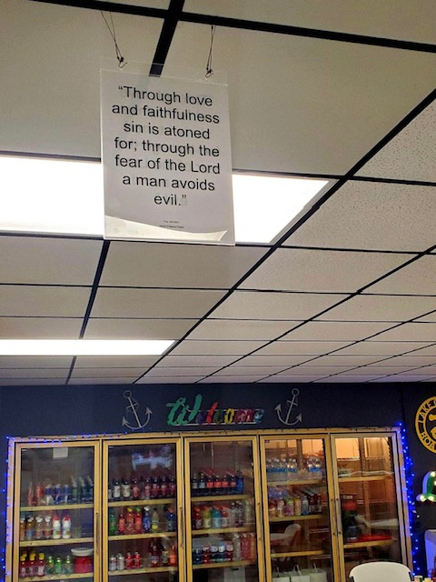

Concho Park Marina

Millersview, TX