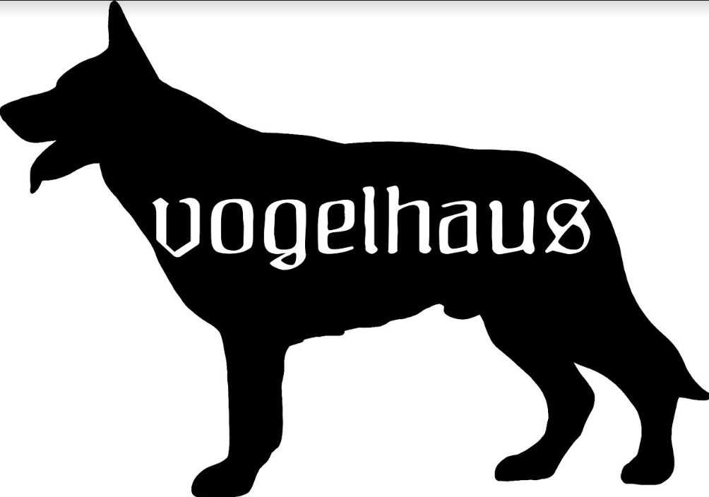
Proper and conscientious placement of our puppies is of utmost importance to us. Please fill out this application truthfully, and as completely as you can in order to help us understand your experience with dogs, and expectations of the dog you seek. German Shepherds are a wonderful breed, but they are not the right breed for everyone. The more we know about you and what you are looking for, the better we can facilitate a lifelong match that is in the best interest of both our puppy/dog and you and your family.
Date:
Name:
Address:
City: State: Zip:
Phone:
Email address:
Occupation:

1. Have you owned a dog before? If so, what breed(s)?

2. Did you crate train your dog(s)?

3. Did you attend obedience classes, or do any formal training with your dog(s)?

4. Please list the pet(s) you currently own. Specify breed, sex, age, spayed or
neutered, and health. If your pet(s) are no longer with you, what happened to
them?

5. Have you ever returned a dog to a breeder, given a puppy away, or taken a pet to
the pound or shelter? If so, what were the circumstances?

6. What is your primary interest in having a GSD?

7. Do you have any personal experience with GSDs? What research have you
done about the breed?
8. Do you live alone? Are there children living with you? If so, what are their ages?

9. Do you Rent or Own?
Type of dwelling: House ___ Condo ___ Apartment ___ Other ___ ?

10. Where do you plan to keep this dog?

11. How will you exercise, confine, and provide for his/her need to eliminate? Do you
have a fenced yard? Do you plan to chain, tie or tether this dog outside?

12. Who will be the primary caretaker for the dog?

13. How many hours a day will the dog be left alone?

14. Can you afford approximately $1,500 per year to provide quality food, supplies, and routine health care for a GSD?

Do you plan to insure the dog?

15. Can you tell me anything about your family, lifestyle, activities, hobbies, work
schedule, etc. that would provide some insight into how this dog would fit
into your daily life?

16. How did you hear about us?

17. Please list three (3) References I can call or email.

18. What is the Name, Address &amp; Phone # of your Veterinarian?

19. Who do you plan on training with dog with?

20. What do you plan on training this dog for?

21. Are you looking for a male or a female? (please see waiting lists timelines on wesite)

Thank you for taking the time to complete this application.

This application does not obligate the applicant or Vogelhaus in any way, and is not an agreement of sale. All our puppies and dogs are carefully placed through a screening process. Although there are certain personality and behavioral traits that can be identified as breed specific, every dog is an individual, and every family situation unique. We work hard to educate the public about this wonderful breed, and our greatest joy is the successful placement of our GSDs in good loving homes. Please email this completed application back to us and we will follow up with a phone call. We look forward to hearing from you again, and will be happy to discuss our breeding plans and answer your questions.

