Bella’s
Breakfast Menu - 8am until noon

Little Bella’s Breakfast 13 GF option
Two eggs, bacon, homemade toast, juice and coffee or tea

Mama Bella’s Breakfast 15 GF option
Two eggs, bacon, hash browns, homemade toast, juice and coffee or tea

Popeyes 12 Veg, GF option
Two fried eggs in homemade toast, with a side of homemade hash browns

Maple French Toast 12 Veg, GF option
Two maple spiced slices of French Toast made with homemade bread, served with maple syrup

Blueberry Pancakes 14
Three fluffy blueberry pancakes with our homemade blueberry sauce

Beans and Toast 11 WFPB, Veg, V, GF option
A traditional, hearty Newfoundland breakfast, with homemade white or whole wheat toast

Continental Breakfast 10.00 Veg, V, WFPB , GF option
Cereal or oatmeal, toast, juice and coffee or tea
Side Orders

Bacon (3 slices) 5
Hash Browns (Veg, V, PB option) 4
Toast (2 slices) 3
Cold Cereal (GF options) 4
Egg 3
Oatmeal (GF) 3.50
Maple Pecan Date Muffin 4.50

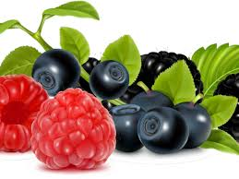 Smoothies $6.50 WFPB, V, GF
made with real fruit and juice

Good Morning Sunshine Happy Juice
Pineapple, Mango & Strawberry Blueberry, Cherry & Melon

Beverages

Coffee – Regular and Decaf $2.50
Tea $2.50
Organic Local Tea $2.75
Juice – Apple and Orange $1.50/2.50
Milk $1.50/2.50
Soda $2.50

Bella’s
Lunch and Supper Menu ~ noon until 7
Soups 8
Our homemade soups are made with the freshest local ingredients and served with homemade bread

~ Chicken Vegetable ~ Beef Barley
~ Root Cellar ( WFPB, Veg, V) ~ Vegetable (WFPB, Veg, V)
~ Vegetarian Pea Soup (WFPB, Veg, V)

Pulled Pork Sandwich 22
Seasoned and slow roasted pulled pork with our homemade smoky barbeque sauce, topped with our fresh coleslaw, on a toasted bun. Served with fries.

Fish Cakes 22 GF option
Made with local salt cod, these fish cakes are a Newfoundland
favorite. Served with homemade beans, chow, pickled beets
and homemade bread.

Mushroom Potato Cakes 22 WFPB, Veg, V, GF option
Filled with sauteed mushrooms, onions and peppers, grilled crispy brown. Served with homemade beans, chow, pickled beets and homemade bread.

Three Bean Chili 9 WFPB, Veg, V, GF option
Our plant-based chili is served with homemade bread

Hearty Meat Chili 11
Our hearty meat chili is served with homemade bread

Boiled Beans 8.50 WFPB, Veg, V, GF option
A hearty Newfoundland favorite, with homemade bread

Chicken Wings 17/½ dozen; 22/dozen
Dry spiced crispy chicken wings, served with home fries.

Grilled Cheese Sandwich 11 Veg, GF option
Made with homemade bread and cheddar cheese, served with home fries.

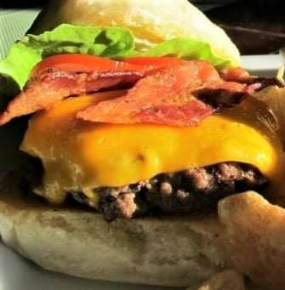 Burgers

Meat Vegan
Marinated lean ground beef Beyond Meat TM

Bay Burger Platter 18
Our tasty beef burger topped with lettuce, tomato and onion, served on our grilled artisan bun. Served with home fries.

Bella’s Cheese & Bacon Burger Platter 21
Our Bay Burger topped with cheddar cheese and bacon.
Served with home fries.

Bella’s Blueberry Chutney Burger Platter 19
Bay Burger topped with our homemade blueberry
chutney, made with local blueberries. Served with
home fries

Dill Burger Platter 19
Bay Burner topped with our homemade dill aioli and dill pickles. Served with home fries.

Smoky BBQ Mushroom Onion Burger Platter 20
Our Bay Burger topped with grilled mushrooms and onions
and our homemade smoky barbeque sauce. Served with home fries.

*Add fresh homemade coleslaw for $3

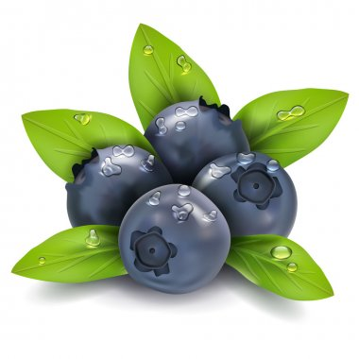 Dessert
Blueberries in a Cloud 8
A light whipped cream dessert made with local
blueberries, topped with Bella’s Blueberry Sauce.

Blueberry Date Squares WFBP, V, GF 8
Warm blueberry date square topped with Bella’s
Blueberry Sauce

Sweet Potato Chocolate Cake WFPB, V, GF 8
Rich and delicious, both the cake and the icing
are made with sweet potatoes.

Cookies $2 ea or 2 for $3.75

~ Chocolate Chip ~ Oatmeal Raisin GF
~ Peanut Butter WFPB, V, GF ~ Baygirl Cookies WFPB,, GF
Brownie WFPB, V, GF 6
Rich chocolate and perfect almost-chewy texture.

Energy Balls
$2 ea or 2 for $3.75 WFPB, Veg, V, GF
Named after our UNESCO Geopark Sites, each Energy Ball is a nutritional powerhouse!
Sea Arch Brook Point Sea Stack
Pecans, peanut butter Cashews, nut butter Cocoa, dates, coconut
dates, raisins, coconut coconut, applesauce chia seeds, maple syrup
maple syrup flax seeds, dates rolled oats
Beverages
Hot Drinks: 2.50 Cold Drinks: 1.50 small; 2.50 large

Coffee Juice: Apple and Orange
Tetley Tea Milk: White or Almond Milk

Soda: Coke, Pepsi, Ginger Ale: 2.50

Premium Organic Tea from The Newfoundland Tea Co.: 2.75
~ Cream Earl Grey ~ Wild Blueberry ~ Cinnamon Chai ~

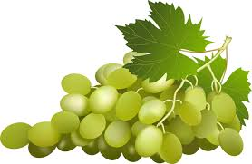 From the Bar
Spirits: $7/oz
Iceberg White Rum
Iceberg Vodka
Screech
Bells Blended Scotch
Wiser’s Rye Whiskey
Captain Morgan Deluxe Dark Rum
Kahlua
Baileys

Beer: $7 Blue Star ~ Black Horse ~ Bud Light ~ Coors Light
$8 Quidi Vidi Iceberg
$9 Local Craft Beer by Port Rexton Brewing Co.

Wine
Red: Glass Bottle (750ml)
Jackson-Triggs Cabernet
Sauvignon $8 $27
Jackson-Triggs Merlot 8 27
Bolla Valpolicella 9 32

White:
French Cross Chardonnay 8 27
Jackson-Triggs Sauvignon Blanc 8 27

Bella’s

We hope you’ll enjoy the healthy new options we’ve added to our menu! Here’s a short explanation:
- WFPB - Whole Food Plant Based eating focuses on plants – vegetables, fruits, seeds, nuts, legumes, whole grains; no animal or dairy products and limited sugar and oil. We buy local organic food whenever we can.
Veg - Vegetarian: no animal products
V - Vegan: no animal or dairy products

GF - Gluten Free: we use ground gluten-free oats in our baking and we can substitute gluten-free bread in any of our menu items.

We take utmost care in the preparation of gluten-free menu items to ensure there is no cross-contamination with gluten, however we do have wheat containing products in the kitchen so they may not be safe for those with celiac disease.

