THE
PROPOSAL
FOR
CHRISTHOME NURSERY AND PRIMARY
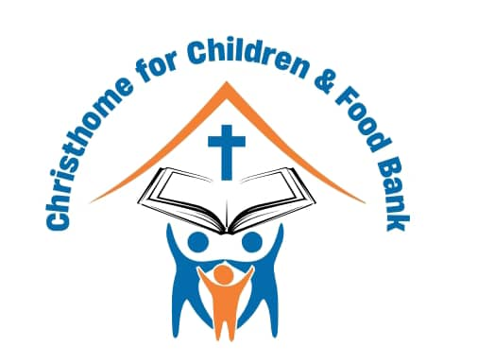
SCHOOL

LEAVING NO ONE BEHIND
Luke 15:4

2023
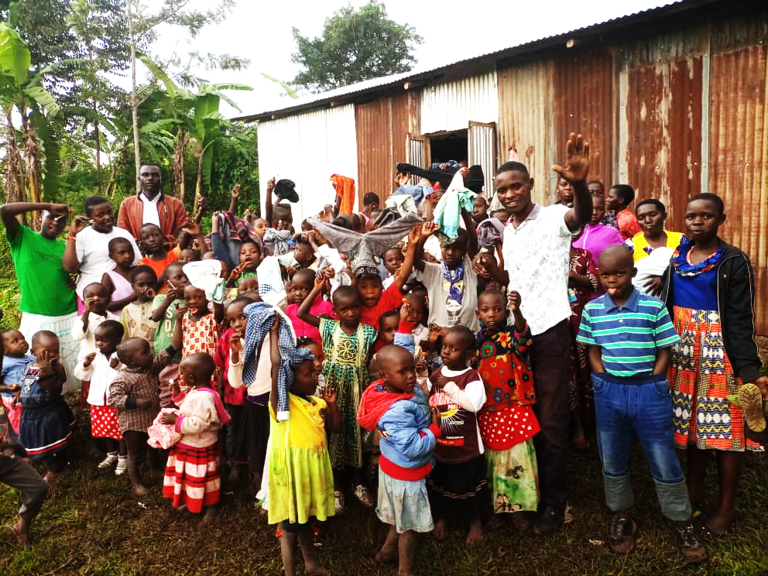

Building a foundation of hope for a brighter future for orphan and vulnerable children
I Corinthians 3:9

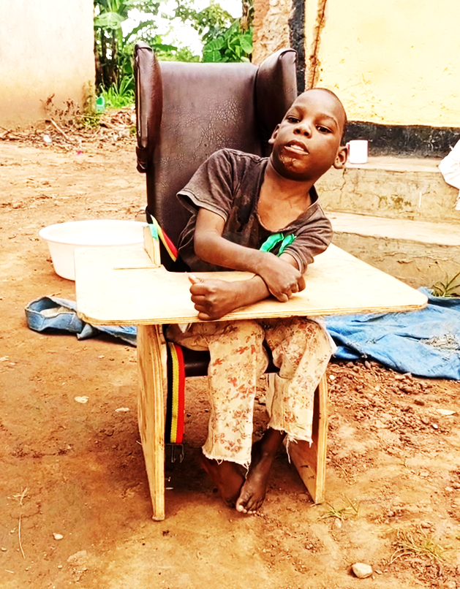
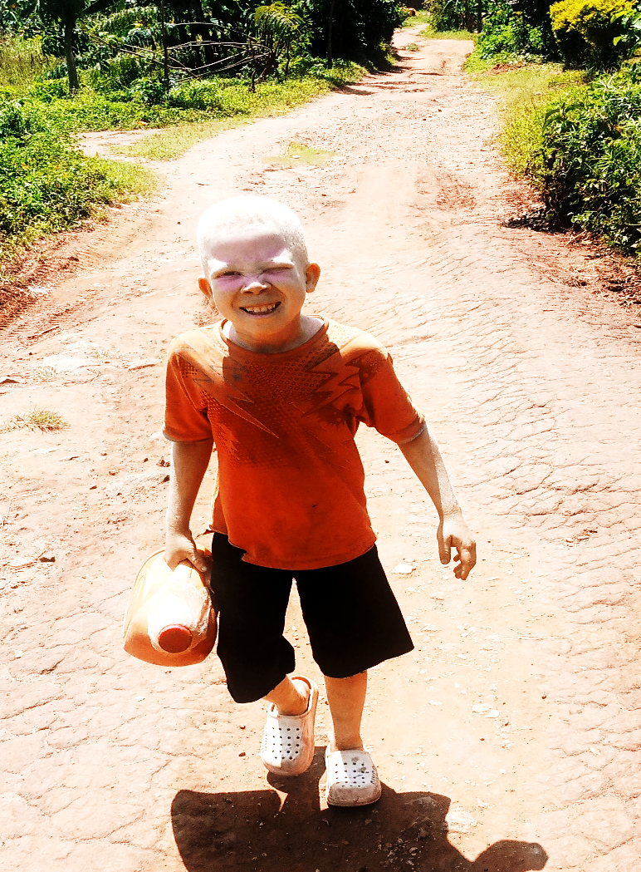

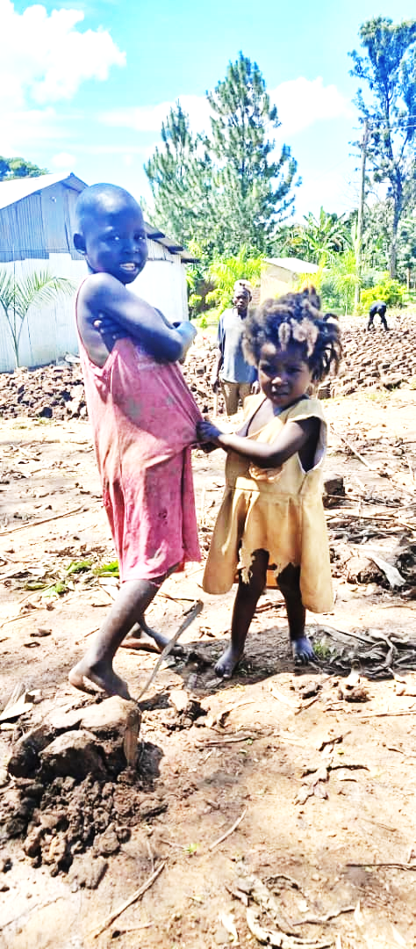
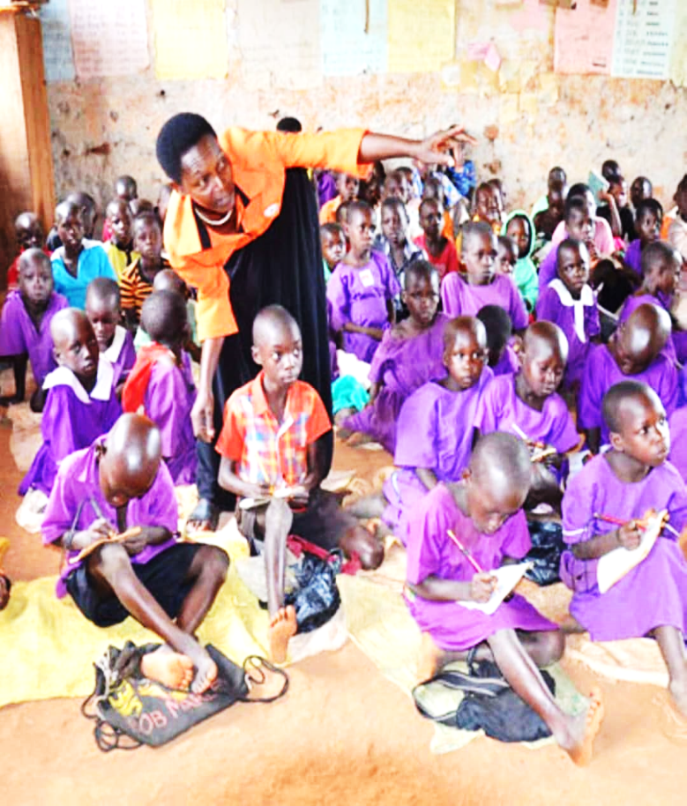
Project name | Christhome Nursery And Primary School (CHNPS)
Thematic Focus | “Leaving No One Behind”
Scope | Build and Education
Proposed Location | Nabweya Top Village, Mbale Northern City Division,  P.O.Box 361 Mbale, Uganda.
Project Duration | 2 years
Target Group(s) | The direct beneficiaries of this program are the poor children, the orphans, vulnerable children, disabled, and street children in Mbale district, and the neighboring communities.
Total Project cost | US$ 333,284
Project Coordinator | Nabude Sarah, +256782919880
Founder / Patron | Wachagi Charles and Muzaki Joan; +256 775 555139 and +256 703770053
Email | christhome4childrenfoodbank@gmail.com
Account | Account Name: Christhome for Children and Food Bank  Bank Name: Bank of Africa  Account Number: 03893520006  Swift Code: AFRIUGKA

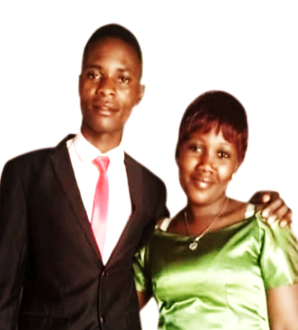

Profile: Founders of Christhome for Children and Food Bank.

Our Journey to Christhome.
Our story began with hardship, but it’s being written with unwavering hope. Every day, we’re reminded of the transformative power of providing a safe, loving, and supportive environment for children who deserve nothing less.
My name is Pastor Wachagi Charles and my wife is Muzaki Joan, my earliest companion was hunger. As the 9th of 16 children with unemployed parents, food was scarce; two of my brothers starved to death. I was malnourished and joined school at nine, walking miles barefoot with torn books, education was a distant dream. My wife, an orphan, understands this profound pain. By God's grace, our paths converged, united by similar struggles and a shared empathy for vulnerable children.
A pivotal moment for me was Pastor Joe Peters (Peters family) from the USA, who sponsored me through Compassion International, igniting a passion to break the cycle of poverty. Basing on Joan's and my experiences, it's clear that essential needs like spiritual guidance and education can transform vulnerability into stability, as it did for me with Pastor Joe Peters' help. This became our mission.
In 2017, this conviction led us to establish Christhome for Children and Food Bank (CCFB) in Bufumbo, in Mbale City, Eastern Uganda. As the Senior Pastor and Founder of Body of Christ Ministries Mbale Uganda, I saw an urgent need for a shelter for homeless, orphans, needy, and vulnerable children. Today, we care for 130 children, offering them a safe place to heal and grow.
However, we face significant challenges: overcrowded housing, insufficient land for food production, lack of educational opportunities, and inadequate medical care.
Inspired by the children's resilience, we envision expanded housing and renting more land for year-round food security. Our most profound dream is to build a Christhome Nursery and Primary School (CHNPS) on the orphanage grounds, providing free, quality education. And for the self-sponsored students in helping to sustain the school and subsidize our orphan’s education. We also plan a small health clinic.
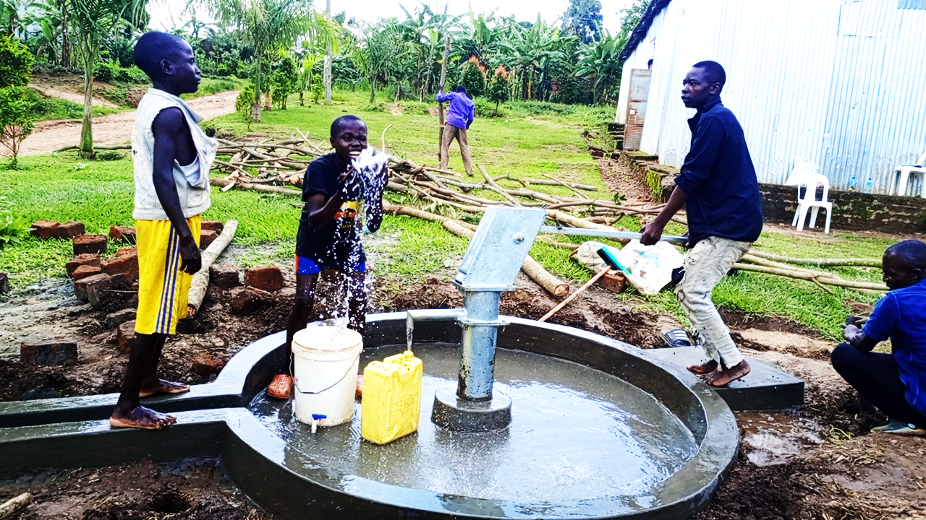
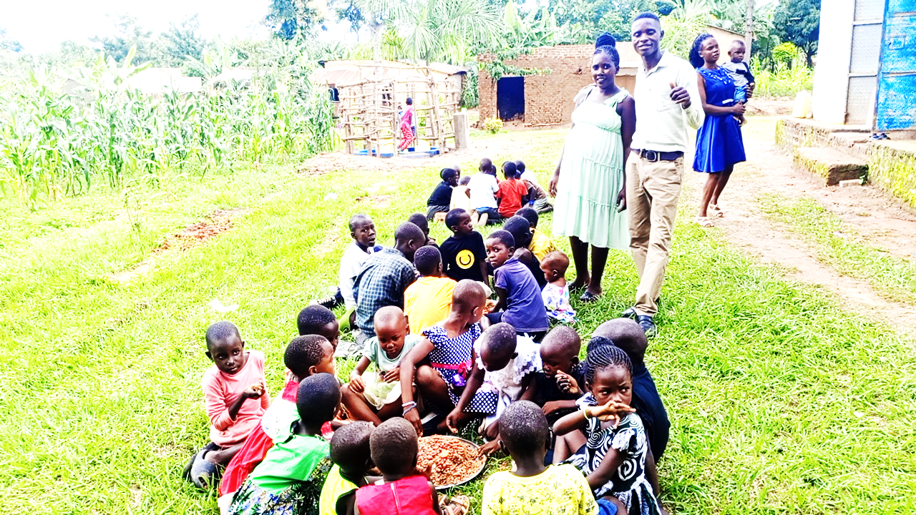
For long-term sustainability, we're diversifying income through crafts, skills training, local business partnerships, and selling excess produce. Our ultimate goal is for Christhome and its school to be a self-sufficient haven, empowering these children to thrive as independent, contributing members of society.

1.0 Introduction
The Christhome Nursery and Primary School (CHNPS) project proposes the construction of a modern Christian educational facility in Nabweya Top village, Mbale Northern City Division, Mbale City, Uganda. This initiative, spearheaded by Christhome for Children and Food Bank (CCFB), aims to address the critical lack of accessible and quality education for poor, orphaned, disadvantaged, and disabled children in this rural setting, where existing government and private educational services are severely limited or financially inaccessible.
The primary objective is to construct a comprehensive school comprising seven primary classes, nursery facilities, dormitories, administration block, kitchen, toilets, special education rooms, and essential support infrastructure. This will provide a safe, inclusive, and conducive learning environment for over 360 pupils, with potential for expansion to 500 beneficiaries. The project is a long-term commitment to fostering socio-economic welfare and transforming the community by empowering the younger generation through education.
The founder of CHNPS has already procured 2 acres of land valued at US$ 31,156. The local community has demonstrated significant commitment through contributions of labor and some materials. To bring this vital project to fruition, an amount of US$ 333,284 is required to cover the remaining construction and initial operational costs. This proposal details the project’s justification, scope, management, financial plan, and commitment to sustainability, inviting partners to contribute to this transformative endeavor.

1.1 Background
The community of Nabweya Top village, located in Mbale Northern City Division, Mbale City, Uganda, along with its surrounding villages, faces a profound challenge in providing adequate education for its children. Despite the fundamental right to education, a significant number of children in this area, particularly the poor, orphans, vulnerable, disabled, and street children, lack access to proper schooling, healthcare, and sufficient nutrition. This difficulties is aggravated by the limited presence of government schools, and where they do exist, their infrastructure only is in disrepair, characterized by structures lacking doors, shutters, and adequate furniture. While some private schools have emerged, their services remain largely out of reach for most families due to prohibitive financial costs and the long distances children must travel daily. The predominantly peasantry community finds it exceedingly difficult to afford school tuition and other requirements, making capital investments in educational infrastructure unsustainable.
Furthermore, the vulnerability of children in Mbale is heightened by the loss of parents (HIV and AIDS), leaving them in a cycle of dependency. Disabled children face even greater burdens, often confined to their homes due to lack of knowledge and skills within families to provide appropriate care and the absence of inclusive educational opportunities. This situation stunts their mental and physical development, leading to few opportunities in the workplace and perpetuating a cycle of poverty and social marginalization. The community’s deep desire for a modern school with up-to-date facilities underscores the urgency of this project.
The Christhome Nursery and Primary School (CHNPS) project is an initiative of Wachagi Charles and Muzaki Joan, the Executive Directors and founders of Christhome Nursery and Primary School, operating under the umbrella of Christhome for Children and Food Bank (CCFB). Founded in 2017, Christhome for Children and Food Bank (CCFB) is a registered non-governmental and non-partisan organization dedicated to supporting and caring for the poor, needy, vulnerable, orphans, disabled, and street children, as well as other identified needy persons from the Eastern region of Uganda. The establishment of CHNPS is a direct response to the dire educational needs observed within this community, driven by a Ugandan native committed to community transformation.

1.2 Purpose of Christhome Nursery and Primary School
Christhome Nursery and Primary School is purposefully focused on supporting and caring for the most vulnerable children in Eastern Uganda. Recognizing the extreme difficulties faced by these children, including lack of access to education, healthcare, and sufficient food, CHNPS, through CCFB, was founded on a solemn commitment to collaboratively plan, work, and mobilize resources to eliminate poverty and idleness by nurturing young children and inspiring the youth.
This effort is integral to a broader, long-term program promoting alternative care for vulnerable children. As traditional tribal structures struggle to cope with the increasing number of orphans (e.g., due to AIDS) and street children, CHNPS aims to ensure socio-economic welfare in the entire locality and provide a proper learning environment with habitable accommodation. This project directly assists the Government of Uganda in attaining the Millennium Development Goals (MDGs) by providing essential ablution facilities and contributing to universal education.

1.3 Vision, Mission and Motto

Vision Statement
To cultivate a community of empowered learners, rooted in divine wisdom, who will lead with integrity, serve with compassion, and innovate with purpose, transforming their communities and the world for the glory of God.
Mission Statement
Our mission is to:
- Nurture spiritual growth and character development: Instilling in every student a deep understanding of divine principles and fostering virtues such as integrity, compassion, perseverance, and humility.
- Achieve academic excellence: Providing a rigorous and holistic education that encourages critical thinking, creativity, and a lifelong love of learning, enabling students to discern and apply God's wisdom in all areas of knowledge.
- Empower students for service and leadership: Equipping individuals with the skills and confidence to positively impact their families, communities, and the world, recognizing their unique God-given talents and purpose.
- Cultivate a supportive and inclusive environment: Creating a safe, nurturing, and respectful community where every student feels valued, celebrated, and inspired to reach their full potential, reflecting the wisdom and love of God.
Motto: “God’s wisdom is sufficient.”

1.4 Project Objectives

1.4.1 Overall Objective (Project Goal)
To make good quality Nursery and Primary education more accessible to pupils in a rural, deprived area of Eastern Uganda and to equip these pupils with a broad range of skills for the 21st Century. This project also aims to motivate rural disadvantaged pupils to consistently give their best, to grow in strength, health, and happiness, and, above all, into mature young women and men of sound character, able to face the world with confidence, and the opportunity to thrive, achieve in a range of careers, and contribute towards wider society.

1.4.2 Specific Objectives
* To construct, equip, and manage a Nursery and Primary School with the capacity to provide good quality education and enrichment extra-curricular activities to 360 pupils.
* To nurture and produce curious and happy girl and boy learners who are flexible in thinking, independent in learning, effective in communication, research-oriented, and innovative.
* To ensure that the behavior of pupils is outstanding and that pupils show consistently excellent attitudes to learning with a strong desire to do outstandingly well.
* To actively promote the educational status of the community in which high self-esteem is developed by recognizing success, embracing change, being creative, and adopting new technology.
* To create a safe inclusive learning environment, prioritize the acquisition of knowledge by ensuring interactive class sessions, develop the desire and aptitude for inquiry, experiment, and hypothesis, and to take calculated risks.

2.0: Project Justification and Rationale

2.1 Problem Analysis
The problem of limited and poor-quality education in Nabweya Top village and its surrounding is multifaceted and deeply rooted in socio-economic challenges. The scarcity of established schools means that many children, particularly those from impoverished backgrounds, are deprived of their fundamental right to education. The existing government school is a stark example of neglect, characterized by dilapidated structures, separated and very far distance between schools and majority of families including our orphanage hence this pose safety risks and offer an unconducive learning environment. The absence of basic amenities like proper roofs and doors, windows, and sufficient furniture further hinders effective teaching and learning.
While private schools have attempted to fill the void, their fees structures are prohibitive for the predominantly peasantry community, making quality education a luxury rather than a right. The long distances children must walk to reach these schools also acts as a significant barrier, leading to fatigue and reduced attendance.
Furthermore, the vulnerability of children due to parental loss (e.g., to AIDS) leaves them without financial or emotional support, pushing them further into poverty and out of school. Disabled children face even more severe marginalization; lacking specialized support and inclusive educational settings, they are often confined to their homes, unable to develop their full potential. This exclusion contributes to their continued dependency and limits their future employment prospects in a region already grappling with high unemployment. The current situation perpetuates a cycle of illiteracy, poverty, and idleness, hindering the community’s overall development.

2.2 Needs Assessment Findings
The information provided clearly highlights the urgent need for a new, modern Christian school in Nabweya Top village. The community’s inability to support capital projects for existing schools due to financial constraints and the government’s limited infrastructure grants underscore a critical gap in educational provision. The desire expressed by the community for a modern Christian school with up-to-date facilities further reinforces this need. The high number of unprivileged children, including those with disabilities, without appropriate educational support is a clear indicator of the dire situation.

2.3 Anticipated Benefits
The construction of Christhome Nursery and Primary School is anticipated to yield significant and transformative benefits:
* Educational Benefits:
* Increased Access: Provide quality education to over 360 (potentially 500) poor, orphaned, disadvantaged, and disabled children who currently have limited or no access to schooling.
* Improved Learning Environment: Offer a Christian safe, modern, and conducive learning environment with proper classrooms, sanitation, and essential facilities, fostering better concentration and academic performance.
* Enhanced Learning Outcomes: Equip pupils with a broad range of 21st-century skills, encouraging critical thinking, creativity, and independent learning.
* Inclusivity: Specifically cater to children with vulnerabilities and disabilities, ensuring they receive appropriate support and are integrated into the mainstream education system.
* Social Benefits:
* Community Empowerment: Engage the local community in the construction and ongoing management of the school, fostering a sense of ownership and collective responsibility.
* Reduced Child Vulnerability: Provide a protective environment for vulnerable children, reducing their exposure to street life, idleness, and exploitation.
* Gender Equality: Ensure equal access to education for both boys and girls, promoting gender parity in learning outcomes.
* Improved Health and Sanitation: Provision of modern ablution facilities will significantly improve hygiene practices among students and the wider community.
* Job Creation: Generate temporary employment opportunities for local casual labor during the construction phase.
* Economic Benefits:
* Long-Term Human Capital Development: Investing in education will build a skilled and literate workforce, contributing to the long-term economic development of the region.
* Poverty Reduction: Breaking the cycle of poverty through education, enabling beneficiaries to secure better employment opportunities in the future.
* Increased Local Spending: Funds injected into the local economy through procurement of materials and labor.

2.4 Alignment with National/Local Policies
The CHNPS project directly aligns with the Government of Uganda’s commitment to achieving the Millennium Development Goals (MDGs) related to universal primary education. By providing accessible and quality education, particularly to disadvantaged groups, the project supports national efforts to reduce illiteracy, improve human capital, and foster sustainable community development. Furthermore, the emphasis on inclusive education for children with disabilities resonates with national policies promoting equity and non-discrimination in education. The collaboration with the Ministry of Education and Sports (as mentioned in the sustainability plan) further solidifies this alignment.

3.0: Project Description and Scope
These paragraphs details the proposed infrastructure and the planned approach to its construction.

3.1 Proposed Infrastructure
The CHNPS project proposes the construction of a comprehensive modern Christian Nursery and Primary school facility designed to accommodate the educational needs of children in Nabweya Top village and its surrounding villages. The proposed structures include as below:
Proposed structure plan for Christhome Nursery and Primary school
The CHNPS project proposes the construction of a comprehensive modern Christian Nursery and Primary school facility designed to accommodate the educational needs of children in Nabweya Top village and its surrounding villages. The proposed structures include:
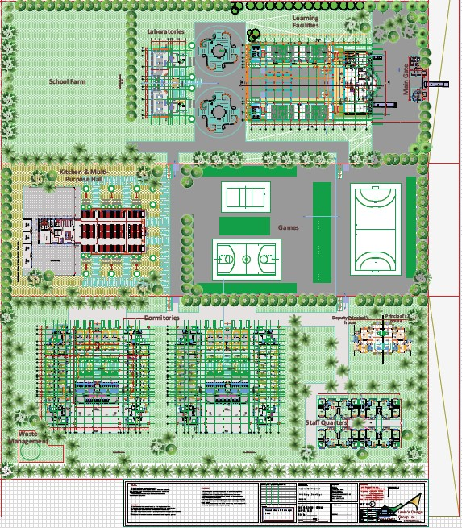
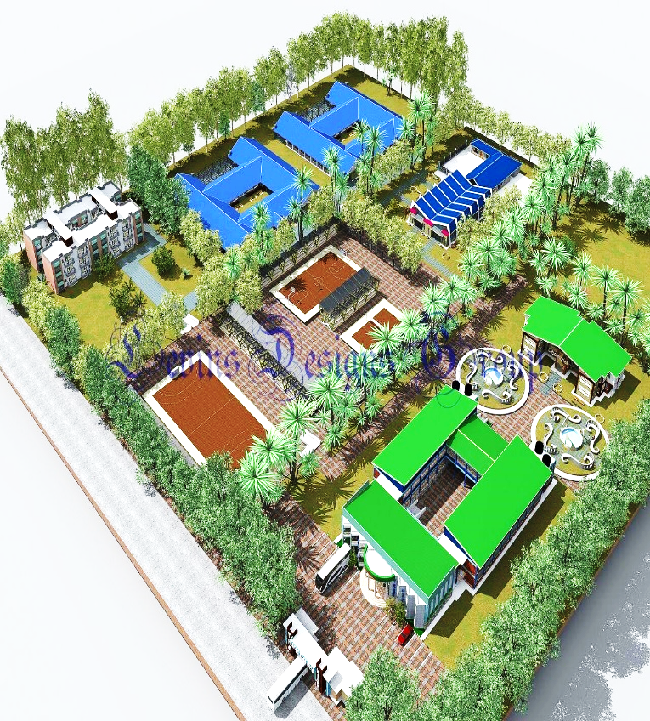
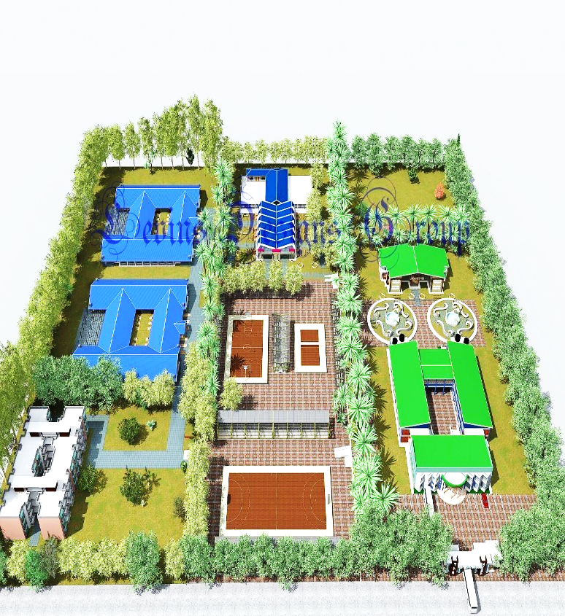
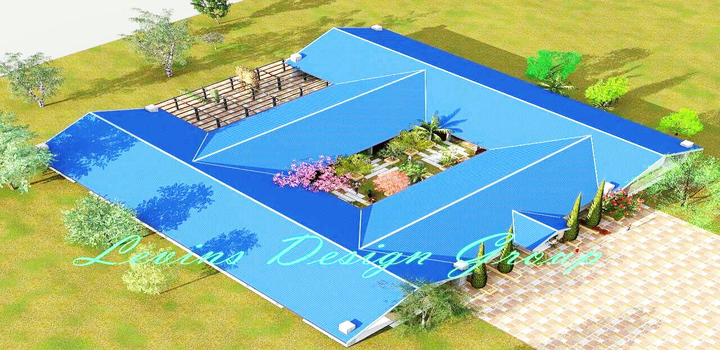
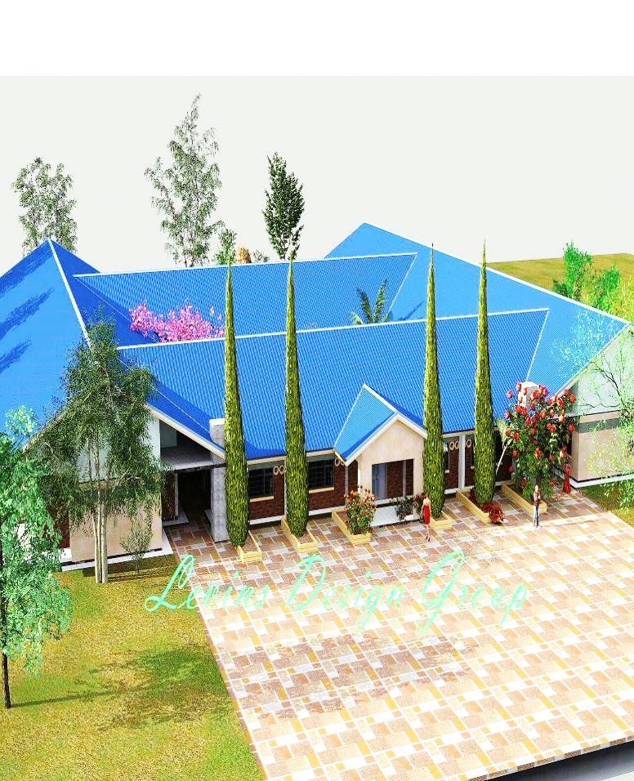
* Classroom Blocks: Ten (10) modern classrooms, designed to accommodate over 360 pupils, divided into streams of 30-35 pupils, from baby grade to Primary Seven, under the Ugandan nursery and primary school education system. This allows for future expansion to 500 beneficiaries on the acquired land.
* Dormitories: Six (6) dormitory rooms, specifically designed for boys and girls, to provide habitable accommodation for children who may come from distant areas or are in particularly vulnerable situations.
* Administration Block: A dedicated administration block to house school management offices, staff rooms, and potentially a reception area.
* Dining Hall and Kitchen: A combined dining hall and kitchen facility to ensure pupils receive nutritious meals and have a suitable space for eating.
* Sanitation Facilities: Fourteen (14) units comprising six (6) toilets and eight (8) bathrooms, ensuring adequate and hygienic ablution facilities for all students and staff.
* Special Education Rooms: Two (2) dedicated special education rooms to cater to the specific needs of children with disabilities, providing a tailored learning environment.
* Computer Lab and Equipment: A dedicated computer laboratory equipped with necessary technology to introduce digital literacy and skills to students.
* Library and Resource Rooms: Two (2) library and resource rooms to provide access to educational materials, foster a reading culture, and support independent learning.
* Sports Grounds: Three (3) designated sports grounds for various activities, including volleyball, basketball, netball, and football, promoting physical activity and holistic development.
* Children’s Outdoor Activities Area: A dedicated area for children’s outdoor play and recreational activities.
* Multipurpose Hall: Two (2) multipurpose halls for assemblies, indoor sports, community events, and other large gatherings.
* Essential Utilities:
* Rainwater Harvesting Tank: A tank for collecting rainwater to ensure a sustainable water supply.
* Water Well Drilling: A water well has been drilled to provide a reliable and clean source of water for the school and the community.
* Emergency Power Source: A generator to provide emergency power, ensuring continuity of operations during electricity outages.
* Security Infrastructure: Parking area, perimeter fence, and gate to ensure the safety and security of students, staff, and school property.
* Equipment Store: A dedicated store for educational equipment and other school supplies.
* School Furniture: Sufficient furniture for all classrooms, dormitories, dining hall, offices, and other facilities.
* School Vehicle: A school vehicle for transportation needs, including emergencies and logistical support.

3.2 Architectural Design Overview
While specific architectural plans are not provided, the proposal emphasizes the construction of “modern” facilities. The design will prioritize functionality, safety, and accessibility. The use of locally available building materials (bricks, river sand, stones and timbers….etc) will be considered to optimize costs and involve the local community in the construction process. The structures will be designed to withstand local climatic conditions and provide a conducive learning environment with adequate ventilation and lighting.

3.3 Construction Methodology
The construction will proceed in phases, contingent on the availability of funds. The project will employ a combination of skilled expertise (building technocrats, contractors…) and local casual labor. This approach aims to maximize local employment opportunities and skills transfer within the community. The construction work will be overseen by a contractor employed by Christhome for Children and Food Bank (CCFB), with supervision from the CHNPS Administration to ensure adherence to plans, budget, and timeframe.

3.4 Technology Integration
Our commitment to developing modern facilities is evident in the integration of advanced architectural and graphic technologies, alongside essential construction equipment. This includes the use of Building Information Modeling (BIM) for precise design and planning, Computer-Aided Design (CAD) software for detailed blueprints, and potentially drone technology for site monitoring and progress tracking. This strategic adoption of technology will enhance efficiency, accuracy, and overall project management, ensuring the construction of contemporary and sustainable structures.

3.5 Safety and Accessibility
Leveraging the technologies outlined above, our design prioritizes the safety and accessibility of all occupants. Building Information Modeling (BIM) will be instrumental in digitally simulating and validating safety features such as the placement and structural integrity of appropriate fencing and secure gates, ensuring optimal protective barriers. CAD software will be used to meticulously design accessible pathways, ramps, and door clearances, guaranteeing that all areas, including specialized education rooms, are compliant with universal design principles and easily navigable for children with disabilities. Furthermore, drone technology will facilitate regular, high-level inspections of the construction site, allowing for proactive identification and mitigation of potential safety hazards, thereby contributing to a safer construction environment and ultimately, a more secure and accessible final facility for all students.

3.4 Project Management and Implementation Plan

3.4.1 Project Phasing
The CHNPS project will be implemented in phases, adapting to the availability of funds. This phased approach allows for flexibility and efficient resource allocation. While not explicitly detailed, typical phases would include:
* Phase 1: Planning & Design (Ongoing/Completed): Land acquisition (acquired 2 acres), architectural design, detailed budgeting, fundraising.
* Phase 2: Site Preparation & Foundation (Initial Construction): Site clearing, leveling, excavation, foundation laying.
* Phase 3: Structural Construction (Key Buildings): Erection of classroom blocks, dormitory shells, administration block, and other primary structures.
* Phase 4: Finishing & Utilities: Roofing, internal and external finishes, installation of plumbing, electrical systems, and sanitation facilities.
* Phase 5: Equipping & Furnishing: Installation of school furniture, computer lab equipment, library resources, and other essential supplies.
* Phase 6: Operational Setup & Handover: Staff recruitment, curriculum development, enrollment of students, and official opening.

3.4.2 Work Plan/Timeline
The project is estimated to take 1-2 years to complete, depending on the availability of funds. Once funds are available, construction work will commence immediately. A detailed Gantt Chart outlining specific activities, durations, dependencies, and milestones for each phase will be developed and presented in the Appendices. Regular reviews of the budget and implementation plan will be conducted to ensure efficiency and address any unforeseen challenges.

3.5 Organizational Structure and Key Personnel

3.5.1 Governance:
Christhome Nursery and Primary School (CHNPS) will be responsible for both the construction phases and for overseeing the management of the children at school. The CHNPS – education trustees are responsible for appointing the Project Manager and the Bursar, setting academic policy, supporting and encouraging the Project Manager and Bursar, and monitoring their performance.
3.5.2 Project Implementation Team:
The project will be managed by a dedicated team with clear roles and responsibilities:
Executive Director (Wachagi Charles and Muzaki Joan Founders, Christhome for Children and Food Bank) /Christhome Nursery and Primary School: Overall strategic oversight, fundraising, and liaison

30 May 2023
To our sponsors and Partners,
We, the undersigned, have collectively participated in this proposal.
We affirm our commitment to bringing the project to its fruition.
We undertake the supervision and monitoring of the progress to this project till its fully completed and handed over to the Christhome Nursery and Primary school – Mbale Uganda
Approved and authorized by the following boards of trustees members:
NAME: | POSITION | SIGNATURE
WACHAGI CHARLES | FOUNDER / DIRECTOR
OTHIENO ALEX | ADMINISTRATOR
NAMASABA LYDIA | PROJECT COORDINATOR
WABENDE DAVID | FINANCIAL OFFICER
MUZAKI AMINAH | CO- FOUNDER
WANDYETYE AMOS | HUMAN RESOURCES MANAGER
NAGUDI JUDITH | SOCIAL WORKER / ORPHAN CARE
KIBBO YESE | DIRECTOR EDUCATION
NABUDE SARAH | DIRECTOR OPERATIONS
MUBALA SAMUEL | DIRECTOR OF DEVELOPMENT (FUNDRASING OFFICER)
WAMUNDU KENNETH | CHILD AND FAMILY CARE
KHAYIYI CHRISTINE | HEALTH / MEDICAL PERSONEL

