LOCALLY OWNED & OPERATED – SHOP LOCAL

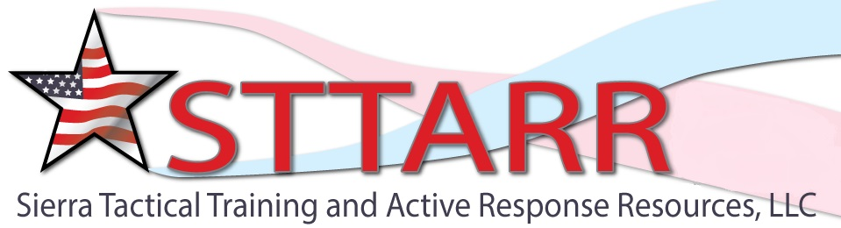
2019 Concealed Carry Weapons (CCW) Permit Classes
A one-day course which meets the training requirements to obtain or maintain a CCW permit in Inyo and Mono Counties.

Saturday January 5th, 2019 - CCW & Renewal

Saturday February 2, 2019 - CCW & Renewal

Saturday March 2, 2019 - CCW & Renewal

Saturday April 6th, 2019 - CCW & Renewal

Saturday May 4, 2019 CCW & Sunday May 5, 2019 (Basic Defensive Handgun Training)

Saturday June 1, 2019 CCW & Sunday June 2, 2019 (Advanced Defensive Handgun Training)

Saturday July 13, 2019 - CCW & Renewal

Saturday August 3, 2019 - CCW & Renewal

Saturday September 14, 2019 CCW & Sunday Sept. 15, 2019 (Basic Defensive Handgun Training)

Saturday October 12, 2019 - CCW & Renewal

Sunday November 17, 2019 - CCW & Renewal

Saturday Dec. 14, 2019 - CCW & Renewal

Saturday Jan. 4, 2020 - CCW & Renewal

To register & Description of the class go to: www.sttarr.net or email joe@sttarr.net or call Joe Pecsi @ 760-784-0699.
Class size limited so please register early!
These dates are subject to change due to range availability, weather, etc.

