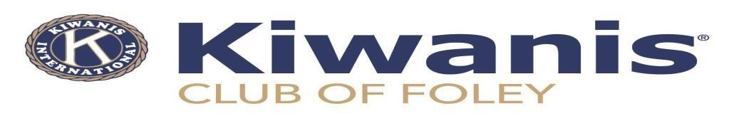
June 10, 2022

Dear Friend of Kiwanis

We hope things are going well for your business as this area seems to be experiencing exceptional growth at this time. Preparations for our annual Kiwanis events are also underway for us. We are continuing to upgrade our social media pages, websites and updating our procedures to better serve your interests. We’re counting on the businesses of this community continuing to support our Christmas Parade, Special Olympics, Foley Boys & Girls Club “Summer Camp”, scholarships awarded to high school seniors and continue to work with local food banks for those with needs. We need your support to make these programs continue. Our Radio Day at WHEP will recognize your support of our community programs.

New this year we are offering a package for a lucky business to sponsor our April 29, 2023, 3rd annual Foley Kiwanis Poker Run presented by your business with logo and name heading up our advertising avenues and recognized for your support at all our events in 2023. Radio Day is planned for October 25, 2022.

A Kiwanian will be contacting you in the near future about your donation or sponsorship. In appreciation of your community support, we’ll provide your business with valuable recognition as we acknowledge your support live on the air at Kiwanis Radio Day, provided to us by WHEP (92.5 FM and 13.10 AM), also on our web-sites, Facebook and social media pages. Your business Information will be posted on https://foleykiwanis.club, (Foley Kiwanis Club, and Foley Kiwanis Poker Run Facebook pages and the Onlooker Newspaper.

We encourage you to contribute to us with a Donation or Sponsorship of $5,000.00 for full sponsorship of our events. We will show your business as the presenter of our Foley Kiwanis Motorcycle Poker Run and you’ll be recognized at our many events. Several sponsor packages are available on the second page. If your company or industry will be making a donation or sponsorship make check payable to: Foley Kiwanis Foundation. We are a tax exempt, 501 (C) 3 organization. We are also seeking corporate members to help us support our club and the children of the community. We will be available to participate in your own corporate community events. As they say, “WE’RE ALL IN THIS TOGETHER”.

We are able to accept credit cards on our website. We use Venmo and PayPal devices with I-phones when requested

Please use the following address for mailing your donation or sponsorship check.

Foley Kiwanis Foundation P.O. Box 576 Foley AL 36536

If you need additional information, feel free to contact members below via phone or email.

Russ Morrison John Jackson
Club President Secretary/Treasurer
859-771-6091 251-223-6097
russmorr24@yahoo.com jjackson@cityoffoley.org

