How to Sign up for IEA 2026-2027
https://www.rideiea.org/
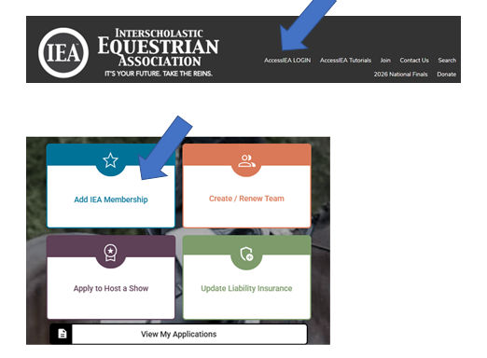

If you are new to IEA the parent must first set up an account under their name, then add on your youth rider to your account. New adult riders sign up for their own account.

NOTE: All adult riders will need to submit documentation of Safe Sport Training and take the IEA rules Quiz


Answer questions 1-7 about rider: name/ date of birth/ethnicity etc.

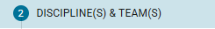

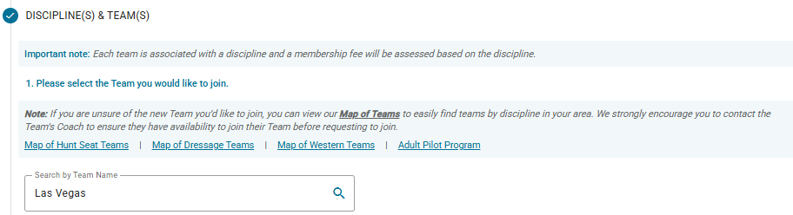

These are the Las Vegas teams that will pop up: select team(s) your rider wants to join
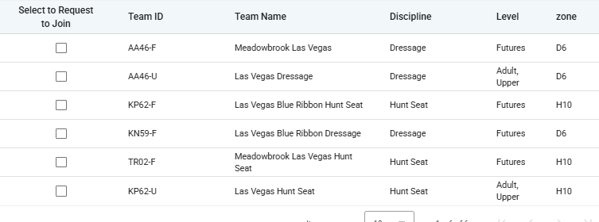

For High School (entering grades 9-12) Dressage (all coaches): join team “Las Vegas Dressage” AA46-U
For High School (entering grades 9-12) Hunt seat (all coaches): join team “Las Vegas Hunt Seat” KP62-U

For middle school (entering grades 4-8) Blue Ribbon Teams with coaches Missy Corbin and Annette Spinetti:
Middle school Blue Ribbon Dressage: join team “Las Vegas Blue Ribbon Dressage” KN59-F
Middle School Blue Ribbon Hunt Seat: join team “Las Vegas Blue Ribbon Hunt Seat” KP62-F

For middle school entering (grades 4-8) Meadowbrook Teams with coaches Catherine Prato and Trillium Daniels
Middle school Meadowbrook Dressage: join team “Meadowbrook Las Vegas” AA46-F
Middle School Meadowbrook Hunt Seat: join team “Meadowbrook Las Vegas Hunt Seat” TR02-F

For Adult Dressage (all coaches): join team “Las Vegas Dressage” AA46-U
For Adult Hunt Seat (all coaches): join team “Las Vegas Hunt Seat” KP62-U

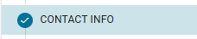
Answer questions 1-8 about addresses/phone numbers/parent information etc

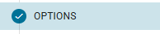
Sign up for any optional things you want – such as giving your rider a username and password so they can access the database themselves….not required
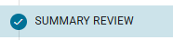
Review all your information and team requests for accuracy
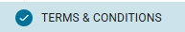
Parent signs permission forms, etc


Pay $85 for each discipline signed up for (Note: adult rider membership is $75.00 per discipline)
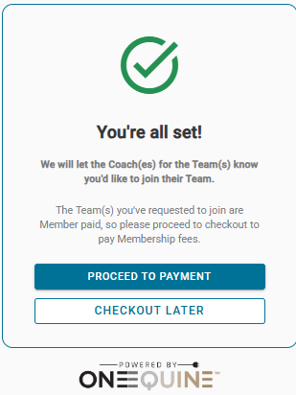
Pay by credit card or PayPal

