A.T.F. Resume: Fred Weeks Master Instructor
Allied Tang Soo Do Federation ( Summary Of Martial Arts Experience) hello

Year Style Instructor Organization Rank
l969-70 Goju Joe Tabor YMCA Karate Club 6th Green
1969-71 Jukite JJ Claude Woodson |  |  | YMCA MA Program | No Rank
1970-71 | TaeKwonDo | Phil Meeks | YMCA Karate Club | 4th Green
1971-72 | TangSooDo | Mike Murphy | Rapid City TSD | 2nd Red
1972-73 | TaeKwonDo | None | Karate Club  A. T. A. | 2nd Red
1973-80 | Norris System | Chuck Norris Tip Potter | U. F. A. F. | 1st Black
TangSooDo
1980 Broke from Norris System, Founded A. T. F.
1982-83 TangSooDo Ollie Speakman American Moo Duk Kwon 2nd
Black

1983-89 NO ORGANIZATIONAL TIES
1989-90 A. T. F. Ray Walters USA Korean Karate Assn 3rd Black TangSooDo
1989 TangSooDo Tom Hunnicutt Associate Mbr 4th Black (Advisor) A.O.O.M.K.A. (Yondon)
1993 TangSooDo Tom Hunnicutt Associate Mbr 8th Black A.O.O.M.K.A. (Hac hiDan) "Kyoshi”
2001 Tang Soo Do Little Rock Martial Arts Association 10th Degree 2009 AOOMKA Grand Master Tom Hunnicutt Honorary 10th Degree

1980-Present Founder and Chief Instructor of the Allied Tang Soo Do Federation.
I began instructing in 1972 at the rank of 2nd Degree Red and have owned and operated a school since that date. I have trained THOUSANDS of students since first opening a school and have trained and promoted three (3) Jr Black Belts, twenty two (22) students to the rank of 1st Degree Black Belt and five (5) to the rank of 2nd Degree Black Belt, three (3) 3rd Degree, two (2) to the rank of 4th Degree and one (1) 8th Degree Black Belt. In addition I have trained three (3) other students who have left my school with the rank of Red Belt and were later promoted to Black Belt in another system. Also of interest, for the school year 1985/86 I taught a college accredited P.E. Course for Southern Baptist College and carried a class roster of 35 students.
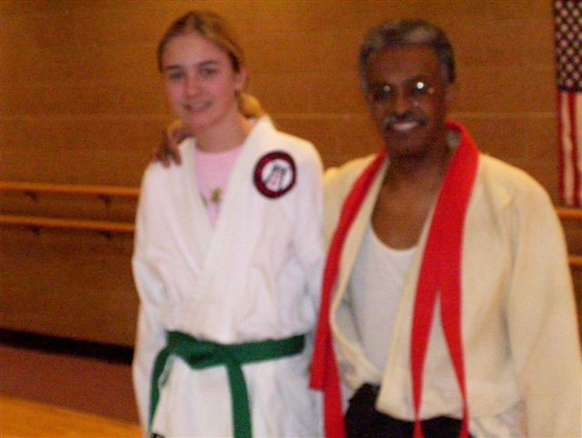
Until recently my greatest Martial Arts experience was my 1st Degree Black Belt test and having both Chuck Norris and Bill Wallace on the test board. Seeing my wife promoted to 1st degree Black Belt the following year, by Chuck Norris, was a very gratifying experience. One of the greatest honors I have received was award of an Honorary 10th Dan given in recognition of my thirty years of instructing Tang Soo Do. Perhaps overshadowing all else is seeing my sons ,Chance and Range, progress in their training and knowing that what I am passing on to them, will be passed on to my grandchildren...and knowing that the tradition will continue after me.
Most recently, my grand daughter, Grace, has trained in Jukite JuJitsu under Master Claude Woodson, a style which I studied under Master Woodson, early in my martial arts career. She received her Brown Belt before graduating High School.
How neat is that!

CONTENT

Page 1.. . . . . . . . . . . . . . . . . . . . . . . . . . . . . . . . . . . . . . . . . . . . . . . . . . . . . . . . . . . . . . . . . . . . . . . . . . . . . . . . . . . . . . . . . . . . . . . . . . . . . . . . . . . . .Resume F.Weeks
Page 2.. . . . . . . . . . . . . . . . . . . . . . . . . . . . . . . . . . . . . . . . . . . . . . . . . . . . . . . . . . . . . . . . . . . . . . . . . . . . . . . . . . . . . . . . . . . . . . . . . . . . . . . . . . . . . . . . . . . . .Content
Page 3.. . . . . . . . . . . . . . . . . . . . . . . . . . . . . . . . . . . . . . . . . . . . . . . . . . . . . . . . . . . . . . . . . . . . . . . . . . . . . . . . . . . . . . . . . . . . . . . . . . . . . . . . . . . . . . . . . . .Dedication
Page 4.. . . . . . . . . . . . . . . . . . . . . . . . . . . . . . . . . . . . . . . . . . . . . . . . . . . . . . . . . . . . . . . . . . . . . . . . . . . . . . . . . . . . . . . . . . .Statement of Purpose/Code of Conduct
Page 5.. . . . . . . . . . . . . . . . . . . . . . . . . . . . . . . . . . . . . . . . . . . . . . . . . . . . . . . . . . . . . . . . . . . . . . . . . . . . . . . . . . . . . . . . . . . . . . . . . . . . . . . . . . . . . .Student ID Page
Page 6.. . . . . . . . . . . . . . . . . . . . . . . . . . . . . . . . . . . . . . . . . . . . . . . . . . . . . . . . . . . . . . . . . . . . . . . . . . . . . . . . . . . . . . . . . . . . . . . . . . . . . . . .Student Personal Goals
Page 7.. . . . . . . . . . . . . . . . . . . . . . . . . . . . . . . . . . . . . . . . . . . . . . . . . . . . . . . . . . . . . . . . . . . . . . . . . .What is Tang Soo Do / Cardio Kick-Boxing / Korean Terms
Page 8.. . . . . . . . . . . . . . . . . . . . . . . . . . . . . . . . . . . . . . . . . . . . . . . . . . . . . . . . . . . . . . . . . . . . . . . . . . . . . . . . . . . . . . . . . . . . .Lineage /A.T.F. Tang Soo Do System
Page 9.. . . . . . . . . . . . . . . . . . . . . . . . . . . . . . . . . . . . . . . . . . . . . . . . . . . . . . . . . . . . . . . . . . . . . . . . . . . . . . . . . . . . . . . . . . . . . . . . . . . . . . . . . . . . .AT F Black Belts
Page 10& 11. . . . . . . . . . . . . . . . . . . . . . . . . . . . . . . . . . . . . . . . . . . . . . . . . . . . . . . . . . . . . . . . . . . . . . . . . . . . . . . . . . . . . . . . . . . . . . .Rules / General Information
Page 12.. . . . . . . . . . . . . . . . . . . . . . . . . . . . . . . . . . . . . . . . . . . . . . . . . . . . . . . . . . . . . . . . . . . . . . . . . . . . . . .Uniform Requirements / Special Projects / Charities
Page 13.. . . . . . . . . . . . . . . . . . . . . . . . . . . . . . . . . . . . . . . . . . . . . . . . . . . . . . . . . . . . . . . . . . . . . . . . . . . . . . . . . . . . . . . . . . . . .Rank Information and Progression
Page 14.. . . . . . . . . . . . . . . . . . . . . . . . . . . . . . . . . . . . . . . . . . . . . . . . . . . . . . . . . . . . . . . . . . . . . . . . . . . . . . . . . . . . . .Instructors Requirements / Come Prepared
Page 15.. . . . . . . . . . . . . . . . . . . . . . . . . . . . . . . . . . . . . . . . . . . . . . . . . . . . . . . . . . . . . . . . . . . . . . . . . . . . . . . . . . . . . . . . . .The School Patch Colors and Meanings
Page 16.. . . . . . . . . . . . . . . . . . . . . . . . . . . . . . . . . . . . . . . . . . . . . . . . . . . . . . . . . . . . . . . . . . . . . . . . . . . . . . . . . . . . . . . . . . . . . . . . . . . . . . . . . . . .DRAGONHEART
Page 17.. . . . . . . . . . . . . . . . . . . . . . . . . . . . . . . . . . . . . . . . . . . . . . . . . . . . . . . . . . . . . . . . . . . . . . . . . . . . . . . . . . . . . . . . .Birth & Evolution of DRAGONHEART
Page 18.. . . . . . . . . . . . . . . . . . . . . . . . . . . . . . . . . . . . . . . . . . . . . . . . . . . . . . . . . . . . . . . . . . . . . . . . . . . . . . . . . . . . . . . . . . . . . . . . . . . . .Fighting Name & Request
Page 19.. . . . . . . . . . . . . . . . . . . . . . . . . . . . . . . . . . . . . . . . . . . . . . . . . . . . . . . . . . . . . . . . . . . . . . . . . . . . . . . . .Value of Testing / Nerve Centers, Pressure Points
Page 20.. . . . . . . . . . . . . . . . . . . . . . . . . . . . . . . . . . . . . . . . . . . . . . . . . . . . . . . . . . . . . . . . . . . . . . . . . . . . . . . . . . . . . . . . . . . . . . . . . .Record of Promotions / KiAi
Page 21.. . . . . . . . . . . . . . . . . . . . . . . . . . . . . . . . . . . . . . . . . . . . . . . . . . . . . . . . . . . . . . . . . . . . . . . . . . . . . . . . . . . . . . . . . . .The Salute, Background and Meaning
Page 22.. . . . . . . . . . . . . . . . . . . . . . . . . . . . . . . . . . . . . . . . . . . . . . . . . . . . . . . . . . . . . . . . . . . . . . . . . . . . . . . . . . . . . . . . . . . . . . . . . . . . . . . . . . . . .Hyungs (Forms)
Page 23.. . . . . . . . . . . . . . . . . . . . . . . . . . . . . . . . . . . . . . . . . . . . . . . . . . . . . . . . . . . . . . . . . . . . . . . . . . . . . . . . . . . . . . . . . . . . . . . . . . . . . . . . .Hyung Requirements
Page 24.. . . . . . . . . . . . . . . . . . . . . . . . . . . . . . . . . . . . . . . . . . . . . . . . . . . . . . . . . . . . . . . . . . . . . . . . . . . . . . . . . . . . . . . . . . . . . . . . . . . . . . . . . . . .Sparring/Attitude
Page 25.. . . . . . . . . . . . . . . . . . . . . . . . . . . . . . . . . . . . . . . . . . . . . . . . . . . . . . . . . . . . . . . . . . . . . . . . . . . . . . . . . . . . . Sparring/Attitude/Consciousness vs Instinct
Page 26.. . . . . . . . . . . . . . . . . . . . . . . . . . . . . . . . . . . . . . . . . . . . . . . . . . . . . . . . . . . . . . . . . . . . . . . . . . . . . . . . . . . . . . . . . . . . . . . . . . . . . . . Importance of Respect
Page 27.. . . . . . . . . . . . . . . . . . . . . . . . . . . . . . . . . . . . . . . . . . . . . . . . . . . . . . . . . . . . . . . . . . . . . . . . . . . . . . . . . . . . . . . . . . . . . . . . . . . . . . . . . . . . . . .Basics/5,5, &5
Page 28.. . . . . . . . . . . . . . . . . . . . . . . . . . . . . . . . . . . . . . . . . . . . . . . . . . . . . . . . . . . . . . . . . . . . . . . . . . . . . . . . . . . . . . . . . . . . . . . . . . . . . . . . . . . . . .Stances/Blocks
Page 29.. . . . . . . . . . . . . . . . . . . . . . . . . . . . . . . . . . . . . . . . . . . . . . . . . . . . . . . . . . . . . . . . . . . . . . . . . . . . . . . . . . . . . . . . . . . . . . . . . . . . . . . . . . . . . .Blocks/Punches
Page 30.. . . . . . . . . . . . . . . . . . . . . . . . . . . . . . . . . . . . . . . . . . . . . . . . . . . . . . . . . . . . . . . . . . . . . . . . . . . . . . . . . . . . . . . . . . . . . . . . . . . . . . . . . . . . . .Punches/Kicks
Page 31.. . . . . . . . . . . . . . . . . . . . . . . . . . . . . . . . . . . . . . . . . . . . . . . . . . . . . . . . . . . . . . . . . . . . . . . . . . . . . . . . . . . . . . . . . . . . . . . Kicks/Origins of Forms (Hyungs)
Page 32.. . . . . . . . . . . . . . . . . . . . . . . . . . . . . . . . . . . . . . . . . . . . . . . . . . . . . . . . . . . . . . . . . . . . . . . . . . . . . . . . . . . . . . . . . . . . . . . . . . . . . . . . . . . . . . .Origins contd
Page 33.. . . . . . . . . . . . . . . . . . . . . . . . . . . . . . . . . . . . . . . . . . . . . . . . . . . . . . . . . . . . . . . . . . . . . . . . . .Korean/Sino-Korean Numbering System/Naihanchi Forms Page 34.. . . . . . . . . . . . . . . . . . . . . . . . . . . . . . . . . . . . . . . . . . . . . . . . . . . . . . . . . . . . . . . . . . . . . . . . . . . . . . . . . . . . . . . . . . . . . . . . . . . . . . . . . . . .Pyong Ahn Forms
Page 35.. . . . . . . . . . . . . . . . . . . . . . . . . . . . . . . . . . . . . . . . . . . . . . . . . . . . . . . . . . . . . . . . . . . . . . . . . . . . . . . . . . . . . . . . . . . . . . . . . .Five Basic Boxing Techniques
Page 36.. . . . . . . . . . . . . . . . . . . . . . . . . . . . . . . . . . . . . . . . . . . . . . . . . . . . . . . . . . . . . . . . . . . . . . . . . . . . . . . . . . . . . . . . . . . . . . .Testing Requirements 10th Yellow
Page 37.. . . . . . . . . . . . . . . . . . . . . . . . . . . . . . . . . . . . . . . . . . . . . . . . . . . . . . . . . . . . . . . . . . . . . . . . . . . . . . . . . . . . .Testing Requirements 9th Purple/8th Orange
Page 38.. . . . . . . . . . . . . . . . . . . . . . . . . . . . . . . . . . . . . . . . . . . . . . . . . . . . . . . . . . . . . . . . . . . . . . . . . . . . .Testing Requirements 7th Blue / Focus, Concentration
Page 39.. . . . . . . . . . . . . . . . . . . . . . . . . . . . . . . . . . . . . . . . . . . . . . . . . . . . . . . . . . . . . . . . . . . . . . . . . . . . . . . . . . . . . . . . . .Testing Requirements 6th, 5th, 4th Green
Page 40.. . . . . . . . . . . . . . . . . . . . . . . . . . . . . . . . . . . . . . . . . . . . . . . . . . . . . . . . . . . . . . . . . . . . . . . . . . . . . . . . . . . . . . . . . . .Testing Requirements 3rd, 2nd, 1st Red
Page 41.. . . . . . . . . . . . . . . . . . . . . . . . . . . . . . . . . . . . . . . . . . . . . . . . . . . . . . . . . . . . . . . . . . . . . . . . . . . . . . . . . . . .Valuable Information for 1st Red/Testing Tips
Page 42.. . . . . . . . . . . . . . . . . . . . . . . . . . . . . . . . . . . . . . . . . . . . . . . . . . . . . . . . . . . . . . . . . . . . . . . . . . . . . . . . Testing Requirements for 1st Dan/Black Belt Oath
Page 43.. . . . . . . . . . . . . . . . . . . . . . . . . . . . . . . . . . . . . . . . . . . . . . . . . . . . . . . . . . . . . . . . . . . . . . . . . . . . . . . . . . . . . . . . . . . . . . . . . . . . . . . . . .Executive BB Board
Page 44.. . . . . . . . . . . . . . . . . . . . . . . . . . . . . . . . . . . . . . . . . . . . . . . . . . . . . . . . . . . . . . . . . . . . . . . . . . . . . . . . . . . . . . . . . . . . . . .ATF Cross Training Curriculum
Page 45.. . . . . . . . . . . . . . . . . . . . . . . . . . . . . . . . . . . . . . . . . . . . . . . . . . . . . . . . . . . . . . . . . . . . . . . . . . . . . . . . . . . . . . . . . . . . . . . . . . . . . . . . . . . . . .Moo Duk Kwon
Page 46.. . . . . . . . . . . . . . . . . . . . . . . . . . . . . . . . . . . . . . . . . . . . . . . . . . . . . . . . . . . . . . . . . . . . . . . . . . . . . . . . . . . . . . . . . . . . . . . . . . . . . . .Cross Training Syllabus
Page 47.. . . . . . . . . . . . . . . . . . . . . . . . . . . . . . . . . . . . . . . . . . . . . . . . . . . . . . . . . . . . . . . . . . . . . . . . . . . . . . . . . . . . . . . . . . . . . . . . . . . . . . . . . . . . Syllabus/Kubudo
Page 48.. . . . . . . . . . . . . . . . . . . . . . . . . . . . . . . . . . . . . . . . . . . . . . . . . . . . . . . . . . . . . . . . . . . . . . . . . . . . . . . . . . . . . . . . . . . . . . . . . . . . . . . . . . . . . . . Jeet Kune Do
Page 49.. . . . . . . . . . . . . . . . . . . . . . . . . . . . . . . . . . . . . . . . . . . . . . . . . . . . . . . . . . . . . . . . . . . . . . . . . . . . . . . . . . . . . . . . . . . . . . . . . . . . . . . . . .Composite Training
Page 50-53. . . . . . . . . . . . . . . . . . . . . . . . . . . . . . . . . . . . . . . . . . . . . . . . . . . . . . . . . . . . . . . . . . . . . . . . . . . . . . . . . . . . . . . . . . . . . . Muay Thai, Kali, Escrima, Silat
Page 54.. . . . . . . . . . . . . . . . . . . . . . . . . . . . . . . . . . . . . . . . . . . . . . . . . . . . . . . . . . . . . . . . . . . . . . . . . . . . . . . . Boxing, Kick Boxing, Grappling, Ground Fighting
Page 55-56. . . . . . . . . . . . . . . . . . . . . . . . . . . . . . . . . . . . . . . . . . . . . . . . . . . . . . . . . . . . . . . . . . . . . . . . . . . . . . . . . . . . . . . . . . . .Judo, Jiu Jitsu, Brazilian Jiu Jitsu
Page 57.. . . . . . . . . . . . . . . . . . . . . . . . . . . . . . . . . . . . . . . . . . . . . . . . . . . . . . . . . . . . . . . . . . . . . . . . . . . . . . . . . . . . . . . . . . . . . . . . . .Weapons Training Addendum
Page 58.. . . . . . . . . . . . . . . . . . . . . . . . . . . . . . . . . . . . . . . . . . . . . . . . . . . . . . . . . . . . . . . . . . . . . . . . . . . . . . . . . . . . . . . . . . . . . . . . . . . . . . . . . . . . . . . . Health Tips
Page 59.. . . . . . . . . . . . . . . . . . . . . . . . . . . . . . . . . . . . . . . . . . . . . . . . . . . . . . . . . . . . . . . . . . . . . . . . . . . . . . . . . . . . . . . . . . . . . . .Life Preserver On A Stormy Sea
Page 60-66. . . . . . . . . . . . . . . . . . . . . . . . . . . . . . . . . . . . . . . . . . . . . . . . . . . . . . . . . . . . . . . . . . . . . . . . . . . . . . . . . . . . . . . . . . . . . . . . . . . . . . . . .Instructor Profiles
Page 67.. . . . . . . . . . . . . . . . . . . . . . . . . . . . . . . . . . . . . . . . . . . . . . . . . . . . . . . . . . . . . . . . . . . . . . . . . . . . . . . . . . . . . . . . . . . . . . . . . . . . . . . . . . . . . . .The Mountain
Page 68.. . . . . . . . . . . . . . . . . . . . . . . . . . . . . . . . . . . . . . . . . . . . . . . . . . . . . . . . . . . . . . . . . . . . . . . . . . . . . . . . . . . . . . . . . . . . . . . . . . . . . . . . . . . .Learning Process
Page 69-72. . . . . . . . . . . . . . . . . . . . . . . . . . . . . . . . . . . . . . . . . . . . . . . . . . . . . . . . . . . . . . . . . . . . . . . . . . . . . . . . . . . . . . . . . . . . . . . . . . . . . . . . . . . . . . . Dedications
Page 73. . . . . . . . . . . . . . . . . . . . . . . . . . . . . . . . . . . . . . . . . . . . . . . . . . . . . . . . . . . . . . . . . . . . . . . . . . . . . . . . . . . . . . . . . . . . . . . . . . . . . . . . . . Children’s Program
Page 74-75. . . . . . . . . . . . . . . . . . . . . . . . . . . . . . . . . . . . . . . . . . . . . . . . . . . . . . . . . . . . . . . . . . . . . . . . . . . . . . . . . . . . . . . . . . . . . . . . . . . . . . . . . . . Hyungs (Forms)
Page 76. . . . . . . . . . . . . . . . . . . . . . . . . . . . . . . . . . . . . . . . . . . . . . . . . . . . . . . . . . . . . . . . . . . . . . . . . . . . . . . . . . . . . . . . . . . . . . . . . . . . . . . . . . . . . . . Student Notes
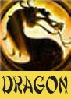
Centerfold. . . . . . . . . . . . . . . . . . . . . . . . . . . . . . . . . . . . . . . . . . . . . . . . . . . . . . . . . . . . . . . . . . . . . . . . . . . . . . . . . . .Pictorial and brief written History of A.T. F.

This Training Book Published By
Allied Tang Soo Do Federation
Te nth Edition June 2015

Please Note: The name change to ATF Martial Arts in 2009 was necessary to better identify the various other arts we now teach

Dedicated to the Black Belts of this System named on Page 9
With Special Thanks to All Who Contributed

Allied Tang Soo Do Federation
Founded 1980

Founder, Master Instructor, Mr Fred Weeks 10th Dan
A.T.F. Liaison & Training Director, Dr. Keith Waggoner 9th Dan Administrative Director, Mr Robert Warden 8th Dan
Black Belt Board President, Mrs. Janet Atkinson 5th Dan

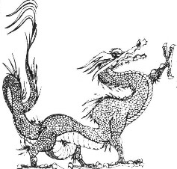
STATEMENT OF PURPOSE
The A.T.F. Tang Soo Do Karate system primary objective is for students to develop physically, mentally, and in character.

I. The serious student, will make improvements in general physical fitness, strength, flexibility, balance and coordination.
II The serious student, will make progress mentally by being required to demonstrate the appropriate level of discipline, endurance, perseverance and self-control.
III. The serious student, will develop his/her character by working with others, by learning to trust his/her classmates and by being trustworthy to classmates, by being sensitive and responsive to classmates best interests, by finding self-confidence through self-improvement, by working in a chain of command, by giving and receiving respect, by enduring appropriate degrees of discomfort through physical activity and mental control, and by learning and demonstrating the responsibility that comes with the knowledge gained through the study of Tang Soo Do.

Tang Soo Do is studied by some persons as an art, by some as a means of self-defense, some for fitness and by others as a competitive activity. Regardless of motivation, the A.T.F. Tang Soo Do System requires it’s students to carry their knowledge and skills, gained through the study of this art, with RESPECT, DIGNITY AND HONOR!
W ritten by........Phillip Midkiff 1994 1 ^{st} Degree Red Belt ATF System

Code Of Conduct

- Never Lie

- Never Cheat

- Always Work Hard

- Stand Up For Beliefs

- Help Others In Need

- Self Improvement

- Healthy Mind/Healthy Body

- Never Misuse Knowledge

- Self Discipline

- Respect Self and Others

- Commitment

- Dedication/Loyalty

- Deal With What Is Confronting You

- Set Goals......Never Quit Until Attained

Remember...Honesty and Integrity Will Never Fail You!

Student’s Name________________________________

Date Started Training_____________________________________________

NOTES


Personal Goals Date Attained

1.

2.

3.

4.

5.

6.

7.

8.

9.

10.

What is Tang Soo Do
Tang Soo Do. (Art of the Knife-Hand) is a Korean Martial Art with origins dating back centuries to the “Tang Dynasty”. Immediately following World War II, Grand Master Hwang Kee developed the TSD System incorporating the hard linear strikes with the flowing circular movements found in many of the Chinese systems. It is a composite style, being 60% Soo
Bahk Do, 30% northern Chinese and 10% southern Chinese. Tang Soo Do is both a hard and a soft style, deriving hardness from Soo Bahk and soft flowing movements from the northern Chinese systems. The kicking techniques, for which TSD is unsurpassed, are based on Soo Bahk and date back to the Silla Dynasty (618-925 AD.
Training in Tang Soo Do stresses the development of the total person: the mental, spiritual and the physical. It provides an excellent form of self defense while keeping the student physically fit and mentally alert. Tang Soo Do is a Martial Art not a sport, and is taught as a Martial Art in the ATF System.. A high regard is placed on Dojang etiquette and proper respect is expected of all students.
Cardio Kick-boxing (CKB) as taught at the A.T.F. Dojang, is a unique form of cardiovascular exercises interwoven with Martial Arts training techniques and an up-beat music tempo that will challenge all levels of fitness. No machines are involved, just a sweat popping, heart thumping workout which develops muscle memory and conditioned reflexes. The sustained effort accelerates your heart rate which burns calories and builds stamina and endurance. CKB is an excellent exercise program for those wanting to lose weight.
CKB is integrated into and taught as part of the A.T.F. Tang Soo Do Karate System. By supplementing the traditional training techniques of this centuries-old Martial Art with the modern concepts of endurance training, and coordination drills, a student will benefit from an intensive physical fitness program while learning a very potent and effective system of self defense.
Consult with your physician before beginning this CKB training program. Any physical disability should be noted on registration form.

Korean Terms
Being a Korean style, most of the formal exercises have Korean names which are taught, along with the English translations, as the student progress in rank and learns these specific exercises. The TERMS listed below should be learned and memorized immediately, by all beginner students.
Moo Duk Kwon....................................................................................Inst itute of Martial Virtue
Tang Soo Do..............................................................................................Art of the Knife-Hand
Yong Sim Jang.......................................................................................................Dragon H eart
Dojang...............................................................................................................................School
Jun Bi..................................................................................................................................Ready
Charyut..........................................................................................................................At tention
Kyung Nye..........................................................................................................................Sal ute
Shijok...................................................................................................................................B egin
Goman....(The word BREAK is often substituted here)...................................................Stop Sho.......................................................................................................................................Rest
The word “KARATE” has been universally accepted over the years, as the single word which best defines most Martial Arts. This word is actually two words, “KARA” and “TE” which are Japanese in origin when translated mean “Empty Hand”.

THE
A.T.F. TANG SOO DO
SYSTEM
Mr Fred Weeks is the founder and chief instructor of the Allied Tang Soo Do Federation. He began instructing in 1972 as a 1st Degree Red Belt, and after a seven year membership in the “Chuck Norris System and United Fighting Arts Federation”, he founded the A.T.F.
Tang Soo Do System in 1980.
Mr Weeks holds rank in four different Martial Arts, those being, Tae Kwon Do, Goju Ryu, Shorin Ryu and Tang Soo Do. His highest rank is 8th Dan in Shorin Ryu, and in 2002 he was presented an Honorary 10th Degree in recognition of 30 years instructing the Art of Tang Soo Do. He received his First Dan from Mr. Chuck Norris in 1978.
Much of what is now the A.T.F. System comes from the Norris System but it has become a more eclectic style with the addition of techniques from Goju and Shorin Ryu, Tae Kwon Do, American Kick-boxing, Jeet Kune Do and Chinese Grappling. After many years of intensive training in other arts, Dr. Keith Waggoner returned to his ATF home school, and brought with him, his many years of experience in Kali, Silat and Brazilian JuJuitsu. These arts were then integrated into the ATF Martial Arts System. Although the A.T.F. Tang Soo Do system has been “Americanized” somewhat, the training and Dojang etiquette are very traditional, with respect and a proper attitude expected from every student.
Mr Weeks is a Fourth Generation Black Belt in the Norris System and his lineage may be traced as follows;
2nd Generation.........................David Douglas, Certificate #019
3rd Generation.........................D.T. Tip Potter, Certificate #098
4th Generation..........................Fred Weeks, Certificate #228 dated 9-17-78
4th Generation..........................Susan Weeks Certificate #267 dated 8-12-79

NOTE: Grandmaster Jae Chul Shin Dan#698 Korea/USA, trained directly under both Grandmaster Hwang Kee and Kim Yong Duk. He was promoted by Grandmaster Kee. Mr Chuck Norris was a student of, and was promoted by GM Shin . Chuck Norris Dan#2819

Areas of development experienced from training in Tang Soo Do
Mark them off as you experience them yourself.

1. | Physical Fitness | 2. | Coordination | 3. | Balance
4. | Motor Skills | 5. | Body Control | 6. | Weight Loss
7. | Speed/Quickness | 8. | Agility/Reflexes | 9. | Energy/Vitality
10. | Tension Relief | 11. | Attention Span | 12. | Concentration
13. | Self Discipline | 14. | Determination | 15. | Respect
16. | Tenacity | 17. | Self Defense | 18. | Self Confidence
19. | Self Accomplishment | 20. | Self Respect | 21. | Positive Attitude
22. | Pride | 23. | Inner Strength | 24. | Emotional Control
25. | Self Fulfillment | 26. | Inner Awareness | 27. | Self Esteem
28. | Leadership | 29. | Follow Instructions | 30. | Good Conduct
31. | Better School Grades | 32. | Focus | 33. | Teamwork
34. | Trust | 35. | Social Skills | 36. | Assertiveness
37. | Overcome Shyness | 38. | Appreciation | 39. | Work Ethic
40. | Planning | 41. | Follow Through | 42. | Meeting Deadlines
“I am today, what I am, because I was yesterday, what I was”

BLACK BELT Rank......1978 - 2015
#55 Keith Waggoner.......................6th Degree.....April 12

CERT
#1 Fred Weeks.......”Dragon”......1st Degree.....Sept 1978
#2 Susan Weeks.........NFN............1st Degree....Oct 1979
#3 Dennis Reed..........NFN............1st Degree.........Jul 81
#4 Gary Ring............"EAGLE"...1st Degree........Jul 81
#5 Janet Harp..........."COBRA"..1st Degree.........Jul 84
#6 Sandy Blazer........NFN............1st Degree.........Jul 84
#7 Mary Ball...."SCORPION"....1st Degree.......Aug 87
#8 Al Ball..........."JAGUAR".......1st Degree........Aug 88
#9 Becky Bennett...”WOLF".......1st Degree.......Aug 88
#10 Jesse Ferrell...”WOLVERENE"1st Degree....Aug 89
#11 Shawn Lancaster.."LYNX"....1st Degree........Aug 89
#12 David Coker....."EAGLE"......1st Degree.........Oct 90
#13 Robert Warden.. "BEAR"......1st Degree.........Oct 90
#14 Becky Bennett...........................2 nd Degree.......Oct 90
#15 Jesse Ferrell..............................2nd Degree.......Dec 94
#16 David Coker............................2 nd Degree.... ..Dec 94
#17 Robert Warden........................2nd Degree......Dec 94
#18 Keith Waggoner."FALCON".1st Degree........Feb95
#19 Gene Cullum......"MANTIS"..1st Degree........Feb 95
#20 Amanda Warden."CHEETAH"1st Degree....Feb 95
#21 Sam Colburn.."BADGER"......1st Degree........Feb 95
#22 Robert Warden.........................3 rd Degree......Aug 95
#23 Chris Warden...."LION".........1st Degree.......Nov 96
#24 Jim Kapales."MONGOOSE"..1st Degree.......Nov 96
#25 Robert Warden.........................4 th Degree.......Sep 97
#26 Keith Fowler....”PUMA”..........1st Degree..... Apr 99
#27 Jim Kapales... Degree..............2nd Degree.......Sep 99
#28 Chance Weeks.“Komodo Dragon”.. Jr BB.. Apr2000
#29 Chance Weeks..........................2 nd Degree Jr.. May 01
#30 Keith Fowler............................2 nd Degree........Sep 02
#31 Chance Weeks...........................1 st Degree.......Sep 03
#32 Emily Hoffman..“SERVAL”...1st Degree....... Sep 03 NOTE: Certificate #33 VOIDED
#34 Robert Warden........................6th Degree.......May 04
#35 Chance Weeks..........................2 nd Degree...... Aug 05
#36 Rowdy Fortson.”BULL”........1st Degree..........Feb 06
#37 Keith Waggoner......................4th Degree.........Apr06
#38 Gary Ring................................4 th Degree.........Apr06
#39 Emily Boggs.............................2 nd Degree........Apr07
#40 Range Weeks.”Cobra”...........Jr1st Degree......May07
#41 Janet Atkinson........................3rd Degree........Aug 07
#42 David Coker............................3 rd Degree.........Feb 08
#43 Jim Kapales.............................3 rd Degree........Aug 08
#44 Range Weeks......................Jr 2nd Degree........Aug 08
#45 Tonia Fender.”Copperhead”. 1stDegree.........Aug 08
#46 Rowdy Fortson........................2nd Degree.......Aug 08
#47a Robert Warden......................8th Degree........Dec 08
#47b Keith Waggoner....................5th Degree........Apr 10
#48 Janet Atkinson.......................4th Degree........Apr 10
#49 Emily Boggs...........................3 rd Degree........Apr 10
#50 Range Weeks...........................1 st Degree........Nov 10
#51 Jason Boggs.”Silverback”......1st Degree........Nov 10
#52 Jamie Yowell..NFN................4th Degree........Nov 10
#53 Tom Hunnicutt..........Supreme Advisor............Jul 11
#54 Tom Johnson.”Phoenix”.........1st Degree.........Jan 12
#56 Janet Atkinson.........................5 th Degree......April 12
#57 Emily Boggs............................4 th Degree......April 12
#58 Rowdy Fortson.......................3rd Degree......April 12
#59 Range Weeks...........................2 nd Degree.....April 12
#60 Jason Boggs.............................2 nd Degree....April 12
#61 Tonia Fender...........................2nd Degree....April 12
#62 Matt Noblin.”Leopard”..........1st Degree........Feb 13
#63 Tom Johnson............................2 nd Degree....June 13
#64 Keith Waggoner......................9th Degree.....June 13
#65 Chance Weeks..........................3 rd Degree.....June 13
#66 Range Weeks............................3 rd Degree.....June 13
#67 Jason Boggs..............................3 rd Degree.....June 13
#68 Matt Noblin...............................2 nd Degree...June 14
#70 Tristan Hoffman.”Tiger”..Junior 1st Degree.Nov 14
#71 Mike Montgomery..”Mustang”.1st Degree.....Feb 15
#72 Baylee Rash..” Badger”...Junior 1st Degree...Feb 15
#73 Riley Hubbard.”Spartan”.Junior 1st Degree.Feb 15

The following are important aspects of training and should be understood by all members of A.T.F.
We teach a non-traditional, non-sport, eclectic style of Korean Karate called Tang Soo Do which is further enhanced with cardio-fitness workouts and influenced by techniques from other systems.

We are a Martial Art and NOT a sport.

We want students who are interested in learning a Martial Art in an environment where the students are concerned with helping each other, rather than COMPETING with each other.

We want students who study Tang Soo Do for the positive benefits it can provide, not for the potential damage it can do to others.

We want students who understand the difference between helping yourself and hurting others.

We want students who are willing to work hard to achieve a goal and who understand that all ranks are earned, NOT GIVEN OR SOLD.

We believe that instructors are here to help students achieve...not to dominate, intimidate or humiliate them.

All students of Allied Tang Soo Do Federation train with a purpose and dedication and they are understandably resentful of those who do not.

We, the instructors and students, understand and are very serious about our responsibilities as Martial Artists.

At A.T.F. Martial Arts we have four primary principles......

      - We train hard so that we may grow in our art.

      - No one gets hurt.....Safety is our first consideration and we will always strive to protect ourselves and others from injury.

      - We will always try to help those less fortunate in any way we can. This begins in the Dojo!.

      - We will always keep in mind the seriousness of what we are learning and practicing, but understand that we can have fun as we grow.

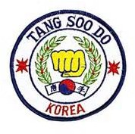

A.T.F. Rules and Expected Behavior

        - No student will test for promotion if behind on lessons and/or monthly dues.
        - No Profanity and No Smoking.
        - Instructors will ALWAYS be addressed as Mr, Mrs, or Miss and Sir, / Ma’am’ will be the EXPECTED in reply to all questions.
        - No street shoes will be worn on the mat.
        - No student will join /leave class in progress without instructor’s permission.
        - Students will always keep fingernails and toenails trimmed to avoid injury.
        - Students will always wear a clean, proper uniform in good repair.
        - Students will salute training floor before entering and leaving.
        - No student will EVER challenge a higher rank to free spar.
        - No gum chewing will be allowed in class.
        - No jewelry will be worn during class.
        - Students will not spar without protective gear.
        - Minimum attendance requirements must be met before student will test.
        - No student shall be a member of, or participate in, any other Martial Arts organization or activity while an active member of this Federation, without the express approval of the ATF Chief Instructor and/or the Black Belt Board of Directors.

Grounds For Dismissal From Class
          - Non-payment of monthly dues
          - Drinking alcoholic beverage before or during class
          - Failure to meet minimum attendance requirements
          - Lack of proper attitude and/or evidence of disrespect during class
          - Improper behavior outside of class which discredits or brings an unfavorable reputation to your school
          - Any abuse of school privileges or misuse of knowledge and expertise gained through membership in this school.
          - Taking any form of drugs immediately before or during class. (If you are taking any kind of medication prescribed by a doctor and want to attend class, please notify your instructor)

General Information
- Testing will be every four months as follows: April, August and December.
- Cost of instruction is $40 per student, per month with reduced rates available for families or groups. Classes are held twice weekly. Tuesday and Thursday 5:00-8:30pm
- Monthly dues are payable before the10th of each month.
- No student will test if behind on dues.
- Students should always strive for perfect attendance but it is recognized that this is not always possible.
60 % attendance is the minimum which will be accepted for testing purposes... If extenuating circumstances arise, it is the instructor’s prerogative to make an exception to this requirement.
- Equipment required: Before the first test students must have uniform, school patches, mouthpiece, cup/supporter and protective hand & foot pads.

Uniform Requirements
The Jacket- All students will wear a white jacket with school patch over heart, American flag
on upper left sleeve and Korean flag (RED up) on upper right sleeve. “TANG SOO DO” in black 2" block letters will appear on the back across the shoulders in an arch with a 4" center rise. The letters “ATF” will be centered in the arch, also in 2" block letters. After passing the 6th level test the student must trim the yoke of the jacket with the appropriate color. At 1st Degree Black belt
the student will add his/her name to the back of the jacket in black 3" block letters below the letters “ATF”. The yoke, bottom and cuffs of the jacket must also be trimmed in black. The student may also wear an all black (workout) uniform with only the school patch and flag patches as described above. All Dan Rank may also wear a Red Jacket with Black
Trim. Other patches, for all three jackets, may include Academic Achievement (right chest), Instructor/Assistant Instructor (right upper sleeve), Fighting Name (above school patch), Fighting Patch (lower right sleeve), Victory Marks (red, left sleeve...blue, right sleeve) Black Belt Board Members will also wear the Red Band on the White Jacket sleeve to indicate their position as a Board Member.

NOTE; This does NOT INCLUDE the YOKE PATCHES which are awarded for participation in the Expanded Curriculum Program. Their placement will be described in that section of this book.

B. The Pants- All students will wear white, unadorned (Victory Marks & DH Patch excluded) pants until the 3rd level test is passed. At that time, the student may at his/her discretion, choose to wear red pants until the 1st Dan test is passed. At the rank of 1st degree black the student may wear an all white uniform with the White jacket appropriately trimmed, an all black workout uniform or Black Trimmed Red Jacket with Black Pants. However, for formal gatherings such as tests and tournaments, the uniform required will be the properly trimmed Dress Gi with white top and black pants. If the student has at any time won the “Dragon Heart” award, the DH patch is worn on the lower right leg. “V” marks may also be worn down the leg, after the sleeve is full.
All uniform requirements and sparring gear may be ordered through the school.

Special Projects/Charities
As part of the students on-going training in “helping others in need”, (item #5 in code of conduct), the A.T.F. System , over the years, has supported two charitable organizations. The first is the March Of Dimes. Between the years of 1990 and 1998 our school sponsored an annual board break to benefit the March of Dimes’ fight for Healthy Babies!
During this time the students and instructors of the A.T.F. System have broken over 5,000 (five thousand) pine boards and raised over $16,000.00 for the March Of Dimes!
The second charity we support is the Lawrence County Food Bank. At every testing (three times per year) each student is required to donate three cans of food as part of their test fee. These donations to the Food Bank are used to assist needy families in Lawrence County. In 2006and 2007, Students and Instructors performed a Demo/Board Break as part of the Annual Iron Mountain Fall Festival. This project delivered
$1,500.00 to the Lawrence County Food Bank. In 2008, over $3,000.00 was collected during the two-hour demonstration, bringing the total to over $4,500.00 collected for the Food Bank in a period of three years. Most recently, 2009-2012, our efforts have been directed to helping the Children’s Shelter and to date we have been fortunate enough to earn over $8,000.00 to help displaced children. To Date:6-2015, ATF Martial Arts has collected $48,000.00 for these charities.

Leaders who aid others in growing
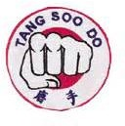
are certain to experience growth within themselves

Rank Information and Progression
(Rank Stripes and Proficiency Stripes)
Starting at 9th Degree Purple, proficiency stripes may be awarded at every level. Each rank will have proficiency level I,(Cho) II,(Yi) or III(Sahm). Rank stripes will be yellow and proficiency stripes are black. Rank stripes will be worn on the left side (under the school patch), and proficiency stripes on the right. The single Blue Stripe and the Double Green Stripe at Yellow Belt are RANK stripes and NOT proficiency stripes. At 5th and 4th Green, also at 2nd and 1st Red, Yellow Stripes denote this rank. EXAMPLE: A 5th Degree Green Belt Proficiency III (Sahm), would have one Yellow Stripe worn on the left side (under the school
patch) and three black stripes on the other end of the belt. All stripes begin 1" from the end of the belt.

The criteria for awarding Proficiency stripes are as follows;
- If a student performs all the necessary requirements for the next level then Color is awarded.
- If a student does everything requested but needs some work to perfect the technique then Proficiency
Level 3 (Sahm) is awarded.
- If a student is lacking in some of the requirements but what is demonstrated is satisfactory to the test board then Proficiency Level 2 (Yi), is awarded
- If the student is lacking in requirements and what is demonstrated needs more work to perfect then Proficiency Level 1 (Cho) is awarded.

This system of promotion gives the test board several options for promoting and rewarding the student for hard work and accomplishment. It also provides a system of promoting younger students who traditionally do not advance in rank as quickly as adults. Usually with younger students the use of proficiency stripes begin at Orange Belt but it is not uncommon to promote proficiency levels within the Purple Belt. It is VERY UNCOMMON to promote students under 13 years of age, color to color. Usually they advance by proficiency stripes

Rank Progression

10th Yellow
NOTE
The beginning student should expect to be tested every four months. Test will include all acquired knowledge to that point in training. If the student performs well and passes every test along the way, it should take approximately four (4) years to reach the level of 1st Degree Black Belt. Minimum age for 1st Degree Black is 16yrs. If student is eligible at a younger age, he/she may be awarded a Jr. Black Belt. Minimum age for Jr Black Belt is 12 yrs. Jr Black Belts will continue testing every 4 mo to show proficiency until eligible for 1st Degree. Jr Black Belts will not be required an “Original Form” as part of their testing and may advance through 3rd Degree Jr Black Belt by demonstrating progress on their original form during annual testings. Any Senior Black belt will always have authority over any Jr Black Belt regardless of degree.
10th Yellow/blue
10th Yellow/green
9th Purple 8th Orange 7th Blue
6th Green
5th Green 1 yellow stripe 4th Green 2 yellow stripes 3rd Red
2nd Red 1 yellow stripe 1st Red 2 yellow stripes 1st Black
note:
Jr Black
if student is under 16 yrs of age

Requirements for Instructors
As the student advances through the ranks and acquires more knowledge of Tang Soo Do, they are required to share this knowledge with beginner students. This is a part of their
training and is a requirement for promotion to the rank of 6th Green. Red Belts and Green Belts are considered Junior Instructors and their ability to instruct is a consideration for promotion at every level after 6th Green. By the time the student is eligible to test for 1st Degree Black, he/she should be comfortable in leading a two- hour class at every level of instruction. This training process eliminates what is seen in many schools where a student is promoted to 1st Dan and has no ability to pass this knowledge on to others. In the ATF Tang Soo Do System, when a student is presented the rank of 1st Degree Black, that student has already been instructing for two years.

Titles:
Sa Bom Nim..............Chief Instructor
Sa Bom.......Instructor (Red or Black Belt)
Sun Bi..............................Green Belt
U Bi.................Any Rank Under Green

Note: All instructors will be addressed as “Sir” or “Ma’am”, regardless of age or rank.

Not Correcting Mistakes
Is Issuing a License To Be Sloppy!
Bruised Egos Heal Poor Instruction Lasts Forever

Progress is a result of building on improvement!
Improvement is a result of practice!

No Practice...No Improvement...No Progress!
Come To Class Prepared
This is something we should need to talk about only ONE TIME......but it seems that everyone needs to be reminded occasionally......

WHEN YOU COME TO CLASS...Here's a CHECK LIST
Make Sure You HAVE.........

- Gi Top .......CLEAN
- Gi Pants......CLEAN (Don't laugh...it happens..)
- BELT
- Mouthpiece
- Cup/Supporter
- Headgear
- Sparring Pads (Hands & Feet)
- Training Manual
- Notebook/File Cards
- Pencil/Pen
- Practice Weapons
- Gear Bag
- PROPER ATTITUDE
AND... Remember..Class begins the minute you walk into the building.........NOT when the whistle blows!

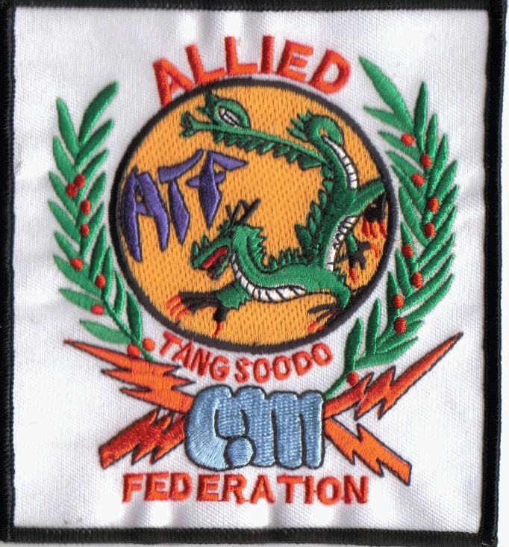
The Philosophy of the ATF School Patch............
The Allied Tang Soo Do Federation school patch has eight colors. In addition to being the eight colors of the belts in this system, each color has a special meaning.
The design of the patch retains the traditional basic elements of Tang Soo Do Moo Duk Kwon, symbolizing the roots of our ATF System.

White................................Purity of a clear mind.
Yellow...............................Desire to learn
Purple...............................No bility of purpose
Orange..............................Ripening of knowledge
Blue...................................Trust in y our abilities
Green................................Growth into your potential
Red....................................Fire a nd determination
Black.................................Understa nding of fundamentals

WHITE....The majority of the patch is white....signifying the BACKGROUND of all other colors...Every student starts as a White Belt..........

YELLOW......The Yellow area is the background for the color Purple.....It is a light color, only slightly darker than white, symbolizing progress from the beginning......It also captures the Dragon....signifying that the Yellow Belts require MUCH from the Dragon.

PURPLE....The Purple ATF pops out of the Yellow Background signifying the growth of one color from the other, and the emergence of the ATF System and the importance of Purple Belts for the growth of the system..

ORANGE......The lightning Bolts denote the power escaping from the Blue fist, which they will soon become.

BLUE.........The Blue fist denotes power and represents the force and authority of integrity.

GREEN.......The wreath acts as a protective barrier, along with the Red, safeguarding the Yellow and Purple within from harm....and signifies loyalty and commitment to ATF and to the Dragon (who is only a Green Belt who didn’t quit) This is important because the second highest drop-out rate occurs as Green Belt!

RED........Works with the Green to protect the integrity of the system and the movement of Red is in harmony with the inner circle of Black. It also works outside the area of Green and forms the foundation and strength of the system. Only Black is more encompassing of the entire patch.

BLACK.....Works within and without ....the inner black circle and the outer Black edge surrounds and holds everything in its proper place and marks the outer limits of our system. Black controls everything within.

NOTE: Traditional Moo Duk Kwon Tang Soo Do Belt Color is Midnight Blue instead of Black.

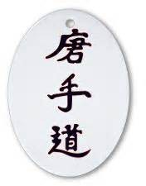

Dragon Heart Creed

“do it better...do it stronger..
do it longer...do it when it counts”

Yong Simjang (dragon heart) Award

At each testing, every student is considered as a recipient of the “Dragon Heart Award”. This is a much coveted and sought after honor, because the person selected is the student who best demonstrates the qualities of true Martial Spirit!
Those qualities are dedication, loyalty, leadership, courage, stamina, unshakable strength in the face of adversity and a “never-quit attitude”!
DRAGONHEART is a Memorial Award, presented in Honor and Remembrance of Zachary Martin Weeks, my son, and
Ryan Michael Brock, my grandson.
It is fitting that these two Children of God be recognized and their lives be honored in this way. Neither had the opportunities offered to the recipient of the award and both were faced with great adversity which ended their lives.
Both never quit until God intervened.
Being selected “DRAGONHEART” should be the goal for every student, at every testing! Only two students , in the entire history of this school, have ever won this award twice. Those Students were, Amanda Warden in 1990/91 & Range Weeks in 2003 /05.
When a student is named “Dragon Heart” it becomes part of his/her fighting name and “Yong SimJang” (Korean for Dragon Heart) is lettered above the student’s fighting name. In the event the student is below the rank of 6th Green, his/her fighting name will be “Yong SimJang” no matter what the rank. “Yong SimJang” will be considered a title for all recipients. A certificate and the DH patch* will be awarded and that student will be addressed as “Dragon Heart” for the duration of the current test cycle or until they are replaced with a new Dragon Heart. The Dragon Heart Creed should be recited at the beginning of every class.
* The patch should be worn centered on the outside cuff, 1" from the bottom of the right leg.

Considerations for “DRAGONHEART”
  - All students testing must submit, the last class before test day, a written description of “What They Feel A DRAGONHEART Should Be”.
  - If you cannot tie your belt properly, you will not be considered!
  - If you cannot recite the CREED loudly and mistake free, you will not be considered!
  - If you do not score a “B” on your forms and basics,(5,5&5) you will not be considered!
  - If you have not been attending classes regularly, you will not be considered!
  - All students must memorize and follow the “Code Of Conduct”!
  - All students should be neat in personal appearance!
  - All students should give FULL EFFORT to every requirement during practice and on Test Day! (In-Class achievements will be considered)
  - The recipient of this award will, in addition to patch and certificate, also receive a $25 merchandise certificate!
  - After this process of SELF- ELIMINATION...........the students left standing will be the true representative of the spirit of our art of Tang Soo Do and a worthy recipient of the award and the honor, to be called “DRAGONHEART”!

It Cannot Be Won....it is not a contest,
It Will Not Be Given......to those who are undeserving,
It Must Be Earned .........by those who best demonstrate the essences of Tang Soo Do, It Will Be Difficult To Earn.....but you will be a better person because of it,
It Will Be An Honor....because you know you did everything necessary to earn it!

The Birth and Evolution of DRAGONHEART
In the early days of A.T.F., before it was A.T.F. there was no “Dragonheart” award! At that time, prior to 1980, a “Most Improved Student” award was given, at testing time, to the student who had made the most progress during the current test cycle. This practice continued even after the founding of A.T.F. in 1980 and there was no actual record kept until 1989 when the first DRAGONHEART AWARD was presented. The list below reflects the DRAGONHEARTS on record.

* Denotes current rank as Black Belt **denotes multiple awards (only two in history of school)
“The spirit of Karate takes many forms and each person who achieves these high standards should be recognized for their endeavors. Therefore, it is proper to praise ones efforts and good deeds as they excel within themselves. Such is the learning experience of life.....so one can explore all of his/her full potential, by obtaining a better sense of self.”
Grand Master Tom Hunnicutt; Matsumura Seito, White Swan Dojo
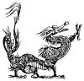
Dennis Reed* | 1979 | Matt Noblin* | 1999
Jim Jamison* | 1979 | Mark Mills | 2000
Randy Anglin* | 1979 | Emily Hoffman* | 2001
Howard Briggs | 1980 | Josh Mosley | 2001
Janet Harp* | 1980 | Casey Dunlap | 2001
Carolyn Tribble | 1980 | Mike Gray | 2002
Charles Ivey* | 1980 | Raven Davis | 2002
Jeff Rickey | 1981 | Range Weeks* | 2002
Sandy Blazer* | 1982 | Elaine Ludwig | 2003
Neal Vaccari | 1983 | Tonia Fender* | 2004
Kyle Smelser | 1983 | Matt Wall | 2004
Neal White First DH | 1989 | Alex Long | 2004
Gene Cullum* | 1989 | Terri Ervin | 2004
Bryan Teel | 1989 | Rowdy Fortson* | 2005
Amanda Warden* | 1990 | Range Weeks * | 2005**
Mike Gaines | 1990 | Tom Johnson* | 2005
Sam Colburn* | 1991 | Eric Wise | 2006
Amanda Warden* | 1991** | Kaige Ludwig | 2007
Chris Warden* | 1991 | Jason Boggs* | 2007
Phillip Cook | 1992 | Blaine Davis | 2008
Phillip Midkiff | 1992 | Katelyn Ellis | 2008
Kathy Colburn | 1992 | BayLee Rash* | 2008
Keith Waggoner* | 1993 | Diana Hubbard | 2008
Rod Jordan | 1993 | Tom Johnson* | 2009
Adina Krupnow | 1993 | C. J. Baker | 2010
Mark McMullen | 1994 | Tristan Hoffman* | 2012
Jim Kapales* | 1994 | C.J. Baker | 2013
Steven Hodge | 1994 | Madison Jones | 2013
Tim Turner | 1994 | Rick Baker | 2014
Jonathan Wichman | 1995 | Axton Allen | 2014
Jonathan Green | 1995
C.V. Rickey | 1995
Keith Fowler* | 1996
Gene Carroll | 1997 | Space Reserved for Future
Chance Weeks* | 1997 | DRAGONHEARTS
Josh Anglin | 1998
Garth Layne | 1999

FIGHTING NAME
At the time the student tests for 6th Green, he/she may select a “Fighting Name” by which they wish to be known. This name can be animal or object but should represent the students fighting style and overall performance in the ring.

Here are a few thoughts on the subject:
    - A fighting name does not necessarily need to be an animal. The names "Rage", Tornado", "WildMan" or "WildThing", "Deceptor" etc...you get the idea.....would all be good choices if this fits your personality and fighting style. The name should be a reflection of YOU! Mrs Elaine's fighting name is "Veil".....It was a personal thing for her and it fit!

    - As Mr Fortson (Bull) says....chances are the name has already found you....all you need to do is discover where it is....NOT what it is! I think all will agree that he IS the BULL!

    - The name should not only fit your personality but your stature as well.....for instance "Bull" would not apply to someone who is small and timid! "Bear" would not be a good choice for a person who has a tiny little voice and is small in stature. Mike Gaines who is "Kodiak" could not be a "Grasshopper" and Range Weeks aka "Cobra" could NOT
....NEVER....EVER be considered as a "Kodiak or "Grizzly". Tonia Fender "Copperhead" has the eyes and hair plus the quickness to have this name which is very appropriate for her.
In my choice of "Dragon", I considered several things before settling on this name. In lore, the Dragon is always very old....which I am....and seem to have always been.....The Dragon is a large creature, I am a large man....The Dragon was the keeper of the Book of Knowledge....The Dragon protected the entry to something important.....The Dragon was a fire- breather, which according to some reports from previous students......I am! (Of course this was when I was much younger) The Dragon is Green....(Black Belts are only Green Belts who didn't quit...and this is especially true in my case...following the national statistics...I almost quit when I was Green) ....
In my younger days....The hooking heel kick was my signature kick...the Chinese call this "The tail of the Dragon"... There was more....... but all things considered...."Dragon" was a good choice for me.

Choosing a fighting name is a process of self-examination and analysis.....
Look at who you are, who you want to be, who you have been, what you are, what you want to be, and what you have been, where you are, where you want to be, where you have been, To all of these..... ask why....
Pick a name that fits not only your abilities, capabilities and skills, but one that also reflects your potential....
This is a very personal and spiritual journey that you must experience and you must experience alone. Others can advise and recommend but only you have the power to make the final decision on this. It is a name you will probably wear for the rest of your life. It should be an appropriate one and one that you will be proud to call your own.
If you can say it....... or hear others say it ........and know that THIS IS YOU...it is the right name for you!
The “Fighting Name” is worn on the left front, just above the school patch and under Yong SimJang (if you have been awarded that title). The fighting patch is worn at the cuff of the right sleeve.

Fighting Name Request

I come before you.................imperfect
But with a strong and competitive heart
And I will do all that is required of me to prevail I respectfully request the fighting name
of_

The Value Of Testing
In the A.T.F. Tang Soo Do system each student should be qualified to test every four months. These tests take place during the months of April, August and December and are necessary for the student to advance in rank. Some schools do not have a mandatory schedule of testing as a requirement for promotion, and the students of these schools are promoted at the discretion of the instructor. It is the belief of the instructors of the A.T.F. System that formal testing not only allows the instructors to view their student’s progress to that point, but it also provides the student with valuable training in several areas of development. Testing provides the Instructor with a gauge of each student’s progress and an opportunity to review and monitor the progress of every member of the class. If students have been trained properly, an instructor should be able to look at a class of mixed ranks and basing a decision on the color of an individual’s belt, know exactly what each student should and should not know. Perhaps most important, it gives the student a continuing experience of functioning under pressure and the result of this is increased self confidence and assurance. For he/she to be promoted, the student must come before a Test-Board every four months and demonstrate the requirements of the next higher rank. It quietly but effectively establishes leadership and promotes a feeling of unity and camaraderie among the students that they seldom find anywhere else. It teaches them patience and the value of waiting their turn and when called upon, to respond with their best effort. The conditions of testing teaches the student to know and to assume the personal responsibility for learning the requirements necessary for being promoted. This is a valuable life’s lesson that every young person will eventually need to learn.

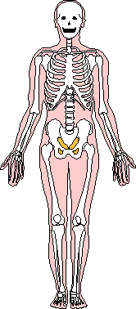
Nerve Centers & Pressure Points
Nerve centers and pressure points are the target areas of the body used by students of Tang Soo Do to maximize the effects of strikes or blocks. The value of learning them is that a blow directed to a vulnerable part of the body is much more effective than a blow of the same force which is directed to a less vulnerable area. There are styles of unarmed fighting which emphasize the development of power as their main objective; in these styles it is not necessary to know where to hit, as any blow which is landed with sufficient force will be effective. The fallacy of this method of training is that it will not work for small people. A 120 pound female would have great difficulty developing enough power to hit indiscriminately against a 220 pound male adversary. The other argument against the “power” theory of unarmed fighting is that you must train constantly, which is not a practical idea for most people. Finally, women and children cannot hope to learn a system of self-defense which depends on power development. The alternative is to learn how to deliver effective blows to the most vulnerable areas of the body with only normal strength. The study of Pressure Points will pinpoint these nerve centers and provide the student with valuable information on the amount of force and type of strike needed for maximum efficiency.
KNOW THEM ......PRACTICE THEM....REMEMBER THEM!

Record of Promotions
10th ..........................................................................................Date
Blue..................................................................Date
Green...............................................................Date
9th Cho Yi Sahm 8th Cho Yi Sahm 7th Cho Yi Sahm 6th Cho Yi Sahm 5th Cho Yi Sahm 4th Cho Yi Sahm 3rd Cho Yi Sahm

2nd
Cho
Yi Sahm

1st Cho Yi Sahm Junior 1st Degree Black 2nd 3rd
Senior 1st Dan 2nd 3rd 4th Date won DRAGONHEART

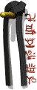
The “KiAi” Definition and Purpose

The “KiAi’, or as some call it, Karate Yell, is a practical and useful tool for all who practice the Martial Arts. The KiAi is an expulsion of air from the lungs, which when done properly, has MANY functions. Many beginner students are so intent on doing a technique correctly, they forget to breathe properly, so #1...The KiAi helps the student remember to breathe. #2...It empties your lungs of air so you are not holding your breath and you will not get the wind knocked out of you. #3...It physically tightens the muscles
protecting the center-line and vital organs. #4...It adds strength and focus to your techniques. #5...It momentarily startles your opponent. #6...It sparks the inner fighting spirit we all have within us and makes us more determined.
An in-depth study and practice of the KiAi at appropriate times is necessary for the student to fully understand the many applications and benefits of a strong KiAi!


Ability ...........is what you are capable of doing

Motivation............determines what you will do

Attitude...........determines how well you will do it

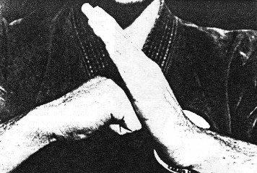
THE SALUTE
Background and Meaning
Virtually all Martial Arts Systems include some type of salutation. In many styles, the traditional bow is the salute of choice, while in others, a hand gesture or bow combined with a hand gesture, is used to demonstrate respect.
Salutes are used for a variety of reasons. Students may salute or bow as they enter or exit the training area, at the beginning and end of a class, before sparring or as they begin and/or end the demonstration of a Form. They also serve a more subtle purpose. They are used as a way to clear the mind, as a reminder to leave problems outside the training hall, and to prepare the Martial Artist for a difficult performance by triggering an attitude appropriate for competition.
One of the most common salutes in the martial arts is an early Chinese version called the “Shaolin Fist”. Since the origin of Tang Soo Do is China, it is appropriate that we use a modified version of the Shaolin Fist (as shown above) for our salute. Much symbolism is read into this gesture and the meaning will vary with each system. Here is a brief rundown on some of the interpretations. It was first used in ancient China as a hand sign to recognize members of a secret society. In one system the right hand fist, represents five people, the thumb is self and the fingers are four friends. When formed into a fist they unite to stand against adversity. The left hand, open, indicates that the student has no weapons, only what is within him. Another version says that the open hand is hiding the treasure (the fist). The fist represents the student’s ability and reminds him to keep his skills hidden and never take advantage of them. Another version is called “Life Hand, Death Hand”.
The death hand is the right fist, representing the ability to kill. The life hand is the left ,open, hand representing benevolence and compassion. The fact that the ”Life Hand” covers the “Death Hand”, reminds the student to seek solutions to problems before fighting. Other styles interpret the Shaolin Fist salute to mean, “Peace overcomes Power,” or, “I keep my weapon in it’s sheath”.
Yet another interesting version of the Shaolin Fist is the “Warrior/Scholar”. In this one, the right hand represents the warrior and the left a scholar, referring to the human being’s need to maintain both physical and mental/spiritual strength to be victorious. Some believe that the open hand of light covers the fist of darkness.

The mechanics of the A.T.F. Tang Soo Do salute are as follows; The feet are together, the left hand, open and straight comes up at a 45 degree angle, elbow down, finger tips about chin high. The right hand comes up at a 45 degree angle, fist closed, palm down. The knuckles of the fist are pressed against the open palm at the first joint of the index finger of the open hand. Both elbows are down at a 45 degree angle. Bend slightly at the waist in a traditional bow and at the same time extend the open hand and the fist, together, slightly outward or forward toward your opponent or the person you are saluting. At the extension of the hands you will verbally salute by saying “Tang Soo”. Immediately recover the hands back to the side. The salute is complete.
In our system, we believe that “the open hand of knowledge will always prevail over the fist of violence I
extend this hand of knowledge to you and I will teach you the way of the hidden fist.
Each salute conveys specific messages about the teachings of a particular system and can reveal the true essence of the art. Salutes are indicative of a style’s purpose and philosophy, helping distinguish it from all others. They will give you a clue about a systems teaching methods and training purpose. Is the salutation treated with reverence or used casually in an informal manner? This is an excellent indicator of a system’s attitude. When a salute is treated with great respect, it is a sign of a high level of formality and an emphasis on tradition and discipline. On the other hand, schools which treat salutes as optional and with less attention to detail, tend to have a more informal and relaxed attitude toward training. Simply put, Salutes are used to show respect for yourself, your art and for others.

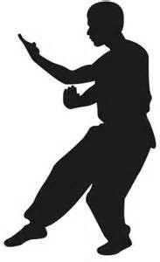
HYUNGS
HYUNGS ,sometimes called KATA, FORMS or PATTERNS, are an important requirement for promotion at every level of rank in the A.T.F. Tang Soo Do System. They are so important that 40% of a students test score is determined by how well he /she demonstrates the required Forms. Forms are a requirement for every test except the first test for children under 10 years of age. The forms increase in difficulty as the student’s skill level increases and he/she
advances in rank. Each one, along the way, represents the new techniques the student has learned during the recent test cycle (4-months).
Forms are a pre-arranged series of moves when performed as an exercise routine, simulate a combat and/or self-defense situation. The number and complexity of the moves will vary with the skill level of the student. Forms may have just a few moves, twenty moves in Giecho Hyung Il Bu, to a more complicated form, TakSan (Korean for big/many), which has one hundred moves.

The benefits derived from Forms Training are many. On the surface we can see that Forms teach; balance, hand/foot, hand/eye coordination, breath control, focus and concentration. They also teach the student stance switching, the proper way to develop power in techniques and fluidity of movement. Perhaps two of the most important benefits to be gained from Forms training are , #1, they teach the student that everything has a beginning and an end and no matter how confused it seems in the middle, there will be an ending, so NEVER QUIT....FINISH WHAT YOU START! #2, they teach the student that everything has boundaries and limits (Forms have specific moves, turns allowed only in certain directions, and a limited number of moves in any direction), and that when the student performs within the specified boundaries of a particular Form they are self-disciplining! So, they teach PATIENCE, CONTROL and SELF DISCIPLINE!

Forms also have a deeper meaning. A problem arises when schools teach only the fighting techniques of their system. Students forget the basic spirit of the Martial Arts, which is to seek peace first and use force only as a last resort. The study of Forms offers students stability and gives them a lifelong challenge to improve themselves. This heightened awareness and enlightenment is often what attracts people to the Martial Arts. It is true that students want to become physically fit and able to defend themselves but some also want something more than just being able to kick/punch and harm another person. They want to add dignity and honor to their lives and believe that the Martial Arts offers them these qualities. They are correct in this belief, for the study of the Martial Arts does in fact, offer these things. However this benefit provided by forms training requires that the school and the instructors retain a respect for tradition, recognize the benefits of this type of training, and do not restrict their teaching to only fighting techniques.
A.T.F. Tang Soo Do is a Martial Art and not a sport! We teach Forms of two varieties: Traditional and Non-Traditional:
The Geicho, Pyong Ahn, Bassai, and Nihanchi Forms are all taught in the traditional manner.

Non-Trdaitional: ATF#1 and ATF#2 are modifications with an increased difficulty factor, of Geicho Hyung Il Bu and Geicho Hyung Yi Bu. TakSan is an original ATF form influenced by the UFAF forms from the Norris System. Two weapons forms are taught which are original ATF Forms: Dragon Stick #1 and Dragon Stick #2. Blocking Sets, though not listed and
counted as a Form is practiced as a Form.

REQUIRED HYUNGS (forms)
Special Note; 10th Yellow, yellow/blue and yellow/green ranks are awarded to any beginning student under the age of 10 yrs and/or to any student with less than four (4) months training in our system. No Form Is Required at Yellow. Listed below are Non-Optional Forms taught in the ATF System required for promotion.

Giecho Hyung Il Bu (Basic Form #1).............................................Required at 9th Purple Giecho Hyung Il Bu Sahm Gup (Advanced Form #1)..................Required at 9th Purple DRAGONSTICK #1...........(Weapons Form).................................Required at 9th Purple A.T.F. #1...........................................................................................Required at 8th Orange
Giecho Hyung Yi Bu (Basic Form #2)...........................................Required at 8th Orange Giecho Hyung Yi Bu Sahm Gup (Advanced Form #2)...............Required at 8th Orange A.T.F. #2.................................................................................................Required at 7th Blue
Giecho Hyung Sahm Bu (Basic Form #3)..........................................Required at 7th Blue
Pyong Ahn Cho Dan (Peace Form #1)................................................Required at 7th Blue
Tak San (Many Moves) First half..................................................Required at 6th Green
Pyong Ahn Yi Dan (Peace Form #2)................................................Required at 5th Green
Pyong Ahn Sahm Dan (Peace Form #3)..........................................Required at 4th Green
Tak San (Many Moves) Second half.................................................Required at 3rd Red
Pyong Ahn Sa Dan (Peace Form #4)...................................................Required at 3rd Red
DRAGONSTICK #2.............(Weapons Form)...................................Required at 3rd Red
Pyong Ahn O Dan (Peace Form #5)...................................................Required at 2nd Red
Bassai (Mighty Fortress)...................................................... ................Required at 1st Red
Original Form* ..................................................................................Required at 1st Black
Nihanchi Cho Dan............................................................... . . . . ....Required at 2nd Black

* There is a 12 month “Seasoning Period” between 1st Red and 1st Black. During this time the student will create his/her Original Form and present it to the test board, along with a written copy of all the moves, a description of the moves, the name of the form in Korean and translated, an explanation of why the form was given that particular name, and finally a flawless demonstration of the student’s creation. This form may or may not include weapons and should have a minimum of one hundred
(100) moves with no more than 40 moves devoted to weapons. The form should reflect the student’s personality, physical stature, fighting name and style. It should be presented at every four-month test cycle (in three 1/3 segments) during the year the student is waiting to test for 1st Degree Black In the case of a Jr Black Belt: The students progress will be reviewed by the Test Board at every testing and a formal presentation of the form will be presented annually, on the anniversary date of the Jr BB Certificate.
Students should master each Form before moving on to the next. The practitioner who moves through the forms too fast and over-reaches himself, does a disservice to both himself and the art of Tang SooDo

We can never become what we need to be by remaining what we are!

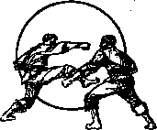
SPARRING
A.T.F. Tang Soo Do techniques are taught and practiced as a martial art, however when sparring is practiced it is necessary to modify these techniques in order to avoid injury. Full power kicks and punches must be controlled to the point that only light contact is felt when hit or kicked. Safety, and the attitude “No One Gets Hurt” is first and foremost when students “bow in” to practice their fighting techniques. Each student is mindful of the fact that the only real protection they have in the ring is “their sparring partner’s control”! They know that
their safety depends on how effective he or she is, at throwing a full power kick or punch and landing it on target with a minimum amount of actual contact being felt by the recipient. They are reminded of the importance of control when their partner fails to demonstrate this! Even with the loss of control, injuries are kept minimal by the use of sparring gear such as pads, gloves, mouthpieces and headgear. This equipment allows students to practice their knowledge and skills more freely and lessen the possibility of injury. BUT...even with gear a student may still be injured if his/her partner doesn’t demonstrate proper control. WHEN SPARRING, THE ONLY REAL PROTECTION A STUDENT HAS, IS THE SPARRING PARTNER’S CONTROL!

Attitude
Students of the Martial Arts usually experience some degree of injury when sparring, both in practice and competition. In most instances nothing more than a jammed finger, a bruise or bump. Today the research and development of modern sparring gear has prompted more sparring competition at a younger age and it is not uncommon at tournaments, to see five-year-olds, barely visible under the layers of padding and headgear, banging away at each other in center ring. At this young age children only know what they have been taught so it is very important that they have the proper ATTITUDE about competition. There are several schools of thought about competition and it’s effect on children, some radical and others more moderate. I will probably draw disagreement from both!
One line of thinking is, “Winning Is Everything” and “First Place is the Only Place”! This is a very dangerous and unacceptable attitude about competition! It is especially unacceptable when taught to children, for the by-product is bad sportsmanship and an ugly and uncooperative attitude as the child matures. The end result is an antisocial adult who tries to bully his way through every encounter with opposition. An attitude such as this can and does lead to many kinds of trouble and a very hostile and unhappy person.
In direct contrast to this is the second school of thought which professes that “Winning Is Not Important”.....that competition is not necessary to life and the only thing which matters is that “We Feel Good About Ourselves”! This is ridiculous, for if we do not learn to compete at an early age then we become a victim of the person who thinks that winning is everything!..We build in them a false sense of confidence for they have not really experienced competition! We have merely become cannon fodder to further develop their bad attitude! This “Feel Good Philosophy” leads to a “Sheep / Wolf” scenario
: One in which the aggressive predator feeds on the unthreatening flock. Imagine for a moment, if you can, ...... never wanting to win....anything! What an astounding concept! If we have no competitive
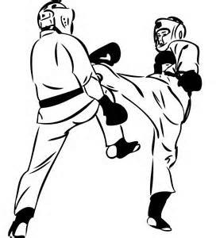
spirit, then we are doomed to failure at every attempt, no matter what the task! This attitude can be life-changing, if adopted at an early age, and should be rejected by all!

Sparring contd
A third attitude about competition is that which teaches “Winning Is Important But It Is Not Everything”! What IS important, is that we always put forth maximum effort! This is our belief at Allied Tang Soo Do Federation, and this is what we teach our students. Competition builds character and losing, painful as it sometimes is, can provide us with a valuable life’s lesson. It can make us aware of our own shortcomings and prompt us to work harder to overcome these weaknesses within ourselves. A proper attitude about competition can build in us a confidence to always give our best effort and to regard each new competition as a different learning experience. When we work harder we inspire those around us to do the same. When we put forth our best effort we also help others achieve more, for it sends a message loud and clear that “If you want to beat me....you had better be prepared to give one hundred and ten percent”! If we learn from everything we do, and if we try harder than we did before, and if we demonstrate a proper attitude , victory will eventually be ours. Attitude overcomes shortcomings! This is why competition is important!
Consciousness vs Instinct
When we are born, everything we do is governed by Instinct, for our mind is a clean slate which has not been exposed to any outside influences. We soon learn that when something is wrong and needs attention, if we cry loudly enough our parents will come running and feed us, bathe us, burp us, hold us, ....do whatever is necessary to make us comfortable. The learning process has begun and now Instinct is gradually replaced by Conscious Decisions. Each time your consciousness learns something new, raw instinct is displaced by decision making. Eventually, as we get older, instinct and consciousness begin to work together. We find that,100% Instinct, which served us so well as an infant is no longer feasible as an adult and we discover that every time our consciousness learns something new, our instincts need to be honed to learn this also.....and we need to slow it down as we learn! Studies show that adults are generally governed by 90% Educated Consciousness and 10% Natural Instinct. In actual use, consciousness and instinct often work against each other when we meet with a situation which must be dealt with. Should I....shouldn’t I.....I want to do this but it doesn’t feel right......etc.
What does all this have to do with the Martial Arts? Think about it for a moment......in a self- defense situation.....if you are grabbed by a kidnapper, mugger, rapist, murder.......a wrong decision could be fatal! Your instinct tells you to GET AWAY........but what if you don’t know HOW and haven’t
practiced HOW TO GET AWAY? Martial Arts training provides the perfect union of Instinct and Consciousness. You learn something new and you physically practice it until the conditioned response replaces the raw untrained instinct. You INSTINCTIVELY KNOW and you react with a conscious
response! You not only know what YOUR response is, but as a result of many hours of practice, you
know what the OTHER PERSONS response will be to your actions. This could save your life!

Success requires practice and preparation. Preparation builds confidence and a balance of Instinctive and Conscious decision making. _{Fw} ₂₀₀₇
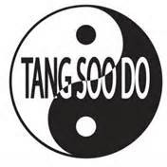

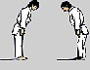
Proper Respect
Respect is an often misinterpreted word. .....especially in the Martial Arts.....Because each and every school puts emphasis on a different meaning of the word. Just to list a few ...they are;

Appreciation, Approval, Awe, Civility, Consideration, Value, Worship, Deference, Reverence, Tact, Thoughtfulness, Fear, Honor, Love, Obeisance, Piety, Regard, Tolerance, Veneration, Acceptance, Admiration, Adoration, Appreciation, Ardor, Awe, Connection, Consideration, Courtesy, Deference, Devotion, Esteem, Heed, Formality, Homage, Honor, Attention, Propriety, Regard......
Soooo......You can readily see that with so many definitions and ideas about What Respect Really Means....it’s very easy for someone, unknowingly.....and unwittingly ...to demonstrate what others might regard as a “DISRESPECTFUL ATTITUDE”. That happens, probably because neither person really knows what respect means to the other.

RESPECT is VERY important in our Dojang, and is EXPECTED......... in fact, DEMANDED from the lowest ranking student to the very highest. Without respect, there can be no learning! Here are some guidelines which may assist you in a better understanding of the word RESPECT and how it applies to ATF Tang Soo Do.

Each and every student must respect the Dojang and everything in it...they must respect the knowledge they are there to learn. They must respect the history of not only their school but of the core style of their system. They must respect all the other students in the school and pay respect to ALL HIGHER RANKING BELTS by addressing them as Sir or Ma’am.

*A lower ranking student should NEVER correct (in class) a higher ranking student and should NEVER challenge a higher rank to spar.
* If a technique, form, blocking set, etc....is being taught and there is doubt about whether it is being taught correctly....you should NEVER correct the instructor during class. Wait until the class is over and ask about it then (In private). If the instructor is unsure of what is being taught...(sometimes if we haven’t done something for a while ..we all forget), and ASKS, if anyone can help ...THEN it is permissible to assist....but THEN...... and ONLY THEN!

Each person, as they learn, has their own individual unique twist on each piece of knowledge they acquire. As they relay that information on to someone else (teach)....that tiny bit of their personality that they have attached to what they know, goes with their instruction. The end result is that you may see a dozen variances in.....say....a down- block.............depending on who taught it. Although basically what the student is doing is correct ...it is not exactly correct. This is why we have testings ...to try to catch these small variations of that down-block, and standardize it so that everyone is doing a down-block in the same way.........THE CORRECT WAY! In education it is called "monitor and adjust", so it is not just martial arts we are talking about....... We are all human and are continually on the track of making ourselves better at all our endeavors.
BUT........I don’’t expect the student who was corrected to go to the person who taught him/her and say....”You Taught Me Wrong”! This is NOT acceptable and should NEVER happen! Your Instructors are there to assist you in learning and to help you avoid mistakes they themselves may have made. Treat them with respect and when they have helped you with something, passed on a bit of information to you, assisted you in overcoming a problem......be sure to show them the proper respect with a “Thank You Sir” or “Thank you Ma’am”!

RESPECT is simply following the rules as you know them to be. It’s when the student doesn’t know the rules that trouble begins! If you ever have any doubts about proper respect....remember....you can NEVER show Too Much Respect.....but You Can Easily Show Too Little!
RESPECT means a lot of different things, but one thing holds true about the word.............in every instance................ To Receive Respect, You Must First Give It. Fw

The Importance of Basics
Basic techniques are the main foundation of Tang Soo Do so it is vitally important that Basics are an integral part of training exercises, especially for beginning students. It is also crucial that basics are practiced repeatedly by the student for in doing this, it forces ones body to adjust to not only rigorous conditioning, but also to develop proper technique, coordination and balance, even when tired, sore or injured. Repetition of technique is also needed to develop the student’s mental attitude and muscle memory. A positive attitude and seriousness towards training and overcoming obstacles is essential for the beginner student. The repetitive practice of techniques will develop the conditioned reflex action that allows the student to act instinctively, without thinking about what to do. Only through strenuous repetitive training does one develop the mind-set that a martial artist must have to succeed. This mind set allows the practitioner to overcome mental obstacles or debilitating thoughts that plague students throughout their training....especially in the beginning when they are struggling with so much new information.
In the A.T.F. System our basics are referred to as the 5....5....and ... 5: Meaning the Five Basic Stances, the Five Basic Blocks and the Five Basic Kicks. Later you learn the Five Basic Boxing Techniques we use in the Cardio Fitness Program which are integrated into the A.T.F. System, but for the beginner, the focus is on the Stances, Blocks and Kicks. Everything we teach is based on the 5, 5, and 5.
Think back to when you first started to school. In Kindergarten you were taught the A, B, C’s...the alphabet.....You memorized all twenty six letters and then you were shown how to put them together to form words.....then you started putting words together to form sentences ....then sentences to paragraphs and paragraphs to pages and pages to books. Very simply you learned to read and write. The 5, 5, and 5, are the alphabet of the A.T.F. Tang Soo Do System. If you know the alphabet, you can write a book.......so it is here...if you master the 5, 5, and 5, basics you can learn the ATF TSD system!

The 5 Basic Stances | The Five Basic Blocks | The Five Basic Kicks
1. Ready Stance | 1. Down Block | 1. Front Thrust Kick
2. Horse Stance | 2. Up Block | 2. Back Kick
3. Fighting Stance | 3. In Block | 3. Side Kick
4. Forward Stance | 4. Out Block | 4. Roundhouse Kick
5. Back Stance | 5. Knife-Hand Block | 5. Crescent Kick

Much of the power generated in Tang Soo Do techniques depends on a proper stance! This makes Stances and proper balance vitally important in every area of your training. Much time and special effort is required to understand the mechanics, proper foot position and application of each and every stance. Each one has specific and different requirements for body positioning and center of gravity. To be able to switch smoothly from one stance to another without visible effort is imperative for the advanced student. This is called Stance Switching and if done properly allows the student to generate a tremendous amount of power and kinetic energy in blocks, punches and kicks. Proper application includes correct foot positioning, weight distribution, center of gravity and pivoting of the supporting foot. This fundamental knowledge must be throughly understood and diligently practiced by beginner students in order to become proficient in the art of Tang Soo Do.

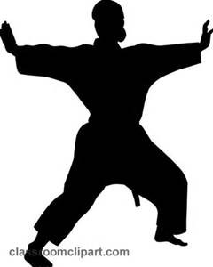
On theFollowing Page........Here are the five basic stances:

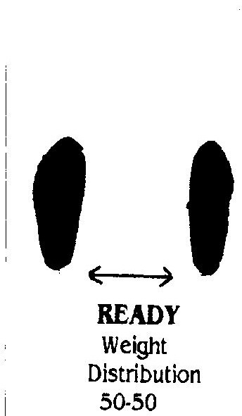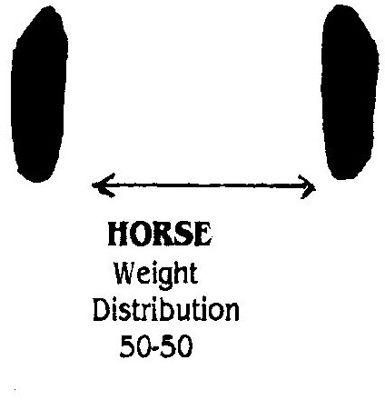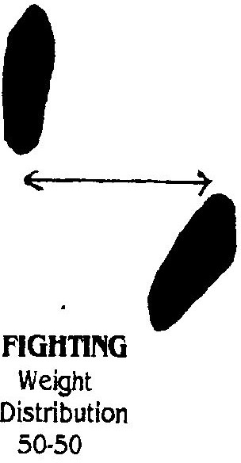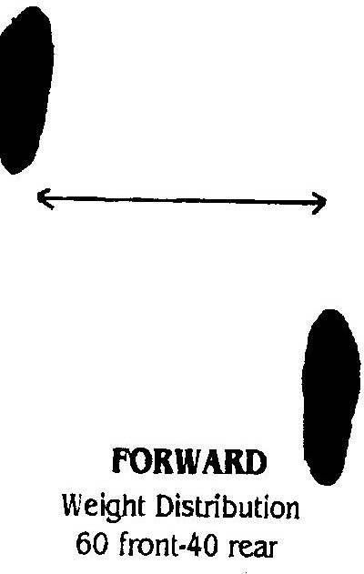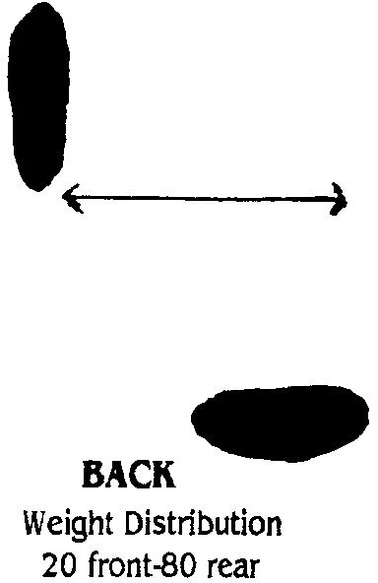A Final Word on Stances
Feet shoulder-width
Knees are relaxed, hips
& shoulders square, hands closed, palm in, at belt level.
Gaze straight ahead.
Wider than ready stance with knees pushed out over the ankles, hand position will depend on technique.

Hips tucked under, shoulders squared, knees bent as if sitting on horseback and feet in stirrups.
Weight is on balls of feet. Feet shoulder-width, both knees bent for mobility. Rear foot 45 degrees

Feet are shoulder-width toes, knees forward Hips and shoulders are squared

Feet shoulder-width, rear foot 90 degrees. Should be able to switch to forward stance by pivot of rear foot.
Work slowly in and on your stances. Feel and understand the power you can generate by pivoting that rear foot back stance to forward stance , how you can retreat and escape a kick or blow by simply pivoting the rear foot into a back stance. The longer and more diligently you work on your stances, the more you will discover. Let them work for you!

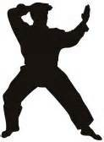
The Five Basic Blocks

Down, Up, In, Out, Knife-hand

NOTE; When learning to step with the basic blocks, each one is done in a four-count....#1 is Jam,
#2 is Fold, #3 is Step,# 4 is Block and recover extended Jam into the chamber. Each one done from a READY POSITION.
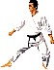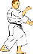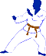

Down Block
Jam with your RIGHT hand, into the direction which you are stepping or turning. Fold your LEFT hand, closed fist, palm to your RIGHT ear. Drop the block over your left knee as you step forward. The palm rotates to a downward position at the completion of the block and the arm is straight but the elbow is NOT locked.

Up Block
Jam with Right hand into the direction which you are stepping or turning. Fold the opposite hand, fist up, across the abdomen and as the block is delivered the fist rotates to a palm forward position. The block is finished with the elbow of the blocking hand ABOVE eye-level and the forearm protecting the entire top of the head.

In Block
Jam with right hand and fold the left hand out to the left side with the elbow bent at a 90 degree right-angle, the elbow should be straight out from the shoulder and the palm of the fist facing outward. As the block is delivered the blocking hand swings forward so that you are looking directly over the knuckles of your closed fist and the fist rotates and is facing inward, toward you. Tha jam retreats into the chamber on the hip.

Out Block
Jam with the right hand, and the left hand folds into the same position as the Up Block (across the abdomen), except the palm of the closed fist is facing downward. Keeping the elbow down, the blocking hand comes up and the fist rotates to a palm IN position and you are looking over the knuckles of the closed fist. (the same position as the In Block). The Jam hand has retreated to the chamber and is ready to fold for another block or to punch from the chamber.

Knife-Hand Block
The Jam and Fold is the same position as the down block....EXCEPT the blocking hand is open instead of closed...palm IN to the ear. The block is executed with the rotation of the hand coming from the ear to an eye-level position, palm facing AWAY from you. The elbow is down, the wrist is straight and the striking surface for this block is the knife-edge (bottom edge) of the hand. From the tip of the fingers to the bend in the elbow....should be a STRAIGHT LINE...(NO BENT WRIST)!

The power of ANY block or punch is enhanced by the torque or rotation of the fist and forearm making contact with your opponent's block or punch..........
and by a STRONG KIAI! Refer to KiAis on page #18 .

It is important to remember the twist ..or rotation of the forearm and fist, which must be done to maximize the power of TSD Blocks and punches.

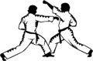
PUNCHES...Forward or Lunge Punch....and Reverse Punch
Forward Punch....The extended FIST is palm down over the forward leg. Reverse Punch.....The extended FIST is palm down over the rear leg.
In BOTH punches, the opposite FIST is PALM UP in the chamber (on the hip) and rotates to a palm
down position at the extension of the arm. It is MOST important to strike with the two LARGE knuckles and AVOID CONTACT with the two smaller knuckles, which are easily injured.

The proper form when punching is:
The extended hand is closed with the fist Palm Down....
The rear hand is in the "chamber" ...belt level on the hip with the palm up. When this hand is extended into a punch the fist rotates from a palm-up position to a twisting-palm-down at the point of impact.

It is important to think of punching as an automatic, rapid-fire weapon...... one projectile is on its way to the target as the other one loads up into the "chamber" and is ready to fire. At the completion of one punch, release the other one, load up the chamber again and again, in rapid succession.

When punching, you should keep your wrist straight and locked (avoid a ski-jump on the end of your arm)! You should also make contact with the two LARGE knuckles and avoid striking with the two smaller knuckles (behind the little finger). Striking with these smaller knuckles will cause what is commonly referred to as a "Boxer's Break"...that is the breaking of the two long bones behind the two smaller knuckles. Practice on the heavy bag and the Makiwara will "keep you honest" and help avoid this injury.

This is the correct procedure to follow if you are block/punching. At the completion of each block there should be an opposite hand in the chamber...a missile loaded and ready to fire!

There should be a loud KiAi at the EXACT point of contact of the punch or block. NOT before........NOT after
.......but at the INSTANT the technique is completed!

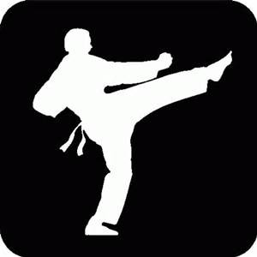
The Five Basic Kicks are:

Front Kick, Back Kick, Roundhouse Kick, Side Kick and Crescent Kick. EACH KICK HAS A DIFFERENT FOOT POSITION! Learn them.............Practice Them...Perfect Them!

FRONT THRUST KICK......Contact with .....The Ball Of The Foot .....The part of the foot touching the floor when you walk on TIP-TOES! Elongate the foot and pull the toes back.
ROUNDHOUSE KICK........Contact with......The Instep (top of the foot) Elongate the foot, keep the toes pointed and slap with the top of the foot.
OR...The Ball Of The Foot...Pull the foot back , pull the toes back and strike with the ball of the foot. CRESCENT KICK.........(Inside Crescent)..Toes are pointed up and contact is with the inside arch of the foot.
(Outside Crescent)..Toes are pointed up and contact is with the outside edge of the foot.
SIDE KICK......Toes are pulled back and foot is pointed down at a 45 degree angle...contact is with the outside "knife-edge" of the foot.
BACK KICK...Toes are pulled back and pointed down, contact is with the heel-to-ankle, outside edge of the foot.
Since kicks are thrown in rapid succession, it is VERY important that students are able to change foot positions instantly and without thinking about which is the appropriate foot position for this particular kick. This is accomplished ONLY BY PRACTICE!
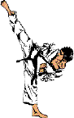
There are SEVERAL things which a student should remember when kicking, in order to properly execute a kick! Here are some guidelines to assist you in kicking properly.

RULE #1 Every kick has a DIFFERENT foot position.
RULE #2 Every kick has a DIFFERENT Fold....AND a different recoil.!
RULE #3 Use the knee of the kicking leg to aim the kick. Point your Knee at the target, the foot will hit it!

Kicking Rules contd
RULE #4 Recoiling the kick STRONGLY is just as important as extending the kick strongly!
RULE #5 Remember, your leg is longer and stronger than your arm.
RULE #6 Close the gap between you and your opponent with kicks. Follow each kick with another kick
...OR hand techniques.
RULE #7 Put your weight forward....into the kick...never lean back...this takes away the power of the kick. This also creates a balance problem.
RULE #8 Keep the supporting foot FLAT on the floor....coming up on the toes lessens the power and will put you off balance. Of course this rule doesn't apply to aerial ...or jumping kicks!
RULE #9 Remember, as an aging Martial Artist, your kicks will desert you more quickly than your hand techniques, so develop, practice and perfect one or two that are your bread-and-butter kicks, and hang on to them as long as possible!
RULE #10 ADAPT the high kicks that you practice in the Dojang by modifying them for self-defense purposes. Head kicks should become body and leg kicks in confrontational or self-defense situations.

Origins of Hyungs taught in the ATF System
As mentioned on Page #21, two varieties of Hyungs are taught : Traditional and Non-Traditional.

Traditional.... are the Geicho, Pyong Ahn, Bassai, and Nihanchi Forms. The following is a brief history of the origins of each set of Hyungs.

The Geicho Forms : Includes.... ILBu, ILBu SahmGup, YiBu, YiBu SahmGup, SahmBu:
Created in Seoul, South Korea in 1947 by Kwang Jang Nim Hwang Kee. Each Form contains 22 movements which include “JunBi and Paro” ( Ready” and “Recover) except YiBu Sahm Gup... 32

The Pyong Ahn Forms:..Includes ChoDan, YiDan, SahmDan, SaDan, OhDan:
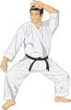
Created in the Hwa Nam area of China in Approximately 1870, by Master Idos Pyong Ahn ChoDan.....24 movements including JunBi & Paro PyongAhn YiDan.........31 movements
PyongAhn SahmDan....29 movements PyongAhn SaDan........31 movements PyongAhn OhDan.......30 movements

The Nihanchi Forms:......Includes ChoDan, YiDan, SahmDan
Created in Ha Buk, (northern) China during the Song Dynasty, approximately 900 years ago.
Nihanchi ChoDan.......37 movements including Junbi & Paro Nihanchi YiDan..........32 movements
Nihanchi SahmDan.....41 movements

Bassai:........Created in HaNam, (southern) China in the mid to late 16th Century.
Contains 33 movements.

origins contd
Non-Traditional...are ATF #1, ATF#2, TakSan, Yong Chipangi Cho (Dragonstick 1), Yong Chipangi Yi (Dragonstick 2), and Blocking Sets.

The ATF Forms: ATF #1 And ATF #2: First stated is ...The ATF System will never intentionally change a traditional form which has been practiced by students for many years before the existence of ATF! However, both AFT #1 And #2 are based on traditional Geicho Forms #1 and #2. In 1994, Mr Weeks increased the difficulty factor of both the Geicho Forms by adding techniques and individual movements which were not covered adequately by any of the traditional forms. These techniques are inherent in the ATF System and needed a formal base on which to practice. The Geicho Forms provided the first step in learning these techniques, so they were used and, with the new moves added, acquired a new name for each. Geicho Hyung IlBu and YiBu remain in the ATF System as stepping stones and are taught asTraditional Forms. Their offspring ATF#1 And ATF#2 are
taught as non-traditional because of the addition of the extra moves. ATF #1.....Contains 46 moves including ready and recover. ATF #2.....Contains 80 moves
TakSan: ...contains 100 moves. This form was created in 1980 and was the first original form of the ATF System. When Mr Weeks founded the system, he listed an Original Form as part of the requirements for testing to 1st Dan. TakSan was his contribution to the new system. In concept, it is based on movements from the UFAF Forms which were an integeral part of the Chuck Norris System. The defensive postures, stutter-step movements and slide-up forward-hand techniques are signature moves of TakSan (Big, or Many Moves)
Dragonstick #1..................contains 25 moves. An original ATF Weapons Form created by “Dragon” ( Mr Weeks) in 1998. This is a beginner Bo-Staff form with very simple staff work integrated with front, roundhouse, side, and spinning-back hooking-heel kicks.
Dragonstick #2...............contains 61 moves. An original ATF Weapons Form created by Dragon (Mr Weeks), Cobra (Range Weeks), and Viper (Eric Wise). This is a Bo-Staff form, with a very high difficulty factor and is a requirement for testing to Red Belt. It was created in 2006.
Blocking Sets ...........contains 60 moves, salute to recover. Blocking Sets are unique to the ATF System in both concept and execution. Although not officially called a FORM, blocking sets provide the same type of training as forms, except in a more focused and concentrated manner. They stress the importance of physical conditioning, strong blocks ,and a quick offense response, which dates back to the early days of Mr Weeks training in Goju Ryu. Kicks do play a part of B.S. but NOT an important part since there are only seven kicks in the entire set. The emphasis is on strong hands and minimum foot movement. Blocking Sets originated in 1980 as the SECOND original
contribution to the ATF System by Mr Weeks.
Korean Numbering System
If you check in a Korean dictionary, you can find what appears to be a contradiction in the numbering system we use to name our forms. What you will find is that the numbering sequence in our forms (Il, Yi, Sahm....) is different than normal counting in Korean....( Ha-na, Dol, Set...). This is because the forms were named using Sino-Korean which is the name for certain words of the Korean language that were either influenced by or originated from the Chinese language. Below I am listing the Korean numbers 1-10 and then the Sino-Korean version of the same. Here you readily see the Chinese influence in the Tang Soo Do System.


#Korean: #Sino-Korean

# 1 = ha-na (HAH-nah) #1=il (Eel)
# 2 = dul (dool or duel) #2= I (Ee) (Sometimes Yi)

# 3 = set (seht) #3= sam (Sahm)
# 4 = net (neht) #4 =sa (Sah)
# 5 = da-seot (DA-soht) #5 =o (Oh)
# 6 = yo-seot (YOH-soht) #6 =yuk (Yook)
# 7 = il-gop (EEL-gohp) #7 =ch’il (Cheel...hard CH)
# 8 = yeo-deol (YOH-dohl) #8 =p’al (Pal)
# 9 = a-hop (AH-hope) #9= ku (Goo)
# 10 = yeol (yol) #10= sip (Ship)

A Brief History of Pyong Ahn and Naihanchi

Naihanchi Cho Dan : This form is required in the Allied Tang Soo Do Federation to move from first degree black to second degree black. In my studies of all the information that I can find on Naihanchi, this is the information that I have found that seems to be the most consistent.

Literally translated from its original form the word translates to mean “internal divided conflict”. Mr. Weeks, like many other martial artists, refers to the form as the “wall” form. The kata is linear, moving from side to side in a horse stance. As you learn the form you will notice that it is a mirror image of itself. I must wonder if this is not at least in part the basis for the name.
Although we do not use them in our system, there are two other Naihanchi forms: Naihanchi Yi Dan, Naihanchi Sahm Dan. It is believed that at one time all three of these forms were one form and they were broken down into the three separate katas at some point in the late 19th to early 20th centuries. This thought is supported by the fact that only Cho Dan has a formal opening.
It has been said of the Naihanchis that “Karate begins and ends with Naihanchi.” In the early days of karate training, it was a common practice for a student to spend two to three years doing nothing but Naihanchi under the strict observation of his teacher. The oldest known written reference to Niahanchi that I am aware of is from the writings of Motobu Choki (a founder in the Okinawan arts) who was born in 1870. There he said of the Nahanchis that it came from China but was no longer practiced there. It was derived from a much older, original kata called Nifanchin which originated in northern China. Since Hwang Kee traveled China in his early years, it seems only natural to assume that this is where he first came in contact with Naihanchi.
In the Okinawan arts, the Naihanchi forms are studied across the varied styles more than any other single set of forms. In my contact with many other forms of martial arts, I have found that the Naihanchis are studied extensively in many various styles. In all those styles there seems to be only one common thread: that being China. Motobu Choki was also quoted as saying in his writings that it contained “all that one needs to know to become a proficient fighter.” Rowdy “Bull” Fortson 1st Dan 2007

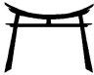

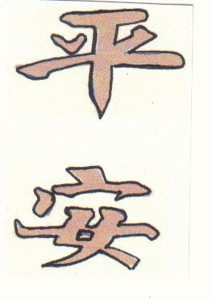
Pyong Ahn
The Pyong Ahn symbols are Chinese characters.
The first (Pyong) shaped similar to that of a balanced scale, corresponds to the English terms Well Balanced, Calm and Peaceful.
The second character (Ahn) means Confidence in English. It is said that through the study of these forms, one can become peaceful and confident in his/hers Martial Arts abilities.

For many years now,there has been
much controversy and discussion in the Martial Arts community regarding the origins of the Pyong Ahn forms practiced in the Tang Soo Do system. Like much of the history of ancient civilizations, vital information is lost if there is no official written record. In our Bible, there are differences in the Books of Matthew, Mark, Luke and John, regarding the life of Jesus, but we do not disbelieve the Gospels simply because they do not totally agree.
In one version of Pyong Ahns history, the forms were traditional Chinese forms which Hwang Kee brought back with him after traveling to China. This is doubted because most believe the forms were origianlly Okinawan.
In another, it is rumored that Hwang Kee and Funakoshi Genchin (the founder of Shotokan) while traveling together in China created the forms. This story is impossible, because when Hwang Kee was in his 20’s and leaving for China, Funakoshi was already 67 and living in Japan where he later died.
In yet another story I found, The forms are said to be Okinawan in origin, and they cannot account for how the forms came to Korea. There are many stories out there, actually so many that I am not sure who to believe.
Therefore, I believe the only hope we have is to deal with the history that we do know. This history is actually a mixture of the three that I have told you. According to Hwang Kee in his writings, he learned the forms in China. However, he also states that the forms were originally Okinawan. This could account for the many variations of the story. It also accounts for the reason that so many martial artists refer to the forms as Pinan. Pinan is the Okinawan pronunciation of the Korean Pyong Ahn.
How far back the forms go, where they originally came from, and how many times they have been changed and adapted, I believe cannot be answered. However, I can tell you this. It is said that if you take two intermediate belts from most any form of martial arts, and put them in side by side rooms, then ask them to perform any 5 forms they know, the Pyong Ahns or some variation of them will be seen at least twice from either martial artist. The Pyong Ahn series of forms is the most widely taught series of forms in the martial arts world today.
The animal representation of Pyong Ahn forms is the turtle. This animal lives in a state of constant peace and confidence. Its actions are always slow and deliberate. It presents an impression of calm, comfort, and peace. The Pyong Ahn Forms are widely accepted and known as “Peace Forms”
Researched and written by Rowdy Fortson “Bull” Addendums and edited by fw “Dragon”

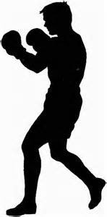
The Five BasicBoxing Techniques
In addition to the 5, 5, & 5 Basic TSD techniques, which builds the foundation of the ATF System, students are taught 5 Basic Boxing Techniques which are integrated into our training regimen by way of CKB (Cardio Kick-Boxing) as mentioned on pages #7 and #26 of this book. CKB stresses physical fitness, endurance, hand-foot coordination and working with combinations of techniques. Longtime students of our system will affirm that, many years before Billy Blanks made millions of dollars selling his Tai-Bo tapes, students of ATF were doing the very same
thing....IF I HAD ONLY KNOWN THE MARKET WAS OUT THERE.....I could be famous! CKB takes the five basic boxing elements and with the addition of kicks and constant movement, up-down, back-forth, side-side, puts it all together, sometimes with music, sometimes without, and the end result is a challenging workout which facilitates our TSD training.
The 5 Basic Boxing Techniques are: Jab, Cross, Hook, Uppercut and Slip.
The Jab: The forward hand is always closer to your opponent so it is used to sting him, make him blink, set him up for a finishing technique. The jab targets the nose and mouth straight-on. As with any strong punch, it is important to keep the elbow behind the fist.

The Cross: A power punch thrown with the rear hand and will land at an approximate 10 degree angle, striking the side of the nose, cheekbone, jaw. This is a straight on power technique which may be thrown as an overhand punch. The power of this punch is increased with the pivoting of the rear foot.

The Hook Punch : Can be thrown with either hand but more effective as a rear hand punch. It strikes the opponent from an extreme side-angle so it is very difficult to see if it is set up properly. It is an up-close punch thrown with the elbow bent and hinging at the shoulder. The elbow stays behind the fist and the palm is facing IN, (not down) when it strikes the target. A DOWN facing fist has more possibility of breaking your own hand when you strike the target, because the impact is absorbed with the weakest part of the hand. Strike with the two LARGE knuckles.

The Uppercut Punch: Also thrown with either hand, the uppercut is simply a hook punch in an upward direction. The target is under the chin or upward under the nose. Again the power is increased by pivoting the rear foot. Very effective when thrown across the body (left-to-right or opposite)

Slip, Duck, Bob & Weave: Defensive posture movements, but can be used to set up a punch or kick.
It is important to never bend over at the waist, for this will give your opponent an advantage for an uppercut or knee-lift. Try to keep your shoulders over your hips, bend your knees and sit into the stance. Balance, footwork ,staying low and keeping a low center of gravity are all stressed during this training.
CKB training is intense but it is a fun part of our class routine. Approximately 30 minutes of each class is devoted to CKB training. It is used at the beginning of every class to warmup, stretchout and prepare to learn and practice the more strenuous and advanced TSD training.
CKB helps the student avoid training injuries through proper conditioning. You may have absolutely NO desire to ever set foot in a ring, but if you are training like a fighter, you’re working hard and getting fit. Train Hard, Have Fun, Get Fit! _{Fw}

TESTING REQUIREMENTS–10th LEVEL 
10th YELLOW

- A.T.F. Creed II Properly Tie Belt
- Know purpose of and execute proper “KIAI”
- Hand Techniques
  - Down Block 2. Up Block 3. In Block 4. Out Block 5. Forward Punch IV Stances
- Ready Stance 2. Forward Stance V Kicks
  - Stationary Front Thrust Kick 2. Stepping Front Thrust 3. Slide-up Front Thrust

10th YELLOW/BLUE

- Yellow requirements plus;
- Hand Techniques
6. Knife Hand Block. 7. Side Punch 8. Bottom Fist 9. Reverse Punch III Stances
- Horse Stance 4. Back Stance IV Kicks
- Stationary Round Kick 5, Spinning Round Kick 6. Slide-up Round Kick V Knowledge of FIVE, FIVE and FIVE
Five Basic Kicks;........................Front, Back, Round, Side & Crescent Kicks
Five Basic Blocks;......................Down, Up, In, Out and Knife Hand Blocks
Five Basic Stances,.....................Ready, Forward, Back, Horse and Fighting Stances

10th YELLOW/GREEN

- All of the above plus;
- Hand Techniques
10. Reenforced Knife Hand Blocks (Low & Center) in a Back Stance III Stances
5. Fighting Stance
IV Kicks
7. Inside Crescent 8. Outside Crescent 9. Stationary Back 10. Stationary Side
11. Slide-up Side 12. Spinning Side Kicks V Pressure Points

NOTE: New testing requirements for each rank will be shown in BOLD TYPE

TESTING REQUIREMENTS ----9th PURPLE

I Forms
- Giecho Hyung Il Bu 2. Giecho Hyung Il Bu Sahm Gup
3. DRAGON STICK #1 (Weapons Form) II Pressure Points
III Basic Hands----Same as 10th Green + Straight Fist & Palm Heel Strike IV Basic Kicks----Same as 10th Green + Stepping Back & Spinning Back V Stances----Same as 10th Green
VI One-Step Sparring–minimum 4 techniques
V Attack Techniques

TESTING REQUIREMENTS----8th ORANGE
- Forms--Giecho Hyung Yi Bu Sahm Gup and below + ATF #1

- Pressure Points

- Basic Hands—Same as 9th Purple + Inverted Punches & Elbow Strikes IV Basic Kicks ---Same as 9th Purple + Combination Kicks
- Jumping Kicks--- Front------Round

- Stances—Cat Stance and Stance Switching VII One-Step Sparring—minimum 6 techniques VIII Attack Techniques
IX Blocking Sets—Nil, Down Block & Up Block

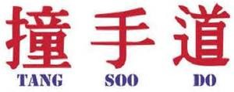

TESTING REQUIREMENTS 7th BLUE

- Forms –Pyong Ahn Cho Dan and below + ATF#2
- Pressure Points
- Basic Hands—Same as 8th Orange +Stutter-step punches, Ridge Hand
Shuto & Inverted Punches
- Basic Kicks—Same as 8th Orange +Slide-up Hooking Heel,
Spi nning Hooking Heel
& Spinning Back Hooking Heel
- Jumping Kicks—Same as 8th Orange + Side Kick, Spinning Side Kick,
Inside/Outside Crescent Kicks
- Stances—Same as 8th Orange
- One Step Sparring—10 minimum (5 left, 5 right)
- Attack Techniques
- Blocking Sets—Same as 8th Orange + In Block & Out Block
- Free Sparring

Has This Ever Happened To You?

You are watching a demonstration of Tang Soo Do Forms, by a student who is performing flawlessly.....Everything is perfect...good hand /foot coordination, good timing, strong kicks and the blocks and punches are snapping out there with force and authority.........You are thinking to yourself..... "This kid's got it all"
Suddenly and out of nowhere he makes a mistake.... grimaces....shakes his head....and PROMPTLY MAKES ANOTHER MISTAKE! WHAT HAS HAPPENED HERE?
The student who, just moments ago ...you thought "had it all"....was lacking in two very important things which are necessary to excel in ANYTHING: Concentration.....&...Focus!
He had lost his Concentration and was NOT FOCUSED enough on what he was doing to recover and go on without making another mistake! Here’s an important tip!
When you make a mistake...forget about it IMMEDIATELY... do not dwell on what has happened but gather yourself and realize that there is nothing we can do about it....after we have made a mistake....JUST BE SURE WE DON'T MAKE ANOTHER ONE!
Do Not shake your head, grimace...or in ANY WAY indicate that you have made a mistake...while you are doing this...you are making another one.... because you ARE NOT FOCUSED on what you are SUPPOSED to be doing! NEVER SHOW YOUR ENEMY THAT YOU ARE INJURED!
A bit of history.....
That's why the British Army...the REDCOATS...wore Red Coats.....Red didn't show the blood when they were shot! They got that idea from the SPARTANS who had the reputation of being the most fierce fighting men of their day....They wore red cloaks. F w

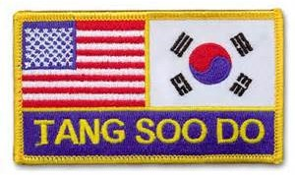

TESTING REQUIREMENTS --- 6th GREEN

- Forms–Tak San (first half) and below
- Pressure Points
- Hands—Same as 7th Blue + X-Blocks high/low, Back Fist, Back Knuckle
- Kicks—Same as 7th Blue
- Jumping Kicks—Same as 7th Blue VI Stances—Same as 7th Blue
VII One Step Sparring—12 minimum (6 left, 6 right) VIII Three Step Sparring—Minimum 3 techniques IX Attack Techniques
- Free Sparring
- Self-Defense—One unarmed assailant
- Blocking Sets—X-Blocks low/high, Knife Hand Block
- Breaking Demonstration—4 Boards ( 1 hands, 1 feet, 2 combination or power break)
- Written Test— Test will cover knowledge student should have acquired to this point in training but may not be limited to knowledge of Martial Arts.
- Fighting Name—Selection of Fighting Name is very important and should reflect the student’s personality and fighting style.

TESTING REQUIREMENTS--- 5th GREEN

- Forms–Pyong Ahn Yi Dan and below
- Hands—Same as 6th Green + Reinforced Forearm Block, Twin Fist
- Self-Defense—Same as 6th Green + 1 armed assailant (club)
- All other areas of the test as required for 6th Green, must show definite improvement throughout!

TESTING REQUIREMENTS --- 4TH GREEN
- Forms–Pyong Ahn Sahm Dan and below
- Kicks–Same as 5th Green + Spinning Back Round, Spinning Bk Crescent
- Self-Defense–Same as 5th Green + 1 Armed Assailant (knife)
- All other areas of the test as required for 5th Green, must show definite improvement throughout!

TESTING REQUIREMENTS--- 3rd RED

- Forms Tak San #2 & Below + DRAGONSTICK #2
- Kicks–Same as 4th Green
- Jumping Kicks–Same as 4th Green + Double Crescent
- Self-Defense–Same as 4th Green + Multiple Unarmed Assailants
- Breaking Demonstration–7 Boards (2-power, 3-combination, 1-hands, 1-feet)
- Written Test
- All other areas of the test must show definite improvement throughout

TESTING REQUIREMENTS--- 2nd RED
- Forms—Pyong Ahn Oh Dan to TakSan

- Jumping Kicks–Same as 3rd Red + Advancing Jumping Round,
Ret reating Jumping Round
- Self-Defense—Same as 3rd Red +Multiple Armed Assailant

- All other areas of the test as required for 3rd Red. Must show definite improvement throughout!

TESTING REQUIREMENTS--- 1st RED

- Forms—Bassai to TakSan
- Kicks—Same as 2nd Red + Dropping Side, Dropping Round
- Self-Defense—Same as 2nd Red + Escape Techniques
- All other areas of the test as required for 2nd Red.
MUST show improvement on EVERY requirement throughout test!

Be Prepared for this one.......This will be your toughest test yet! Your endurance and stamina will be tested to the MAX!



Valuable Information for 1st Degree Red Belts
If you have passed your 1st Degree Red test, now your conditioning for your 1st Degree Black test has begun. It will be the toughest test you have taken to this date. However, before you get there, you must spend the next 12 months in preparation , practice and sharpening your instructing skills.
During this time you should create your “Original Form” which should consist of 100 moves and reflect your fighting name/style. You will also be required to pass a written test and, on test day, appear before a board of Black Belts for an “Oral Examination” which could last for as much as several hours. During the year you will be required to present the progress on your Original Form at the regularly scheduled testings in April, August and December (35 moves required for first showing, 70 at second presentation and 100 at the years end). The danger is that you will become stagnant during this training(waiting) period. This you MUST guard against...... by continually working on your 1st Dan requirements during the entire period.

TIPS FOR TESTING
Everyone has a natural tendency to become tense or even "FREEZE UP" when facing an important or unexpected event. While a LITTLE nervousness is OK ... it keeps you sharp and on your toes.....being nervous can be a disability if you allow it to be. Nerves become tense.....muscles tighten, you become stiff and uncoordinated, you forget to breathe.....NO OXYGEN flows to the ALREADY TIGHT muscles to refresh them....your brain stops working and you suffer a mental blackout....and sometimes a PHYSICAL BLACKOUT.....or simply put...YOU PASS OUT! You come around a few seconds later wondering "what just happened"!
This all sounds pretty grim but there are SEVERAL things that you can do to avoid this happening to you.
#1 Arrive early and get your paperwork done, so you will not feel rushed and "in a hurry."
#2 Stretch-Out and walk through your forms, Blocking Sets, etc....before test starts.
#3 Remember a large portion of the TEST DAY, you will spend sitting and watching other students perform. Watch for their mistakes and listen to the comments of the Test Board, regarding what they have done well or what they are needing work on.
#4 NEVER...do your forms for the first time that day ....in front of the test board...Refer to RULE #1 & RULE
#5 BE PREPARED....Have all the necessary paperwork, written tests, DH Papers....test fees, food donations....etc..when you arrive. Being prepared relieves tension and apprehension or worry about these things.
#6 LOOK SHARP...Both Mentally and Physically.....Get a good nights sleep and have a good breakfast...both Protein and carbohydrates..for energy and strength.
#7 Know your requirements........DON'T GUESS!
#8 ASSUME THE TEST BOARD KNOWS MORE THAN YOU!
Members of the Test Board, have been doing his ...every four months....for a LOT OF YEARS.....and have already witnessed and heard anything you can think of to do or say!
DO NOT attempt to "SNOW" them with "BS".......They have heard it all before and can recognize it instantly. If you are asked a question, for which you DO NOT KNOW the answer.........simply reply..LOUDLY...."I do not know SIR"..... It's not a crime to "Not Know" but you will score NO POINTS with the test board by attempting to "BULLY" your way through questions for which you were clearly NOT PREPARED!
#9 As mentioned in RULE #3...you will spend time sitting and watching....This is all a part of your training to teach students PATIENCE....."Wait Your Turn...When Your Name Is Called...GIVE YOUR BEST EFFORT!
When your name is called, answer LOUDLY...the louder the better....."HERE SIR"....this not only tells the Test Board that you are present, alert and ready.....BUT it will force you to breathe...so LOUDLY..."HERE SIR"...as you get to your feet and DOUBLE-TIME (RUSH) to stand in front of the Test Board.
#10 BEFORE..you open your mouth to speak, BEFORE you begin your forms, basics, blocking sets, etc.............BEFORE you begin ANYTHING...Take A Deep Breath......DO NOT hold your breathe while performing...You will SOON "Run OUTA GAS"!
#11 NEVER TURN YOUR BACK TO THE TEST BOARD! To show your back is a sign of DISRESPECT in any situation....ESPECIALLY on TEST DAY!
#12 NEVER LOCK YOUR KNEES..when standing in a READY POSITION......Keep your legs slightly bent.
#13 If you feel yourself getting tense..let your arms hang loose at your sides and "SHAKE YOUR HANDS"
#14 Remember that the Test Board is there to HELP YOU achieve your goal. It is NOT there looking to fail you but also.....it is NOT there to give you something which you have NOT EARNED!

Testing Tips Contd
Testing is just another LEARNING EXPERIENCE......Many times in life we don't always get what we want....THE FIRST TIME. A true test of character is.... IF THERE IS A SECOND TIME! A student's commitment and dedication can be determined by how LITTLE it takes to make them QUIT!
If you are testing for a COLOR ....and instead...receive a PROFICIENCY STRIPE......for all your hard work....... REALIZE that the Test Board saw something which they felt needed improvement and it is YOUR responsibility to FIX what is needing fixed and come back in four months better prepared and with determination to succeed!

Your appearance will affect the way you feel about yourself so build your self-confidence on test day by making sure your Gi is clean and in good repair. Do not appear before the test board in a dirty uniform with the patches or Victory Marks missing or hanging on by a thread. A sloppy appearance is NOT getting off to a good start and does NOT make a good impression on the test board. Remember...LUCK is what you make it!
Tang Soo Fw

TESTING REQUIREMENTS 1ST DEGREE BLACK BELT

I FORMS--All forms, Giecho Hyung Il Bu through Bassai + Original Form II Written Thesis–Minimum 500 words
- All areas of this test MUST show; MASTERY OF ALL BASIC TECHNIQUES
- Oral Exam
- Other Requirements at the discretion of the Test Board

2ND DEGREE/UP Requirements covered in Black Belt Manual

A.T.F. Black Belt Oath
Upon acceptance of this rank I do hereby acknowledge and accept the responsibility that must accompany it.
I do pledge to always uphold the integrity of the Martial Arts, my system and my school. I will always strive to improve myself and the quality of my knowledge of Tang Soo Do.
I further pledge to always demonstrate the indomitable spirit of my art in all matters. I will defend the honor of my rank, the reputation of my school and the well being of those who may be defenseless, against all aggressors and ill- doers. I will never lay down my rank in the face of adversity and will never lend support to any situation which could possibly cause my rank to be revoked. However, should this issuing authority request the return of my credentials for any reason, I will return or destroy them without question. I understand I will always have a responsibility to those who I may instruct to insure that they are trained only in the high ideals of Tang Soo Do and to follow in the tradition of this system. I will be unwavering in my pursuit of perfection in myself and those who fall under my instruction. I further pledge to work diligently to expand the boundaries of the A.T.F. System. In recognition that the written or spoken word can never encompass all:
To my school, my fellow and future students, my instructors, myself and all who are present, this I Pledge!

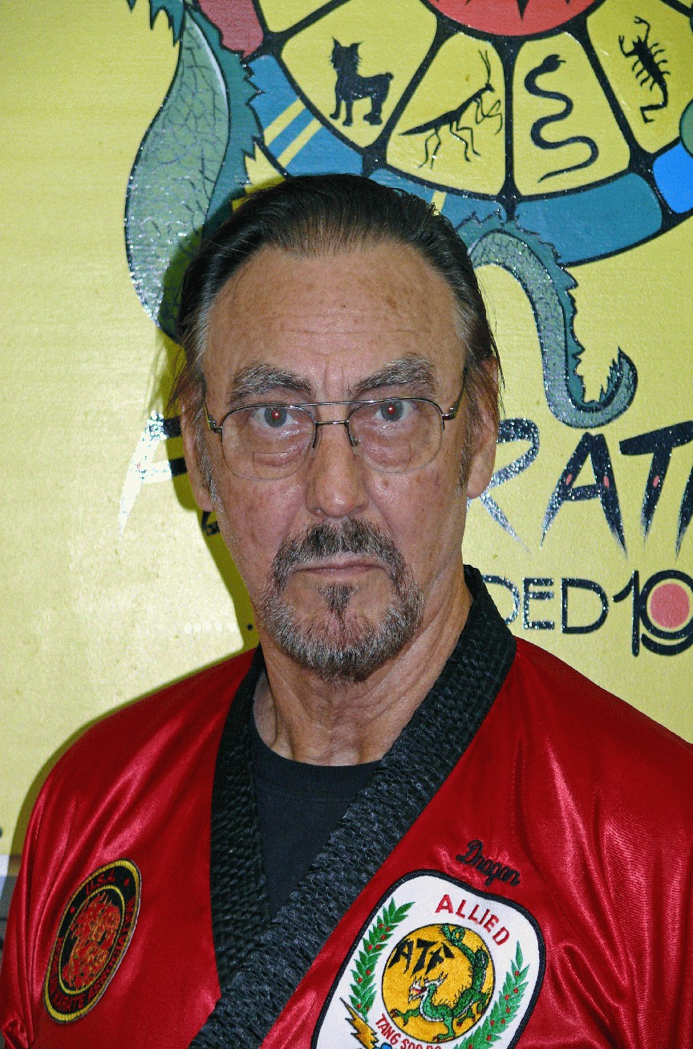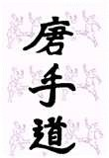

Mr Fred Weeks “Dragon”

Founder, Master Instructor, Historian, Activities Director

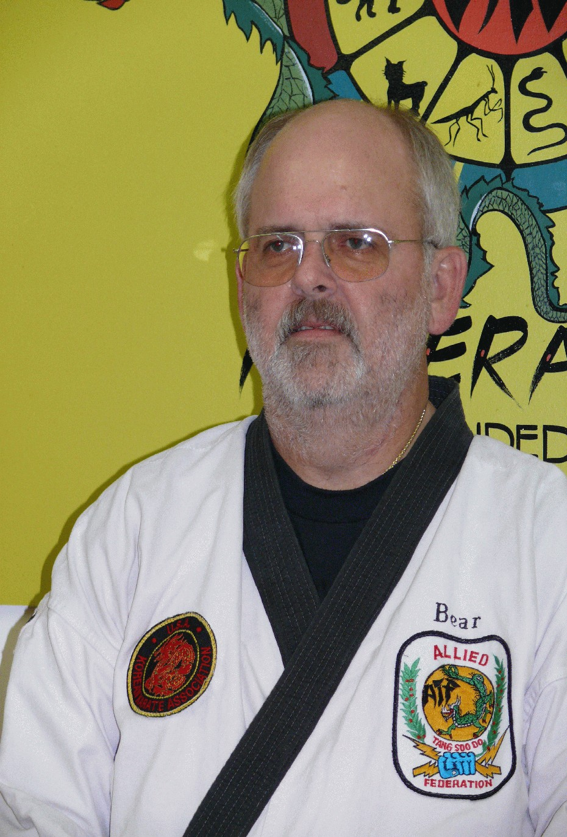
Mr Robert Warden “Bear” Senior Instructor Administrative Director
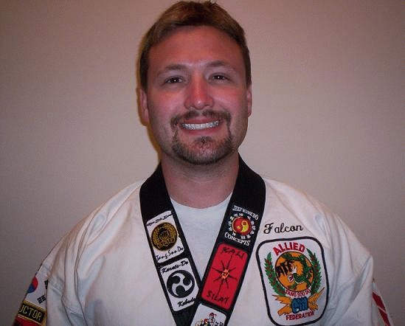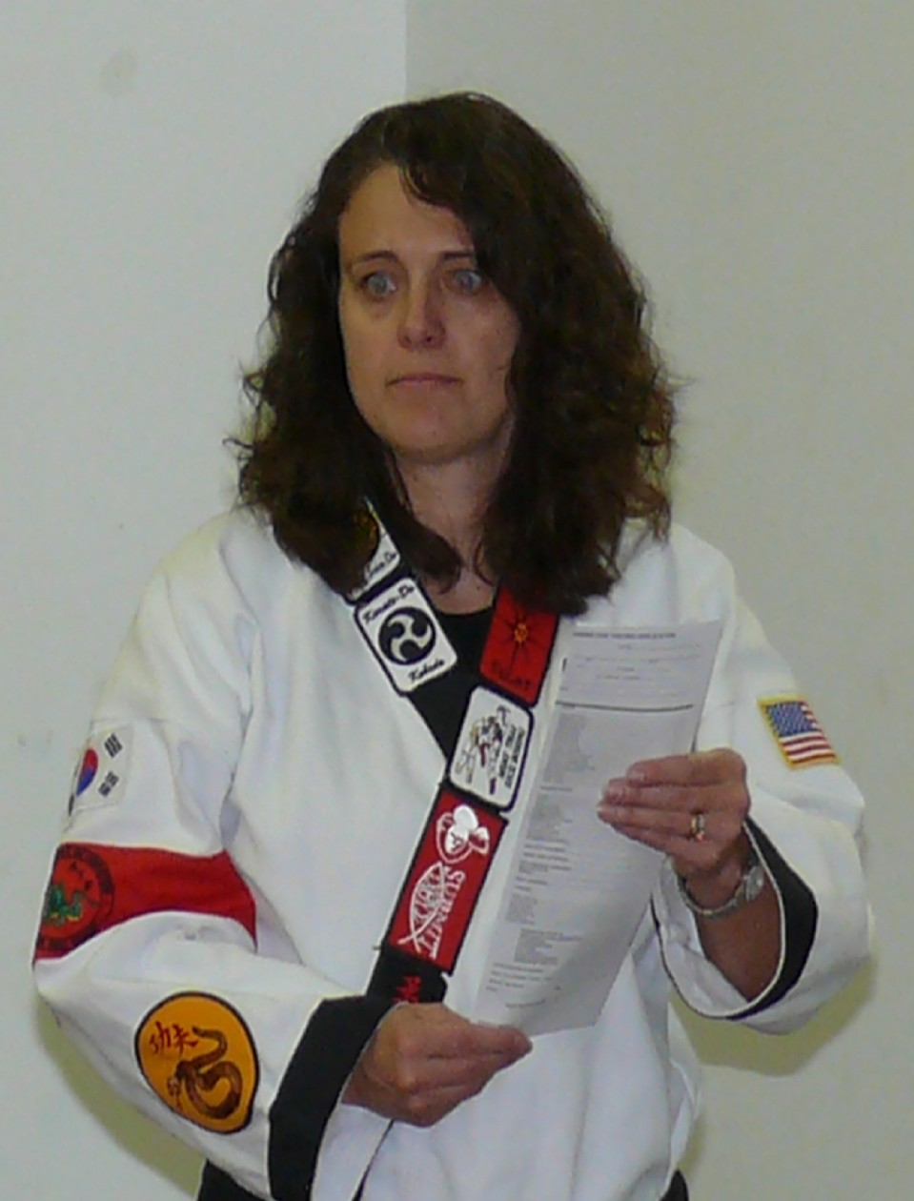

Dr Keith Waggoner “Falcon”
Senior Instructor Training Director, Liaison Director

Mrs.Janet Atkinson “Cobra”
Senior Instructor
Black Belt Board President Asst Liaison/Training Director

Dr. Keith Waggoner was been appointed training director in 2006, in order to spearhead the ATF cross training initiative. Dr. Waggoner is a black belt instructor in the ATF system and has trained since 1985 in the arts of Tang Soo Do, Jeet Kun Do, Kali, Silat, Muay Thai, Jiu-Jitsu, Judo, Aikido, Shorin-Ryu, and Mixed Martial Arts. The Allied Tang Soo Do Federation has always emphasized eclectic systems training in order to better equip its members as holistic martial artists. ATF is now offering its students the opportunity to train in various martial arts from around the world through seminars and expanded curriculum practice.

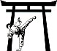

A LLIED

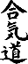
TANG SOO DO
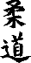
FEDERATION
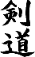
CrossTraining Curriculum

MARTIAL ARTS CROSS TRAINING

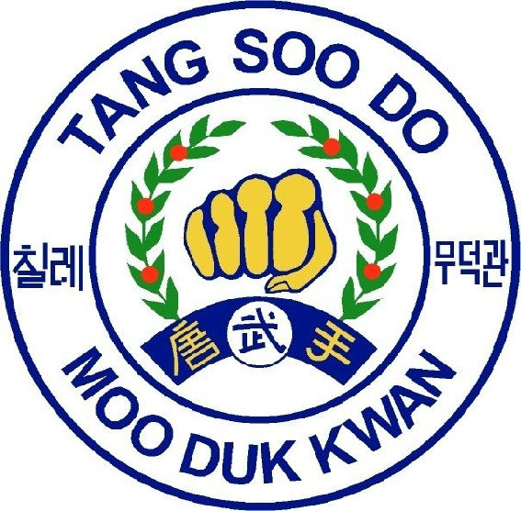
The martial arts cross training program includes lessons and seminars presented in the following arts:
1. Moo Duk Kwon
Moo Duk Kwan Researched & written by Mr. Rowdy “Bull” Fortson
The Brotherhood of Martial Virtue
Moo Duk Kwan (MDK) is not a martial art. MDK is a philosophy, much like Jeet Kun Do whose originator was Bruce Lee. Hwang Kee the founding father of Tang Soo Do (TSD), actually came up with the idea of MDK before deciding on Tang Soo Do/ Soo Bak Do as the vehicle with which to spread his philosophy.
After Hwang Kee studied many martial arts, including Tae Kyun and Soo Bak Do. He then traveled to China where he studied extensively the martial arts of northern China. Upon returning to Korea, he decided that the martial arts were not only a form of self-defense, but also a tool which could be used to make the student a better person. This is the philosophy of MDK.

MooDukKwan Tang Soo Do is loosely interpreted a “brotherhood to stop violence through the use of the art of the knife hand.” He believed that the proper study of TSD, would create a better person on the inside as well as the outside. At some point in our lineage the MDK was dropped. Mr. Weeks in his insight decided early on that we needed something similar to this idea and created the ATF TSD “Code of Conduct.” As you study MDK you will find that the “Code of Conduct” is very similar in many of its ideas to MDK. To see if that was intentional or not, you will have to talk to the Dragon. When the idea of “cross training” other martial arts through our school came up. It was decided that MDK needed to be one of those Primary areas of study.
MDK is based on Eight Key Concepts, and Ten Articles of faith. These are listed below. In order to “patch out” in MDK you must follow these Guidelines.
- Before EACH TESTING the student will choose an area from each of the eight key concepts, & ten articles of faith that you need work in.
- Sit and write an short essay, which you will turn in On Test Day...... that discusses what that concept & article means to you , and how you will use Tang Soo Do to better yourself in that area.
- This essay will be reviewed by the Tang Soo Do Black Belt Test Board.
- Upon the approval of that essay you will be awarded your patch.
- Upon successfully accomplishing that goal, you will then choose another and repeat the process at each testing until All Eight Concepts and All Ten Articles have been examined and discussed.

Eight Key Concepts

- YongGi -Courage
- ChungShinTong II- Concentration
- InNeh -Endurance
- ChungJik -Honesty
- KyumSon - Humility
- HimChoChung - Control of Power
- ShinChook - Tension and Relaxation
- WanGup - Speed Control
Ten Articles of Faith
- Loyalty to country
- Obedient to parents
- Be a loving husband/wife
- Cooperate with brothers and sisters
- Be respectful to elders
- Be faithful to your teacher
- Be faithful to your friends
- Face conflict with justice and honor
- Never retreat in battle
10 Always finish what you start

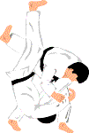
2.) Kubudo (traditional and general weapons training) facilitated by Sabomnim Fred Weeks, & Dr. Keith Waggoner and Mr. Jamie Yowell.
3.) Jeet Kune Do, Kali/Eskrima/Arnis, Silat, Muay Thai, Kickboxing and Western Boxing (facilitated by Dr. Keith Waggoner).
4.) Brazilian Jiu-Jitsu, Grappling-Ground Fighting, Judo, and stand up Jiujitsu (facilitated by Mr. Danny Cooper, Dr. Keith Waggoner and Mr. Jason Boggs).
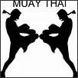
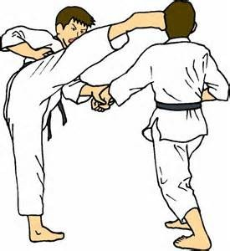
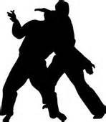
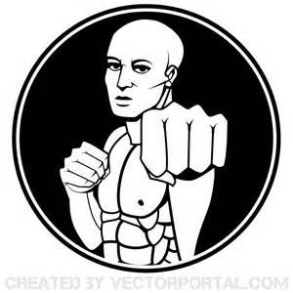
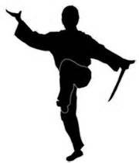
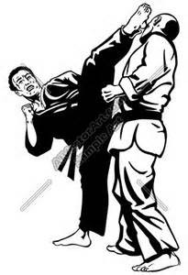
5.) Sword play and Fencing (facilitated by Sabomnim Fred Weeks and Mr. Jamie Yowell).

Presentation Syllabus
Each martial art system will be presented in a special class or seminar format and will be announced in advance. ATF student participation in Martial Arts Cross Training, although not required for ATF advancement, is greatly encouraged for overall martial artist development. There will also be regularly scheduled martial arts cross training sessions after regular ATF class time.
Charges:
Seminars and/or special classes will require a charge separate from regular monthly dues. These fees will be announced in advance. The extra charges are to cover travel costs of visiting instructors, to buy equipment needed for training, and to pay for supplies and resources.
Rank Advancement:
Actual rank advancement in each specific art may be made possible through the cross training curriculum and will be specified for each art.
Requirements for Cross Training Participation:
- If participant is an ATF member, he/she must be a member in good standing.

- All ATF dues must be current.

- ATF class participation of at least 50%.

- Must meet each specific martial art special requirements.

- All ATF cross training students must first obtain Moo Duk Kwon and then Kubudo certification and patch.

- Non ATF cross training participation is subject to instructor approval.

Patches for the ATF formal Gi:
ATF is proud to offer the cross training students special recognition on their formal gis by granting the opportunity to earn a patch for each martial art system trained in.
- Cross training patches may be earned for each martial art system.
- Once earned, patches may be purchased from the instructor.
- Patches are to be worn on the formal ATF Gi during class time.
- Patch order:
- Right lapel
  - Moo Duk Kwon
  - Kubudo
- Left lapel
  - Jeet Kune Do
  - Kali/Silat
  - Muay Thai
  - Grappling/Ground fighting
  - Jiujitsu
- Sword play/Fencing patch and placement will be announced at a later time
- Patch placement:
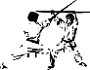
- One half inch below shoulder seam on lapel
- Placed end to end in the order listed above
Moo Duk Kwon Written by Mr. Fortson Pages # 44 & #45

Kubudo Written by Dr. Keith Waggoner
Kubudo (translated as “For War”) is an Okinawan developed martial art that focuses on the use of weapons as a means of warfare. Conventional weapons of the age were outlawed and seized by the occupying Japanese military. Therefore, the Okinawan people developed their farming tools into weapons that were very effective against the invading Samurai. The Kama, Sai, Nunchaku, Bo, Tonfa, Oar and Tekko are the most common implements that were utilized.

The Allied Tang Soo Do Federation requires all of its members who wish to cross train in martial arts to certify in the art of Kubudo because of its lessons in transitioning a practitioner from empty hands (Karate) to weapons use. Kubudo in ATF is not limited to traditional Okinawan weaponry, but will also cover aspects of more modern and conventional weapons as well.
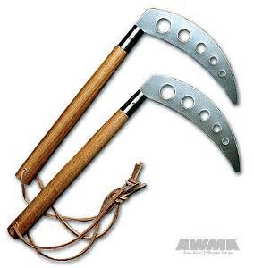
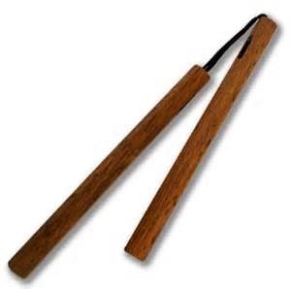
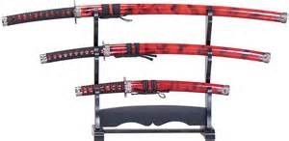
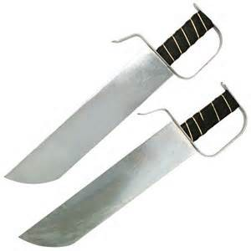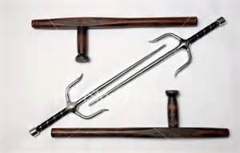
Patch and Advancement:
ATF students who participate in the Kubudo special classes and seminars will have the opportunity to earn the Kubudo patch for their ATF formal gi. This patch is to be worn on the right lapel just below the Moo Duk Kwon patch. There is no rank advancement offered in Kubudo at this time.
What you will learn:
- How to use weapons as an extension of your hand.
- A basic understanding of traditional and non-traditional Okinawan weapons.
- How to integrate weapons into Tang Soo Do training and Hyung.
- How to specialize in at least one traditional and one non-traditional weapon.
- How to use weapons as a means of self-defense and combat.
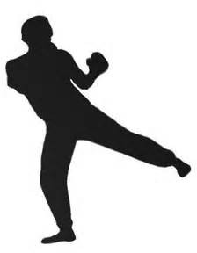Kubudo seminars and special classes may be charged at a special rate separate from the regular ATF dues. These fees will be announced in advance when the dates of the special classes and/or seminars are announced.

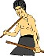
Jeet Kune Do

Jeet Kune Do, literally translated from Chinese is “The way of the intercepting hand and foot”, is a conceptual martial art founded by Bruce Lee. Jeet Kune Do is essentially the way of no way. It is a philosophy applied to all martial arts so that individuals develop at their personal best resulting in a unique style.

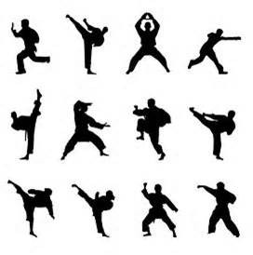
Accompanying Jeet Kune Do is the martial art of Lee Jun Fan Gung Fu. Lee Jun Fan is Bruce Lee’’s Chinese name and Gung Fu is the Southern Chinese pronunciation of Kung Fu. This is the developmental martial art that Sijung (Head Grand Master) Bruce Lee created and practiced himself until the time of his death. Formally the art is termed Jeet Kune Do Concepts of Lee Jun Fan Gung Fu. However, we simply refer to it as Jeet Kune Do or JKD for short.
The Allied Tang Soo Do Federation offers Jeet Kune Do to its students to reinforce the idea that a martial artist is to create the art of their own that fits their personality, physical potential and design, and developmental style. Jeet Kune Do seminars and special classes may be charged at a special rate separate from the regular ATF dues. These fees will be announced in advance when the dates of the special classes and/or seminars are announced.
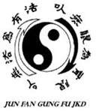
What you will learn:
- How to stimulate creativity as a Martial Artist
- How to choose styles and techniques that fit you best
- How to streamline martial technique no matter what your style
- The developmental function and purpose of the different ranges of combat
- How to read and control your opponent in all stages of confrontation

Patch:
ATF students who participate in the Jeet Kune Do special classes and seminars will have the opportunity to earn the Jeet Kune Do patch for their ATF formal gi. This patch is to be worn on the left lapel one inch below the shoulder seam.

Advancement:
Advancement in Jeet Kune Do will be awarded upon completion of seminars/special classes and subsequent exams of composite curriculum. A sash will be awarded for composite curriculum advancement instead of a belt. Sashes are the traditional Chinese Gung Fu indicating system of rank. These sashes are to be worn during special class/ seminar times.

Composite Curriculum is a compilation of Jeet Kune Do, Kali/Silat, Muay Thai, Western Boxing, Kickboxing, Grappling/Ground-Fighting, and Jiujitsu. Portions of this curriculum will be handed out to students as they progress and pass the exams. An example of this curriculum is listed below.

White Sash with 1 Stripe

Boxing / Kickboxing / Muay Thai Offense: Jab, Cross Combination Offense: Single right kick
Footwork: Step and slide
- Advance
- Retreat
- Right
- Left
Kali / Eskrima / Arnis
Single Stick:
- Amarra (Basic Stroking)
  - Downward figure 8 b. Upward figure 8
- Numbering system:
  - Angles 1-5
- Basic Disarms:
  - Angles 1-5
  - Contra and Sequida at Largo Mano range Empty Hands
Lee Jun Fan Gung Fu:
    - Against a Jab:
      - Catch the jab, return the jab b. Parry the jab, return the jab
    - Intercept the Jab with a Jeet Tek (Stop Kick)
    - Fake the Bill Jee to O’’ou Tek, Juk Tek, Jik Tek
    - From reference position: Pak Sao Punch, both sides

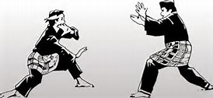
Silat:
1. Puter Kepala (Steering Wheel) Jiujitsu/Judo
Locks:
1. Lock one Throws:
1. Falling and Rolling Grappling/Ground-Fighting
- Knee to belly
  - Hammer fists b. Elbows
- Stand-up in base
- Lying Kicks
  - Push b. Side c. Heel Kali/Eskrima/Arnis/Silat
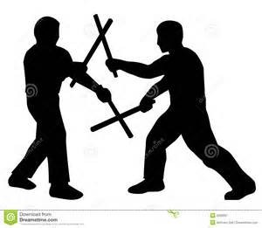
Kali, Eskrima, Arnis, and Silat are martial arts from the Philippines and Indonesia that are known for their use of knives, swords and sticks. In the United States, these arts are often referred to as “Exotic Martial Arts” because of their tribal nature. Each tribe or family was said to have their own versions of Kali/Silat that would be passed down through the generations. These arts are so potent that no invader was able to defeat them until the advent of the firearm by the Spanish Conquistadores.
Guro (Instructor) Dan Inosanto is the man accredited with unifying many of the Filipino fighting systems into a comprehensible martial arts curriculum. Guro Inosanto was also an avid student of Bruce Lee and is considered by many to be his successor in JKD. One of Guro Inosanto’s top students is Sifu/Guro Harley Elmore. Sifu/Guro Elmore has created the Warriors Way Martial Arts Academy in Wichita Falls, Texas and is the instructor of Dr. Keith Waggoner in the JKD/Kali arts.
Kali is derived from the ancient warrior fighting systems of tribal families who primarily used knives, swords, and sticks for their defense against invaders. Kali is properly named after the Hindu goddess of war and death who is depicted as an all seeing, multi-armed warrior who yields swords to decapitate her foes. Kali is considered the father system of Filipino martial arts and is believed to have directly descended from India. Rattan and hardwood sticks are often used in Kali practice to replace the sword for safety.

Eskrima is the Spanish influenced version of Kali that primarily focuses on the use of the Baston (Eskrima stick). A primary difference between Kali and Eskrima is the striking methods and subsequent applications of the baston. In Kali the stick is used as a substitute for the sword, thus most strikes are actually slashes. In Eskrima the stick is used as an actual stick and is wielded with a more blunt force. These differences are very significant in both attacking and defending techniques. Eskrima is greatly used by police units as a means of non-lethal suspect submission.
Arnis is primarily a sport version of Eskrima and is the national sport of the Philippines. Thousands of Arnis practitioners around the world practice and promote the sporting version of the Filipino martial arts.
Silat is primarily an empty hand version of the Filipino martial arts. Most all techniques can be applied with or without a weapon. It is greatly stressed that weapons are simply an extension of your hand. Therefore, any technique delivered with a weapon can also be done without one and visa versa. Like Kali, Silat derives from tribal family systems. It has strong orientations from the island nation of Indonesia. It is thought that many Silat systems came from pirates who fought on and off of their ships. As would be expected from a pirate art, there are many Indonesian systems of Silat that also have weapon applications.
Patch
For abbreviation, the above described Filipino martial arts will simply be referred to as Kali/Silat. ATF students may earn a Kali/Silat patch to wear on their formal gis by attending and training special classes and seminars. This patch is to be worn on the left lapel of the ATF formal gi just below the Jeet Kune Do patch.

Advancement:
Advancement in rank in Kali/Silat will be earned through successful completion of the JKD compilation curriculum and exams. Kali/Silat seminars and special classes may be charged at a special rate separate from the regular ATF dues. These fees will be announced in advance when the dates of the special classes and/or seminars are announced.
What you will learn:
    - How to use weapons as an extension of your body
    - How to rely on your classmates, family, and friends for unified defense
    - A basic understanding and functioning of the sword, knife, stick, and palm stick
    - How to protect yourself at all times against would be attackers
    - A devastating form of self-defense and offense that is used by military and police around the world

Kali and Silat Basic Systems Protocols
There are several basic protocols with our Kali Practices. These protocols establish the command structure, blade etiquette, and safety standards, while establishing methods of communication between students and instructors and creating a logical method of dealing with various issues.
Instructor and Member Responsibilities: Each member is to:
- Be Responsible for the safety and security of those around them.
- Be a Valuable part of the tribe, each watches for the safety of all children, spouses, family and members.
- Observe for unsafe or irresponsible action of junior members
- Monitor and guard the perimeter of his area.
- Work with other members to form improvised teams in times of necessity.
- Relay information and messages to those in need.
- Carry the necessary gear to be effective in combat, communications and medical assistance.
- Work to make all those around him feel welcome and comfortable, even at your own discomfort.
- Assist others in learning and practice of Kali Systems and all areas beneficial to the student or member.
- Train hard to make themselves an expert in the art of Kali Systems and to be a proud representative of the system and family.
- Take action to prepare themselves and their family to be functional in times of crisis.
No Live Blade or Gun Protocol:
During all ATF classes and Martial Arts Cross Training Seminars and Events, unless otherwise noted, no one is allowed to wear, carry or conceal live blades (sharp) and/or guns of any kind. This is a protocol to prevent accidental injuries during training as well as removing the potential for poor judgment from visitors and guests. If live blades or guns are found during training they are automatically the property of Allied Tang Soo Do Federation and/or the immediate instructor at the time.

Muay Thai, Western Boxing, Kickboxing
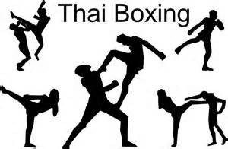
Muay Thai (translated) “Much Power” is a martial sport developed in the Asian country of Thailand. It is believed that Muay Thai derived from the combat art of Kabri Kabron. Like many martial sports today, Muay Thai is a safer version of its originating martial art. However, it is considered by many to be the most devastating form of stand up sport fighting because of its use of kicks, punches, head butts, elbows, knees, and throws.

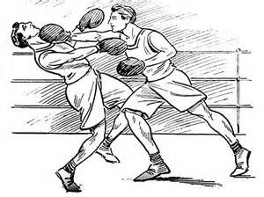
Western Boxing was formed from British and European pugilist (fist fighters) who developed a combat sport with rules and limitations to limit injury. Boxers are limited to using only their hands. The name “boxing” was coined because of the square, box like, ring that the contests were held in. Western boxing is a tremendously popular combat sport around the world.
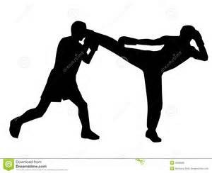
Kickboxing is an Americanized combat sport which adds kicks to the regular boxing repertoire. There are many variations of kickboxing all over the world. Some of these variations include rule differences that may allow throws, grappling, sweeps, and varied targets to the body. The origin of this art is unclear. Many countries and cultures have histories of kickboxing like martial arts dating back centuries to Asia, India, and Greece.

What you will learn:
- How to utilize your body mechanics to attack, defend, and evade your opponent.
- How to emphasize fitness and cardiovascular training as a means of martial advantage.
- How to seek and acquire offensive targets.
- To move in and out of technique ranges.
- To maximize speed and strength with correct body mechanics and techniques. Patch and Advancement:
The Muay Thai Kickboxing patch may be earned by participating in these special classes and/or seminars. The Muay Thai Kickboxing patch is to be worn on the ATF formal gi’’s left lapel just below the Kali/Silat patch. Advancement in Muay Thai, Kickboxing and Western Boxing will be accomplished though the JKD compilation curriculum by attending special classes and seminars and passing the exams.

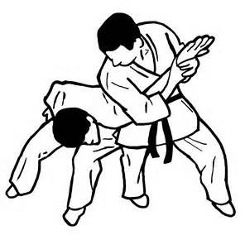
Grappling, Ground-Fighting
Grappling and Ground-Fighting is as old as man himself. In the JKD curriculum these martial arts are derived from Jiujitsu, Judo, Aikido, Hapkido, Pancration (Greek martial arts), Catch Wrestling (British martial arts), Free-style Wrestling, Shoot Fighting, and Panantukan (Filipino Grappling). These arts are taught in a self-defense and combat format which facilitates empty hands, weapons, and multiple opponent scenarios. Statistics prove that most physical altercations and attacks wind up on the
ground. Therefore it is essential that every martial artist know what to do when the fight does turn to grappling or ground-fighting.

Patch:

The Grappling and Ground-Fighting Submissions patch may be earned by special class and seminar participation. This patch is to be worn on the ATF formal gi on the left lapel just under the Muay Thai Kickboxing patch.

Advancement: Rank advancement in Grappling and Ground-Fighting may be earned by passing the compilation curriculum. Please note that this rank is separate from the Brazilian Jiu-Jitsu rank.

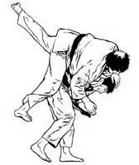
Jiujitsu/Judo
Jiujitsu (Translated) “The Gentle Way” is a Japanese martial art originated by the Samurai to fight armed and armored opponents on the battlefield. It utilizes throws, joint locks and chokes to incapacitate the enemy. This martial art is a favorite of law enforcement around the world in order to subdue vigilantes. Many Jiujitsu techniques were deadly and difficult to practice without harming the partner. Therefore, a man
named Jigaro Kano developed a sporting version of Jiujitsu named Judo. Judo utilizes safer versions of throws grappling and joint locking that may be practiced repetitively in order to perfect technique.

Patch and Advancement:

A Jiujitsu patch may be earned for your ATF formal gi by attending special classes and seminars. This patch is to be worn on the ATF formal gis left lapel just below the grappling/ground-fighting patch. Advancement in Jiujitsu will be earned by passing the martial arts cross training compilation curriculum.

What you will learn:

- How to subdue and control your opponent.

- How to manipulate joints and soft tissue.

- How to use locks and throws in combat.

- To use your opponents’’ momentum to your advantage

- To maintain your center of balance and leverage.

Brazilian Jiu-Jitsu:
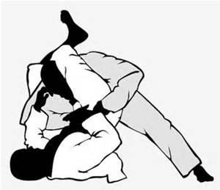
is a grappling martial art that focuses on dynamic body mechanics to control, counter, and manipulate your opponents’’ body. Brazilian Jiu-Jitsu (BJJ for short) originated from a Brazilian man named Helio Gracie. Mr. Gracie studied Jiu-Jitsu from a visiting Jujitsu and Judo master from Japan. Mr. Gracie used the techniques he learned and then refined them on the streets of Brazil. The result was a highly effective grappling system that has revolutionized the martial arts world.

Advancement:
Brazilian Jiu-Jitsu rank advancement is based on proficiency. This means that students only get promoted when they can actually perform techniques at a high level of skill while actually grappling. Student’s skills are evaluated by watching them grapple with other students and instructors. Below is a list of the techniques required for advancement to the first Brazilian Jiu-Jitsu belt.

Brazilian Jiu-Jitsu Blue Belt Curriculum:
Controlling Positions Sweeps
- Guard 1. Scissor
- Half Guard 2. Flower
- Side Control 3. Kimura
- Scarf Hold
- North and South
- Mount Takedowns
- S- Mount 1. Single Leg
- Rear Mount with Hooks 2. Double Leg
- Knee on Belly 3. Body Lock
4. Defense of Each Transitions Submissions
- Mount (From Guard, Mount & Knee on Belly, and escapes for each)
- Snake Move 1. Rear Naked Choke
- Half Mount 2. Branch-Up Arm Bar
- Side Control 3. Kimura (Branch –– Down Arm Bar)
- 2 Guard Passes 4. Guillotine (Standing and lying)
- 2 Half Guard Passes 5. Triangle Choke (Arm and Leg)
- Mount to Side Control 6. Baseball Choke
- Recovering Guard 7. Gator Choke
- Escaping Mount 8. Straight Arm Bar
- Escaping Guard
- Mount to Knee on Belly
Requirements: BJJ students must have at least one year of one hour training per week, a demonstratable proficiency of this BJJ curriculum, and possess and wear an approved Jiu-Jitsu gi.

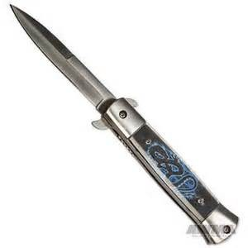
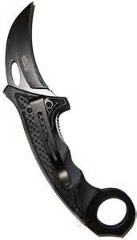
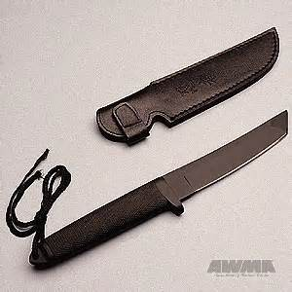
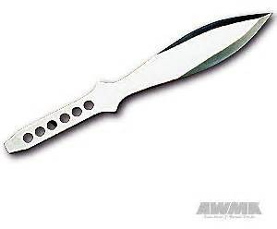
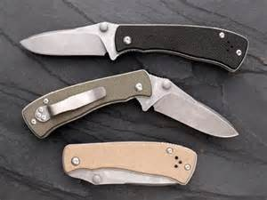

NOTE:
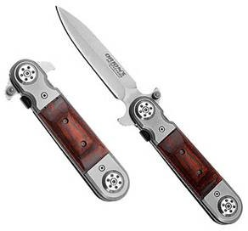
Street Carry Knife Training
will be offered to students over the age of 13 (with parental approval)

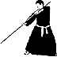
Addendum To Weapons Training Program
Here is additional information to supplement and standardize the ATF Weapons Training Program.

- Any student may participate in the Weapons Program however Purple Belt is the minimum rank allowed to actually work with weapons.

- Each student must first complete a Moo Duk Kwon assignment before being allowed to wear the Kubudo patch

- Students are required to attend regularly scheduled Kubudo seminars.

- After attending the Kubudo seminar and achieving the rank of 9th Degree Purple, the student should decide on a particular weapon with which to begin training. It is at this point in time, after completion of steps #1-#4 that the student is qualified to wear the Kubudo patch on the Gi lapel.

- At the next scheduled testing the student should formally request to begin training in that weapon. Permission must be given before any work with the weapon begins.

- The student should then research the weapon and write a short essay on the history and usage of that particular weapon.

- Next the student should begin practice and create a short hyung, form, (minimum 30 moves), submit text and present a physical performance of the form.

- Performances will be presented to a Review Board for critique, every four months on Belt Awards Night.

- Weapons practice will be separate from regularly scheduled classes and should not take away from work on TSD Test requirements.

- After presentation of the hyung to the review board, the student may choose another to begin working on and repeat the cycle.

- When enough students have become proficient with their specific weapon, we will have regularly scheduled inter-school weapons competitions.

- In addition to the Kubudo patch, students will be eligible to wear a patch for each weapon which the cycle is completed.
The general focus of this program is to stimulate the student’s continuing interest in the Martial Arts and more specifically to expand the overall understanding of the connection between weapons and empty hand combat training.

And FINALLY.....If you are taking Martial Arts Training for the physical conditioning benefits
and possible weight loss...here are 11 Nutritional Tips to assist you in your fitness program.
SOURCE : Peak Performance Sports Medicine

- Skipping meals or reducing your calorie intake does not help control weight in the long term. It is important to eat at regular intervals, ideally every 3-5 hours, as this helps to keep blood sugar levels stable.

- Most of us do not drink enough water. Symptoms of dehydration include dizziness, lack of concentration, irritability and headaches. Aim to drink 6-8 glasses of water a day and you will stay well hydrated.

- Your mother was exactly right when she forced you to eat your greens. We should be eating 5 servings of fruit and vegetables a day for general health. To allow your vegetables to retain as much goodness as possible, put them into a pot of boiling water and cook them quickly.

- Beware the hidden fat foods, which are normally those tasty party foods quiche, sausages, pork pie, salami and dips are some examples. Of course biscuits, cakes and desserts should also be kept to a minimum and only eaten as a special treat.

- When you buy yogurt go for low ‘‘live bio’’ versions. These help to restore the ‘‘good’’ bacteria that aid digestion.

- Bread, potatoes and pasta are all carbohydrate foods that have received bad press in the past. These foods do not make you fat on their own. However, if you have a big cheese sandwich, butter on your potato, have chips, or make a rich cream sauce for the pasta you will increase the amount of fat you are eating.

- Alcohol taken in moderation can be beneficial to health, but if you are watching your weight it is relevant to know that the calories from alcohol cannot be used as fuel for exercise, nor do they provide any vitamins, minerals or fibre.

- The butter versus margarine debate continues to rage. The best advice is not to eat a lot of either, but to eat a little of both. The best oil for cooking is Extra Virgin Olive Oil. It is not the cheapest but a little goes a long way.

- Dairy products are a high source of fat and cholesterol, BUT they do provide us with other beneficial nutrients. The best approach is to buy “low fat” versions of milk, cheese, yogurt etc. as they will provide you with all the nutrients without the fat element.

- It is not necessary to cut meat out of your diet. Instead buy the leaner cuts and trim off any fat. It is also recommended to eat oily fish (tuna, mackerel, herrings) at least three times a week as they contain the beneficial Omega 3 oil.

- Finally, whoever said “a little of what you fancy does you good” was probably right –– exercise moderation in all things and you can’t go too far wrong. It is not what you eat between Christmas and New Year that makes the difference but rather what you eat between New Year and Christmas.

Happy eating........and better training!.

Life Preserver On A Stormy Sea
During a lifetime, an average person may expect to experience some hard times. They may be spiritual, emotional, physical or financial but unless you are the luckiest person alive, you too will have your share. Some of these problems you may bring on yourself and others may fall upon you like a storm, whatever the reason doesn’t matter! You may be going through a divorce, or breaking up with your sweetheart, lost your job or have other financial dilemmas, lost your scholarship, or trying to survive the death of a friend or loved one. This is when you need to know that you have something that cannot be taken from you. You need, at that point in time, something to help you through these difficulties. Faith and prayer works well for some but others may need something more. Something more physical and something they can do to affirm that IT is still theirs and IT is that which cannot be taken from them! They need a life preserver to cling to until the winds die down and the seas calm. . At this point in your life you need calm, and stability, you need something on which you can depend to be an anchor, a point of reference from which you can gather yourself and begin your life again. In such instances the Martial Arts fit this scenario quite well
The knowledge you have gained through the study of and commitment to a Martial Arts program can sustain you. As a Martial Artist, you are the result of all the time, effort and sweat that you have put into your studies, and no one, or no set of circumstances, can alter that fact. Your skills belong to you alone and unless you choose to give it up, your knowledge, unaffected by outside forces, will remain unchanged and in your possession. A down block is a down block, an up block is still an up block and Geicho Hyung Il Bu is unchanging as it has been since its concept. You can lose yourself in your forms demanding perfection from your self at the completion of each one. You can visualize any person’s face on the heavy bag and punch until you drop, then get up and kick on it until you crawl from the training floor and straight to bed, then crash into a deep, much needed, sleep.
Speaking from a personal point of view I can attest to all of the above, for over the years, my Martial Arts training has revived me on more than one occasion. Since 1969, when I began my training, I have been forced to deal with three of the most devastating events a person should ever have to face. Being separated from my children as the result of a divorce, a failed business, and the death of a child. Although seemingly overwhelming, my Martial Arts training helped me through the first two ordeals, and served me well, but it was the death of my son Zachary, which brought me to my knees and made me turn to God. Perhaps you haven’t arrived at that point in your life, and I pray that you never have to deal with that situation, so it is possible that Martial Arts training will be all you need, As for myself I use both, training and faith, and carry them with me wherever I go. Like American Express advises, “I never leave home without it.”
Barring accidental death, you will probably live a long time and eventually you will experience problems, some small, others totally crushing and life shattering. How will you handle these problems? Do you have a Life Preserver?
Join a good Martial Arts School and train hard all week, you never know when a mishap will befall you and your training may save your life.
Then go to church on Sunday and give thanks for your many blessings! Fw 1996

ATF Instructor Profiles
The Black Belt Instructors listed below, represent 275 years of Martial Arts experience

Mr Fred Weeks 10th Dan......................... Founder, Master Instructor (46 Years)
Dr Keith Waggoner 9th Dan.............................Senior Instructor (25 Years)
Mr Robert Warden 8th Dan............................Senior Instructor (25 Years)
Mrs Janet Atkinson 5th Dan.............................Senior Instructor (36 Years)
Mr Rowdy Fortson 2nd/4th Dan.....................Advanced Level Instructor (30 Years)
Mrs Emily Boggs 4th Dan........................Advanced Level Instructor (19 Years)
Mr Chance Weeks 3rd Dan................................Instructor (23 Years)
Mr Range Weeks 3rd Dan................................Instructor (15 Years)
Mr Jason Boggs 3rd Dan................................Instructor (9 Years)
Mrs Tonia Fender 2nd Dan................................Instructor (11Years)
Mr Matt Noblin 2nd Dan................................Instructor ( 19 Years )
Mr Tom Johnson 2nd Dan................................Instructor ( 7 years )
Mr Mike Montgomery 1st Dan.................................Instructor ( 10 Years )

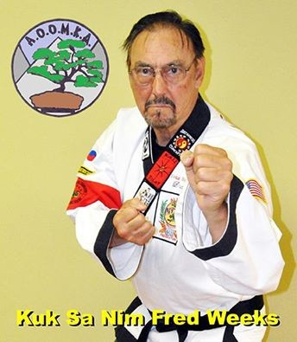
Mr Fred Weeks Founder 10th Degree(Dragon)
Former member of American Tae Kwon Do Assn, American Korean Karate Assn, American Tang Soo Do Congress, United Fighting Arts Federation, Chuck Norris System, Current Member and Advisory Board A.O.O.M.K.A. ,( founded by GM Tom Hunnicutt.)
Mr Weeks holds rank in four different Martial Arts, those being, Tae Kwon Do, Goju Ryu, Shorin Ryu and Tang Soo Do. His highest rank is 8th Dan in Shorin Ryu, and in 2002 he was presented an Honorary 10th Degree in recognition of 30 years instructing the Art of Tang Soo Do. His second 10th degree Certificate was awarded in 2008 by AOOMKA Founder Grand Master Tom Hunnicutt. He received his First Dan from Mr. Chuck Norris in 1978.

Much of what is now the A.T.F. System comes from the Norris System but it has become a more eclectic style with the addition of techniques from Goju and Shorin Ryu, Tae Kwon Do, American Kick-boxing, Jeet Kune Do Kali, Silat, Muai Thai, Chinese Grappling and weapons training. Although the A.T.F. Tang Soo Do system has been “Americanized” somewhat, the training and Dojang etiquette are very traditional, with respect and a proper attitude expected from every student.
Mr Weeks is a Fourth Generation Black Belt in the Norris System and his lineage may be traced as follows;
2nd Generation.........................David Douglas, Certificate #019
3rd Generation.........................D.T. Tip Potter, Certificate #098
4th Generation..........................Fred Weeks, Certificate #228 dated 9-17-78
4th Generation..........................Susan Weeks Certificate #267 dated 8-12-79 NOTE: Grandmaster Jae Chul Shin Dan#698 Korea/USA, trained directly under both Grandmaster Hwang Kee and Kim Yong Duk. He was promoted by Grandmaster Kee. Mr Chuck Norris was a student of, and was promoted by GM Shin . Chuck Norris Dan#2819

Dr Keith Waggoner 9th Degree (Falcon)
Keith Waggoner is a practicing Life Coach and Hypnotherapist and holds the academic degrees of Ph.D, D.Min., MSMFT, and B.S. He is an ordained minister and former K-9 Search and Rescue Officer. At this writing he has been married for 16 years and has two children.

Keith is the ATF Training Director and instructs us in the arts of Jeet Kune Do, Jun Fan Gung Fu, Kali, Silat, Krav Maga, KAPAP, Muay Thai Kickboxing, and combat grappling.

Mr. Waggoner holds the Martial Arts Rankings of: 5th Degree Black Belt- Allied Tang Soo Do Federation; 4th Degree Black Belt- Sung Kul Mae Martial Arts Academy; Level Three Instructor- Phoenix Martial Arts (Jeet Kune Do, Jun Fan Gung-Fu, Kali, Silat, Muay Thai Kick Boxing, Grappling Ground- Fighting); Level Two Instructor- Warriors Way Martial Arts; 1st Degree Black Belt- American Kickboxing Systems; 1st Degree Black Belt- Tae Kwon Do; 1st Degree Black Belt- Kubudo; 1st Degree Black Belt- Shorin Rhu; Expert Level One- Krav Maga; Expert Level One- KAPAP; Brown Belt- Judo; Green Belt- Aikido; Green Belt- Jujitsu; Blue Belt- Brazilian Jiu-Jitsu.
Here is a letter Dr. Waggoner wanted to share:

I began formal martial arts training on February 14, 1985 with my good friend and fellow martial artist William "Rowdy" Fortson. I grew up as a fan of Bruce Lee, Chuck Norris, and Bill Wallace. I always admired their skill and life-style of discipline. When I began training I expected to learn defense and skill. What I actually learned changed my life and developed my character, along with giving me expert abilities.

I received my first black belt in 1995. Since then I have trained non-stop either with instructors or by myself. I have been

privileged enough to learn from some of the worlds best martial artists and fighters. Since receiving my foundation at ATF I have branched out into the arts of Jeet Kune Do, Jun Fan Gung Fu, Wing Chung, Kali, Escrima, Arnis, Silat, Sayoc, Muay Thai, Bermise Boxing, Savate, Tae Kwon Do, Shorin-Ryu, Kubudo, Hapkido, Judo, Aikido, Ninjitsu, Small Circle and Weeping Style Jujitsu, Brazilian Jiu-Jitsu, Combat Submission Wrestling, Shoot Fighting, Boxing, Kickboxing, Krav Maga, KAPAP, and MMA.

I believe the Allied Tang Soo Do Federation Martial Arts Academy has a bright future. We have a solid past built on sound principles and outstanding leadership. Our lineage is distinct and provable and our founder Kuk Sa Nim Fred Weeks is a tremendous martial artist, leader, and Christian man. Since I was 14 years old Mr. Weeks has been a father figure in my life. He allowed me to clean the dojang when I was unable to pay tuition. I will never be able to repay him for his generosity, tutelage, and martial skill.

I am proud to be a part of the Allied Tang Soo Do Federation. I highly recommend it to anyone seeking a martial art steeped in Korean discipline and tradition yet with American openness and opportunities to train in martial arts from around the world. Adults and children alike will benefit from ATF's regimen of fitness training, character building, and life skills learned through the martial arts.

Robert (Bear) Warden 8th Degree
I was born in Walnut Ridge April 4, 1954 went to high school in Walnut Ridge as well as Castle Heights Military Academy in Lebanon, Tn followed by obtaining a Associate of Science in Mortuary Science
in Nashville, Tn..

I”m married to Gayla Ann Ellis Warden, December 28, 1973, who is a Second Degree Red Belt, who was injured during her testing for First Degree Red Belt ending her martial arts career. We’ve two Children: Amanda Michelle Warden, First Degree Black Belt, and a son, Robert Christopher (Chris) Warden, First Degree Black Belt.
I was awarded my First Degree Black Belt Oct 90. I am presently a 8th Degree Black Belt that was awarded Dec 08. I also hold a Honorary 8th Degree Black Belt Awarded and Approved by an association of four Martial Arts Schools, home based in Little Rock, Arkansas: Waggoner Martial Arts Academy, Little Rock, AR.; South Region of Phoenix Martial Arts, Little Rock, AR.; Kijono Judo Academy, Little Rock, AR.; Drings Living Defense Martial Arts, Little Rock, AR..
Presently I hold the position of the ATF Martial Arts Authorized Signature as well as head chair on the majority of test boards for ATF. Due to past and present health concerns, I do not attend regular classes and only sit the Test Board when required to do so. Martial
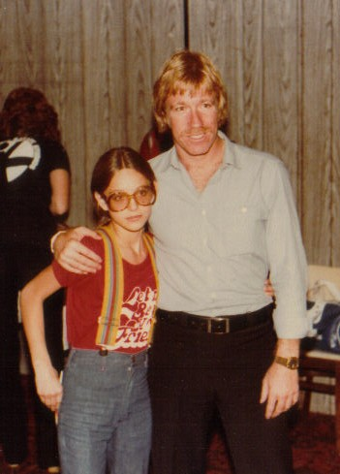
Arts has been a major part of my adult life, starting my training in 1986 with my wife and children joining ATF following my promotion to First Degree Black Belt in 1990.

Janet Atkinson 5th Degree (Cobra)
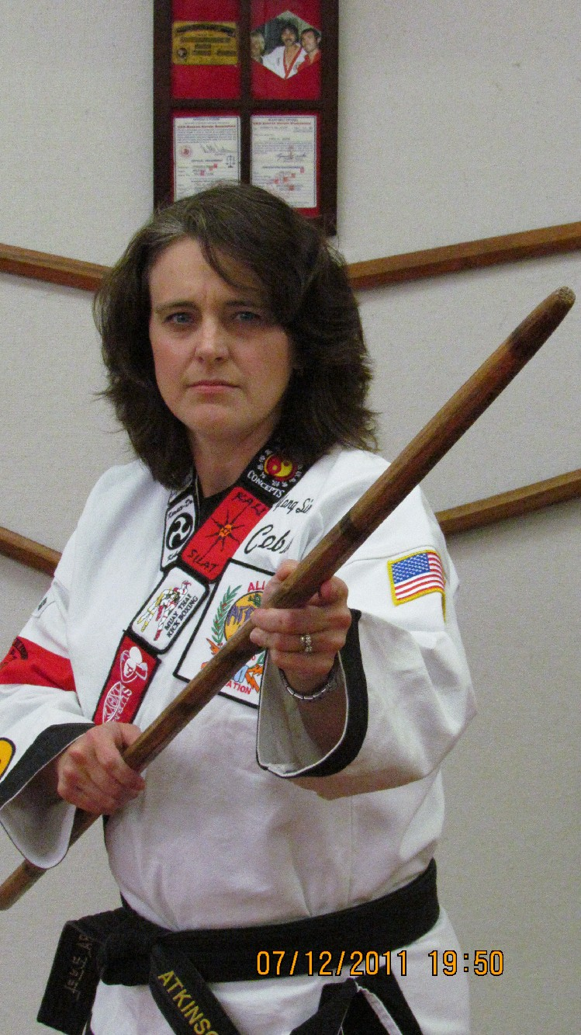
P icture at right with Chuck Norris in 1980

I am Janet Harp Atkinson, known as Cobra in ATF.
I began my martial arts training in January 1978. Yes, I said 1978. That was 37 years ago. I have been around nearly as long as Mr. Weeks.
I had the privilege of being trained by Mr. and Mrs. Weeks. I graduated from Hoxie High School in 1984 as salutatorian. I began college at
Arkansas State University in June of 1984, and tested for my 1st degree Black Belt in July of 1984. I hold certicate #5 in ATF. I graduated from Arkansas State University in December of 1990 with a BSE in Education. I have been teaching in the Hoxie School District for the last 26 years. Teaching children gives me great joy, whether I am in a traditional classroom or in the

karate dojo.
During college, I drifted away from classes, got married, and had two children, Katelyn and Jake. But ATF was never far from my heart. I always knew I would find my way home. Mr. Weeks never gave up on me. I returned to classes several times through out the years, but I returned full time in May 2007, and this time I brought my daughter, Katelyn with me. I received a 3rd degree Black Belt in September of 2007. Since returning to classes I have enjoyed taking part in the many Demos that ATF has been a part of, including the Freedom Demo Team.

Over the years I have seen the location of the ATF dojo change 3 times. What is ironic, all 3 locations have been within 1 city block of each other. Also, in my many years with ATF I have seen many students walk through the door of the dojo. Some with natural, God-given talent; some with the determination of Job; others that you knew would not be back after the 1st night's workout. ATF is a family. Once you become a member, you always have a home there. But one thing is for certain, for those that have the staying power, for those that have the determination, for those that have a fire burning within to learn; the door of the dojo will be open and an ATF instructor will be there to teach. That door will continue to be open for all, but especially to those with the character to finish what they start.

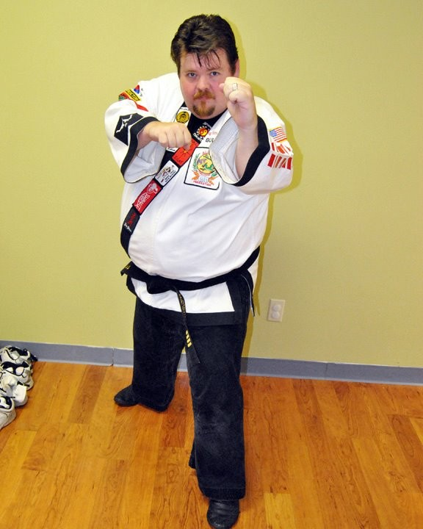Mr Rowdy Fortson 3rd Degree (Bull)
My name is William T "Rowdy" Fortson II. I am known to the ATF family as "Bull." I began training in Tang Soo Do February 14th, 1985. My first night was accompanied by Mr. Waggoner. I began my martial arts career as the overweight kid who was looking for something athletic that maybe I could actually do. Little did I know that I was starting a life of learning about self-defense. After a few years of study I took some time off from the ATF. I returned, then was forced to sideline again. I then return in 2004, and achieve first degree Black in 2006. A second degree in 2008.

During my times off from the ATF, I still loved the martial arts. I studied Kempo, and Pang Gai Noon. Since returning to the ATF, I have also focused on gaining knowledge in Kali, and have ranked as a white belt, second kyu, in Brazilian Jiu Jitsu. I am also now a Level 1
Instructor in Krav Maga. I am a former President of the ATF Black Belt Board, and have written articles for the current Blue Book for the system. I am an active instructor at the ATF Martial Arts Academy, and an assistant instructor to Mr. Waggoner for the extra curricular material in Moo Duk Kwan, Kubado, Lee Jun Fan Jeet Kun Do, Kali, and Muy Thai.
During my off time I am a high school art teacher in Harrisburg. I hold an Associates degree from Crowleys Ridge College, a Bachelor's degree in Art Education from Williams Baptist College, and a Master's Degree in Education from Arkansas State University. I am also a minister for the church of Christ, and a Chaplain for the Jonesboro Police Department and the Harrisburg High School JROTC. I am a musician who plays the Guitar, Bass, Drums, Mandolin, and a little banjo. My wife and I are perpetually in bands that range from Bluegrass to Classic Rock. I also travel across the state, training teachers in discipline management.

I am married to Harmony (White) Fortson. She is a classically trained Opera Singer, who holds a teaching certificate in both choir and band. She is now a stay at home mother who runs a Piano/voice studio out of our home. I currently have a 4 year old daughter named Aria Bella, and another on the way. We live in Jonesboro, Arkansas and have for 13 years.

My martial arts philosophy is that I train so that I might be able to protect my family, my beliefs, and the ideals of life that we hold precious. I pray that my training will never be needed or called upon, but it is my responsibility to train as if I need them always. NOTE: Mr Fortson is currently on sabbatical due to health issues but we anticipate his eventual return to active participation.

Mrs Emily Boggs 4th Degree (Serval)
My Name is Emily Boggs I am 24 years old and currently am a 2nd degree Black Belt. I began my training in August of 1996,when I was ten years old. My first night wasn't what I expected, I didn't realize that there was so much detail, but I

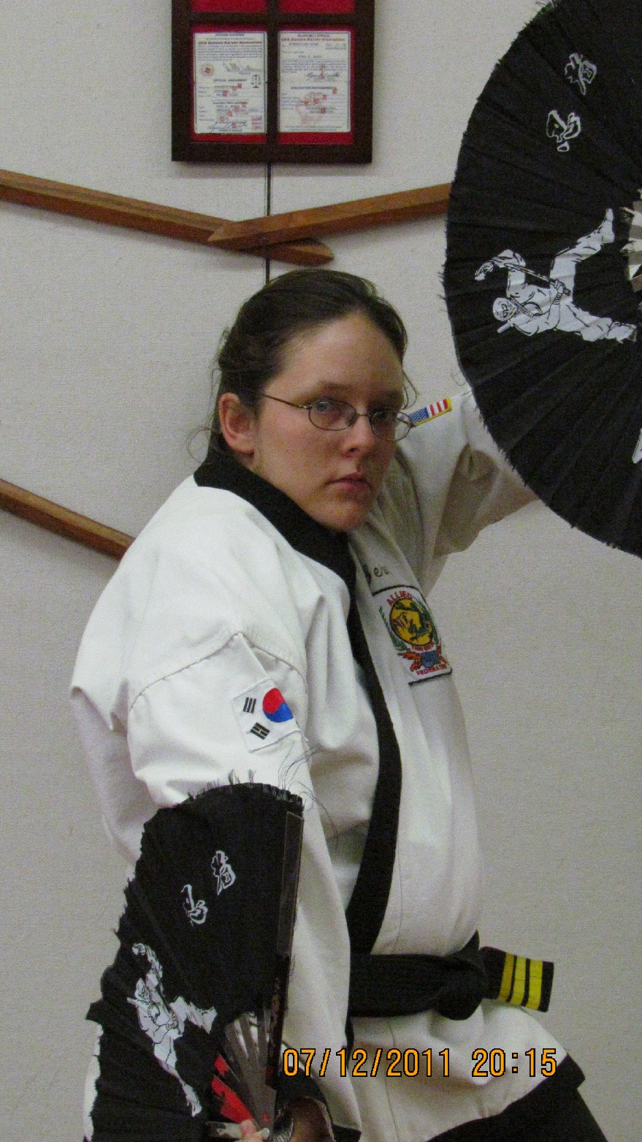
am glad I kept at it. Not only did I learn routine things like how to block, kick, and punch, I learned respect, values, take pride in what you can do, these things I use every day at home or at work. I grew up in the ATF with Mr Weeks.
I received my first degree Black Belt, on September 13th 2003,my senior year in high school. My second degree came on April 24, 2007. I have experienced many things in my years here, I've watched my mom receive her green belt, I've watched my husband come up through the ranks, and his 1st Degree Black Belt. It's had ups and downs, happy and frustrating times, but it's made me who I am today.
In the future I hope that the ATF will be even more successful than it is now, I can see more schools branching out, and teaching martial arts to people from all walks of life.
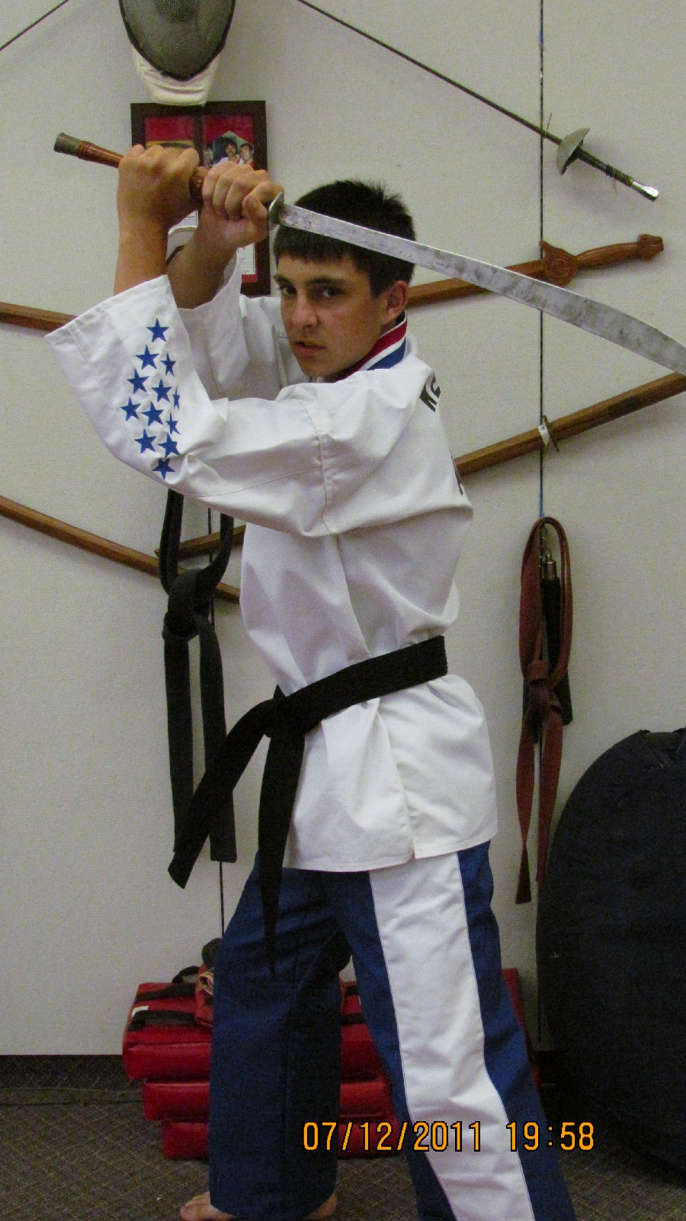
The ATF system is not something that you'd see in the movies where everybody is perfect and never makes mistakes, we are real, we put in "Blood ,Sweat, and Tears". I feel that our system holds more knowledge than the local library. In the future I think we will still be the same, with maybe a few advancements but we will still be cranking out top martial artists. Member of First Place Demo Team 2001.

Mr. Range Weeks 3rd Degree (Cobra)
My name is Range Weeks and I am 15 years old. I have been with the Allied Tang Soo Do Federation for 10 years, I began training shortly after my 5th birthday.
I currently hold the rank of Jr. 2nd Degree Black Belt, which I received August of 2008. When I reach the age of 16, I am eligable to test for the rank of Sr. 1st Degree.
I couldn't see myself without the martial arts, or the Allied Tang Soo Do Federation. It has been almost like a second family, and I love that about the ATF school. Within the ATF, I really enjoy working and instructing. I feel that I work best with students around my age group and up, but working with young students is fun and exciting too.
I plan to continue my martial arts training until the day I die. There is a wealth of knowledge out there and I believe that knowledge is one key to living a safe lifestyle. I take pride in our school for how structured it is. If you don't understand something, you can go to numerous people who are willing to take the time to help you understand to your fullest potential.

I highly recomend the ATF to any student who is looking to study the martial arts. They will benefit in numerous areas of their lives.
NOTE: Range is now 20 and currently attending the University of Arkansas. He is inactive on a regular class basis, but still returns for School Testings and Special Events. While active he was KEY in developing many of the Advanced Techniques and Hyungs which are currently being taught. His expertise and particular skills were invaluable to the growth of ATF during his active participation. Member of First Place Demo Team 2001

Mr Jason Boggs 3rd Degree (Silverback)
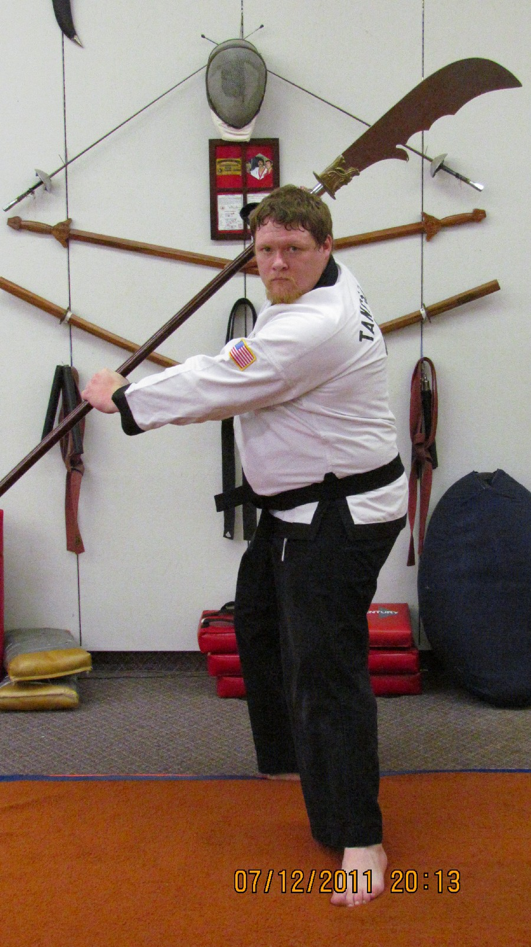
In our martial arts school I’m know as Silverback or Mr. Boggs, while the rest of the world knows me as Jason Boggs.
I started my training in the A.T.F. system in June of 2006 at the age of 21 without any previous training. At the time of this writing I have earned my 1st degree Black Belt with A.T.F. (November 8, 2010) and a white belt fourth kyu in Brazilian JuiJitsu. I also have training in Jeet Kune Do, Jun Fan Gung Fu, Moo Duk Kwan, Escrima, Arnis, Silat, Sayoc, Muay Thai, and Krav Maga through our training director Dr. Keith Waggoner.

I have been happily married to my wife, and fellow A.T.F. Black Belt, Emily since the 8th of May in 2006. We have one son named Stanley Monroe Boggs who I see attending classes very soon. He is only 4 years old at this time; otherwise he would already be in there! My brother and sister have also started training, and I hope to see them earn their Black Belts some day.

The A.T.F. system has been home to quality martial arts training for forty years, and will continue to be for years to come. The system has begun training in other styles to better suit our students and their training for self defense. Mr. Weeks has always told us that, ‘No one

technique works 100% of the time,’ so under his guidance the extracurricular material has been adopted. While also being an instructor of A.T.F. curriculum, I also am involved in expanding our training by keeping the Brazilian JuiJitsu training going.

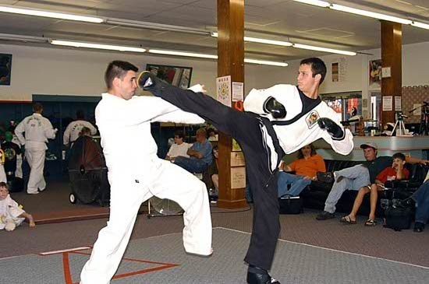
While I have a wonderful family by genetics, I am blessed by God to be a part of the A.T.F. family with Mr. Weeks as the head. The friendships that I have made will last me my lifetime and I hope my son’s lifetime as well.

Chance Weeks 3rd Degree (Komodo Dragon)
Chance is currently a 3rd Dan who began his training at in 1992 at age 5. Chance received his 1st Dan before he graduated from High School and remained an active Instructor until his graduation from The University of Arkansas with a degree in Mechanical Engineering. His job now takes him all over the country but he still returns occasionally to participate in School Testings.
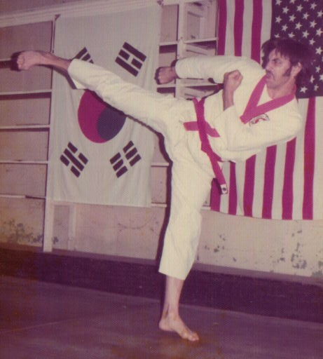
He is responsible for training many ATF students who grew under his watchful eye. He and his contributions were a vital part of ATF’s growth during his years of participation.
Chance Weeks 2005
Chance was a Member of the First Place Demo Team 2001. He is greatly missed
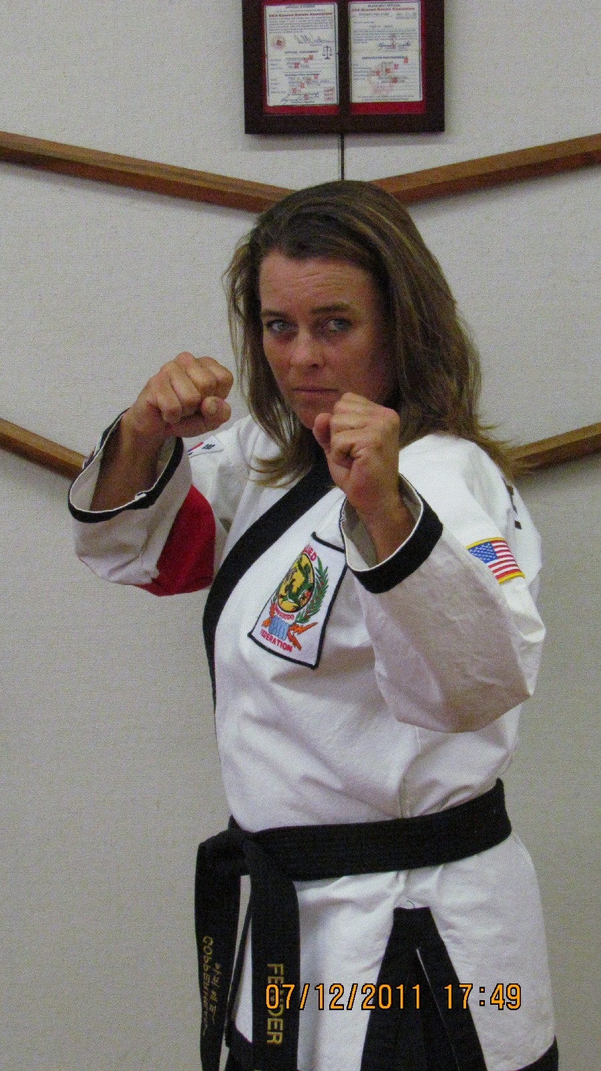
Fred Week s 1973 Any similarities between the two kicks?

Mrs Tonia Fender 2nd Degree (Copperhead₎
Hello, My name is Tonia Fender. I am 40 years old. I started my training in ATF in January of 2004. My children started and I got tired of sitting and watching them and decided this is something we can do together. I earned my 1st degree Black Belt on August 2, 2008 a day before I turned 39. It was the best birthday present I could have recieved. Now 6 years after I joined my ATF family I hope to watch my daughter take her 1st Jr. Black Belt test this spring. I think that every girl or woman should have martial arts training so they have a better chance of protecting themselves.
I have made friends that will last a life time and will make more as the years go by. I hope to keep training in the martial arts for many years to come. Copperhead

Mr. Tom Johnson 2nd Degree “Phoenix”
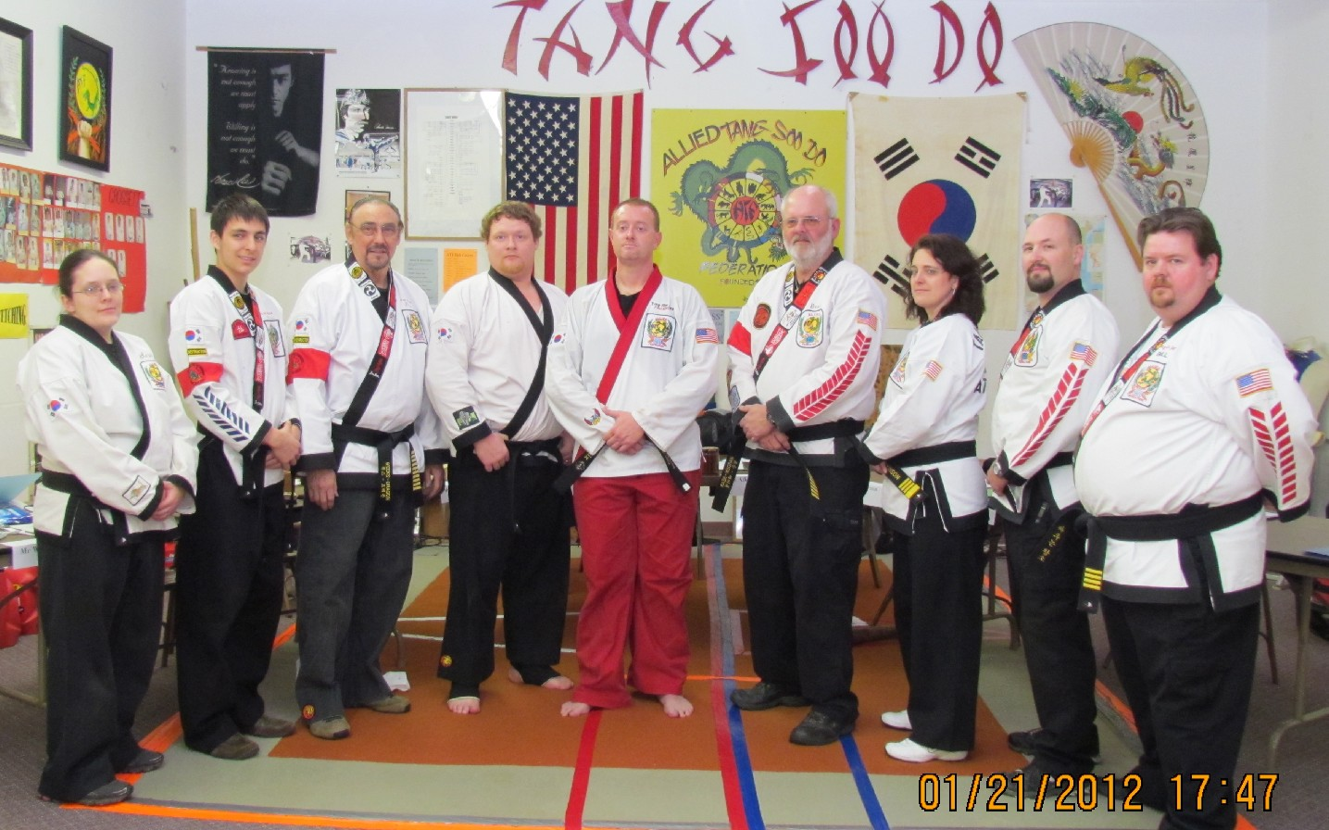
At the occasion of his promotion to 1st Dan
Member of ATF since 2008 and received his 1st Dan in 2012. Tom is a Fireman who faces life threatening situations on a daily basis, where timely decision making is a matter of survival. “Thinking on your feet and the ability to make quick, accurate, on the spot decisions,” is just one of the attributes that Mr Johnson brings with his instruction. He is married to his wife Jocelyn and has two sons, Jared & Kyle. Tom and his family live in Jonesboro.

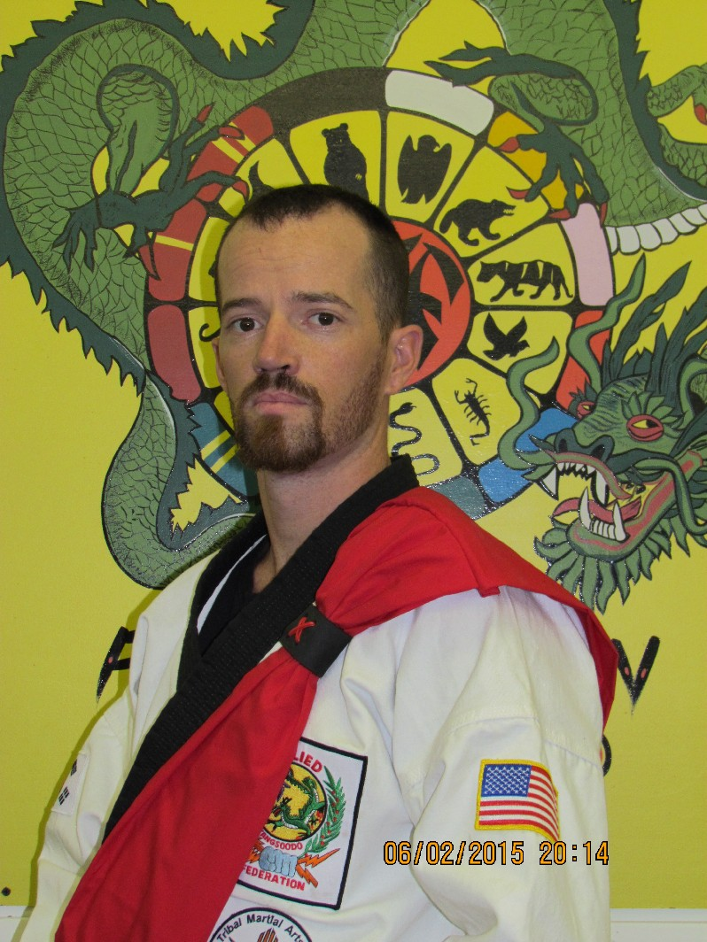
Matt Noblin 2nd Degree (Leopard)
My name is Matt Noblin and my Fighting Name is Leopard. I began my training in Tang Soo Do in 1996. I received the coveted “Dragonheart Award” in 1999 when I skipped rank and was promoted from 8th Orange to 6th Green. It took a long time for me to get from Green to Black. I took several years off from training when I moved out of state, but when I returned I immediately returned to ATF for training. I received my 1st Dan ion February 2013.
Some of my accomplishments in addition to Dragonheart, were Member of 2nd Place Demo Team in 2000, Member of First Place Demo Team in 2001, The last tournament in which I competed I was awarded 1st Place in Forms, 1st Place in Weapons and 1st Place in Free Sparring.
I love KICKS...almost as much as Mr Weeks does and I have dedicated myself to become the best kicker I can possibly be. Bruce Lee once said...”Be Like Water”.....”it can be solid like a mountain and it can be smooth like a new car” My kicks are fierce and solid like the mountain but like the Leopard......smooth and quick as a new car! Demo Team 2001

Mike Montgomery 1st Degree (Mustang)
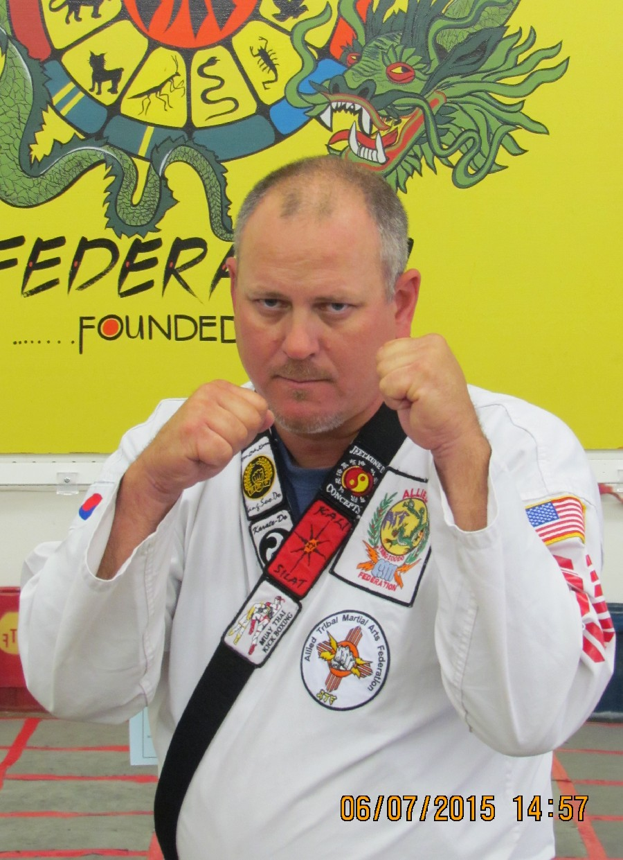
I started training on March 25th 2006. Attained Black Belt in February 2015 at the age of 45 years.
Married since 1998. Two daughters Macy age 14 and Sydney age 11. My wife (Shania) and youngest daughter ( Sydney) are both active members of ATF and each currently hold the rank of purple belt.
I am an army veteran having served in Desert Storm and currently live in Jonesboro, AR.

Grand Master Tom Hunnicutt
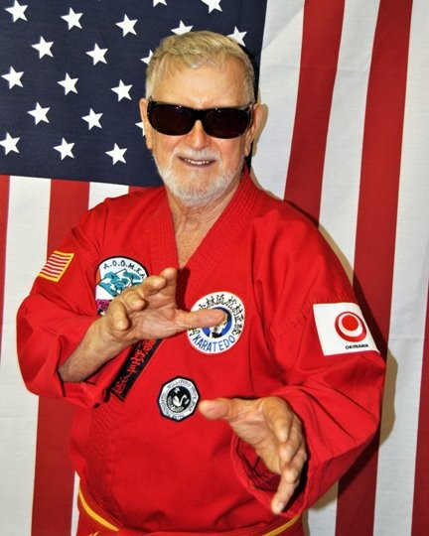
Founder AOOMKA (All Okinawan Ozark Mountain Karate Association)
GM Hunnicutt is a long time friend and Mentor of ATF Martial Arts. He holds ATF Certificate #53 and is on our Advisory Board as Supreme Advisor. His training dates back to mid 60's in Okinawa where he trained with Shorin Ryu Legend Grand Master Hohan Soken. He founded AOOMKA in 1992. His advice and guidance has been a blessing over the years in the development of our Martial Arts System.

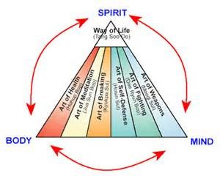

The Mountain
Once upon a time there was this big mountain just outside the village and for many years...the townspeople would wake up in the morning , look at the mountain and say to themselves..."One day I'm gonna climb that mountain"....everyone in the village at one time or another would say to themselves or a friend...."I'm gonna climb that mountain...SOMEDAY"! But they never did....Meanwhile...the mountain .....with the effects of the elements...wind...erosion....etc...slowly disappears into the landscape......
When the mountain first appeared, the people were afraid to go near it, for it was foreboding the clouds hung over it like shrouds of mystery. The clergy spoke about the evils awaiting folks if they ventured too close to the mountain, so they looked at it from afar and wondered about it for many years. Finally a few brave and stout-hearted souls threw caution to the wind and defying tradition began a quest to the top of the mountain. After their success, others....seeing that the mountain could, in fact, be climbed, followed in the footsteps of their predecessors and began their journey. Along the way they experienced difficulty and sometimes ridicule from the townsfolk who didn’t understand, but they too triumphed, and upon reaching the first peak, felt a sense of accomplishment never before experienced! Soon, everyone was talking about the mountain and it was seen as not foreboding ......but recognized as challenging!
Those who wanted to climb the mountain, but never did....let the moment pass....AND OF those who did climb the mountain ....feeling that the FIRST PEAK was high enough....MOST never tried for the summit. A few who did were ill prepared and fell into the valley ....never to attempt the climb again.
Over the years there has been many climbers...of all ages...The little ones begin their training on very gentle slopes which get progressively steeper as they mature and gain experience, older climbers begin their ascent immediately. As they climb, the young and old alike ...the young as they mature, the old as they age, begin to realize that there is more here than just climbing a mountain. There is camaraderie as they meet other climbers along the way.... and they become family while they lend assistance to each other during difficult periods of the climb. They look for and find, those little ledges on which to stop and rest..... and gather strength to continue. They become self sufficient as they check, and double check, the necessary knowledge and tools to continue in their quest for the summit.
They discover that in climbing the mountain a person experiences every possible human emotion and learns to cope with the negative ones replacing them with confidence and self-assurance. The positive effect of the struggle for survival on the side of that mountain, sometimes hanging only by a very thin rope, will provide the climber with many smiles and happy memories of success in later years as they reminisce about the “good old days”.

The Mountain contd
To the many...many...many of you who have climbed on the mountain for these many...many...many

years...I will say it has been a pleasure to know you ...
To those of you who got tired and stopped along the way I will say “I wish I could have gotten to know you better.”
To those of you who have made the long climb to the first peak, I have enjoyed your companionship and I would remind you that there is always another challenge awaiting you.
To those few who have matched me step for step up ...always upward.....even though sometimes the crest is sometimes hidden with clouds...we know it is there......and let us continue together....we never know who will show up at the top! The mountain is still there..... but undeniably the elements have taken their toll.....It still is on the landscape ...but who knows when one last sandstorm will finally erode all that is left ...and it WILL sink into the horizon.
I really do not immediately foresee the final setting of the sun ... but who knows......
If you really want to see God laugh, just tell him your plans!

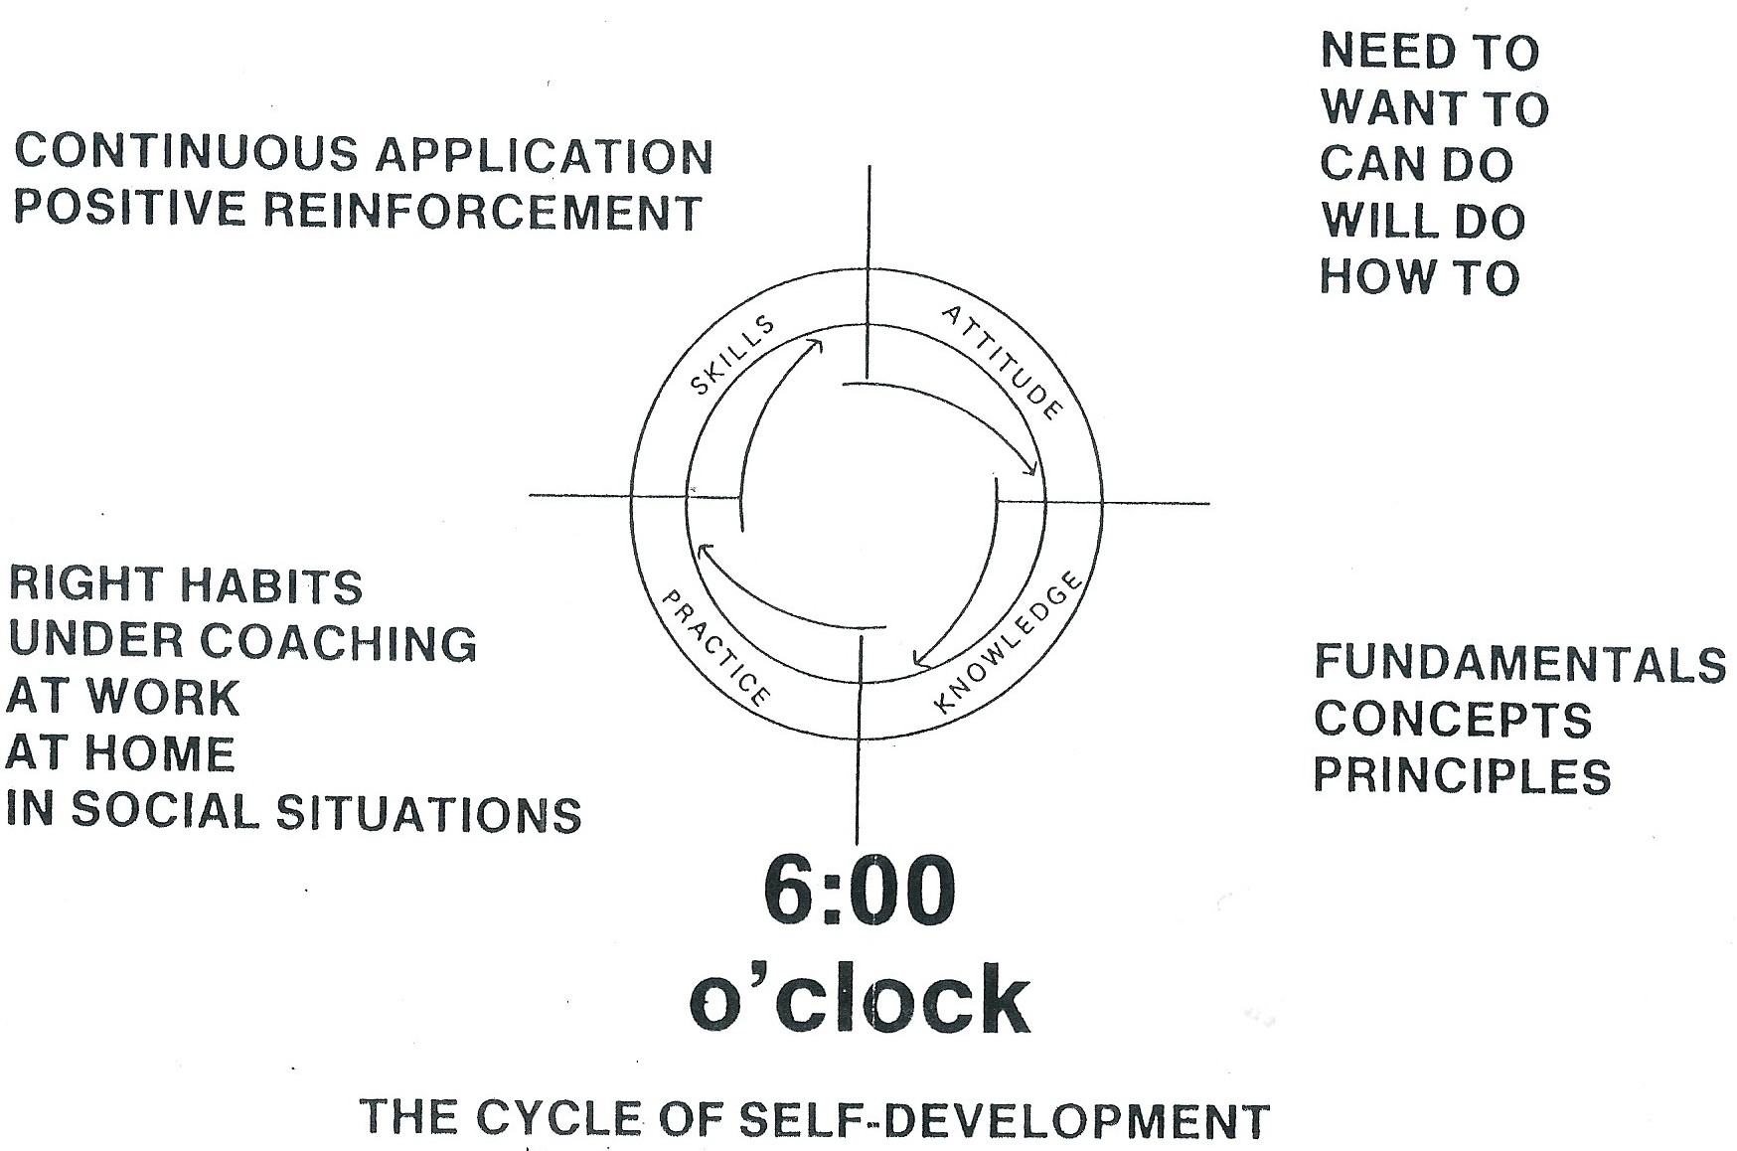
The Learning Process

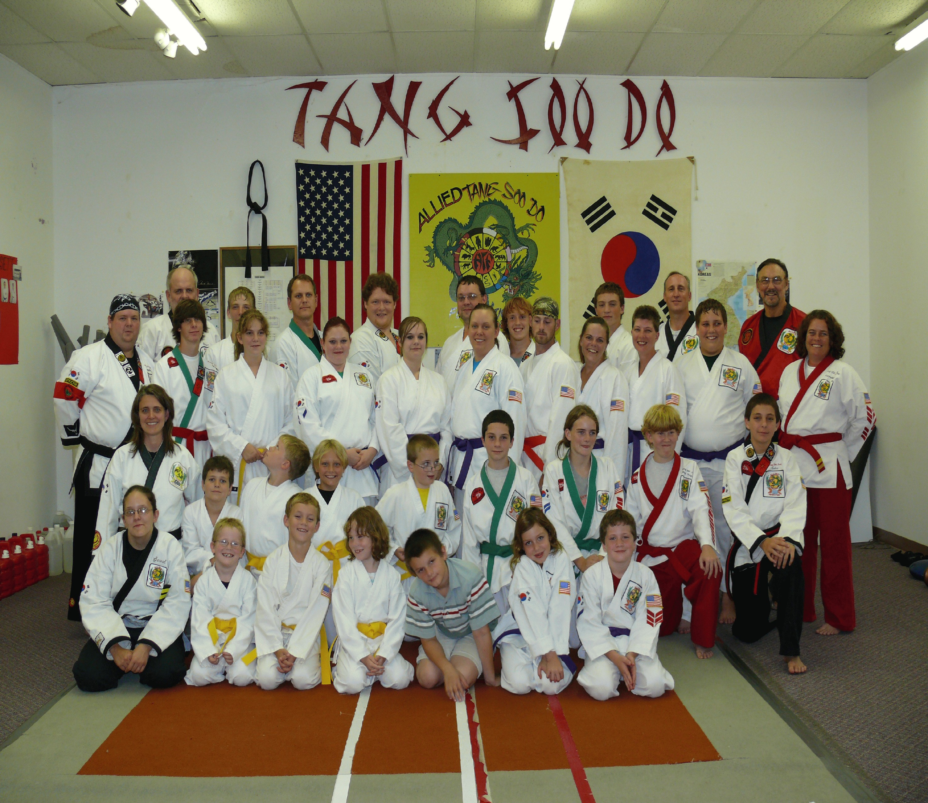

August 2007 Testing of ATF students
“We can never become, what we are supposed to be, by remaining what we are.”
This is the ninth printing (June 2015) of the ATF Training Manual and it has grown and gotten larger and better and more complete, with each printing. There are many measures for success. To some it is wealth and fame and to others it is simply a sense of accomplishment.. I allow myself to indulge in that feeling of accomplishment when I think back to the beginning of my Martial Arts experience, and I see how I have progressed as an instructor and grown as a person. And when I do, I realize that this, and all the friendships I have developed over the years, would not have been possible, except for my loving wife Susan, who has not only supported me but has encouraged and challenged me every step along the way. Every man should be so lucky. Several times over the years I have considered quitting and putting my time to other matters, but she would have none of it! The building we are in today is a result of her not allowing me to quit, when we moved from the old school, and urging me to find something better. The twenty-plus ATF Black Belts mentioned in “The Journey” would not be ATF Black Belts! All the folks we have helped with our fund-raising efforts, would not have had our help, and the thousands of kids who we have instructed over the many years would not have known about something better than what they had. Many of these kids needed something better in their lives!
This book which you have just read is a result of Mrs Weeks intervention on your behalf! It is fitting that on this last page, the final dedication of this book is to my loving wife Susan, who Co Founded ATF Martial Arts .....soooo long ago. Fw

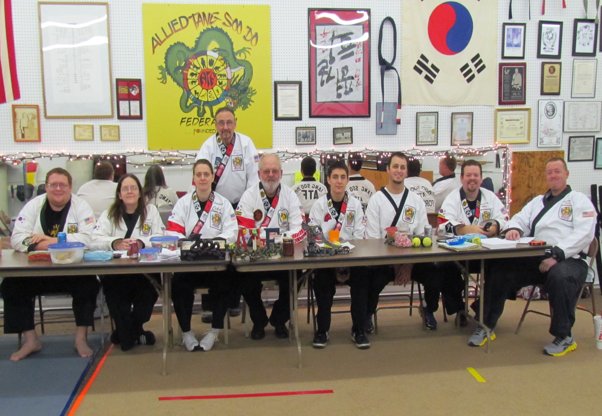
ATF Test Board
August 2014
Each person in this picture has contributed in some way to the growth of the ATF System. Each has left their own special impression on the students they have instructed for so many years.
Even more than.... Instructors, Comrades In Arms, Fellow Black Belts and Friends..................
We are...........Brothers & Sisters
.........Family!
Founders and Sustainers of ATF Martial Arts Since 1980

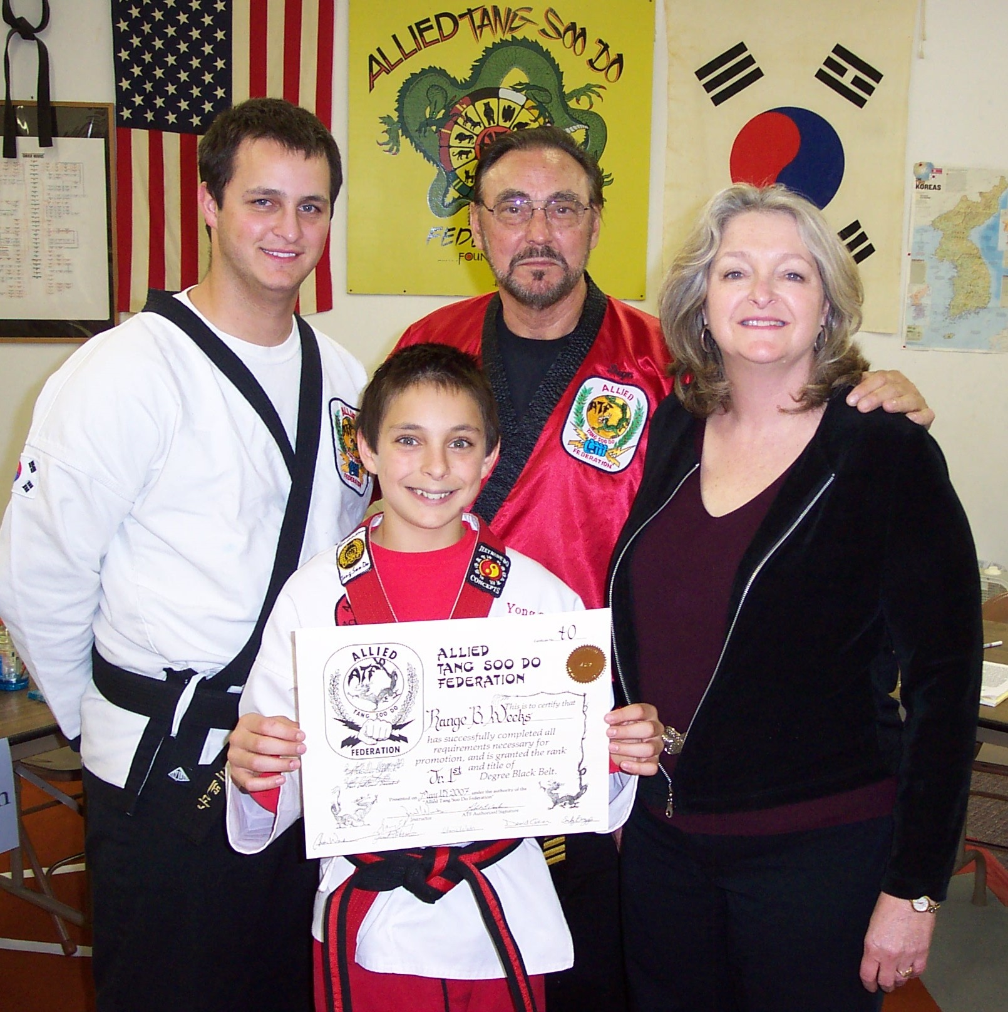
Fred, Susan, Chance & Range Weeks
Picture taken in 2007, at the completion of Range’s Junior Black Belt Exam.
Without the support and contributions of my family, ATF Martial Arts would not be what it is today.

Items #11 & #12 of the ATF Code Of Conduct...............
  - Commitment
  - Dedication & Loyalty

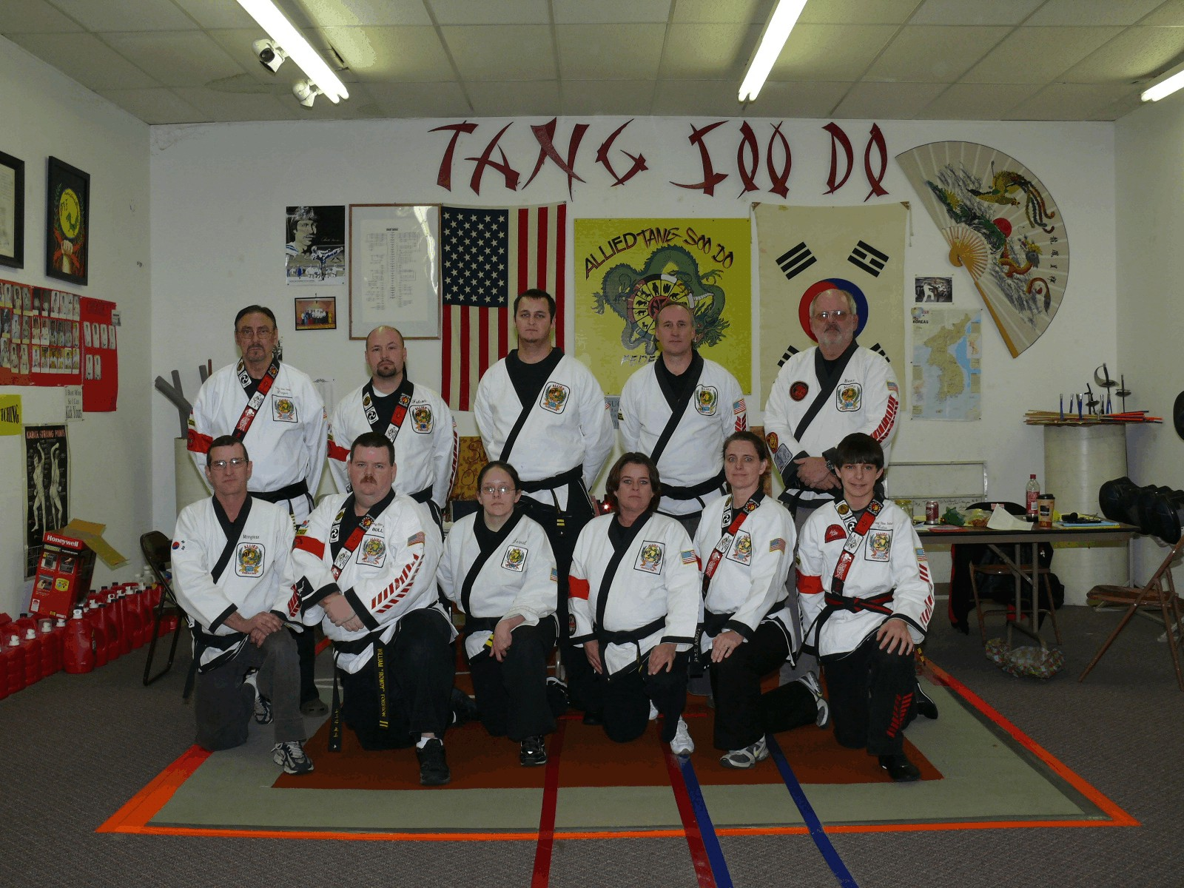

Active ATF Black Belts 2009
L-R Back: Mr Fred Weeks, Dr Keith Waggoner, Mr Chance Weeks, Mr David Coker, Mr Robert Warden,
Front: Mr James Kapales, Mr Rowdy Fortson, Mrs Emily Boggs, Mrs Tonia Fender,
Mrs Janet Atkinson, Mr Range Weeks
“Grow strong, my comrade … that you may stand
Unshaken when I fall; that I may know
The shattered fragments of my song will come At last to finer melody in you;
That I may tell my heart that you begin Where passing I leave off, and fathom more.”

Will Durant, The Story of Philosophy

“A teacher presents the past, Reveals the present,
And creates the future”

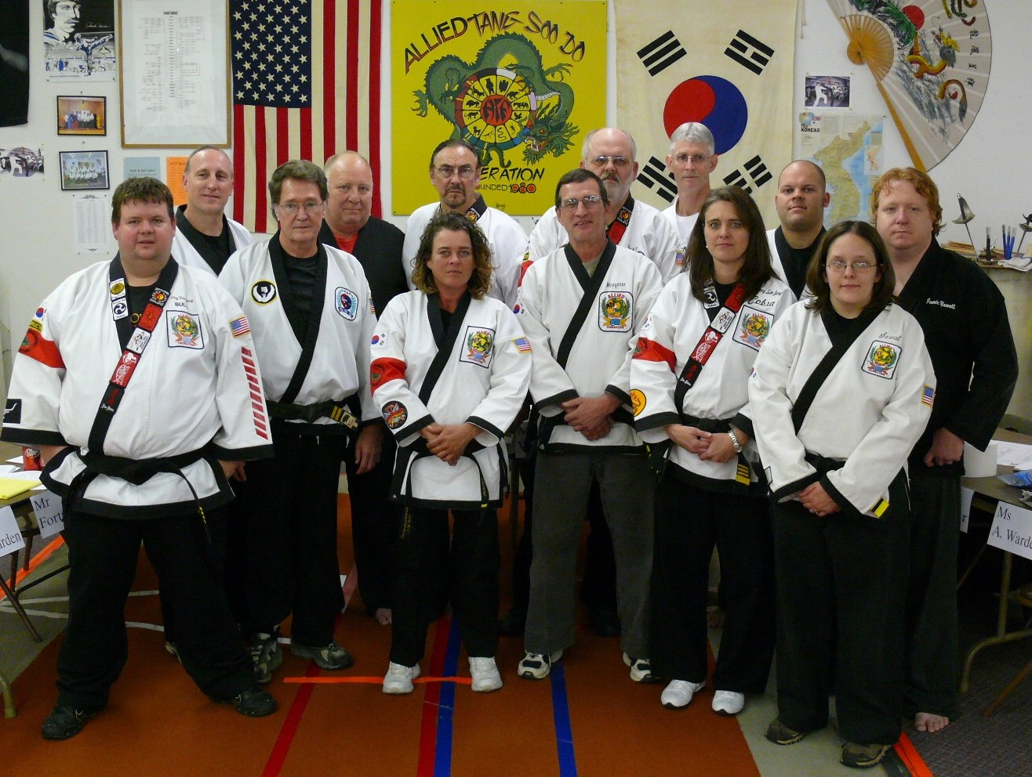

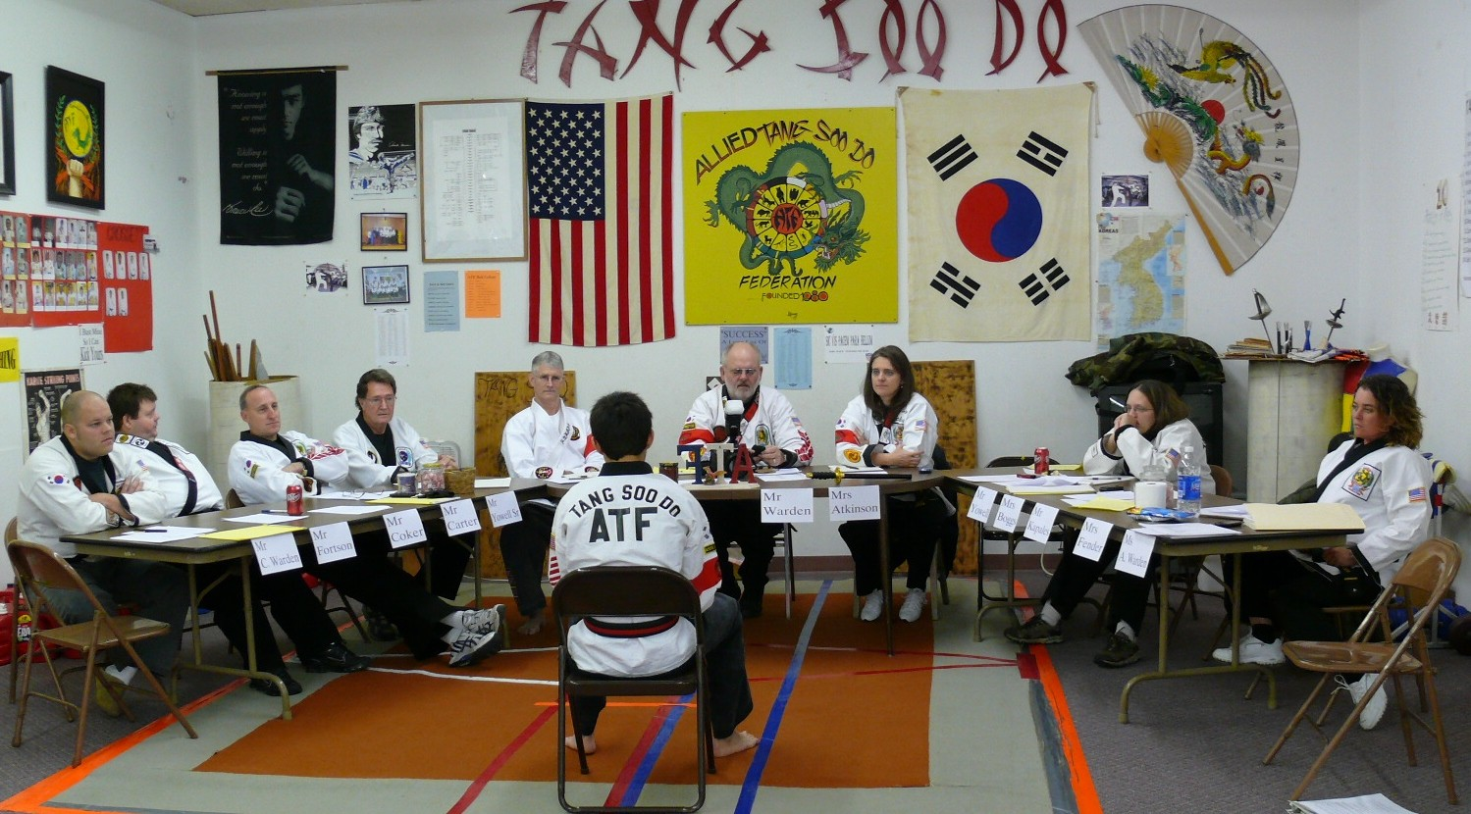
Range Weeks, Oral Exam Black Belt Test 2010

2010 Black Belt Test Board
At the occasion of Range Weeks Testing From Junior to Senior Black Belt Rank
L-R Mr Rowdy Fortson, Mr David Coker, Mr Tom Carter, Mr James Yowell Sr., Mr Fred Weeks, Mrs Tonia Fender,
Mr Jim Kapales, Mr Robert Warden, Mr Gary Ring, Mrs Janet Atkinson, Mr Chris Warden, Mrs Emily Boggs, Mr Jamie Yowell

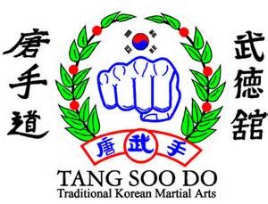

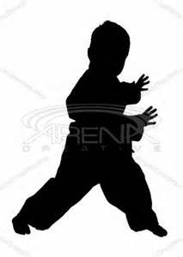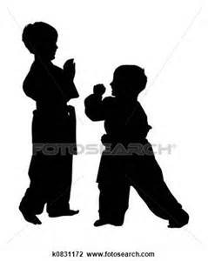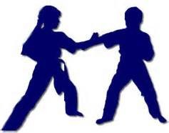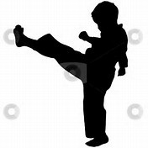ATF Children’s Programs
Martial Arts training is widely recognized as one of the most complete training regimens for a total body workout.
In addition to learning an effective method of self defense, the strength training, cardio routines, stretching exercises and coordination drills provide a child with physical abilities which enhance any other sport in which he/she participates. ALSO: No Child Sits On The Bench or In The Dugout watching others play!

In addition to training in traditional Martial Arts, our young students are drilled on “Stranger Danger Scenarios” which will help them avoid potentially dangerous situations and how to react should they need to protect themselves or escape from an attacker.

Youth Ranking System
Children age 5-12 should expect to be promoted through the Proficiency levels as explained on Page 13. Generally children do not have the attention span, or the ability to grasp the higher level concept of Martial Arts Training. Nor do they completely understand the urgency and immediacy of Self Defense Training. Plus....the safety measures involved in training, which adults immediately recognize and understand, require more time and more positive reinforcement with children. This leads to a more efficient ranking system that insures that the student thoroughly understands all the requirements for promotion at each testing. Since they will not test for Junior Black until after their 12th birthday, there is no need to rush them through the colors.
Our Primary Children’s Instructor, Mrs Janet Atkinson, is a highly qualified Martial Artist who began her training in 1978 and currently holds the rank of 5th Degree Black Belt. She is a well seasoned Elementary School Teacher with 26 years experience in the Public School System. However, all ATF Black Belts are well qualified and experienced Instructors. See Instructor BIO Page #61)

Parents can rest assured that when their child is trained at ATF Martial Arts, he/she is receiving the very best training available anywhere in NE Ark. Children not only receive the knowledge and ability to defend themselves, but they also receive the “Cautionary Training” that we feel must accompany that knowledge.
Since 1972, Thousands of children have received training at ATF Martial Arts. Parents who were once young students themselves, are now bringing their own children to be trained in the martial arts.

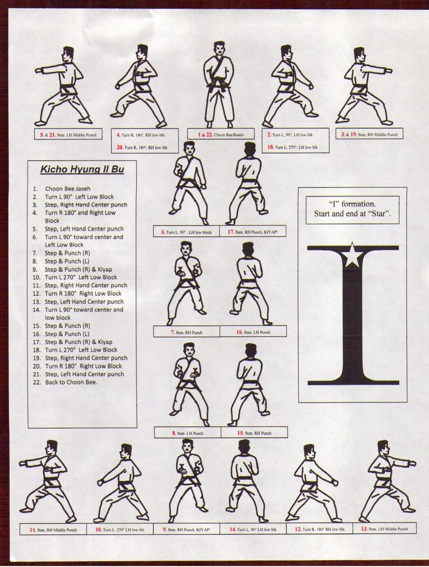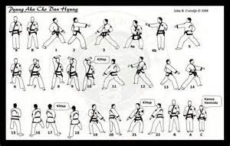
ATF Hyungs (Forms)

The First Geicho Form

The First Pyong Ahn Form

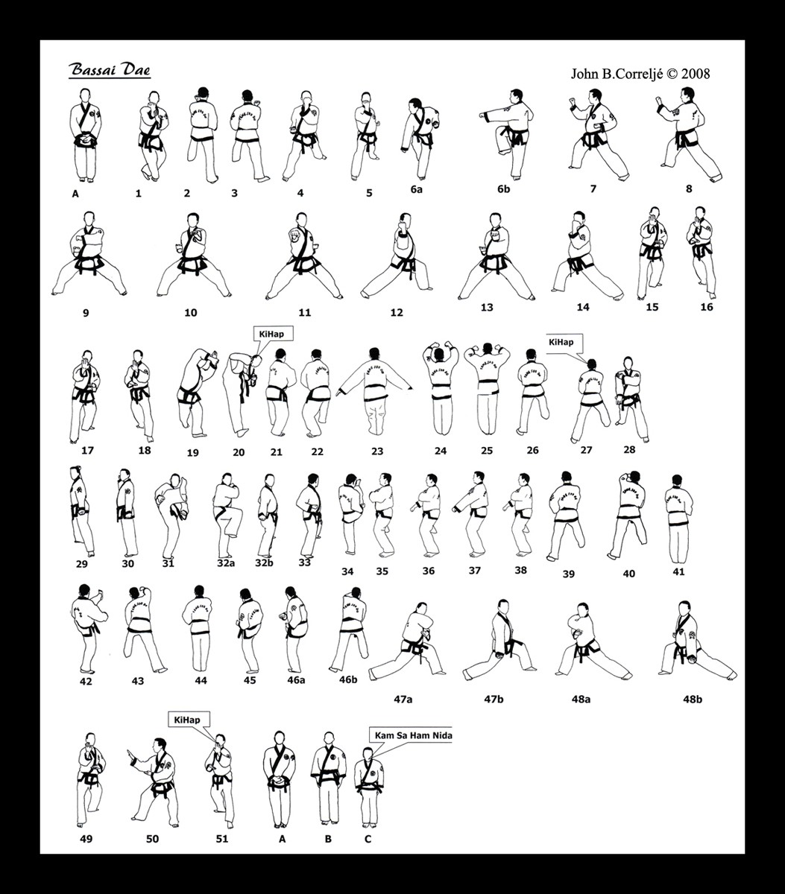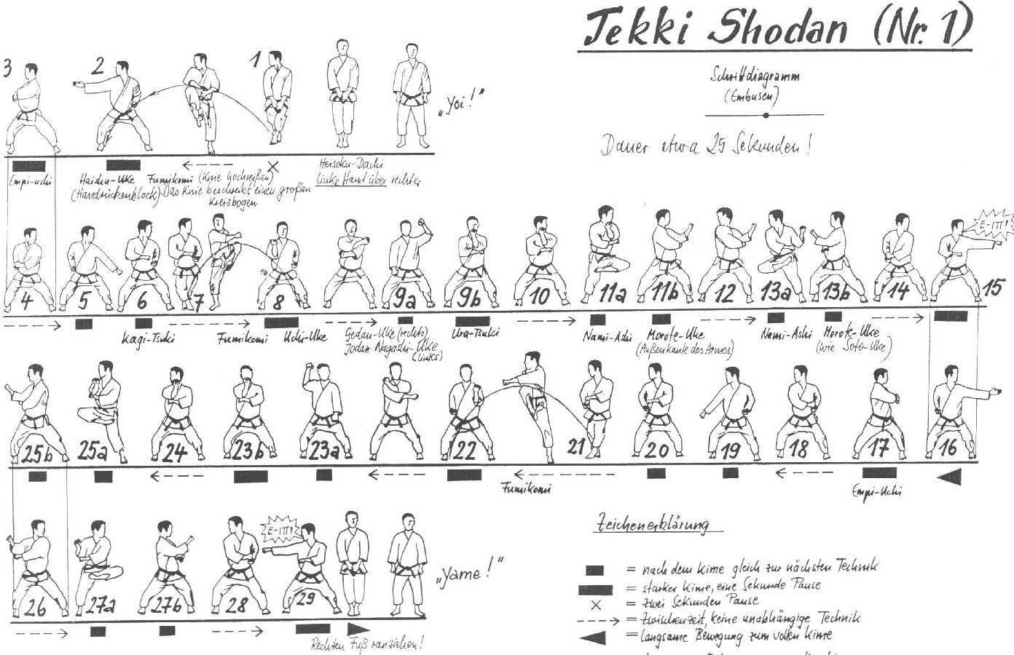
The First Bassai Form

NOTE: There are slight variations of these Forms in the ATF System.

The First Nihanchi Form

STUDENT NOTES

