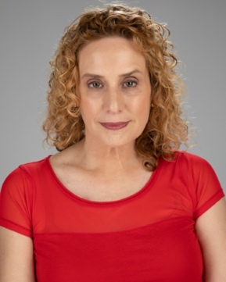
Monica Harker
Height: 5’7” Weight: 123 lbs Eye Color: Hazel Hair Color: Strawberry Blonde
https://monicaharkeractor.com 954-815-5974 monicahactor@gmail.com
Instagram:@MonicaHActor US Passport and Driver’s License

Performance Experience
Pins and Needles | Mindy | Not Your Average Theatre Group
Love Lies and Casserole | MC Margarita | Not Your Average Theater Group
Serial Dating | Kim | Not Your Average Theater Group
When Harry Met Sally | Marie | Sunrise Senior Center
The Turnpike Trauma | Jeanie | Not Your Average Theater Group
Yes And | Molly | Not Your Average Theater Group
Mama’s Boy | Lila | Seaside Players
Splitting the Check | Waitress | Seaside Players
Unclaimed Baggage | Passenger | Seaside Players
MediSocks Bilingual Commercial | Spokeswoman | Intellibrands LLC
The Brainers | Person 9 | Steinfeld Productions
Group Therapy | Tammy | Seaside Players
Good Old Way | Erin | Seaside Players
Jack Danger | Italian Spy | 48Hour Film Festival
Lethal Ghostbusters Weapon | Biker | Borike Productions
Atomsteam | Reporter (Supporting) | Atomsteam LLC.
The Game | Lisa (Principal) | Not Your Average Theatre Group
A Theatre Showcase | Jill (Principal) | Sunrise Senior Center
The Improvables Performance | Improvised Characters | ArtServe
The Enforcers | Babs (Supporting) | Sea Shorts Play Festival
The Gospel According to Jesus: | (Supporting Roles) | Lesbian Thespians
Love Ya Man | Wife (Principal) | Behind the Scenes Theatrical
Bare Bones | Edna & Laveen (Principals) | ArtServe
The Toymaker | Lucy (Prinipal) | Saint Lucy Ballet
Lip Sync for the Love of It | Performer | Behind-the-Scenes Theatrical
Bare Bones | Angela (Principal) | ArtServe
The House of Blue Leaves | Bunny (Principal) | BCPA Showcase
Goodbye to Charles | Jill (Principal) | BCPA Showcase
Kitchen Sink Drama | Elaine (Principal) | Private Showcase
Special Skills
Multi-lingual English/Spanish/Italian | Swimming | Driving
Spanish/English Translator and Interpreter | Dancing | Modeling
Education
ActBroward (Film/Stage) | Soref JCC | Ed Casas 2023
Acting for the Camera | ArtServe | Sara Rogers 2022
Scenes & Monologues | ArtServe | Sara Rogers 2021
Acting Coach | Private Instruction | Rachel Finley 2020-Present
Adult Acting | Broward Center for the Performing Arts | Gail Garrison 2017-2020

