Plant List Lely Indian Wells Trees, Scrubs, Palms, Ground Cover

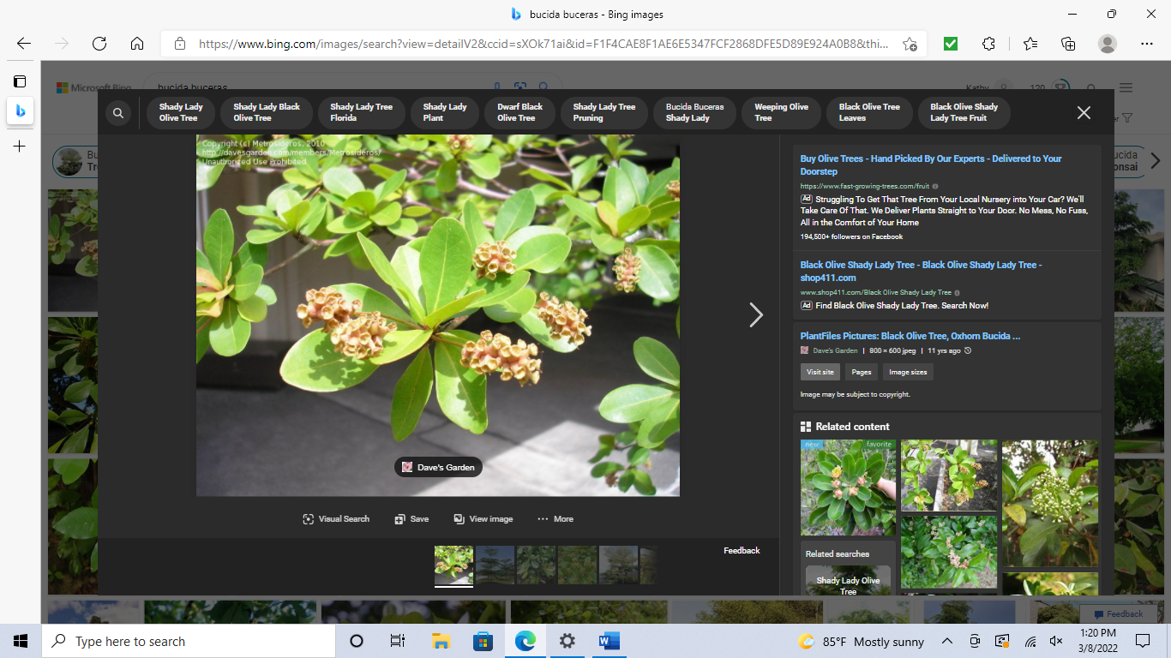Black Olive-Disputed possible native to Florida Keys, S America, Caribbean up 30 ft.
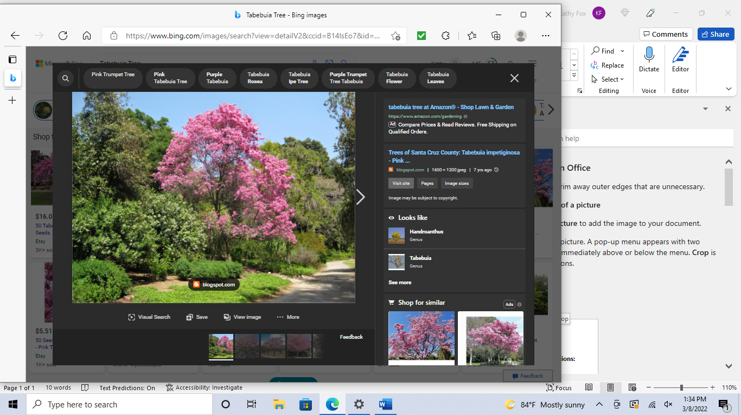 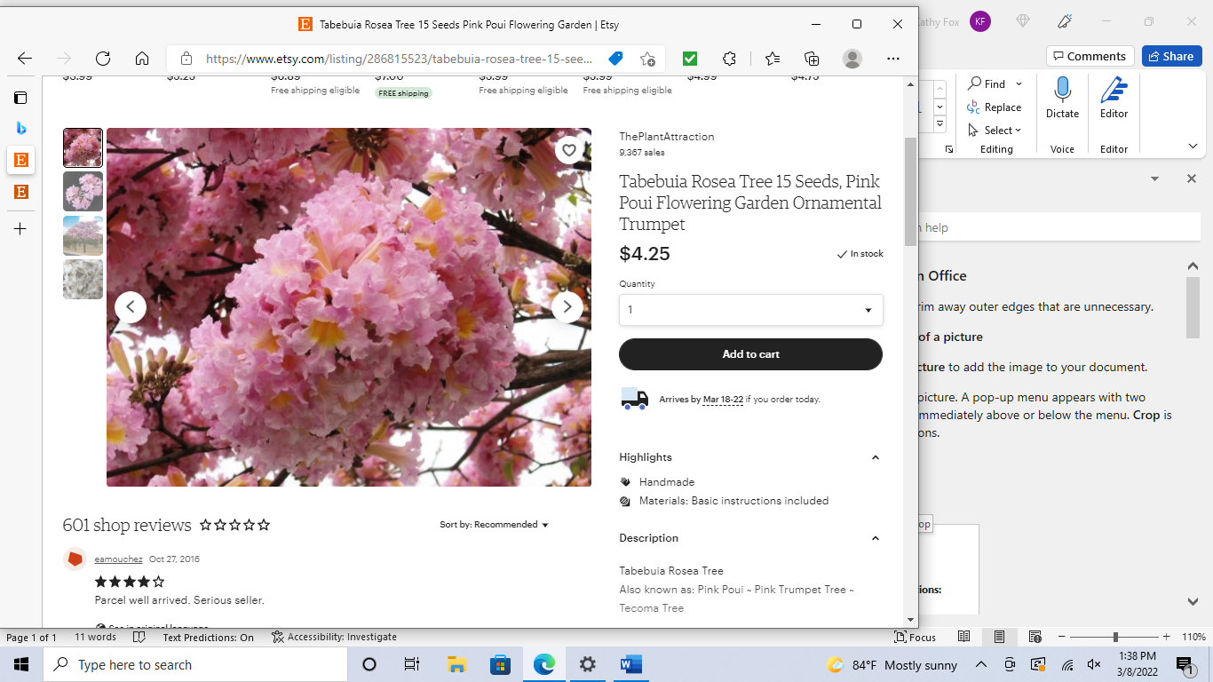Tabebuia or Cuban Pink Trumpet Tree or Angel Trumpet 10-36 ft.
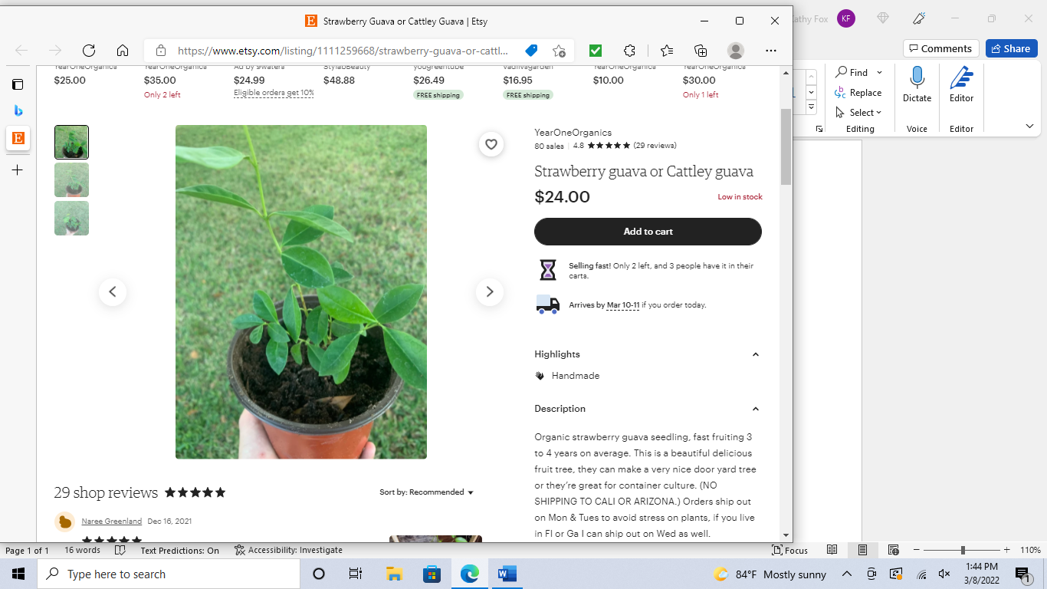Cattley Guava or Strawberry Guava small evergreen plant suitable for hedge-14 ft.
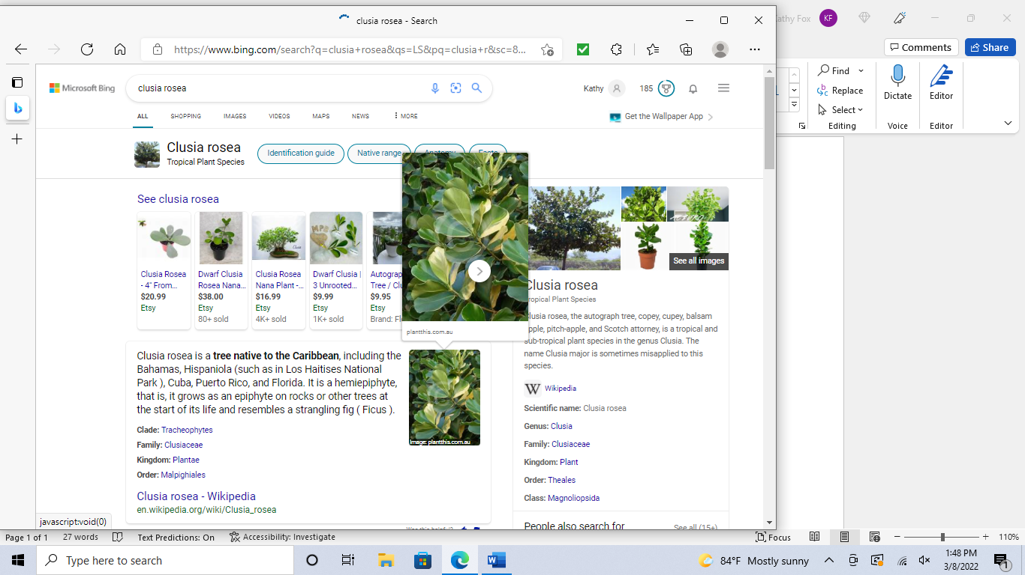Clusia Rosea (Signature Tree) Native to Cuba, Caribbean; up to 20 ft.
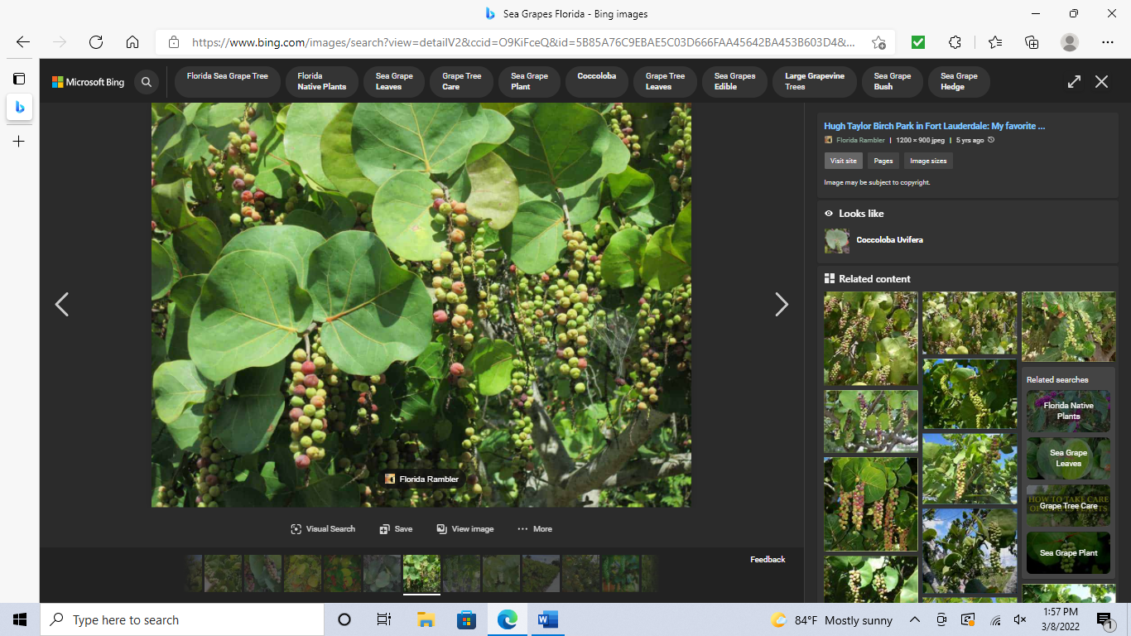 Seagrape native to Florida, Tree 30-35 ft
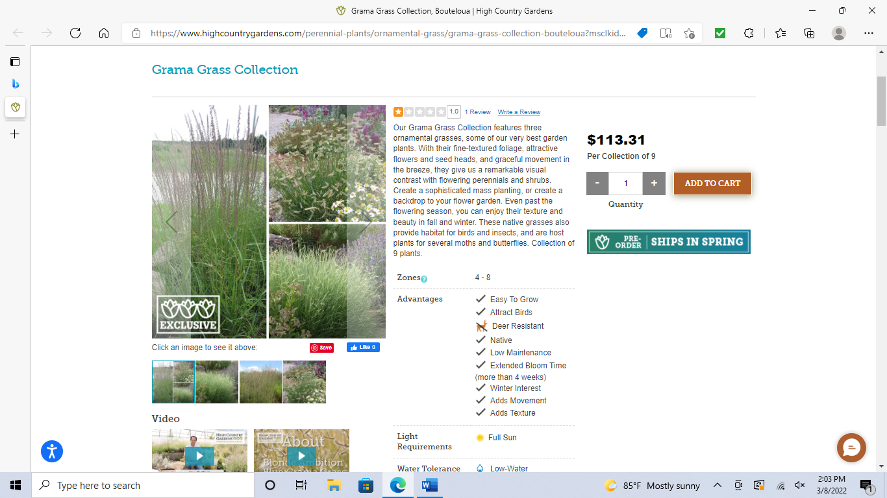Fakahatchee Grass 4-6 ft Florida native
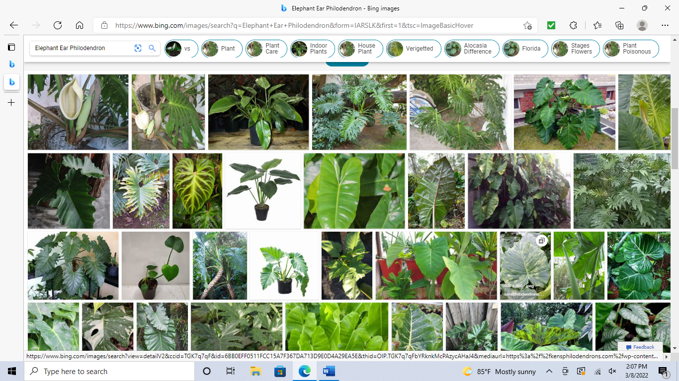Philodendron many varieties, vines, climbs, spreads on its’ own
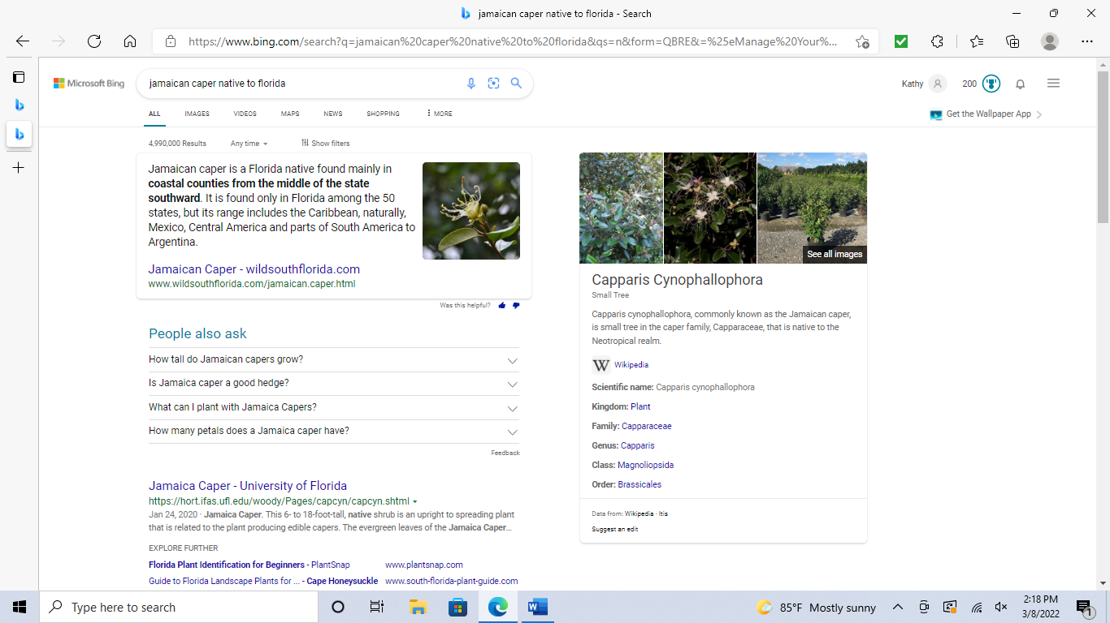Jamaica Caper native to Florida, Cuba, Caribbean 6 to 18 ft.

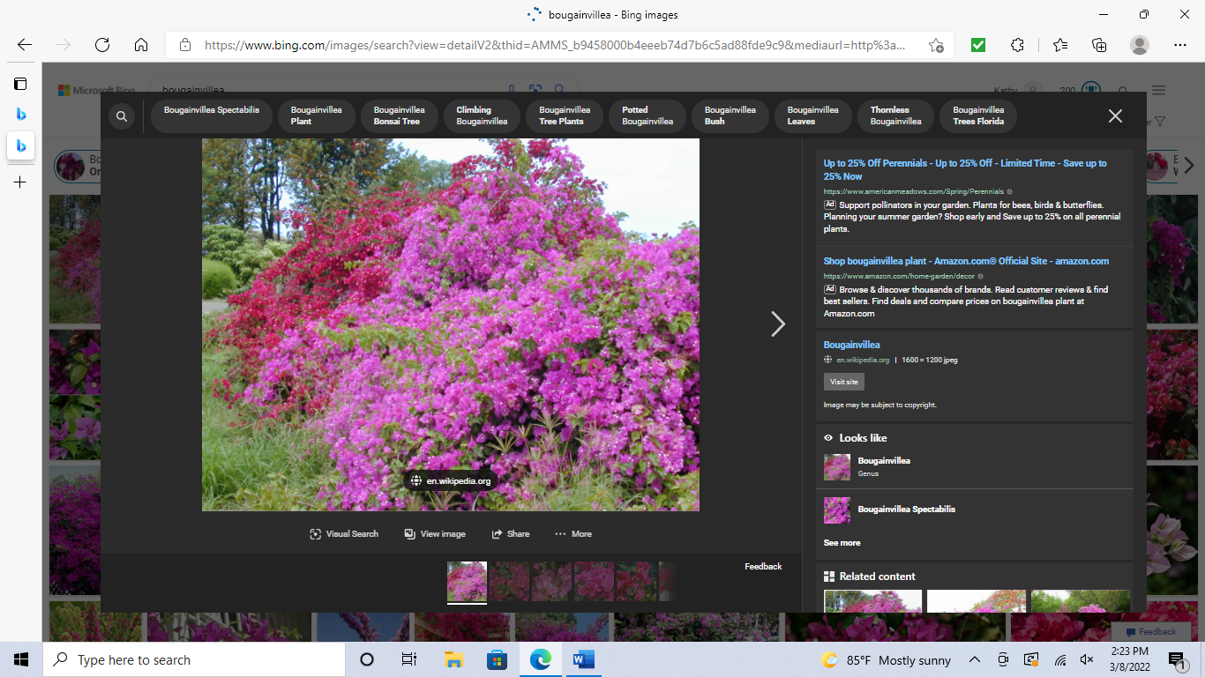Dwarf Bougainvilleanative to S. America, vines, thorns
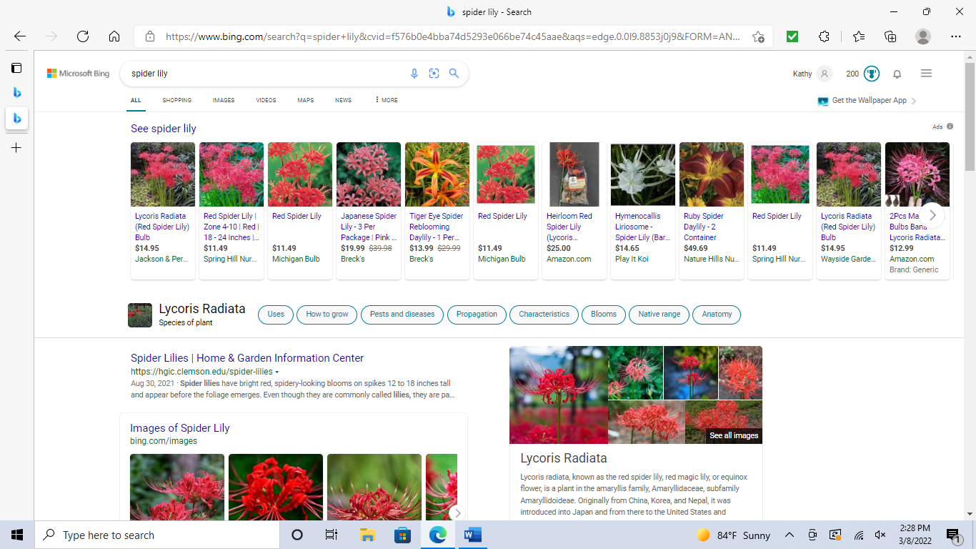Spider Lily native to China, Nepal
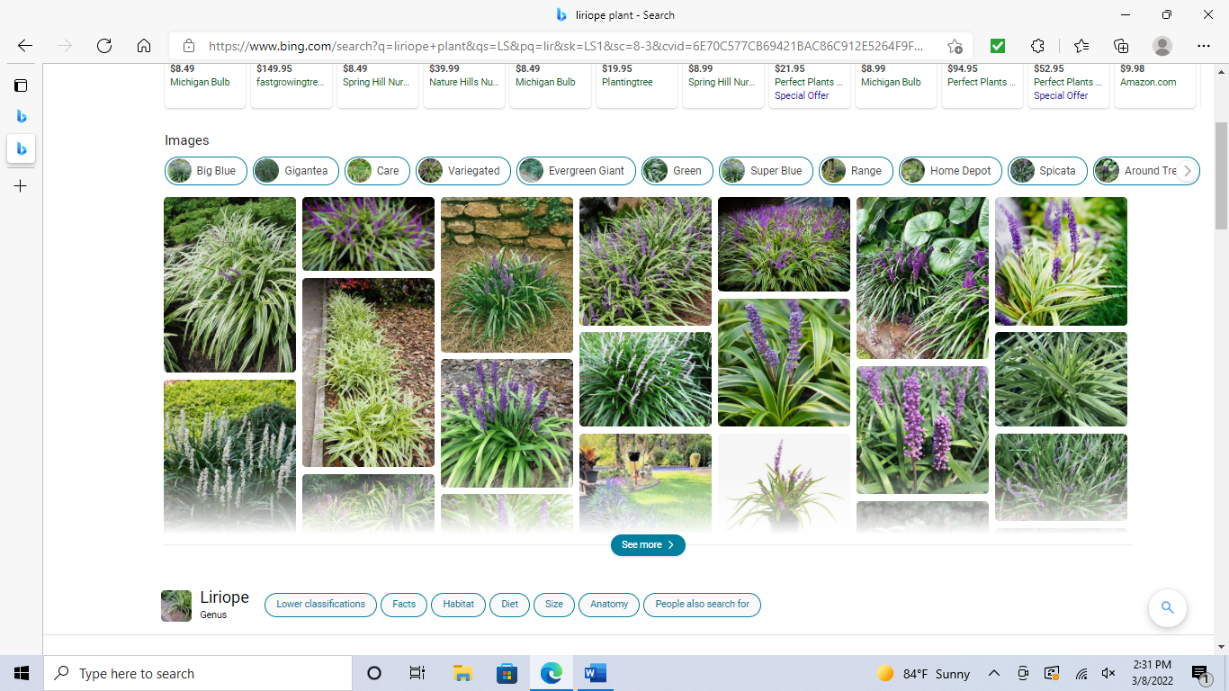Liriope comes in white or purple ground cover; mounds of grass-like growth

Palm Trees
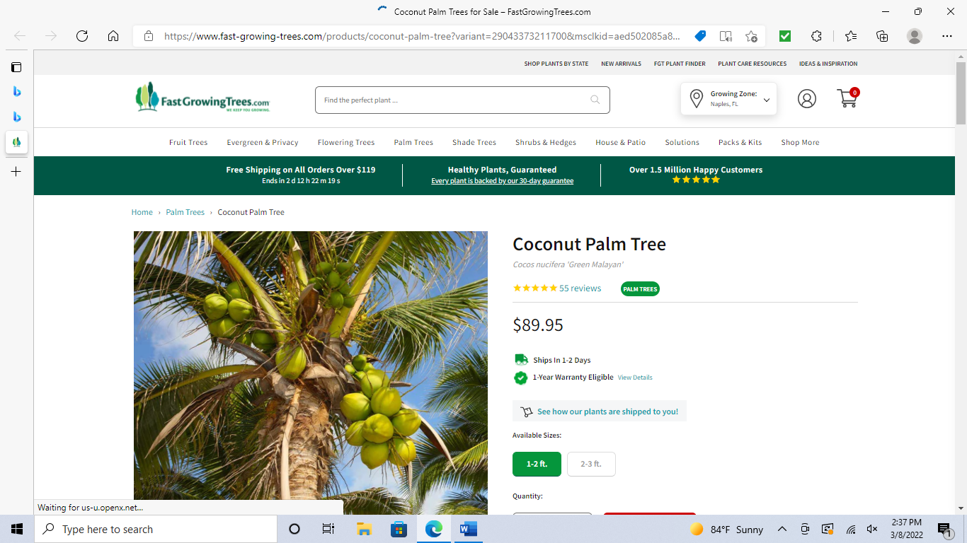Coconut requires regular trimming and removal of nuts; 50 to 80 ft, curved trunk

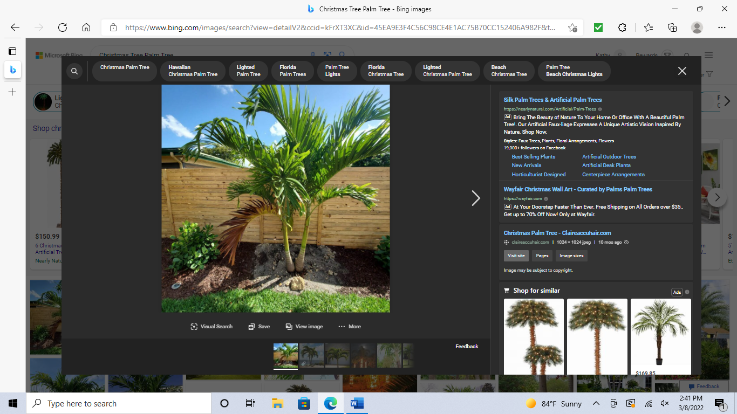Christmas is single or multiple trunk palm 20-25 ft. Self-cleaning palm
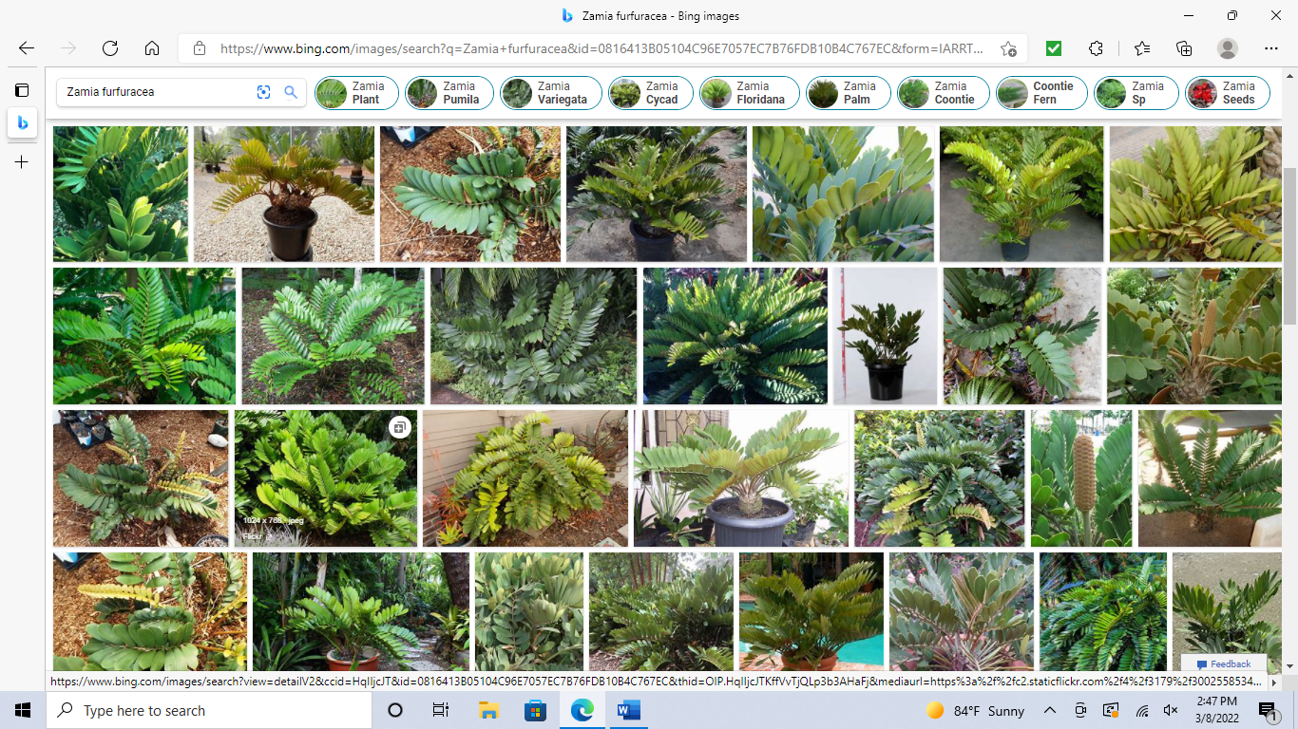Cardboard Palm 3-11 inches native plant in Mexico
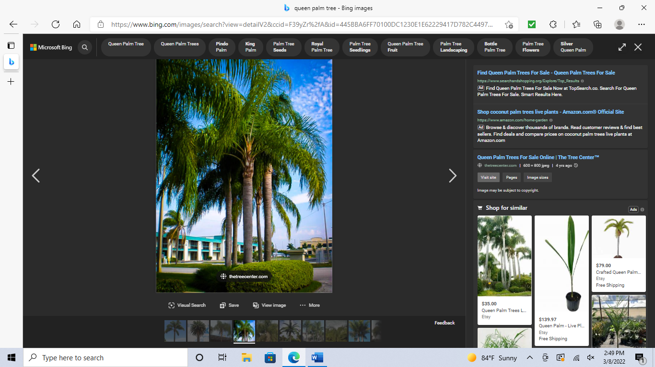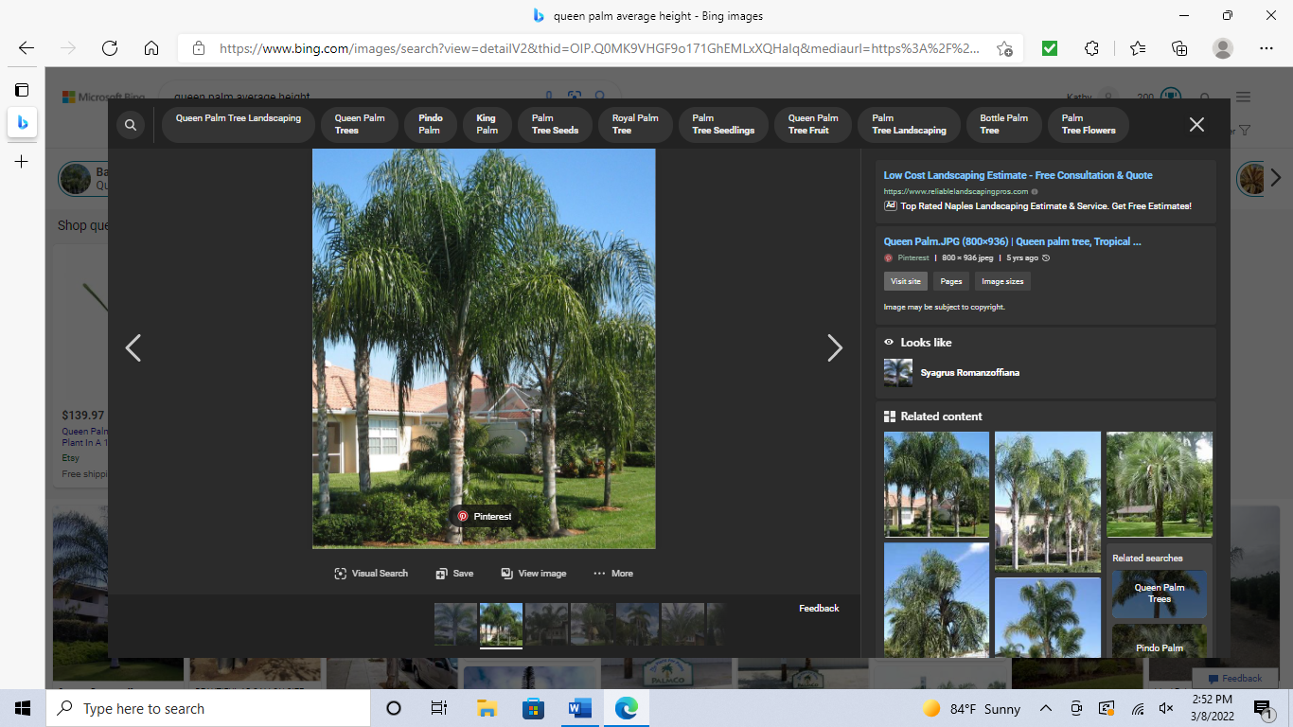Queen Palm fast growing 25-35 feet, pruning required

Thorny or date palms have thorns and are not pictured.

