**Indian Wells Landscaping Information, Plans & Efforts**

There are several things going on creating some confusion, so I am writing this note as to what is going on now and thoughts about going forward. I am going to list activities in reverse chronological order as the more recent events seem to be causing the most email traffic.

1. Work on the landscape barrier on Jim Seabasty’s property (8481) adjacent to the south cul-de-sac that Tricia brought to our attention on 27 July 2023.
   1. Jim contracted Goodwin Lawncare for $2800-2900 to clean up the hedge as it was growing on this house.
   2. It would have been nice if he had given the Board and ARC a heads ups on this since we are working on plan for the south hedge, but unless they actually removed entire original plants or planted new ones, he appears to be entirely in his right to do this and he not obligated to communicate this work nor submit an ARC request as I understand the Declarations, our ARC guidelines, and rules.
   3. If he/they had removed original plants or added original plants the Declarations would have obligated him to make an ARC request
   4. While not directly applicable to this situation but goes to intent… the research Fox did after the tornado last year uncovered the fact that we have 6 owners that have landscape barrier easements on their properties. Jim is one of them.Our Plat dedicates the maintenance of those hedges to the HOA but there is no definition on the Plat or at the County or State level as to what that means or who pays. The combination of the Plat and our Declarations suggested that the HOA could choose to maintain the hedge by purchasing and planting new plants and charge the Owner which the Board felt was unfair, so a rule was passed in and open and noticed meeting that said “For landscape barriers (buffers) in LBEs on Owner’s properties, the party who wants new plantings, pays. All other landscaping not part of the LBE buffer on Owner’s property, even if in the LBE is at Owner’s expense per our Declarations.” Evidently Jim wanted the change faster than the Board was working on it.
   5. There is also past precedent on owners occasionally trimming these hedges and/or trees on their property. As one example, Larry and Pat Schulz did the some trimming several years ago on the other side of this cul-de-sac because their lawn was not getting adequate sun.
2. Planning for maintenance work to address the aging/dying plants in the LBE along Lely Resort Blvd. and the resulting open gaps. It was first noticed that plants seem to be dying and gaps were forming towards the end of dry season, and this was discussed in the May 10th BOD meeting but it is unclear from the minutes who was going to discuss this with Miquel. We typically budget about $1500 for this kind of landscape maintenance each year and that was the number of this year too when the proposed south cul-de-sac work was excluded. Given that the rainy season did not perk up the plants, Fox asked Takacs to take the lead on working with Miquel to gather his suggestions and proposal(s). Jean met with Miquel and Mike Billings and provided the following information which not only addresses this topic, but the south cul-de-sac and other issues identified during their walk.
   1. Landscape Hedges facing main boulevard-
      1. North side: 10 viburnum hedges need replacing.
      2. South side: 6 viburnum hedges need replacing.
      3. TOTAL: 16
   2. South Cul de Sac- (currently looking at the middle section that is in view of the neighbors as they look down the street) Adding a total of 15 green schefflera and cutting out anything behind it that isn’t a Guava tree. Trim Guava trees and don’t touch anything in the row facing Mustang Island currently.
   3. Also noted on walk:
      1. A. North side facing main boulevard we have 2 sections of trees. One with Eastern Gama grass in front and one without presenting an unbalanced look.
      2. North Cul de Sac in the mid-section has drying out viburnum. Miguel says it’s on Patrick’s irrigation.
      3. On the back of the entrance walls near Meagan’s house and the other corner house there is a tree behind each one with crotons on one side of the tree but not on the other side presenting an unbalanced look.
   4. Miguel to do:
      1. Provide the Board a copy of the sprinkler schedule for the hedges along the main boulevard. (We want to make sure the sprinklers are working properly where the current hedges have died prior to replacing with new ones).
      2. Provide estimate on 16 (25) gallon viburnum (same size as now) and (15) gallon ones (4ft. in size)
      3. Provide estimate on Gama grass to match trees in front of hedges on north side that have the same grasses in front.
      4. Provide estimate on a total of 15 green schefflera needed including cutting out behind it, plus trimming guava trees. Quotes will be given on 15-gallon size (height there now) and 7-gallon size (4ft. size)
      5. Provide quote on 6 crotons that would go behind entrance walls by corner homes. Three on each side.
      6. Miguel mentioned palm tree pictures sent to board and that he sent the estimate.
   5. Miguel did provide three quotes and Jean forwarded them to the ARC and Board members. Unfortunately, the quotes don’t line up with our projects and are incomplete and probably outdated with regards to the south cul-de-sac scope and may have combined “or” options as “and” overstating scope of work and cost. These issues need to be worked out with Miguel. Fox has consolidated the three quoted to a one-page spreadsheet with questions and comments and also created a second one page spreadsheet lining up the info provided by project to the extent that is a match to facilitate discussions and better number from Miguel.
3. The South cul-de-sac. Fox has been pushing for addressing issues in a phased approach over several years since his LBE information was presented in the spring of 2022. We budgeted ~$6K for it this year, although Anchor is not actually collecting enough for the 2023 approved budget by an amount close to this. That said, Mike Cohen at BOD request had started work in late May to collect information, scope and cost proposals. While that effort seemed to slowed recently and the first contractor hasn’t provided a written proposal with scope and cost info, we did learn several important things:
   1. The Indian Wells Plat drawing (produced before Mustang Island was developed) is not visually accurate with regards to the landscape barrier. Visually, it looked like our Owners property went close to the sidewalk in Mustang Island implying the whole barrier was our responsibility. However, measurements and dimensions suggest that there is land not a part of Indian Wells that is between Indian Wells and the Mustang Island sidewalk which is part of Mustang Island. Therefore, Mustang Island is responsible for a part of the hedge immediately adjacent to their sidewalk. This is beneficial to us in a couple of ways. It reduces our scope of work and it creates a barrier while we may have gaps in our new barrier before plants fill out.
   2. It appears that the landscaper that Mike Cohen met with, the Goodwin landscaper that Jim used valued the existing Cattley Guava trees that were part of the original LBE in 1996 per landscape drawings. Mike’s landscaper said they aren’t near the end of their life and they should look good after they rebound from trimming. These are “naked looking plants” in Tricia’s picture below.

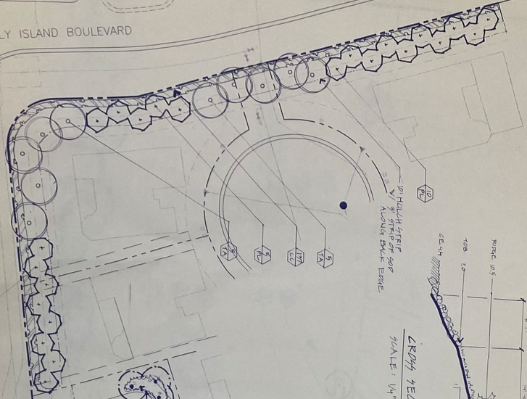

1996 Landscape plan for south cul-de-sac

*(The PL plants denoted by the hexagon shape are Cattley Guava)*