
It is hard to believe that it has been three years since we launched Travel to Hope. With only a desire to help as many patients as possible, you have allowed us to do more than I ever could have imagined.

Bringing Hope and Healing to Cancer Patients and Families
When I wrote to you this time last year, we had helped 190 patients with over 1,700 trips to treatment. Today, I am pleased to report that your incredible generosity has allowed us this past year to help an additional 145+ patients and has funded an additional 1,300 trips.
We also have helped an additional 34 patients complete their treatment, thanks to your support.
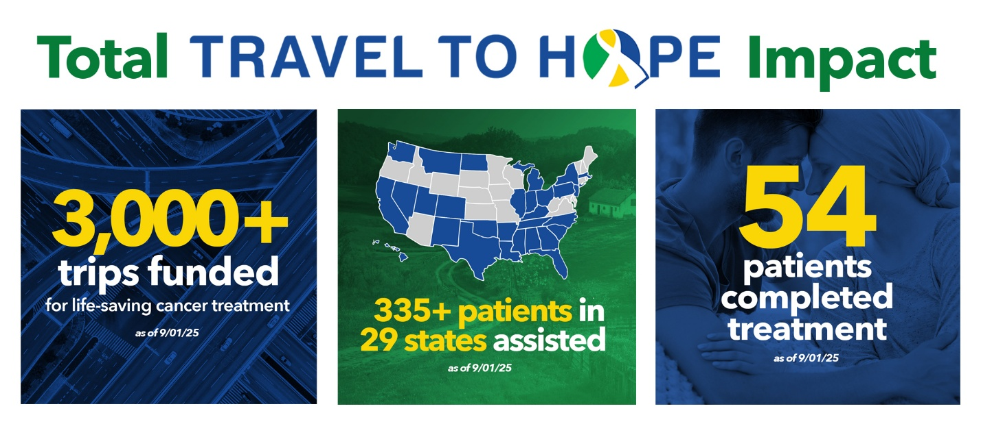

Anniversary Messages from Our Patients
Our patients are a highly diverse group… of all ages and ethnicities, from all regions, and with wide-ranging occupations and backgrounds. But they have two things in common: they need our assistance to travel for life-saving treatment, and they share a deep gratitude for your generosity that allows them to travel to receive the care they so desperately need.

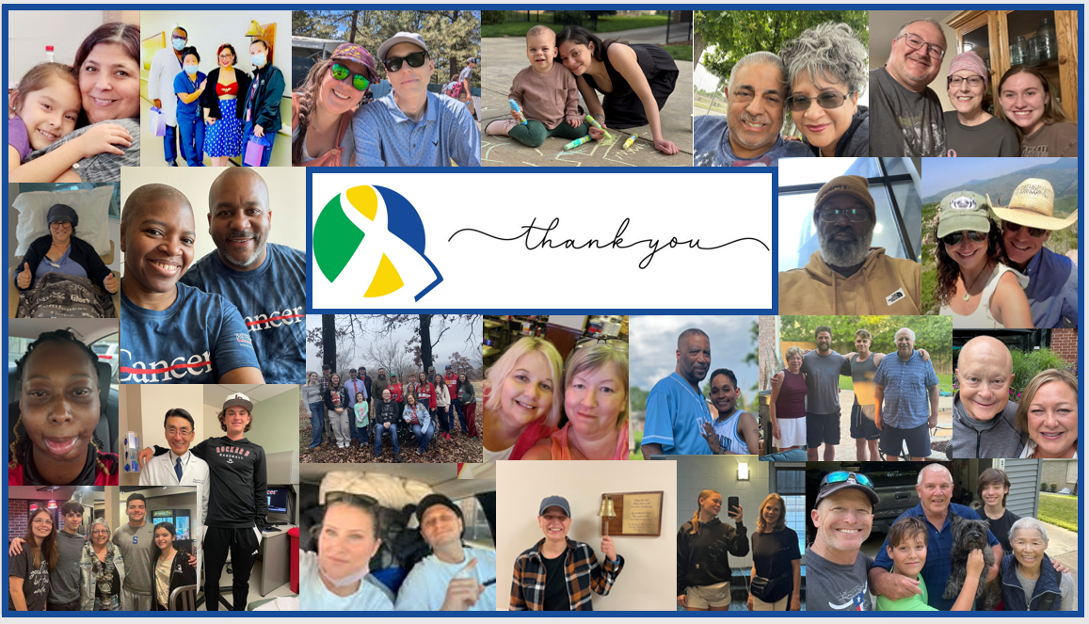

Patient Thank You Messages
My words can never truly convey the impact your generosity has had on them and their families, so I will let them express it best. I hope you will take a few minutes to review the many heartfelt thank you messages that our patients asked that I share with you.
Please click here to view their messages.
You may notice in these messages something that sets Travel to Hope apart from many other nonprofits. Our intent has always been to travel along with our patients and families in their cancer journey for as long as they need our help. Several of these patients have been with us for over 2 years. Thank you for the incredibly generous and ongoing support that allows us to continue to be there for them.

Moving Forward
We have helped so many in need, but much work remains ahead of us. The demand for assistance remains incredibly high, and we often face a waitlist of patients needing our help that our funding cannot support.

How You Can Help

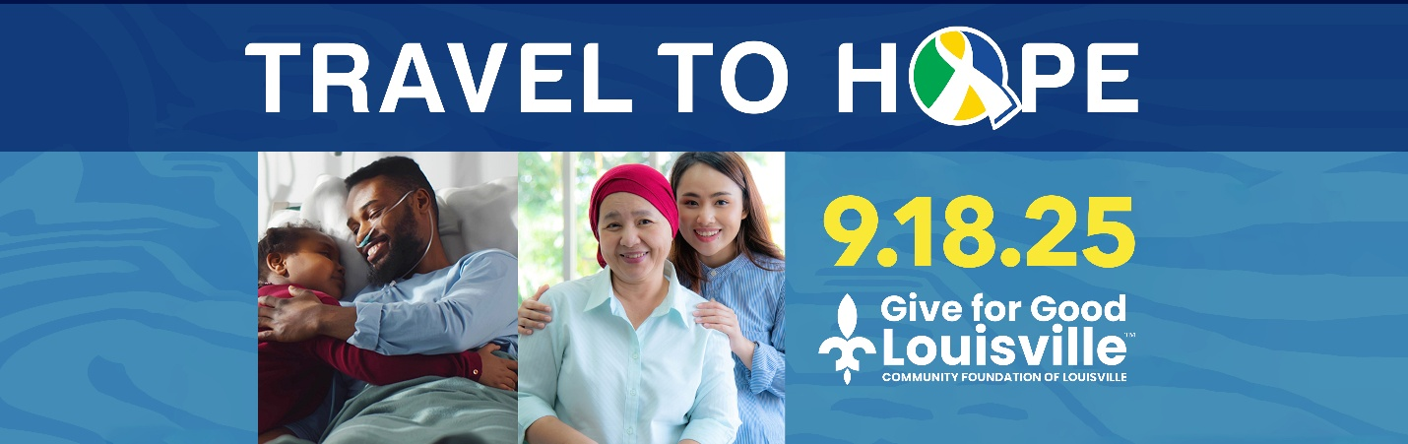

Give for Good Louisville … Thursday, September 18
The Community Foundation of Louisville is sponsoring its 12th annual Give for Good Louisville event – a unique fundraising opportunity for Louisville-based nonprofits.
Starting today and culminating on Thursday, September 18, Travel to Hope has an opportunity to receive up to $10,000 in matching gifts from a very generous donor and to receive a portion of the available $303,500 in cash prizes.
Please be sure to mark your calendars, share our social media posts and donate so we can achieve our goals of raising $20,000 and securing 100 new donors so that we can fully utilize this wonderful matching gift opportunity, compete for the available prize money and be able to continue to support our current patients and help every patient who has asked for our help!
If you would be interested in being a Travel to Hope fundraiser for this week’s event, you can create your own fundraising page here. Just click “Fundraise,” create your page and share with your friends, family, and colleagues!



Giving Tuesday 2025 … December 2
Last year we raised $51,030.30 on Giving Tuesday. Our goal is to increase that number by nearly 50% to raise $75,000 in donations on Giving Tuesday 2025. The number of patients that we support has increased more than 75% over the past year. Raising $75,000 over Giving Tuesday 2025 will help ensure we can continue to support our current patients AND be able to assist additional patients who desperately need our help.
We have already secured $12,000 in matching gift opportunities from generous donors for Giving Tuesday 2025. If you would be willing to join as a matching donation sponsor, please let me know. Matching gifts truly make a tremendous difference on our fundraising success!
Also, we are hopeful that we will once again have generous Corporate Employee Matching opportunities this year to help us achieve our goal. Please check with your employer to see if they will provide a matching gift to maximize the impact that your Giving Tuesday (or other!) donation has.
Stay tuned for more Giving Tuesday details in the coming weeks!

Additional Ways You Can Help
- Share this update with friends, family, and colleagues.
- Follow us on Facebook, LinkedIn, and Instagram and invite your networks to follow us as well!
- If you are celebrating a special milestone (birthday, anniversary, graduation, etc.), please consider celebrating that occasion by helping our patients through a Facebook Fundraiser. It is easy to do and 100% of your fundraiser proceeds come directly to Travel to Hope.
- Introduce me to individuals or charitable foundations that, like you, have a passion for helping cancer patients in need and might be willing to support our efforts.
- If you might consider making an additional donation, please consider making your gift a recurring donation or consider making a gift of stock which enables us to plan for the long-term support of patients more confidently.

Stewardship and Transparency
As we begin our third year of operation, our funding model continues to ensure that all administrative expenses are paid for independent of your donations which ensures that 100% of every donation made to us goes directly to helping cancer patients with their travel expenses.
We also are extremely proud to have been awarded this year the Candid GuideStar’s Platinum Seal of Transparency, their highest designation which is held by fewer than 1% of all US nonprofit organizations.

We are immensely grateful for entrusting us with your amazing support this past year and hope for your continued generosity to allow us to help even more cancer patients in need.
On behalf of the 339 patients and families you support, thank you for the hope you give.


Gretta Feldkamp
Executive Director, Travel to Hope
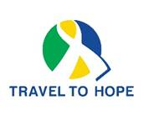
www.TraveltoHope.org
(502) 899-5261

P.S. If you no longer wish to receive communications from Travel to Hope you can opt out here.

