|  |  |
| --- | --- |
| crayons on colored background  Muswellbrook Pre School  Newsletter  25-27 Sowerby Street, Muswellbrook, 2333  Ph: 65 41 5333 Fax: 65 41 5288  Email: [admin@muswellbrookpreschool.com.au](mailto:admin@muswellbrookpreschool.com.au)  Website: www.muswellbrookpreschool.com.au |  |
| Pre School Closed  Friday 6th April Pre School will be closed for staff training. All staff will be attending a conference in Sydney to enhance our programs, expand our knowledge and keep up to date with Early Childhood developments.  Dear Families…  Welcome to Muswellbrook Pre School for 2018!  I hope everyone had a relaxing and happy break. It is great to see so many smiling faces ready for Pre School this year.  In this newsletter you will find information regarding bus travel, important term dates, lunch box ideas, office news and a range of handy hints. If you have any suggestions for our newsletter, please drop them into the office.  Please call into the office at any time if you have questions or concerns and I will happily meet with you (Urgent appointments only Thursdays as I am on class).  Kelly Constable  Director  C:\Users\kelly\AppData\Local\Microsoft\Windows\Temporary Internet Files\Content.Outlook\7SHZ6ERY\IMG_5572.jpg | Office News…  Open Monday to Friday  8.30am to 4pm.  Fee statements have been sent home. Please ensure your fees remain in advance at all times.  Image result for child quotes  Bus Travel  If your child will be travelling to or from Pre School on the bus, please call into the office to collect more information. The bus will commence Monday 12th February.  PRE |

**Our Renovations….**

During the Christmas holidays our Hill Street building received a lovely makeover. Rooms 2 and 3 have been completely renovated including new floors, kitchens, art prep areas and paint. Room 1 has a lovely fresh coat of paint and we are saving our pennies to have the floor replaced in there also. Thank you to everyone who made these renovations possible!

Welcome Night

Our annual Welcome Night will be held on Tuesday 13th March. We will send home an invitation shortly. We hope all our families and friends will be able to join us!

Follow us on Facebook

Muswellbrook Preschool Kindergarten

Keep a check on our page for updates, information and items of interest.

AGM

Our Annual General Meeting will be held on Wednesday 28th March. More information will be sent home in the coming weeks.

|  |  |  |  |  |  |  |  |  |  |  |  |  |  |  |  |  |  |  |  |  |  |  |  |  |  |  |  |  |  |  |  |  |  |  |  |  |  |  |  |  |  |  |  |  |  |  |  |  |  |  |  |  |  |  |  |  |  |  |  |  |  |  |  |  |  |  |  |  |  |  |  |  |  |
| --- | --- | --- | --- | --- | --- | --- | --- | --- | --- | --- | --- | --- | --- | --- | --- | --- | --- | --- | --- | --- | --- | --- | --- | --- | --- | --- | --- | --- | --- | --- | --- | --- | --- | --- | --- | --- | --- | --- | --- | --- | --- | --- | --- | --- | --- | --- | --- | --- | --- | --- | --- | --- | --- | --- | --- | --- | --- | --- | --- | --- | --- | --- | --- | --- | --- | --- | --- | --- | --- | --- | --- | --- | --- |
| |  |  |  |  |  |  | | --- | --- | --- | --- | --- | --- | |  | Monday | Tuesday | Wednesday | Thursday | Friday | | Wk 1 | 29th Jan | 30th Jan | 31st Jan | 1st Feb | 2nd Feb | | Wk 2 | 5th Feb  Children Return | 6th Feb | 7th Feb | 8th Feb | 9th Feb | | Wk 3 | 12th Feb | 13th Feb | 14th Feb | 15th Feb | 16th Feb | | Wk 4 | 19th Feb | 20th Feb | 21st Feb | 22nd Feb | 23rd Feb | | Wk 5 | 26th Feb | 27th Feb | 28th Feb | 1st Mar | 2nd Mar | | Wk 6 | 5th Mar | 6th Mar | 7th Mar | 8th Mar | 9th Mar | | Wk 7 | 12th Mar | 13th Mar  Welcome Night | 14th Mar | 15th Mar | 16th Mar  Muswellbrook Show | | Wk 8 | 19th Mar | 20th Mar | 21st Mar  Harmony Day | 22nd Mar | 23rd Mar | | Wk 9 | 26th Mar  Sea Life Show  ----------------------------- | 27th Mar  --------Easter Celebrati | 28th Mar  AGM  ons------------------------ | 29th Mar  ----------------------------- | 30th Mar  CLOSED –  Good Friday | | Wk 10 | 2nd Apr  CLOSED –  Easter Monday | 3rd Apr | 4th Apr | 5th Apr | 6th Apr  CLOSED – staff  conference | | Wk11 | 9th Apr | 10th Apr | 11th Apr | 12th Apr | 13th Apr  Last Day Term 1 |   **Term 1 - 2018** |  |
| Image result for child quotes |  |

Play and Sun Safety

Our sun safe policy requires children to wear clothing with sleeves (no singlet or tank tops) and hats (supplied by preschool)

Please No THONGS as they are not good for running and climbing. Enclosed shoes or those with a strap around the back are great.

Ensure there is a spare set of clothes in your child’s bag. Don’t forget their name. Coming into the warmer weather we will be playing with water and your child may need a dry set of clothes when finished.

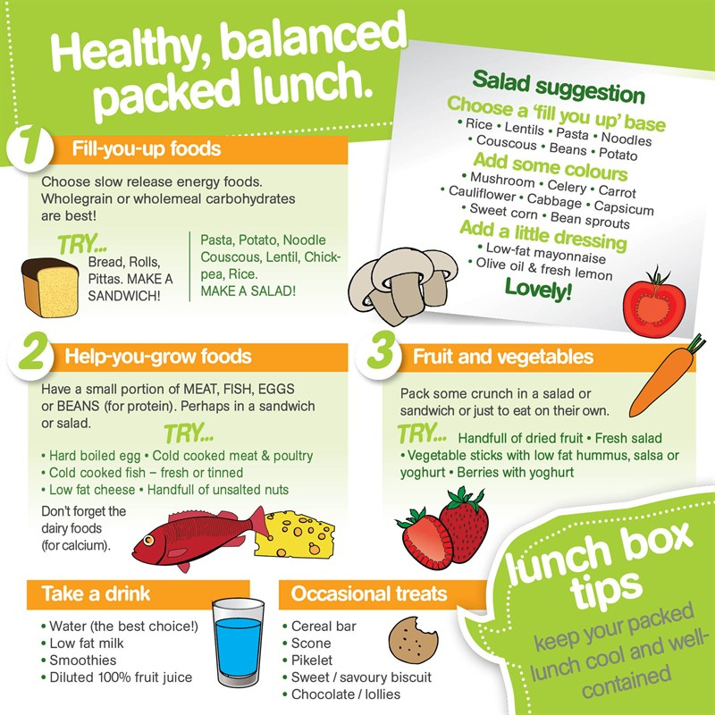

THIS IS A BIG HELP FOR US

Every year we go through heaps and heaps of tissues. It would be lovely if each family please donate a box of tissues for their classroom. Thank you.

Did you know that we regularly practice our Evacuations and Lockdown drills?

As part of the safety of everyone at Muswellbrook Preschool we practice evacuations and lockdowns every term.

If there are times where there is threat of harm the children are very practiced at what they should do and they are very good at it too.

Have a chat to your child and you will be surprised what they have learnt.

We have several policies regarding this at Preschool and parents can ask for a copy of these at any time.

Homemade muesli bars

ingredients

1/2 cup (125mL) honey

1/4 cup caster sugar

125g butter

3 cups rolled oats (see note for gluten-free option)

1 cup Rice Bubbles

1 cup sultanas

1/2 cup chopped apricots, dates or choc chips

1/2 cup desiccated coconut

1/4 cup pepitas (pumpkin seed kernels), sunflower or sesame seeds

method

1. Preheat oven to 180°C (160°C fan-forced).

2. Grease and line a slice tray (31 cm x 22cm) with baking paper.

3. Combine honey, sugar and butter in a saucepan over medium heat. Cook, stirring, for 2-3 minutes until butter melts and sugar dissolves. Bring to the

boil and cook for 2 minutes or until syrup thickens slightly. Remove from heat.

4. Combine remaining ingredients in a large bowl. Pour over the hot syrup and stir to combine.

5. Spoon into prepared pan and press firmly to make sure the mixture will stick together.

6. Bake in oven for 15-20 minutes or until golden.

7. Cool and then refrigerate until well chilled and cut into 24 slices (about 2cm x 6cm).



**NO PARKING ON THE FOOTPATH**

There have been several occasions when parents are parking on the footpath of Sowerby Street when dropping off or picking up children for Preschool. This is against the law and we have been informed that the Muswellbrook Shire Council will fine vehicles that are parked on the footpath. We understand that parking is in short supply at those times of the day but it would be better to walk a little bit further than pay a hefty fine for a short park on the footpath.

Could all families please ensure that everything is clearly labelled, everything – hats, shoes, shirts, lunchboxes, drink bottles, socks, undies, everything! We have lots of the same items coming to Pre School and occasionaly lots of lost propertey. We don’t like to send wrong items home with the wrong child so please label your items. Each classroom has their own lost property spot so ask staff to check for you if you have anything that has been misplaced and please return anything that doesn’t have your name on and isnt yours. Thank you for your help with this.

[](http://www.bing.com/images/search?q=clothes+clip+art+free+images&view=detailv2&&&id=110265AD0AFBDA9C9563F1247EDE96D1F04DFD40&selectedIndex=14&ccid=HQmen5Al&simid=607999028494208053&thid=JN.UL6AxykQTy12Yyh2aEbCYA)[](http://www.bing.com/images/search?q=hats+clip+art+free+images&view=detailv2&&&id=A238BE47E74A342DDF498351651CD48AB975528B&selectedIndex=12&ccid=2kEc8p0z&simid=608011629936641485&thid=JN.snXlGHoTEc3YlnWaCKOUqg)[](http://www.bing.com/images/search?q=lunch+box+clip+art+free+images&view=detailv2&&&id=24A176F6B20B99004F5E89DA97923588EAC59531&selectedIndex=6&ccid=yRXgtqtm&simid=607990180870029777&thid=JN.kz2Qdl2Qsofgd3vAeK45EQ)[](http://www.bing.com/images/search?q=socks+clip+art+free+images&view=detailv2&&&id=430212D7EE3120F52C76F9186248B9609AF16D58&selectedIndex=4&ccid=3%2bCRt3Xn&simid=608017574169415345&thid=JN.NczxKm07Ru6ofIs7UyO%2bSA)