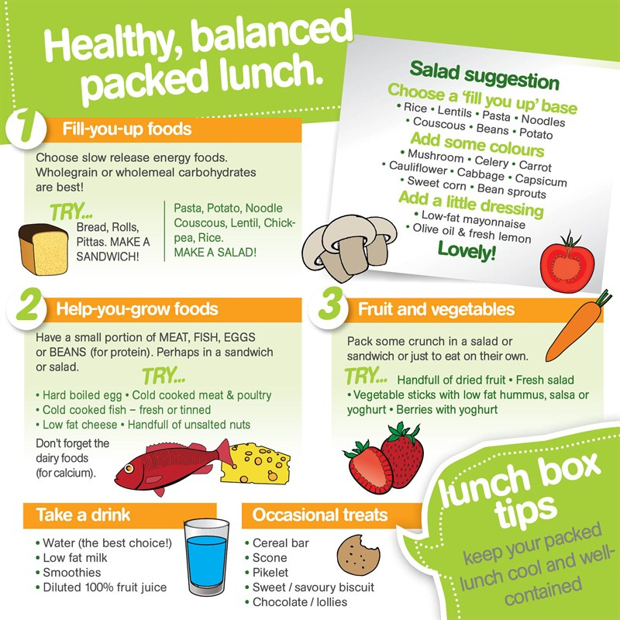

Important…. Publication Error

In our recent newsletter the below document was included.

Please note the “handful of unsalted nuts” and “chocolate/lollies”

ARE NOT PERMITTED at Pre School.

Sorry for any confusion, I will endeavour to proof read the newsletter a little closer next time!