Welcome To

Muswellbrook Pre-School Kindergarten Inc.
“Learning to Play – Playing to Learn”
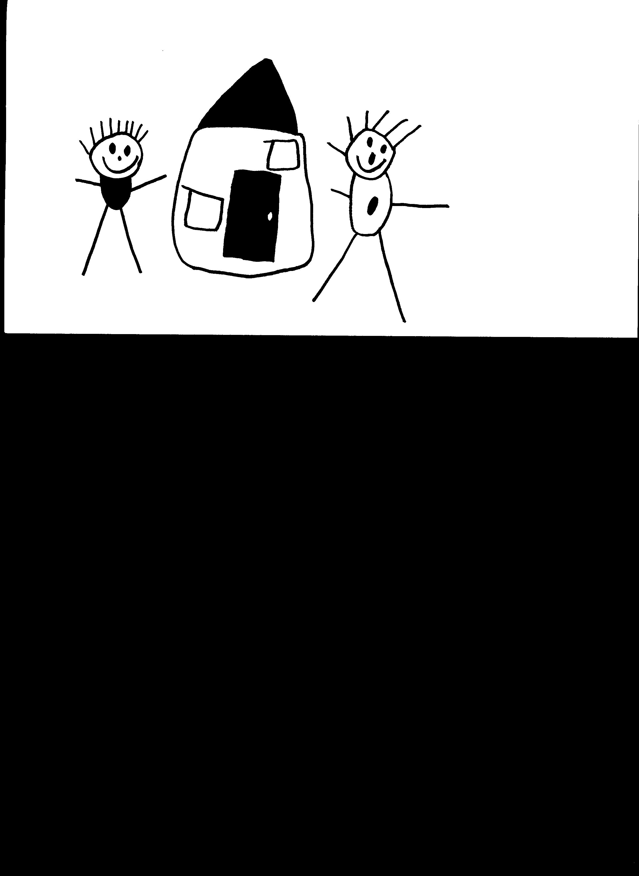

Hill Street and Sowerby Street, Muswellbrook 2333
Ph: 02 6543 2637 or 02 6541 5333
Fax: 02 6541 5288
Pre-school Opening Hours 8.30am to 4pm

Email: admin@muswellbrookpreschool.com.au
Website: www.muswellbrookpreschool.com.au
Information
Booklet


WELCOME…

Welcome to Muswellbrook Pre-School Kindergarten Incorporated. We hope that your association with the Pre-School will be a happy and rewarding experience for both you and your child.

We hope the information presented in this booklet will be of assistance to you as your child prepares for Pre-School, please keep this booklet for future reference. If you have any queries, please feel free to speak with any staff members.

In line with the Government’s “Start Strong” reform package, all children who attend Muswellbrook Preschool are offered a minimum of 15 hours per week. We offer the following placements:
- 2 days a week positions with hours from 8.30am to 4pm, or
- 3 days a week positions with hours from 9am to 3pm

The office is located in Sowerby St open Monday to Friday from 8.45am until 3.45pm.

Muswellbrook Pre-School Kindergarten is incorporated under the Associations Incorporation Act and is a non-profit organisation.

The Pre-school holds both a provider and service approval issued by the Department of Education and Communities. Our management committee are responsible for these approvals. The Early Childhood Education and Care Directorate can be contacted on 1800 619113.

The Pre-School is managed by a Management Committee comprised of parents and interested members of the community who work in a voluntary capacity. All committee positions are elected at our Annual General meeting. To be eligible to be elected, a person must have paid their membership fee to become a member of Muswellbrook Pre-School which is payable on enrolment of your child at the Pre School.
Enrolment

The process for Enrolment for a child is as follows:
- Complete a registration form.
- When a position becomes available you will be asked to complete the enrolment pack.
- Upon completion of all forms and receiving a copy of immunisation details from the Australian Childhood Immunisation Register and a birth certificate, your child may commence Pre School.

Due to Government Funding for all NSW Preschools priority for enrolment is given to…
- Children who turn 4 on or before 31st July in the year prior to school.
- Any child (3-5 years) from a family that identifies as Aboriginal &/or Torres Strait Islander
- Any child (3-5years) from a family holding a current low income health care card
- Any child identified as being at risk of significant harm

Positions are limited for those children who child turn 4 after July, they will not attract funding until the next year.

Immunisation
and
Birth Certificate

Parents are required to provide a copy of their child’s birth certificate as well as proof of their immunisation status. Immunisation is not compulsory; however, a conscientious objection form signed by a doctor must be presented instead. In the event of an outbreak of a vaccine preventable disease, unimmunised children will be required to remain at home for the duration of the outbreak. In such an event, Pre-School fees are still required to be paid if the child’s placement is to be held.


The Pre-School has comprehensive insurance to cover Public Liability which covers parents and volunteers working on the Pre-School premise in an unpaid capacity. Children are covered for personal accident.
FEES 2018

Funding for Muswellbrook Pre-School is provided by the New South Wales Department of Education and Communities, income from children’s fees, fund raising and other sources. Accounts are issued and parents can nominate to pay by the term, or by regular monthly, fortnightly or weekly payments, fees must be 2 weeks in advance at all times.

Fees for 2018:
Age 4 Years or older before 31 July 2018 - $65 for 2 days per week (8.30am-4pm) and $78 for 3 days per week (9am-3pm)
Lower income Subsidy/ATSI 3 to 5 year olds - $40 (2 days per week) $48 (3 days per week)
Unfunded 3 year olds - $50 per day (9am–3pm)
Fees for 2019 will be set in October 2018

Membership/Enrolment fee:
Our current Enrolment fee is $45 per family per year and our Membership fee is $5 per family per year.

Maintenance fee:
A $10 maintenance fee is charged to each family once each term.

Bond: All new families are required to pay 2 weeks’ fees as a holding bond which is credited to their account when leaving preschool.

Holidays/Absences:
Fees are not payable for Public Holidays or school holidays; however, fees are payable for any other absences.

Withdrawal:
Two weeks’ notice in writing must be given when withdrawing your child.

Overdue fees:
Overdue fees may result in your child’s placement being terminated. If you are encountering difficulties paying fees, personal hardship arrangements can be made with the Director.

Late Collection Fees: Late collection of a child will result in a “Late Collection Fee” charged to the families account based on the following rate: Not collected at 3pm or 4pm each day they will be charged $5 for the first 5 minutes after 3pm or 4pm then $1 per minute after that, this cost will automatically be added to existing fees.

Fee Review: Fees are subject to annual review.

The Commonwealth Government provides a rebate to assist parents who are working, actively looking for work, studying or training. The scheme assists with child care costs for children under the age of 13. The rebate can be claimed using a receipt generated from our office from any Centre link or Medicare office at the end of each term when all due fees are paid.

REGULATIONS

Arrival and collection of children
Parents are asked to bring their child to the class teacher at the start of the session and to collect them from the teacher at the end of the day. You are required to record your child’s arrival and departure times in a register in the classroom. Under no circumstance is a child to be left at the gate or outside the classroom. Please note that children can only be collected by a parent or person nominated on your enrolment form unless we have permission detailing other arrangements. If a staff member is not familiar with the person collecting your child, they will ask for photo identification. This is to ensure the safety of your child.

Toys
We ask that all toys are left at home as we provide ample resources for the children to use and we can not take responsibility for lost or damaged toys.

Parking
Parking is available in Hill St and Sowerby St Carparks or close by streets. Please note there is to be NO Parking in Hill view Avenue. Please only use the disabled parking if there is a genuine need to.

Smoke free zone
The Pre-School building, grounds and car parks are smoke free zones.



- A large backpack to fit all your child’s belongings and artwork.
- A lunch box (no cooler bags as they are placed in the fridge) which has a nutritious morning tea and lunch eg sandwich, small salad, dried fruit and cheese. Please see recommended food list.
- 3 year olds will be assisted by staff with the opening of lunchboxes and cutting and peeling of fruit. Older children will be encouraged to be independent with lunch boxes in preparation for school.
Please no nuts or peanut butter sandwiches / shellfish due to severe allergies and anaphylaxis

- A screw/pop top bottle with water in it is preferred.
- The Pre-School hat (issued to each child on enrolment) year round
- Clothes to play in that are comfortable, can get paint on and encourage independent toileting.
- Shoes that encourage the child to become independent.
- No thongs as they make climbing and running dangerous
- A complete change of clothes right down to socks.

Make sure all your child’s items have been clearly labelled with their name as many lunch boxes, shoes and clothing items are identical.
Recommended Food List






Excellent lunch box items include: fruit, veggie sticks, yogurt, custard, cheese and biscuits, sandwiches, plain popcorn, pikelets, scones, rice cakes, salad, pretzels, fruit loaf.







Limited lunch box items, NO MORE than 1 or 2 of these (excess items will be sent home): frankfurts, baked cakes, slices and biscuits (may contain choc chips, cocoa or chocolate icing), muesli bars (NO nuts), yoghurt balls, le snacks, plain potato chips, jumpy’s, jj’s, grain waves, muffin bars.









Lunch Boxes

Healthy eating is an important part of growing up into a healthy and happy adult and early childhood is an important time for children to learn about good and sometimes foods.

At Pre School we encourage all families to pack an overall healthy lunch box as shown in the red lunchbox. These are just some ideas of what to pack. We have made some slight changes in our approach to foods allowed at Pre School and if you have any questions please do not hesitate to speak with Kelly ☺

- Anything containing nuts
Due to allergies
- Shellfish
- LCM’s
- IXL “Fruit” items such as Noughts and Crosses (anything that looks like lollies)
- Flavoured Chips
- Chocolate/Milo Yogos
- Chocolate Bars

- Twisties
- Roll ups
- Poppers
- Jelly and Jelly fruit
- KFC
- McDonalds
- Cheese and Bacon Balls
- Coloured popcorn
- Milk, juice or cordial in drink bottles.

Policies have been developed for the smooth running of the Preschool. Policies are updated regularly according to the needs of the Preschool and to meet the Department of Education and Communities regulations. Policies are available at any time at the office. Following is information from some of our policies;

Sun Safety
The Pre-School provides a 30+ sunscreen. The children are taught to apply sunscreen prior to outdoor play. Outdoor play is scheduled to avoid the high risk hours (11am to 3pm) during summer. The Pre-School has also adopted a ‘No Hat –Play in the Shade’ policy. It is also important for your child to dress in clothes that give protection from the sun such as shirts with collars or high necks and sleeves.


Parents will be notified by telephone if their child is too ill to remain at Pre-School. If parents are unable to be contacted, nominated contact persons will be telephoned. In order to keep illnesses amongst children and staff at the Pre-School to a minimum, we request that if your child shows signs or symptoms of illness, such as a temperature, vomiting and diarrhoea, persistent or prolonged cough we request he/she remains at home until well enough to attend. If your child has had Paracetamol(Panadol)/Ibuprofen(Nurofen) in the 12 hours prior to attending Pre-school, they will not be able to attend that day. If your child has the vomiting or diarrhoea, please keep them at home for 48 hrs after symptoms have subsided. In the case of an emergency where immediate medical attention is required, an ambulance will be called and a staff member will accompany the child to the doctor’s surgery or hospital.
A form giving staff permission to administer medication must be completed and signed by an authorised person in the child’s classroom. All medication must be presented in its original package and have the child’s name, dosage, and expiry date on it and be given to a staff person for safe storage.
Excursions are planned from time to time and we also host visits from performing artists. These activities are part of our educational program and are designed to extend your child’s Pre-School experience. Written permission is required for these activities and some may involve a small cost.

Parents are welcome and encouraged to participate in any outings arranged. Children and adult helpers are covered under the Pre-School insurance policies.

Pre School Program
Environment
The Pre-School aims to provide quality education and care that are appropriate to the needs and interests of each child. Staff understand that the most appropriate environment for children is one, which provides a wide variety of experiences, stimulates curiosity and creativity, in a safe and encouraging atmosphere.
Parent’s role
The role of parents in the education of their children is highly valued and parents are encouraged to become actively involved in their children's class program.
Developmental records
Each child will have an individual program which is aimed at helping them reach their full potential. Records are confidential and are made available only to parents and the Department of Education and Communities unless permission is given otherwise.
Programs
Staff members meet regularly to plan activities designed to enhance each child’s learning experience. They are encouraged to attend in-services to extend their knowledge and experiences and to keep up with current educational practice.
Programs are designed to stimulate physical, intellectual, creative, language, emotional and social development within the security of a daily routine which is always flexible.
The program includes periods of free play and of small and large group activity both indoors and outdoors.
Staff
Staff are committed to providing the highest quality care for the children at this Pre School. Should you wish to discuss any aspects of your child’s development or the Pre-school program, please feel free to make an appointment with your child’s class teacher or the Director.

Thank you for choosing Muswellbrook Pre-School, we hope your experience is enjoyable for both you and your child.

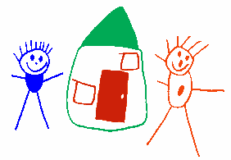
Muswellbrook Pre School Kindergarten Philosophy
At Muswellbrook Preschool Kindergarten children become confident learners, create lifetime memories, become part of friendship groups and become part of the Pre School community of which they will always be welcome!

We value and believe in:

Our Children
- We recognise the importance of a child’s right to be a child and experience the joy of childhood
- We foster their love of learning through play
- We give them the tools and experience to guide their own behaviour and be their own person
- We believe they have a right to a high quality Early Childhood Education
- We believe they are active participants in their own learning
- We allow them to discover new things
- We provide a relaxed, caring atmosphere
- We understand the need for fun
- We believe no two children are the same and enjoy the differences they bring
- We encourage children to be themselves and lead their own play

Our Staff
- Who provide enriching and engaging experiences for all children
- Who implement the Early Years Learning Framework for Australia
- Who believe in the Early Childhood Australia Code of Ethics, the United Nations Convention of Children’s Right and the National Quality Framework
- Who believe in our Pre School and are proud of the service we provide
- Who are a team!
- Who are highly trained and continue learning
- Who respect, trust and support each other
- Who are advocates for all children and families
- Who bring their own values and beliefs and share a passion for each child’s learning and development
- Who believe Early Childhood education is not solely about preparing a child for their future, but also enjoying and appreciating the present

Our Families
- We believe in building relationships between families and Pre School and value families as the child’s first educators
- We link our families with community services and other families
- We encourage, guide and support
- We acknowledge and value that every family is unique
- We welcome families into our preschool community.
- We provide families the opportunity to become active community members

Our Environment
- Which is natural
- Which is appreciated and respected
- Which is sustainable - through our recycling, water conservation and gardening
- Which is relaxed, engaging and fun
- Which is a place where learning takes place
- Which is challenging, interesting and encourages children to explore and be adventurous
- Which is for the child as they form friendships

Our Community
- In which we pay our respects to the Wanaruah and Kamilaroi people, to Elders past and present and we also extend that respect to all Aboriginal people and the people who have come before us.
- In which we have been an active part of the community since 1965
- In which we promote the importance of Early Childhood Education
- In which we respect and acknowledge cultural diversity
- In which we value our own Pre School traditions
- In which we are active participants in our own community
- In which we acknowledge and enjoy the support of the wider community

Muswellbrook Pre School Kindergarten
Code of Conduct for Families
This Code of Conduct establishes a standard of behaviour to be followed by everyone who has any involvement with Muswellbrook Pre School Kindergarten. This Code of Conduct defines how individuals should behave towards each other, towards the children in our care and towards individuals and other organisations involved with Muswellbrook Pre School.

The Committee and Nominated Supervisor have a duty of care to the children attending the service and must ensure “that every reasonable precaution is taken to protect children being educated and cared for by the service from harm and from any hazard likely to cause injury” (National Law: Section 167).

Muswellbrook Pre School Kindergartens community will work together in the best interests of the children and families and will act in a manner that will enhance the standing of the early childhood sector. This involves a full understanding of the role, responsibilities and obligations combined with community involvement and collaborative decision making.

All enrolling parents/guardians must read and sign the guiding principles. If there is any doubts as to the applicability of the code the matter should be discussed with the Director or the Management Committee.

If a breach of this code of conduct occurs this may result in Preschool attendance being withdrawn. This decision will be made at the discretion of the Management Committee.

There is a clause to sign in our Enrolment form stating the code of conduct has been received, read and will be followed.

Thanks

