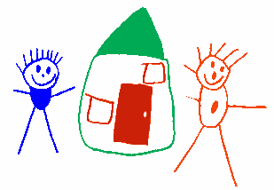
Biting Policy
Quality Area 2 - Childrens’ health and Safety
National Quality Standard 2.3.2; 2.3.3,
ECS National Regulations 85; 86; 87

INTRODUCTION
It is recognised that biting is a natural part of child development. However we want to ensure that every child is safe while in our care. Every child has the right to feel safe, secure and supported.

Muswellbrook Pre School Kindergarten will implement the following:
Procedure
- The biter is immediately removed from the group. The bitten child is consoled and the bitten area washed with soap and water. If necessary, ice is applied to reduce any swelling or bruising. The biter is spoken to regarding the incident and then redirected.
- A written incident report is given to the parents of all children involved when they are picked up that day.
- If the child catches the bus home parents will be notified via a phone call.
- We look intensively at the context of each biting incident for pattern, in an effort to prevent further biting behavior and work with children on resolving conflict or frustration using correct language and social skills.
- Information regarding children involved will remain confidential
- In line with our duty of care to children and staff if a child repeatedly causes harm to another child/ren or staff and multiple strategies have been employed to try to combat aggressive violent behavior and all avenues have been exhausted, the child’s family/caregivers will be contacted to remove the child from the service. If behavior continues to be unacceptable or disruptive procedures for managing the childs behavior will be determined in consultation with parents/caregivers, staff and the Director.
- An individual risk minimization/communication plan will be developed with parent/guardian/Director/staff when the need arises. The plan will include provisions for excursions.

Reviewed February 2017

Signed By | Name | Signature | Date
Committee
Nominated Supervisor
Due for Review February 2019

