Water Safety
Quality Area 2 – Children’s health and Safety
National Quality Standard 2.3.1; 2.3.2,
ECS National Regulations Section 165; 166; reg 168(2)(a)

Muswellbrook Pre School Kindergarten Inc.
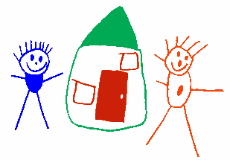

INTRODUCTION
To ensure the safety of all children when near water.

Muswellbrook Pre School Kindergarten will ensure that:
- Water play will be supervised at all times.
- Water play areas will be monitored to ensure safety of all eg slippery surfaces.
- Only fill water containers whilst in immediate use.
- All water holding containers will be emptied immediately after use and stored to prevent the collection of water to prevent a drowning risk.
- On excursions to areas where water is accessible, children are to be supervised with a ratio determined by completion of a risk assessment.
- The ratio of adult to child within fenced pool area will be 1 to 1. No pool filter should be accessible to children.
- If children are taken on an excursion where there is a beach, lake, river, dam or significant water hazard, there must be two adults that hold a senior first aid certificate and/or the knowledge and ability to implement water safety procedures.

Reviewed on 31 May 2017
Signed by | Name | Signature | Date
Committee
Nominated Supervisor

Due for Review May 2019

