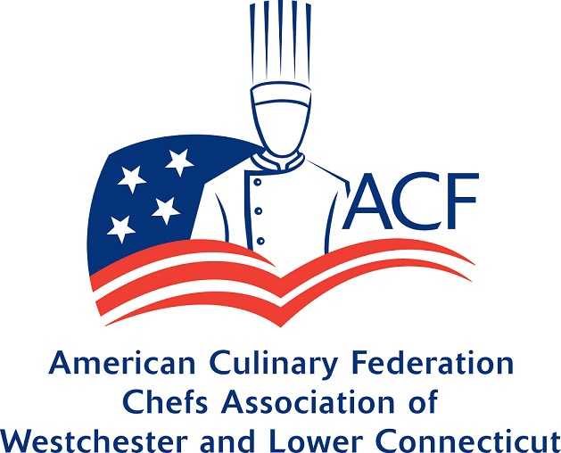

Chefs’ Association of Westchester and Lower Connecticut
2019-20 Calendar

Info: | Topic:
Monday,  September 23, 2019  6:00 pm  Meet & Greet  Light Dinner  6:30 pm Presentation  Meeting Location:  Path Coffee Roasters  106 Purdy Avenue  Port Chester, NY 10573  w. 888.649.1386  info@pathcoffees.com  Cost:  CAWLC Members $5.00  $10.00 for guests  Plus $5.00 at the door | Discussion and Tasting with Chocolations Owner Maria Valente  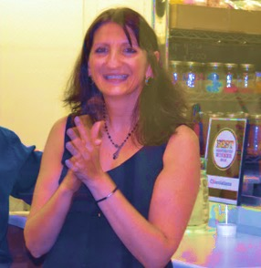  We are kicking off our season with a high-octane discussion on the state of the chocolate industry with the trade’s newest buzzwords: infused, vegan, locally produced, and sustainably acquired chocolate. Our newest CAWLC member, Maria Valente, will walk us through a variety of tasting samples of chocolate and discuss taste innovations in the chocolate world.  www.chocolations.com  The evening continues with Board Presentations:  - President Georgianna Anderson will provide an update on the ACF National Convention  - Vice Presidents Toni D'Onofrio and Emmy Creskey will discuss the upcoming calendar of CAWLC events  - Treasurer Lisa O’Gorman  Thank you to CAWLC members: Jason and Shanie Richter, Path Coffee Roasters for hosting our September meeting and to Kathleen O’Keefe, Smith Party Rental, for the rental of the chairs.
Monday,  October 21, 2019  6:00 pm  Meet & Greet  6:30 pm Presentation  Meeting Location:  Ace Endico  80 International Drive  Brewster, NY 10509  Cost:  CAWLC Members $7.00  Guests $10.00  Plus $5.00 at the door | Micro Greens at Ace Endico  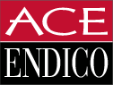  Executive Chef and ACF NY081 Chapter Member Chris Devine is our host for a microgreen discussion and tasting. Looking for a healthy and beautiful way to enhance your menu? Microgreens have more than 50 times the nutritional value of mature greens and can easily be grown in your garden. Rather purchase then grow? Sample east coast and west coast greens from Copper Crest from Long Island and Fresh Origins from California. Still hungry for more? Our own Chef Devine will be making pizza in the turbo Forza Forni oven.  A special thanks to Ace Endico for sponsoring this meeting. Originally a small business founded by William A. Endico and Murray Hertzberg in 1982 located in a small garage in Mt. Vernon, New York to a 200,000 square foot state-of-the-art food service distribution center in Brewster, New York.  Christopher Devine  Corporate Chef  Chef Christopher Devine attended the Culinary Institute of America in New York and has over 30 years of culinary management experience in private clubs and corporate environments. In Devine’s most recent position, he held the position of Executive Chef and General Manager at Trump Tower for 12 years and managed all events as well as scheduled all catering services. Devine also opened and operated six restaurant divisions for the Trump Organization including The Trump Grill, Trump Café, Trump Bar, Trump Store and Trump Ice Cream Parlor. With menu planning and business development under his repertoire, Devine provides culinary knowledge and consultation services for Ace Endico customers.  http://www.aceendico.com  * CEH credits awarded

Info: | Topic:
Monday,  November 18, 2019  6:00 pm  Meet & Greet  6:30 pm Presentation followed by Reception  Meeting Location:  Doral Arrowwood  975 Anderson Hill Road  Rye Brook, NY 10573  Cost:  CAWLC Members $15.00  Guests $25.00  Plus $5.00 at the door | Leadership Development  By Jason Wallace of Cornerstone Business Labs  This is a must attend event for next level education. During this seminar we take a deep dive into leadership development, emotional intelligence, and process improvement. The core curriculum of the seminar is based on the science biology, psychology, and IQ-Vs-El  The Skill of Emotional Intelligence  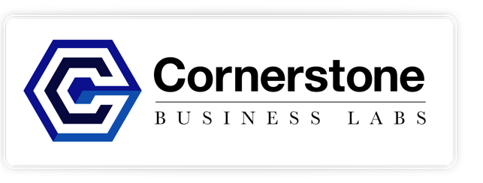  - Biology  - Psychology  - Self evaluations  The CEO in You  - How Your Brain Functions  - Your business needs  - Management - vs – Leadership  Jason Wallace, SSGB  The Restaurant Scientist ™  Regarded as one of the foremost authority on business mastery, Jason Wallace is an expert at helping business owners turn fledging businesses into highly profitable companies with explosive frowth. As a 30-year acclamined strategist, and educator, Jason advises emerging companies who are working to dominate their market. His insights help companies develop and omplement game changing leadership that yields maximum return on investment.  As an operational scientist, Wallace’s client list relects all genres of foodservice, including full-service restaurants, bistros, limited service cafes, quick service restaurants, catering, and institutional dining operations.  While consulting and overseeing nine US Navy foodservice facilities located in seven states including Hawaii, within 10 months Wallace’s scientific analysis and cost control procedures increased operating efficiencies that resulted in a reduction of operating expenses in excess of $300,000.  As a 14 year foodservice educator, Wallace has served as adjunct professor at the New York Restaurant School, the Art Institute, Hudson County Community College, and Westchester Community College.  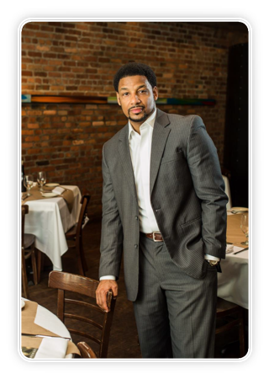  Wallace’s educational seminars for leadership development have been attended by prominent restaurant companies including: Dallas BBQ, Tonu Di Napoli’s, Bogota Latin Bistro, Domino’s Pizza, Dinkin Donuts, Ayza Wine and Chocolate Bar, Havana Central, Fatty Crew, Bierhaus NYC, and Atomic Wings. Wallace has been a 15-year active member of the New York State Restaurant Assocuation (NYSRA) holding various leadership positions such as Treasurer, Vicec Chairman of the Board of Directors and Chairman of the Board of Directors.  Don’t miss out on this incredible evening and chance to meet and learn from one of the industry’s top talents. Sign up today!  For more information visit: www.cornerstonebsinesslabs.com  CEH credits awarded  Thank you to Doral Arrowwood Hotel Conference Center, General Manager James Gambardella and Pastry Chef Stacey Cohen for hosting the CAWLC November meeting.

Info: | Topic:
Monday,  December 2, 2019  6:00 pm  Meet & Greet  6:30 pm Discussion and Dinner  Meeting Location:  Coromandel  Cuisine of India  30 Division Street  New Rochelle, NY 10801  914-235-8390  Cost:  Members $22.00  Guests $40.00  Plus $5.00 at the door | Executive Chef Andrew Payyappilly Deepens Our Knowledge about the Cuisine of India  Start the holiday season with Executive Chef and ACF NY081 Chapter Member Andrew Payyappilly as he guides us through the cuisine of India in a multicourse dinner buffet at his sister restaurant in New Rochelle. Andrew will navigate us through the complex spices and flavors found on Coromandel menus that often remain a mystery to outsiders. As the final meeting of the year, come eat, drink and celebrate with us!  The evening includes a multicourse buffet including a welcome beer or wine (21 and over) a variety of meat and vegetarian dishes, breads, dessert, and Madras coffee.  Andrew Payyappilly  Executive Chef  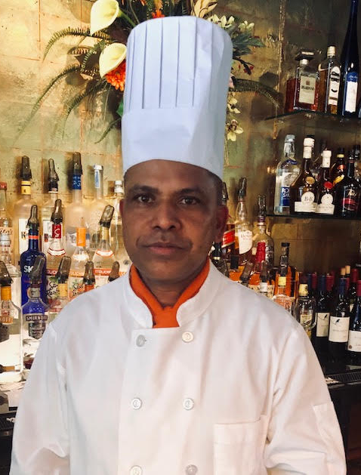  In 1994 Andrew completed, in India, a Bachelors degree in Hotel Management and Culinary Arts He then began a career with Carnival Cruise Lines, Miami, FL from  1994 – 1997. In 2000 through 2009 Andrew was a Chef at the Grand Old House Restaurant in the Cayman Islands. Since that time Andrew has been the Executive Chef at Coromandel Restaurant in Southport, CT.  http://www.coromandelcuisine.com/new-rochelle/
Monday  January 13, 2020  6:00 pm Meet & Greet  6:30 pm Presentation  Meeting Location:  Doral Arrowwood  975 Anderson Hill Rd, Rye Brook, NY 10573  Cost:  CAWLC Members $7.00  Guests $15.00  Plus $5.00 at the door | Tufo’s Presents: An Insider’s View of Select Purveyors  You survived the holidays: now a present for you. CAWLC Member and President of Tufo Foods, Steve Rapillo, has selected a favorite purveyor to present at our first meeting of the new year. With over 3,000 product lines it will be hard to guess who’s coming. Join us for a light dinner, a chance to relax, and an informative night.  Tufo’s is family-owned company and serves the New York Metro area since 1929. All items are purchased directly from manufacturers coast-to-coast, and thus afford our ability to offer the lowest possible prices. Tufo’s strives to become the chef’s complete food source.  Thank you to Doral Arrowwood Hotel Conference Center, General Manager James Gambardella, and Pastry Chef Stacey Cohen for hosting the CAWLC January meeting.
Monday,  February 3, 2020  6:00 pm Meet & Greet  6:30 pm Presentation  Meeting Location:  Westchester Community College  Student Center Bldg.  Valhalla, NY 10595  Cost:  CAWLC Members $5.00  Guests $15.00  Plus $5.00 at the door | Farm to Fork – Bringing Plant Based Cuisine to Life  Innovations in Plant Based Cuisine: Demonstration, Discussion, and Tasting  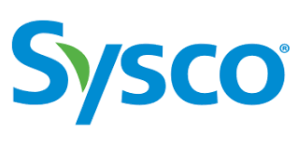  You asked, how do I move plant based and vegetables to the Center of the Plate? Join us for a presentation by Sysco Culinary Consultant, Chef Bill Brooks, on plant based foods and how to use them to gain maximum flavor and food cost potential. Chef Brooks will discuss the variety of plant based foods available through Sysco and how to use them to increase customer satisfaction by enhancing plant based foods flavors and textures. A sampling of a variety of plant based foods and a Q and A about their products will also be included.

Info: | Topic:
Monday,  March 9, 2020  6:00 pm  Meet & Greet  6:30 pm Discussion, workshop and tasting  Meeting Location:  Double Tree by Hilton Company  455 South Broadway, Tarrytown, NY 10591  Cost:  CAWLC Members $7.00  Guests $15.00  Plus $5.00 at the door | An Evening with Heimat New York presented by Ute Londrigan  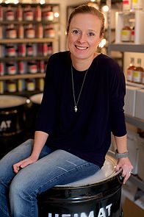  Join us on a liqueur journey with Ute from Heimat New York. Using high quality seasonal New York State fruits, Heimat handcrafts delicious liquors using traditional German recipes. The products are all natural with real whole fruit and naturally filtered for full body and expression. Produced only once a year, this is an exclusive tasting you won’t want to miss.  During the evening we will explore these liquors and how they can be used to create unique drinks.  www.heimatny.com  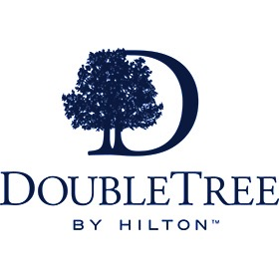  A special thanks to our hosts: DoubleTree by Hilton Tarrytown and the Director of Food and Beverage, Frank Troiano.
Monday  April 6, 2020  6:00 pm  Meet & Greet  6:30 pm Discussion, workshop and tasting  Meeting Location:  Atria Rye Brook  1200 King Street  Rye Brook, NY 10573  Cost:  CAWLC Members $7.00  Guests $15.00  Plus $5.00 at the door | Eco Prima Tea with Anupa Mueller  From drinking to infusing in ice cream or using as brine, tea has become an all-purpose kitchen staple. And what better way to increase your tea sales and use then with Anupa Mueller’s tasting and discussion on tea? Anupa will walk us through how to create the perfect cup from storage, to steeping and serving. Increase your tea sales or your own enjoyment of a cup of tea with this sampling and discussion.  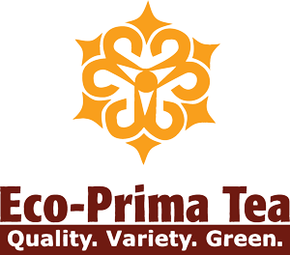  Eco Prima Tea Company Owner Anupa Mueller will help us understand the different types of tea; black, green, oolongs, herbals, decaffeinated, caffeinated. She will take the guesswork out of what sells, based on her years of experience as a tea distributor and business analytics.  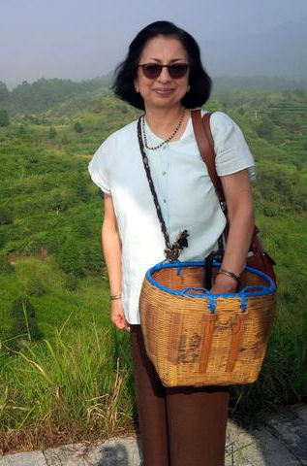  www.ecoprimatea.com  - CEH credits awarded  Thank you to Atria Senior Living Rye Brook and Executive Director Thamara Barbosa-Tirri for hosting the CAWLC April 2020 Meeting.
Like what you have seen so far?

Please consider telling your colleagues to join us!

Visit us on: Twitter @ChefsofWLC, Instagram: chefsofwestchesterlowerct

or Facebook @ Chefs’ Association of Westchester and Lower Connecticut

Info: | Topic:
Monday,  May 4, 2020  6:45 pm  Meet & Greet  7:00 pm Presentation  Meeting Location:  Greenwich Cheese Company  154 East Putnam Avenue  Cos Cob, CT 06807  Cost:  CAWLC Members $35.00  Guests $50.00  Plus $5.00 at the door (if available) | Old World vs. New World  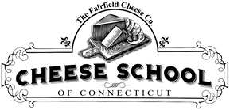  Back by Member Request, the class everyone loved with a new topic. Join us for an old world vs. new world continental taste off. We will pair four American artisan cheeses with four of their European counterparts (with wine, of course) for an in-depth side by side comparison. Have new school American cheesemakers taken old school European inspirations and turned them on their heads? Dare you attempt to improve upon the classics and do European cheeses still reign supreme? Whether you are a die-hard European cheese fan or an American locavore-patriot this class has you covered.  www.fairfieldcheese.com 21+ and proper ID required for tasting  Reserve early, limited space  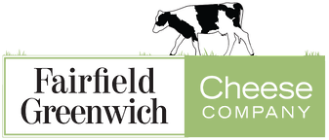  * CEH credits awarded
Wednesday,  June 3, 2020  6:00 pm  Meet & Greet  6:30 pm Dinner  Meeting Location:  American Legion Post 1038  27 Legion Drive  Valhalla, NY 10595  Cost:  CAWLC Members $7.00  Guests $15.00  Plus $5.00 at the door | Smithfield: Slow, Low, and Smoke  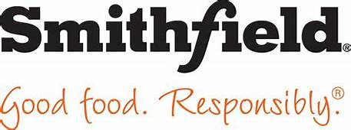  We've spent the last couple of years discussing the craft and science of cooking meat low & slow. The time intensive labor of love turns out some of the most desired dishes in America - smoked meats! Smoke is a flavor additive like salt and pepper. Let's take a look at the creative ways to add real smoke flavor to dishes without necessarily utilizing a commercial smoker and the 10+ hours it takes to cook meat low & slow, and how Smithfield's portfolio of proteins can be the perfect blank canvas to add that delicious smoke flavorwww.smithfieldfoods.com.  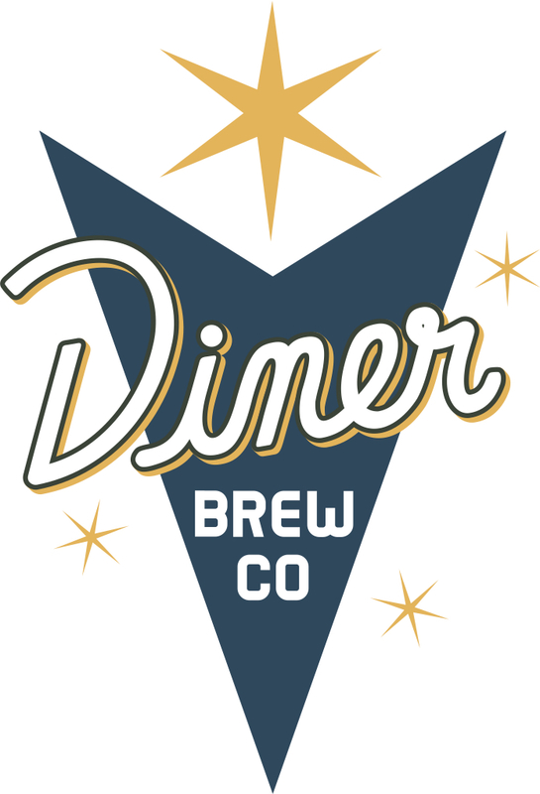  And since nothing goes better with pork then apples, the Mt. Vernon based Diner Brew Company will be talking about and pouring some of their great hard cider. Come and sample southern Westchester's premier cidery & brewery, focused on historical interpretation and forward-looking innovation to craft fine, hard ciders and beers for your enjoyment!  A special thank you to The American Legion Post 1038 in Valhalla, NY, Commander John Creskey and all the Post 1038 Legionnaires for hosting our June 2020 meeting!  