Cote Investigations & Associates LLC
Patrick L. Cote, Investigator/Consultant 1816 North Desert Willow Street Casa Grande, Arizona 85122 AZ License #1560782 Tel. (520) 560-3547 patrick@coteinvestigations.com www.coteinvestigations.com

To: Christopher Handy, Pro Per and Steven Czop, Advisory Counsel
From: Patrick L. Cote, Investigator
Subject: State vs Christopher Handy CR 201900100
Date: October 19, 2022

I was appointed to assist Pro Per Christopher Handy and advisory counsel Czop for a Rule 32. This was an incident that occurred on January 5, 2019, at 2225 hrs (10:25 pm) at E Julia Court, San Tan Valley, Arizona. He was convicted by Jury on 11/13/2019. The charges were Attempted Second Degree Murder, Two counts of Aggravated Assault, Two counts of Endangerment, and Discharging a Firearm at a Residential Structure. All charges were alleged as dangerous nature offenses. On 12/23/2019, he was sentenced to 16 years in the Arizona Department of Corrections.

I reviewed the information provided and noticed that there were no defense investigators on this case to assist counsel prior to trial. Attorney Elizabeth Hale was appointed for the Rule 32, and subsequently Private Investigator Larry Rives was appointed. Attorney Elizabeth Hale withdrew because of a conflict and Investigator Rives was no longer on the case. I reviewed the extensive analysis for the direct appeal by Private Investigator Connie Mayhugh of HSH Investigation, LLC, Greeley, Colorado. The report was dated 11/10/2021. She specializes in appeals. I spoke to the investigator on the phone about her analysis and conclusion. The report raises specific concerns about the investigation and ineffective counsel. I would strongly recommend using this report by Connie Mayhugh as an exhibit to the Rule 32 Supplement. I specifically reviewed the areas she had discussed in her report that I will be addressing. In addition, I spoke to Private Investigator Larry Rives, who had similar concerns regarding ineffective counsel. I am going to highlight the areas of concerns in my discussion.

On January 5, 2019, at about 10:25 hrs, Christopher Handy dropped off his friend, Richard Casan Jamison at the end of the cul-de-sac on E Julia Court, San Tan Valley. As he was driving away to leave the area, he saw someone in the roadway close to his vehicle. He stopped and got out of the car. According to Handy, this person (Winner) came after him and he had to push him away. The second time, Handy testified that he pushed Joe Winner and they both stumbled. He tried to step back, and Joe came at him again. Handy had a fractured knee from an injury in December 2018. When he stumbled backwards his leg buckled. As a result, the gun discharged. Winner sustained a wound to the back of the head.

The state contends that Winner was shot. The defense hired Ron Scott, a gun expert to challenge the state’s testimony regarding the trajectory of the bullet. According to the testimony by Justin and Michael, if Joe Winner was standing facing Handy, then how did the injury to the back of the head occur if the gun was pointed at the front of Winner’s head. The jury convicted Christopher handy on all counts.

I have used defense expert Ron Scott in another case. I am familiar what he can testify to. He is a gun expert and can testify to the safety features of a semiautomatic pistol. He can testify to the trigger pull. The trigger has to be pulled straight back in order to fire. The question remains whether there was an accident discharge caused by an inadvertent pull of the trigger. If there was an accidental discharge of Handy’s firearm, then he should not have been found guilty of these criminal offenses. Defense counsel should have explored these issues further. I believe Ron Scott was the wrong expert to opine on trajectory and wound pattern. I might add that I was a police firearms instructor and NRA firearms instructor and trained many civilians at my former police department in Bristol, Connecticut. I am well aware of firearms safety and potential for accidental firearms discharge.

The following are areas that should have been explored further by defense counsel. Someone should have gone to the scene of the incident and check the lighting and weather conditions. Mr. Handy stated that the conditions were dark and raining. The first question is the visibility. The witnesses stated they could see the handgun pointed at Winner. Keep in mind that all the witnesses were together and not separated before and after the police arrived.
Lighting Conditions

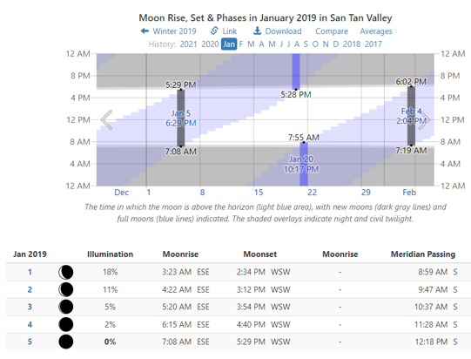

I went out the area of E Julia Court, San Tan Valley to check for streetlights and did not find any. A neighbor told me it is very dark in this area. According to the chart dated January 5, 2019, the illumination was 0%. If this is the case, then it calls into question what the witnesses could have seen at the time of the incident. The police brought in their Light Banks to illuminate the crime scene area.

Medical Records

Defense counsel should have asked for Christopher Handy’s medical records. Christopher stated that his right leg buckled, and he inadvertently pulled the trigger because of the sudden jolt in his leg. These records should have been introduced during the trial. The doctor who was treating Christopher should have testified to his injuries. Normally, Christopher wears a brace on his right leg but he took it off so he could drive the car. I understand that a juror told defense counsel, he may have reconsidered his verdict if the medical records were introduced during the trial. This was an important issue so it should have been addressed at trial. There is a major difference between intentionally shooting a person versus an accidental discharge. The medical doctor who treated Christopher Handy should have been called as a witness.

The Crime Scene

This is the important part of the investigation. The police investigated and interviewed witness, took photos and measurement. I believe the wrong conclusion was reached by the investigators. It is impossible to have a gun pointed point blank at an individual’s head and suffer a bullet wound in the back of the head. After reviewing the police report and viewing the photos the way the incident unfolded defies common sense, physics and logic. A person shot point blank would be shot in the front of the head and killed instantly. There is no magic bullet where it would curve around to the back of the head. The angle is wrong. An explanation was made that the victim ducked and this explains the wound at the back of the head. This is impossible. A person shot at that close range would not have time to duck, so what is the explanation for the wound on back of the head if it was not a gunshot wound?

After having viewed the photos of the crime scene, I noticed the final resting point of the bullet that lodged into the bench in the garage.

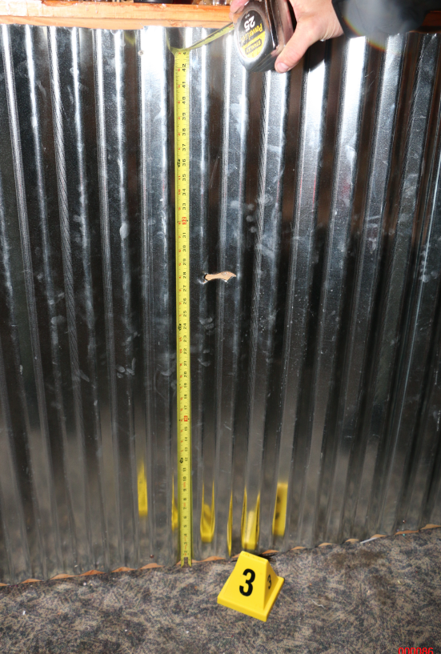
The detective is measuring the distance from the floor to the location of the bullet impact into the bench located in the garage.

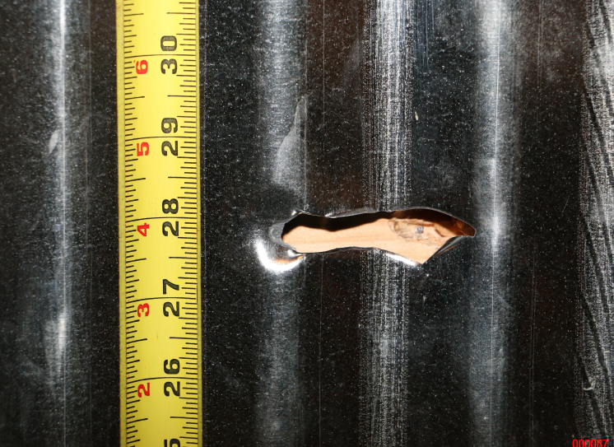
The location of the bullet impact is 28 inches from the floor, and it appears to be horizontal.

The police did not consider this evidence. It appears the bullet traveled in a straight line from the muzzle of the barrel. There was no angle downward. The defense firearms expert went to the scene with the detective. He had photos to check the ejection pattern to see where the shooter was located. Based upon the defense expert’s height of 5’11” he determined Handy (6’2” or 74”) would have to hold the firearm 50 to 58 inches to match the impact of the bullet 28 inches off the floor. However, it all depends upon how you hold the firearm. Witnesses saw the gun being held sideways but it was pitch dark. Mr. Scott did not do a diagram or determine the elevation of the driveway. Also, there is no diagram or report.

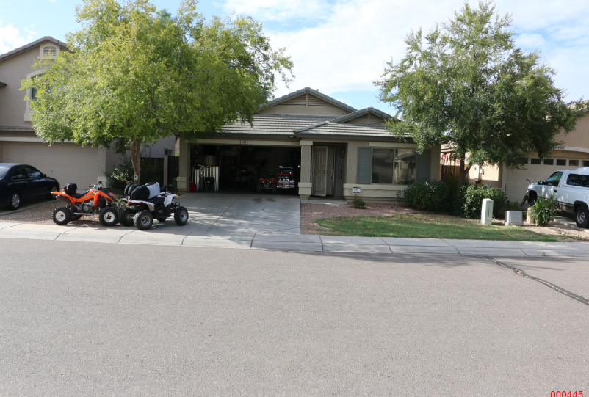
This daylight photo was taken on 9/26/2019. Then incident occurred on 1//05/2019. Bates 00445

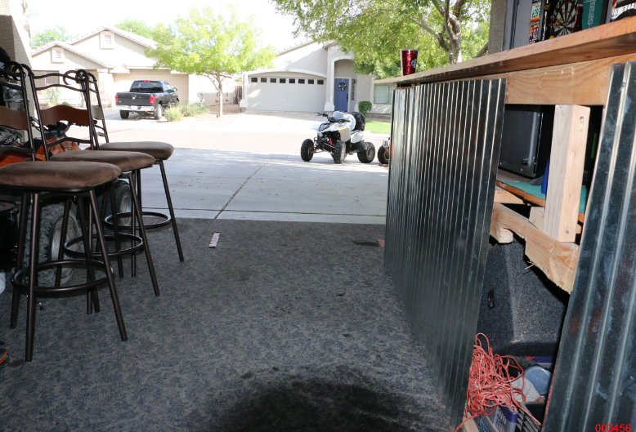
This is the view from the bench to the street. There is an elevation from the street to the garage. Bates 00456

What was needed here was a diagram and a report. The police only took a measurement from the floor to the bullet impact on the bench. The police investigation of the actual crime scene was incomplete. What is needed was a complete analysis of the crime scene along with measurements and diagram. The elevation from the street to the garage level needed to be determined. Estimates are not sufficient for this crime scene. The defense needed a Crime Scene Reconstruction Expert to make a more precise determination to see how the firearm was held to make a horizontal bullet impact on the bench in the garage.

Wound Pattern

In viewing the photos on the wound pattern on the back of Winner’s head, it does not look like a bullet wound pattern or a graze wound. Private Investigator Connie Mayhugh went into great deal explaining the origin of the wound and discussing graze wound research. I agree with Investigator Mayhugh’s explanation and conclusion regarding origin of the wound.

I viewed all of the photos and read the testimony of the Dr. Julie Wynn. It appears to me that the wound on the back of Winner’s head was not caused by a bullet but occurred when he fell and struck the back of his head on the curb. He was highly intoxicated. If Winner was struck in the front of the head, he would have been dead. The bullet will not somehow curve to strike the back of the head. This is impossible. The bullet wound is not a “through and through” as she testified to during the trial. I have seen many gunshot wounds during my career as a police officer and as a private investigator. Most of my cases are homicides and capital cases. I know a gunshot wound when I see one.

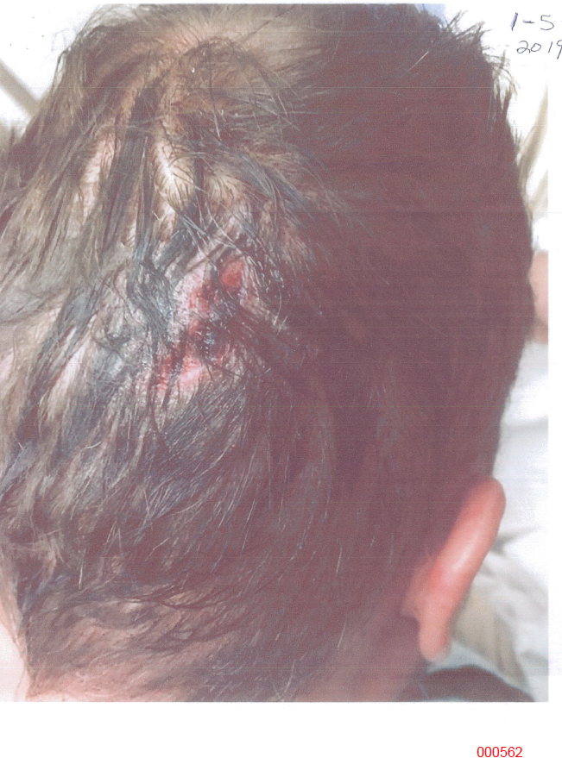
The wound pattern is jagged and goes from about 1 o’clock to 7 o’clock. This is not a bullet graze wound. This most likely occurred when Winner struck his head on the curb. Bates 00582
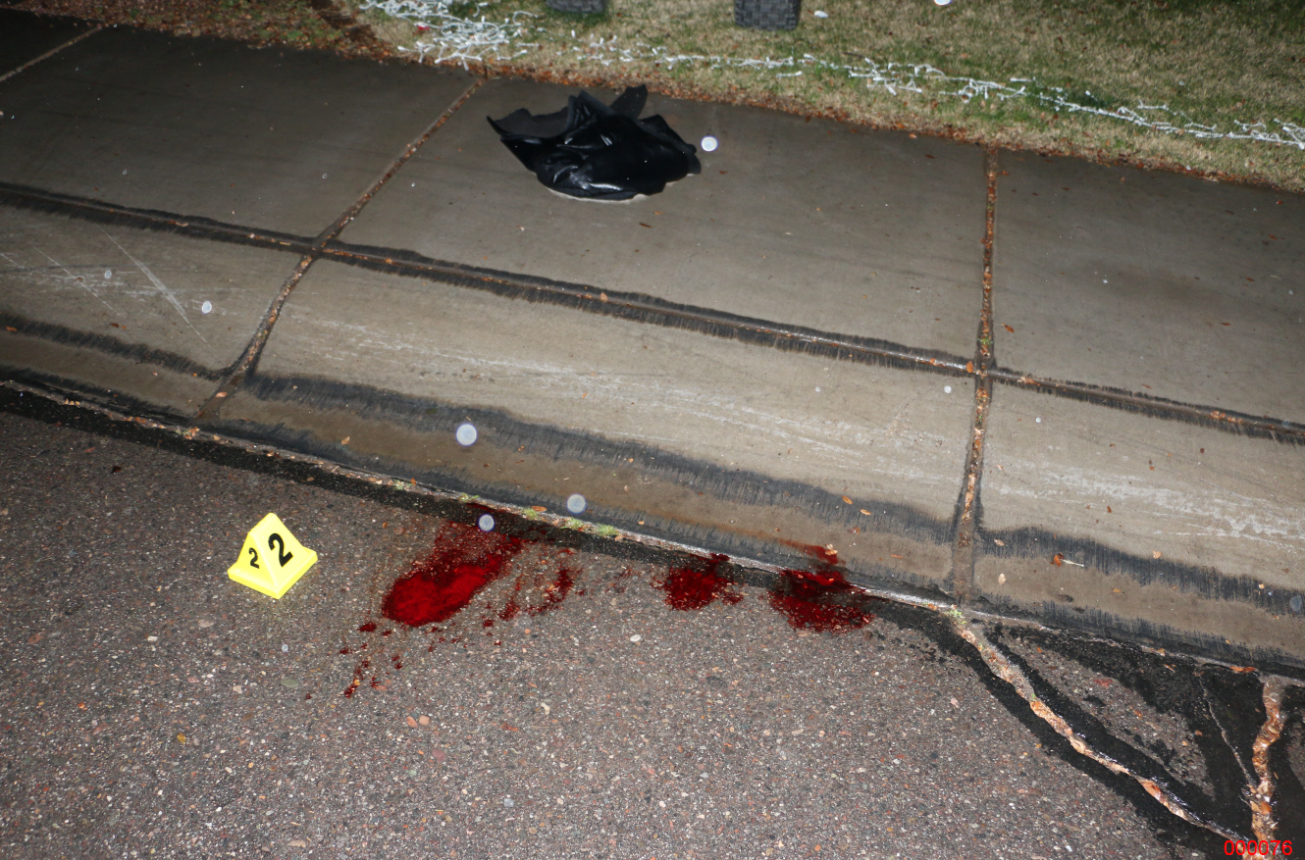
The blood can be seen at the base of the curb. Bates 0076

What was needed here for an examination of the wound pattern is a Forensic Pathologist. An expert should have been retained to review and testify to the wound pattern. Dr. Wynn can testify to the treatment of the wound, but she is not a forensic pathologist. There was no further testing of the recovered bullet itself for DNA.

Defense Witness

Someone from the defense should have contacted Richard Casan Jamison who lives a 1332 E Julia Court. He testified at trial. He could have been a critical defense witness to validate Christopher Handy’s version of the events that night. Christopher Handy dropped off his friend at his home. He could have testified to the lighting and weather conditions at the time. He also could have testified to Christopher’s demeanor. You cannot rely upon the police to contact a defense witness even though there was an attempt to interview him. More specific information should have been asked on direct examination.

Self Defense

Defense counsel should have noted self-defense as a defense on this case and asked for a jury instruction. There was a confrontation with Winner when he was almost hit by the vehicle. Winner was highly intoxicated and was in Christopher’s personal space within 1 to 2 feet. He was allegedly grabbing and pushing. Christopher heard a dog and saw him in the corner of his eye. He had his firearm when he saw the dog. The witnesses were together before the police arrived. The witnesses could have very easily collaborated on what they saw. It was questionable when they could see in the darkness.

Court Statement

The court made some interesting statements as follows:

“I’m going to stop you right there. The testimony that you choose to emphasize, the ballistics expert, the guy who has no medical training whatsoever and apparently the jury disregarded.
The – not the medical professional, a 20-year trauma surgeon who said it’s a through and through gunshot that you ignored in all your motions. Did not emphasize in any way, shape or form.
You’ve relied on a nonmedical ballistics expert who have testimony that bullets don’t – that bullets travel straight, which for anybody who has any kind of common sense bullets travel straight until they hit something and then they can be misdirected depending on what they hit. – 39
There’s one piece of evidence that you choose to ignore, choose to ignore through your entire closing statement, and the jury chose to disregard your argument is that there was a through-and-through gunshot wound in the back of his head -39
There was the evidence of the doctor, and that misstates the facts that was presented to the case. That appears to be where they hung their hat on in this particular case. And I can understand why, because she’s a 20-year trauma surgeon” – 40
Summary
This was an example of a poorly investigated incident that unfortunately resulted in the conviction of an innocent person. Assumptions were made to fit the scenario by the police. I believe the police arrived at the wrong conclusion. There is a strong possibility that this was an unfortunate, accidental discharge of a firearm. Christopher Handy had a leg injury and according to his statement his leg buckled resulting in a jolt to his body and an inadvertent discharge of his firearm. The defense would have benefited by the medical doctor who treated Christopher and could testify to his medical condition and lack of mobility.
Joseph Winner was highly intoxicated and there was testimony and medical records to this effect. Winner fell backwards is the most reliable explanation for his injury. He knocked himself out. This was evident because Christopher stated to me that Winner was snoring. There was blood at the base of the curb and a photo of Winner lying on the ground.
This case needed a Forensic Pathologist who could testify whether this was a bullet wound or a wound from impacting his head on the curb. Hitting his head on the curb or blunt force trauma is more likely the cause of the wound.
The defense needed a Crime Scene Reconstruction Expert to do an in-depth analysis of the crime scene. The defense firearm expert went to the scene with the detective to take some measurement. There was no scene diagram by the police. The defense expert did not create a diagram or author a report. Only the height of the bullet impact on the bench in the garage was taken. There was a horizontal impact on the bench, so the bullet had to travel in a straight line from the muzzle of the gun. What was missing was documentation of the distance from the street to the bullet impact. All we have is a probability. The elevation of the driveway was missing. We know there is an elevation increase from the street to the garage floor. The firearms expert made a judgment that the gun would be held 50 to 58 inches from the road to make the impact. We do not know how the firearm was being held. Christopher Handy is 6’ 2” tall or 74 inches. I believe an effort should have been made to reconstruct the events for a more accurately determination and analysis. The jury was presented with incomplete information.
The defense should have asked more specific questions to a Key Defense Witness, Richard Casan Jamison who resides at 1332 E Julia Court, San Tan Valley. He could have provided important testimony regarding the events that night if he had been interviewed by a defense investigator first.
Last, the Self Defense notice should have been given as a jury instruction. Winner was highly intoxicated and aggressive. He kept grabbing and bumping into Christopher and there were concerns that Winner was being overly aggressive.
In the end, the jury had incomplete information to make an informed decision. They could only go by what was presented during trial. If the firearm was accidently discharged, then Christopher Handy should not have been convicted of Attempted second degree murder, two counts of Aggravated Assault, two counts of endangerment and discharging a firearm at a residential structure. I do not believe there was any intent to commit these crimes.
I believe that strong consideration should be given for Christopher Handy to have a new trial. It appears to me that he did not get a fair trial. Justice was not served. In this particular case the truth was not discovered.

Sincerely,
/S/ Patrick L. Cote
Patrick L. Cote Investigator/Consultant

