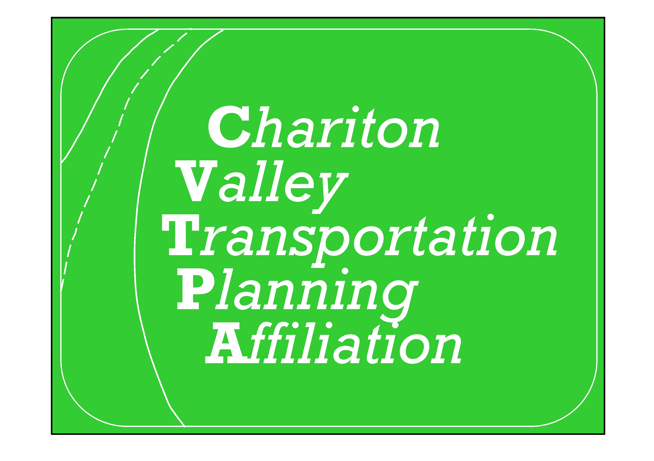
Chariton Valley Transportation Planning Affiliation
308 North 12th Street
Centerville, Iowa 52544
641-437-4359 – phone
641-437-1161 – fax
www.charitonvalleyplanning.com

_______________________________________________________________________________________________________________________
TIP -County Project Selection /Project Amendments
Engineer – Project Submission Sheet – 1 per project
Due; April 15th annually
Sponsor -County/City :______________________________________________________________________________________________________________________
Contact Information: ___________________________________________________________ Phone: ____________________________________________________
Email: _______________________________________________________________________________________________________________________________________
Full Project Number:____________________________ ____________________ TPMS #:__________________________________
Full project description: _____________________________________________________________________________________________________________________
_______________________________________________________________________________________________________________________________________________
County Engineer:
Prefix/Alpha code: _______________________________________________________________________________________
Route #: _________________________________________________ Road ID: _________________________________________________
# of Lanes: ______________ Length: ____________ AADT: ___________ FHWA#: ______________________
Type: ___________________ System: ______________ FFC: ______________ CRD: ___________________________
PA: _____________________________ DOT: ____________________________________________________
Sponsor/Route Type: _________________________ Sponsor/Route: ________________________________ Paren Value: ___________________
(CRD: County – Farm to Market: STBG)
Worksite County: ____________________________ County Work Code: ___________________DOT Work Code:___________________________
Project Expenses to be programmed:
Funding Sources | FY | FY | FY | FY | Funding Totals
Local Funding
Farm-to-Market Funds
Special Funds (Spec, ILL, RISE, LOST, FEMA, Other)
Federal Aid (STBG State or Region, HBP, SPR, NHPP, TAP State or Region)
Other:
FY & Project Totals

Checklist:
Request change by: Amendment________ Admin Mod ______________ New submission _______________
Does it meet LRTP Goals? Yes ___________ No _____________ if No, why? ___________________________________
Which Goal does it meet? ________________________

Application Review Process:
Reviewed by TAC Committee: ___________Date ________________________________
Reviewed by Policy Board: _____________ Date ________________________________
Award amount of request: ___________________________
Other Discussion: __________________________________________________________________________________________________

Signature: __________________________________ Date: ___________________________

CVTPA – RPA17 – LRTP Plan Goals & Objectives
(resource for application)
- Promote Economic enhancement throughout the region.
  - Improving existing transportation systems support marketing efforts of recreation and tourism throughout the region.
    - Support rail transportation systems for economic benefit
        - Southern Iowa Railway (formerly APNC) maintenance and/or expansion to ensure longevity of service
        - Continued Amtrak service
        - Pursue safety improvements at rail crossings
        - Grade separation structures - Bridge underpass/overpass funding
        - Support initiative to ship rock to local counties by rail.
    - Research use of the current passenger and short line rail system and proposed expansion of statewide systems;
        - Promote transportation facilities leading up to regional railroad lines
        - Maintain & keep Amtrak service in the region.

    - Research each county’s needs and capital improvements plans;
        - Develop or improve roadways as needed to enhance economic development
        - Encourage cities to have “site ready” development areas to promote new business growth & current business expansion (IEDA Certified Sites).
    - Support local commercial and passenger air services for future growth and needs.
        - Expand runways as needed to promote economic development (Lamoni, Centerville, Chariton)
        - Support facility updates and expansions at airport facilities to ensure quality services such as offering jet fuel and onsite personnel.
        - Promote access to existing airport facilities such as turning lanes, signage, etc.)
    - Support Community/County enhancements associated with transportation related projects.
        - Sustain Historic Hills Scenic Byway
        - Environmental mitigation activities such as storm water management and reduced wildlife mortality.
        - Historic preservation of transportation facilities
        - Construction of highway turnouts, overlooks, or viewing areas
        - Trails development & maintenance
        - Safe Routes to School
        - Support efforts to develop the old Jefferson Highway Heritage Byway.

  - Encourage coordination between cities and counties within the region to promote increase of populations, possible growth in commuting labor force, and quality infrastructure in smaller communities.
    - Send press releases to legislators, county governments, and policy makers regarding priority needs for future projects;
        - Include documentation that RPA 17 is in opposition of mandatory transfer of jurisdictions from state to local without local consultation first.

    - Implement outreach information via electronic, print, and video media.
        - Develop website with funding information, IDOT, & consultant contact information
        - Develop Small city funding brochures to roadway development in order to educate council members on the process and all requirements.
        - CVPD website will host links to Farm to Market road maps, major collector routes and describe frequent challenges with expending federal funds.

    - Partner with small cities to utilize regional funds.
        - Organize an annual “CVTPA Bootcamp” directed at county/city level elected officials to inform on the process transportation funds.

- Provide adequate, safe and reliable transportation services.
  - Maximize safety of intersections by monitoring sign size, reflectivity, flashing lights, approaches to intersections, speed zones, and school zones.
    - Safety Audits
        - All counties in the RPA 17 participate in DOT program
        - All counties in the region should develop a Local Roads Safety Plan.
  - Target and prioritize road maintenance of the region including resurfacing, rock, etc.
        - Continue ongoing rehabilitation of existing roads and bridges
        - Additional rumble strips
        - Solar powered road signs
        - Explore (encourage private individuals) to develop new railway shipping sites or vendors.
  - Consider all funding options (including alternative methods) for infrastructure improvements to replace bridges and approaches.
        - Explore Federal, State & Local options
        - TIGER grants
        - Highway research board at IDOT

- To provide accessible and efficient transportation options.
  - Encourage alternative modes of transportation throughout the region (i.e. aviation, bike/pedestrian trails, rail and/or transit).
        - Develop trails to increase quality of life
        - Promote community efforts to repair or construct sidewalks for safety, mobility, and ADA compliance
        - Safe Routes to School
        - Promote available TAP funds to support projects
  - Improve transportation links to adjacent regions.
    - Utilize existing local and regional organizations to implement the four-year goals;
        - Partner with adjacent counties to develop regional projects across multiple counties to create greater “regional projects”.
    - Work with local stakeholder committees in all counties & surrounding jurisdictions
    - Identify committee’s needs, concerns and information regarding regional needs.
        - Gather info at regularly scheduled TAC & Policy meetings.
    - Provide information to both TAC & Policy committees.
        - Invite presenters from a variety of modes in the region to display successes, challenges, & needs.
    - Regional Trails Network
        - Create Regional Trails Plan
        - Develop trails to increase quality of life
        - Maintain and promote connection of existing trails
        - Increase safety on RPA 17 trails
    - CVTPA promotion/education of current projects in the region
        - Issue a press release sharing what approved projects will be occurring each calendar year in the RPA 17 region.
          - Engineers bring list of projects to March TAC meeting
  - Educate citizens of the options for transportation in rural areas of the region.
    - Promotion of trails, transit, rails, taxi, aviation, etc.
        - Promote passenger rail opportunities throughout the region
        - Utilize local TV, radio, printed media, social media, & websites
  - Support efforts to offer affordable and safe public transit services.
    - Advocate transit facility improvements for 10-15 Transit and Southern Iowa Trolley;
        - Study the feasibility of construction or purchase a flee maintenance and storage facility for Southern Iowa trolley.
        - Support 10-15 relocation to independent location (ACCOMPLISHED 10/2016)
    - Promote continued funding of transit capital and operating needs beyond existing levels;
        - Replace or expand Southern Iowa Trolley or 10-15 Transit fleet as needed
        - Upgrade or add equipment such as cameras, lifts, & tablets to monitor ridership and drivers
    - Determine needs of transit systems and convey to stakeholders and public sectors.
        - Host countywide needs meetings to identify where improvements are needed.
    - Provide public informational meetings for transit use, availability & accessibility.
        - Develop voucher system for those not able to pay for public transit

