**Revitalization and Resilient Building Improvement Program**

**A new kind of ‘Smart’ City**

The historic devastation seen in 2017 will be forever in our minds and hearts as we watch communities and individuals struggle to rebuild in multiple places at once. The hardest hit areas are faced with historical destruction, which makes a full recovery lengthy and challenging, but **not impossible**. The FEMA *Public Assistance Alternative Procedures Pilot Program Guide for Permanent Work* sets a precedent to support single, holistic, recovery projects.

We conceived a self-sustaining, holistic solution to specifically address the needs of communities all across the United States, and worldwide. We propose to rebuild disaster struck communities with resilient, renewable, self-sustaining structures that will engineer disaster-resilient infrastructure, and create jobs for hundreds of people.

The Fond Development Group (www.fonddevgroup.com), a dba of the Joint Venture between FOND LLC (www.fondllc.com), a Florida Limited Liability Corporation, a leader in Commercial Loan Brokerage, Development and Construction/Project Management, and Mitigation and Resilience Strategies (MRS), LLC (www.mitigationandresiliencestrategies.com), an Oklahoma Limited Liability Corporation, a leader in Proprietary Disaster-focused R&D, Holistic/Self-sustaining/Renewable Building and Design, Emergency Management, Resilience-focused Design and Planning, Risk Management, and Grant Management/Administration.

The Fond Development Group is the place where solution-based inventions, resilience-focused designs, and strategic implementation practices are born. We believe in designing, building, and leaving a legacy of stronger more resilient communities for future generations.

Through its’ JV Partnership with MRS, The Fond Development Group brings Dealer/Distributor relationships industry leaders with specific expertise to make this project work holistically. Some of these industry-leading companies are Globalstar, OGE, Gr8Water, ICF Construction and More, LLC, Quad-Lock, EcoJohn, PortaFloor, US Flood Control, and more.

Before we discuss the details of the program, we would like to explain how we propose to finance a project of this magnitude, as well as the benefits to FEMA and the federal government.

**Funding & Financing**

***The PA Pilot Program***

In 2013, the Sandy Recovery Improvement Act (SRIA) (P.L. 133-2) became law and amended the Robert T. Stafford Disaster Relief and Emergency Assistance Act to add Section 428. This section authorizes the implementation of the PA Pilot Program.

Some of the necessary alternative procedures include but are not limited to the following:

* “…an in-lieu contribution, without reduction, on the basis of estimates for repair, restoration, reconstruction, or replacement of a public facility and management expenses (i.e., eliminates the penalty for alternate projects under sections 406(c)(1)&(2) of the Stafford Act).
* Allows for consolidating, as determined by the Administrator, the facilities of a state, tribal or local government, or owner or operator of the private nonprofit facility as a  
  single project based upon estimates adopted under the procedures.
* Allows for the Administrator to permit a recipient1 or subrecipient to use all or part of the excess funds for cost-effective activities that reduce the risk of future damage, hardship, or suffering from a major disaster and other activities to improve future Public Assistance operations or planning.
* Requires the Administrator to make available an independent expert panel to validate the estimated eligible cost if requested by a subrecipient, and where the Administrator or the certified cost estimate prepared by the applicant’s professionally licensed engineers has estimated an eligible Federal share for a project of at least $5 million.
* Requires the Administrator, at a subrecipient’s request, to consider properly-conducted  
  and certified cost estimates prepared by professional licensed engineers (mutually agreed upon by the Administrator and the applicant)” (FEMA, *Public Assistance Alternative Procedures,* pp. 1-2).

According to FEMA (2016) “The permanent work pilot program is effective for any major disaster declared on or after May 20, 2013,” and is specifically for “large projects” for “subawards where the total estimated cost of eligible work, reduced by any actual or anticipated insurance proceeds, meets or exceeds the large project threshold²” (p. 2).

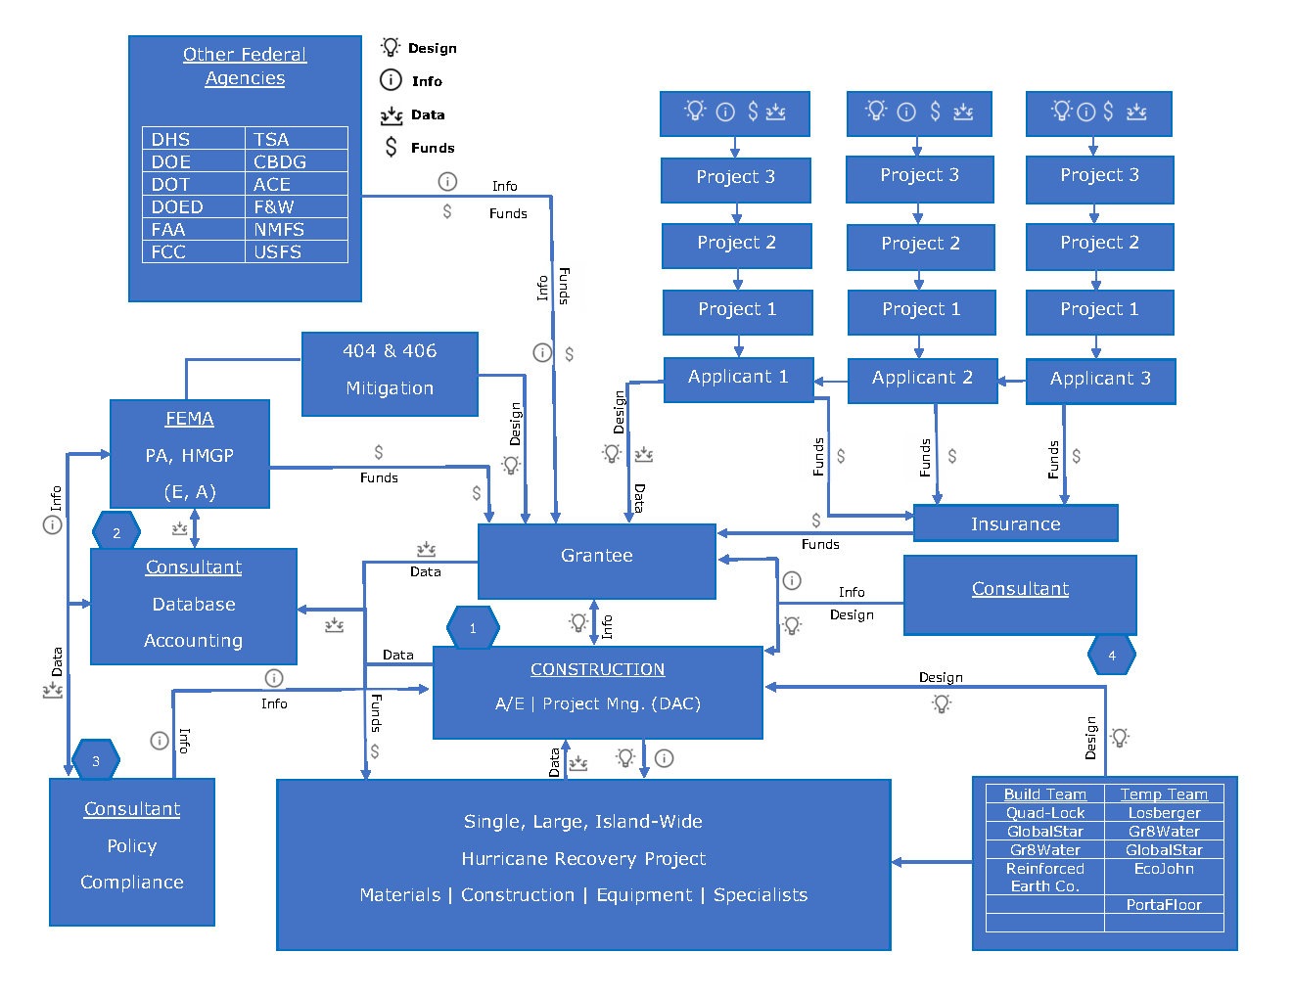

There are two parts of the Pilot Program that are crucial to the applicability of our program; 1) *Elimination of the Reduction in Eligible Costs for Alternative Projects*, and 2) *Use of Excess Funds.*

1. ***Elimination of the Reduction in Eligible Costs for Alternative Projects***

FEMA (2016) outlines the following:

“Under standard procedures, FEMA reduces the Federal share of eligible cost for alternate projects in accordance with the requirements of sections 406(c)(1) and 406(c)(2) of the Stafford Act. FEMA will not apply this reduction to subawards funded under the alternative procedures pilot program. This provision applies only to projects for which the subrecipient requests alternative procedures for a subaward based on a fixed estimate. Subawards approved and obligated under standard procedures are not eligible for elimination of the reduction in eligible  
costs for alternate projects. All alternate project scopes of work require FEMA’s review and approval in accordance with PA Program requirements” (p. 14).

1. ***Use of Excess Funds***

As defined by FEMA (2016) “Hazard mitigation activities that will reduce the risk of damage in future disasters. The subrecipient may use the funds for hazard mitigation on facilities not damaged in the declared disaster,” and “activities that improve future PA Program permanent work operations, such as training and planning for future disaster recovery operations” (p. 15) are considered acceptable.

**How the Pilot Program Works for the Program**

The state or local government operates as the legal representative (recipient) for the local jurisdictions who wish for them to do so. All eligible funds found for these sub-entities (sub-grantees) are assigned to a group fund established for the sub-entities as a whole but tracked as individual funding for each one. All projects are considered to be Alternative Procedures (Pilot Program) for permanent work, and the funds can be expended, in essence, as an improved/ alternative project. If a sub-recipient decides not to participate with the state or local government, they can follow standard FEMA procedures. However, if the sub-recipient chooses to opt-out of participation, they will **not** **receive** the additional close-out and project tracking assistance, and will **not be eligible** to be part of the Revitalization and Resilient Building Improvement Program. However, they may qualify for consultant representation and a case-by-case basis for additional private funding made available through this program. As an added benefit, Lewis Howard, CDO-MRS LLC-FOND LLC, has an intimate knowledge of this program and an in-depth familiarity with the processes within, as well as other programs and procedures.

Mr. Howard’s vast background shows his previous experience with executing a project and interconnecting multiple federal entity funding within a single grant. The technical report he authored was used to incorporate three (3) government agencies, the FAA, TSA, and FEMA, into a single airport improved reconstruction project in Louisiana, as well as to provide estimated breakdowns and grant funding breakdowns. These breakdowns outline each agency’s obligation to allocate their funding to a single project fund. Mr. Howard developed the grant for FEMA by using the policy and funding from all three entities to categorize the project scope into eligible work for each federal agency. This project was fully funded and, at present, is currently undergoing close-out procedures by FEMA and the state of LA. The FAA and TSA completed their review and grant proceedings.

As outlined in the PA Program and Policy Guide (PAPPG), eligible and reimbursable services include but are not limited to, project management and design services including activities such as procurement, document review, construction management, engineering and design services, construction inspection, and more. In fact, if the project is considered one, large recovery project administered directly by the grantee, it is feasible for a single company with the above-suggested team structure, to manage it efficiently. Once a contract is established between the state or local government and the team, ‘the’ consultant, an Amendment may be drafted to include the necessary Scope of Work, involving the management of construction projects and the administration of grant operations. Working together as a team provides a capable platform of expertise and industry experience to facilitate these projects.

The Pilot Program is similar to procedures used by state contractors during a large-scale disaster event. For instance, the grantee hires a consulting firm to assist in all processes in the management of the disaster. Often, sub-grantees hire consultants of their own to help them do the same. In effect, duplicating the same work and cost that most times generates an adversarial environment between the grantee and sub-grantee.

For a more detailed plan description, please contact Mr. Howard: [lewis@fondllc.com](mailto:lewis@fondllc.com) or [lewis.howard@mitigationandresiliencestrategies.com](mailto:lewis.howard@mitigationandresiliencestrategies.com).

***Commercial Investment***

A number of options are available through commercial funding for projects of this magnitude, and each one will be as unique as the development. We evaluate the project holistically to determine the viability of multiple forms of financing options. Traditional Lending is one of the many ways of financing a project, as well as Bond Financing, Infrastructure Investors, Private Equity Partners, and so on. There is no one way to describe the process of securing additional funding, but we have the knowledge to assist in the process from start to finish.

Another applicable advantage to Government and Commercial Funding is to combine it with a Public-Private Partnership.

**The Advantages of a Public-Private Partnership (P3)**

Additional benefits from a Public-Private Partnership (P3) in conjunction with our solution include, but are not limited to the following:

* Resources for projects not entirely funded by FEMA and insurance will be immediately available through the private backing aspects of the program.
* Commercial investors will be motivated to input capital for the community’s recovery as the joint project(s) will generate revenue for investors when completed.
* Holistic community design and development to build mitigation into the entire community to harden infrastructure and structures against similar and even worse events.
* The ability to leverage intellectual and monetary capital into a unified goal with a tangible, achievable, and measurable outcome.

**Project Design and Function**

To provide the safest, energy-efficient, self-sustaining, and resilient design possible, we’ve incorporated a proprietary product invented by Belinda A. Bentley, Ph.D., A. Lewis Howard, and Anthony Fond, designed to address the destruction and devastation caused by hurricanes.

The revitalization and resilience project includes but is not limited to:

* New renewable energy structures (residential, commercial, industrial, and governmental)
* Renewable retrofitting to any existing structures
* Commercial Building Automation Systems
* New underground/aboveground power infrastructure
* Clean water infrastructure
* Water infrastructure fitted with in-ground generators
* Energy Storage System(ESS) Plant
* GeoThermal energy solutions
* Alternative power sources such as wind farms, water turbines, and solar collectors
* Levee system that delivers the most advanced mitigation in hurricane and flood prevention available anywhere in the world.

Our Livable Levee System™ will ensure communities will not feel the effects of another devastating hurricane, as well as providing maximum height advantage, livable square footage, and renewable energy sources. This structure can be designed to accommodate multiple functionalities.

**Sustainable Engineering: Constructing The Livable Levee System™**

The intended purpose of The Livable Levee System™ is to create a union of functionality and resiliency, utilizing a combination of green engineering technologies, existing materials and products that exceed energy-efficient standards, and self-sustaining design principles. These principles present a platform to address green engineering technologies that increase economic growth and decrease reinvestment over the entire life cycle while improving quality by redeveloping a new ‘status quo’ within the industry. The multi-faceted design of the system will mitigate against natural and man-made hazards, provide commercial space and residential housing, as well as incorporate building standards that turn the entire structure into a “safe room.” This system was designed to meet or exceed energy-efficient standards and integrates existing materials and products already approved for use nationally and internationally to create a holistic, renewable energy system that will deliver significant ROI within a Public-Private Partnership (P3).

After an extensive investigation by our resident Doctor and Research Analyst, Belinda “Bella” Bentley, the facts are clear. In her own words, “The most crucial component in the design of our system are the products provided by our carefully chosen Product Partners. Due to the climate in different regions of the US, if an attempt is made to re-design this system with other products, failure at some point is imminent as atmospheric conditions, soil erosion, etc. affect products used to build any structure” (personal communication, May 5, 2017).

Dr. Bentley continues by saying, “Design parameters in residential, commercial and industrial construction, as well as our nations critical infrastructure, is failing. It is critical to our nation’s safety and security to provide holistic, resilient, self-sustaining solutions to new construction and to retrofit existing structures” (personal communication, May 5, 2017).

For complete drawings and design parameters, please contact Dr. Bentley: [bella@fondllc.com](mailto:bella@fondllc.com) or [belinda.bentley@mitigationandresiliencestrategies.com](mailto:belinda.bentley@mitigationandresiliencestrategies.com).

These are just examples of holistic redevelopment concepts that can be integrated to expedite recovery of communities throughout the nation. Continuing to apply a patchwork fix to dysfunctional and antiquated infrastructure, only makes it more difficult to repair when extreme weather damage is growing more significant year after year.

**The Development Process**

Our process starts with concept development and feasibility, followed by research to determine concept applicability, cost, risk, and viability on a broad scale. Once we have a marketable concept, we begin project development and feasibility, followed by numerous processes that include but are not limited to; weather- and disaster-related modeling, Cost-Benefit Analysis (CBA) Research, Estimating, Grant and Funding program opportunities, Risk Assessments, product sourcing, and much more. Because of our vast disciplines and broad knowledge base, we look at the development process holistically based on the original idea as each project will be as unique as the idea, the developer, and the team.

**Government Cost Savings**

One of the most significant benefits of this program is the savings to FEMA and the federal government. This program approach to state and local governments disaster recovery events will alleviate much of the required administration burden from FEMA, especially from the TAC aspect. The scoping and costing that occurs at the CRC level will be very limited as the applicants, through our assistance, will provide most of the documentation. Another simplification is the standard practice for FEMA project close-outs becomes virtually non-existent. All of the PAAP projects are handled like small projects, so the scope and actual cost alignments are unnecessary. These facts alone will cut the FEMA grant administration efforts and associated cost by at least half, if not more.

Furthermore, by establishing a plan to mitigate the damaged structures against future disasters of this magnitude or greater, we will save FEMA billions of future dollars. These innovative efforts to incorporate resilient reconstruction of facilities with hardened infrastructure becomes the forefront of efficiency and sustainability news. Working together with FEMA to establish standard reporting criteria and a steady, accurate, flow of data and information on specifics of the program allows us to not only receive permission for the projects, but it also builds a partnership with the federal government in this endeavor.

**Conclusion**

The Fond Development Group was founded for this very purpose; to bring hope to those devastated by disaster by providing solutions that will last for generations. What makes us different from other companies is our ability to think ‘outside-the-box’ while maintaining the core values of who we are as individuals and as a team. We believe in hard work, team collaboration, open-door communication, and a Principle-Centered Leadership style that incorporates our convictions; honesty, loyalty, integrity, and ethically-based business principles. We understand the value of commitment, and we take great pride in knowing the true meaning of giving and keeping our word.

The goal of this holistic project is to construct profitable, resilient, self-sustaining communities that can withstand the devastating effects of natural and man-made disasters while being regarded as some of the safest places to live and visit in the world.

We hope you will share in our dream to leave a legacy for future generations where safety, security, and resilience becomes the new kind of ‘Smart’ City; an example for the world to emulate.