Blank Labels
For use in designing your own scenarios,
permission to photocopy granted.
XXXX | XXX | XXX | XXX | XXX | XX | XX | XX | XX | XX

XXX+ | XXX+ | XXX+ | XX | XX | XX | X | X | X | X

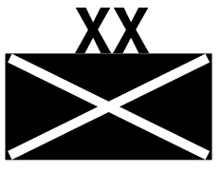 |  |  |  |  | 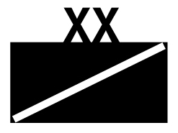

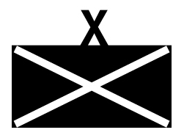 |  |  |  |  | 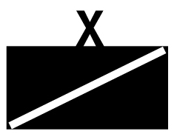

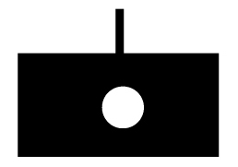 |  |  |  |  | 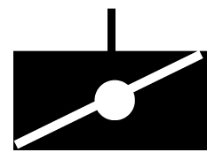

 |  |  |  |  | 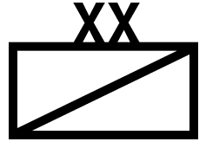

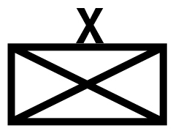 |  |  |  |  | 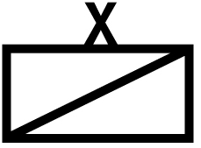

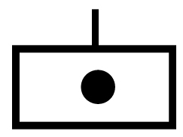 |  |  |  |  | 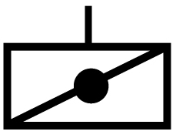

XXXX | XXX | XXX | XXX | XXX | XX | XX | XX | XX | XX

XXX+ | XXX+ | XXX+ | XX | XX | XX | X | X | X | X

