ALUMINIUM AND GLASS DIVISION

PRE-QUALIFICATION

1

Welcome to VAULTARMOR
A leading specialist in manufacturing and installation of
Architectural Glass, Aluminum, Cast Aluminium, Steel and Cladding in INDIA
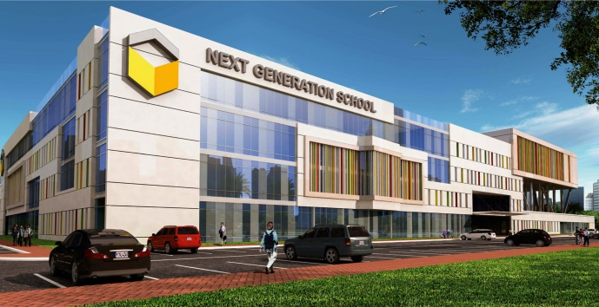
Established in 2016, VAULTARMOR a sister concern
Of REGENT GROUP which is one of most advanced
Glass & façade Specialist Company UAE.
Strategically VAULTARMOR located at Kolkata with
strong financial and technical support from its
parental company REGENT Steel Industries LLC in
UAE.REGENT Group established in 2000 &
covers a total area of 50,000 sq.ft, including a
Large stockyard. VAULTARMOR actively involving
processing glass, aluminum and Cladding, and
provides integrated glass solutions to its
Extensive network of clients. VAULTARMOR
import raw materials from various sources
complying with most stringent international
Standards. This has been one of the reasons.

Why VAULTARMOR has achieved unparalleled levels of professional excellence, reliability and quality in serving customers. VAULTARMOR mainly concentrates in the local sector. Backed by an outfit and highly qualified professional staff and engineers, VAULTARMOR Reinsures fabrication of every order is accurate and complying to international accepted quality control standards. With a well structured Environment, Health and Safety procedure in place, VAULTARMOR has carved a niche, as a trusted quality conscious organization, adopting the latest technologies and working techniques in all its activities including field work, administration and project management.

VISION
To deliver to our customer, the highest added value in the manufacturing process, enabling them to reinforce their own competitive strength.
MISSION
Aiming to build lasting alliances with our customers....
Offering our customer’s cost-effective production solutions with groundbreaking technology, Quality, reliability, professional product support and services....
Advising our customers before the sale on the economic efficiency and possible applications of the products they are considering purchasing.

OUR SERVICES
With sound infrastructure facility and highly experienced professionals and technicians, VAULTARMOR has perfected the practice of fabricating and installing advanced Aluminium and Glass applications of ranging complexities...
Services – Glass Services  - Toughened glass  - Heat Strengthened Glass  - Insulated Glass  - Lamination Glass  - Interior Glass  - Sandblasted Glass  - High Performance Glass  Services - Architectural Facade Division  - Structural Glazing  - Staircase and Balcony  - Hand Railings  - Doors & Windows  - Sky Lights  - Facades  - Aluminium Composite Cladding (ACP)  Services – Cast Aluminium Division  - Balcony Railing  - Staircase Railing  - Hand Railings  - Doors & Gates  Services – Steel Division  - Stainless Steel Cladding  - Car Park Shade  - Tent  - Steel Doors  - Structural Work  - Staircase & Railing  Aluminium Systems  - Gulf Extrusion  - Technal  - Schuco  - Kawneer  - Jindal  - Albertini  - ESC  - Alupco  - Reynaers  - Hindalco  - Alom | 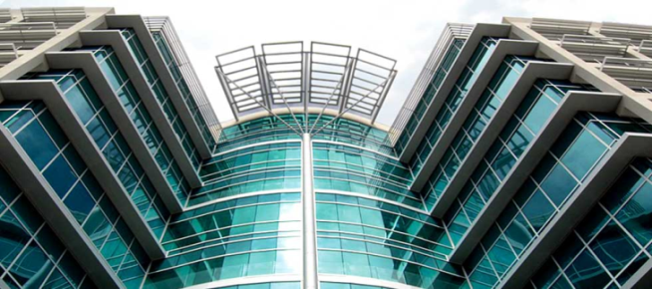

We understand client’s requirements and provide them with customized solutions. Our team is driven to successfully achieve project milestones within stipulated time frame with superior workmanship
TOPOLOGY
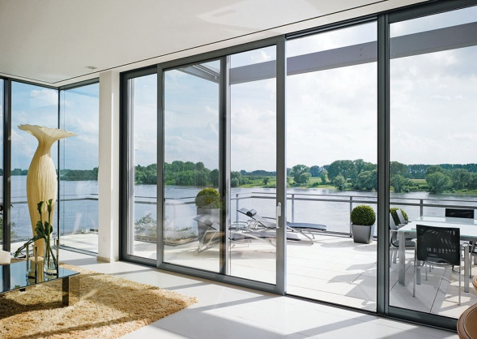
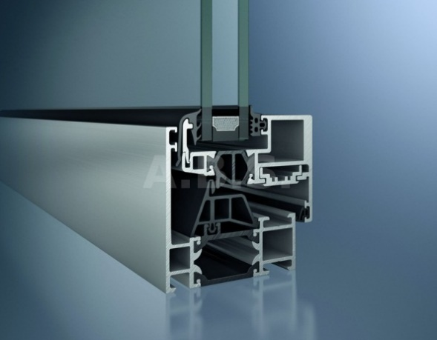
Sliding Doors
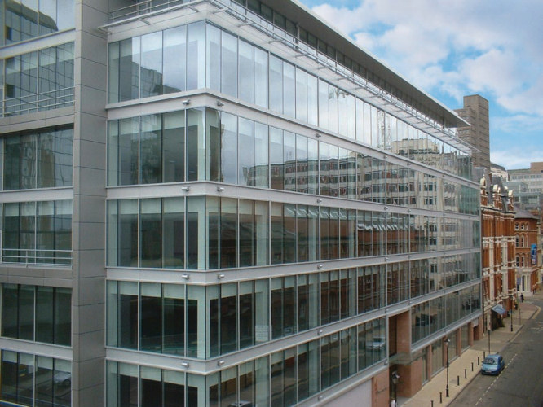
Curtain Walling System

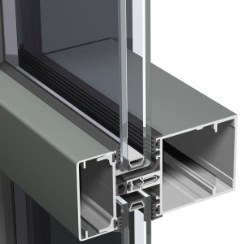

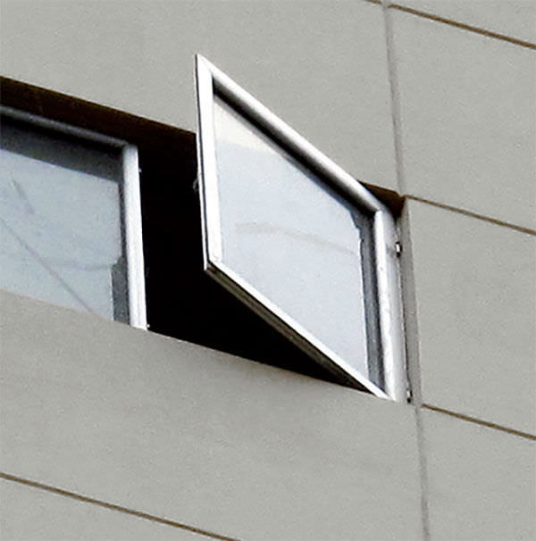
Casement System
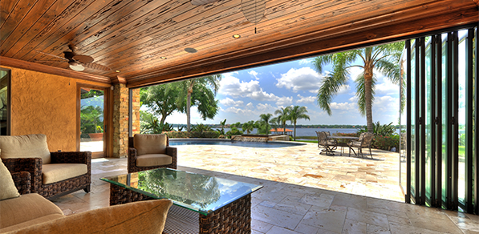
.Folding System
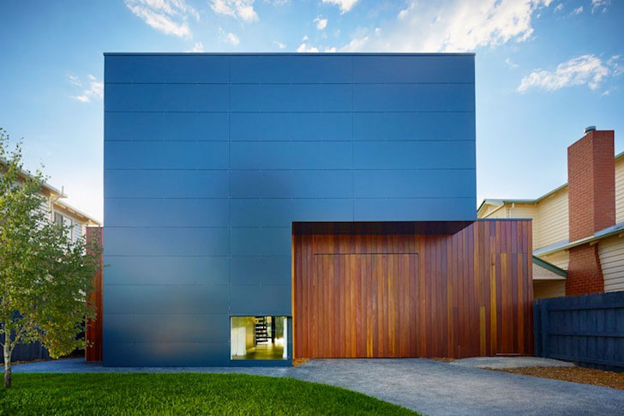
ACP Cladding
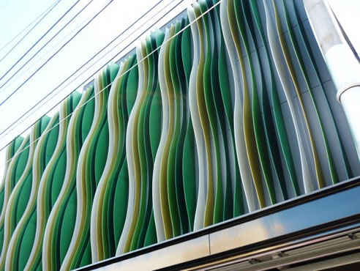 Aluminium Fins
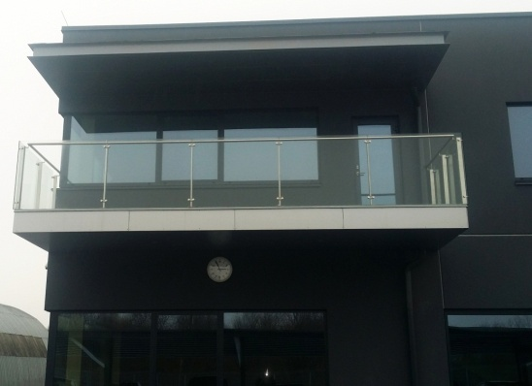
Railings

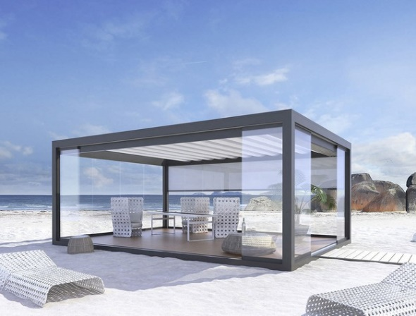
Aluminium Pergola
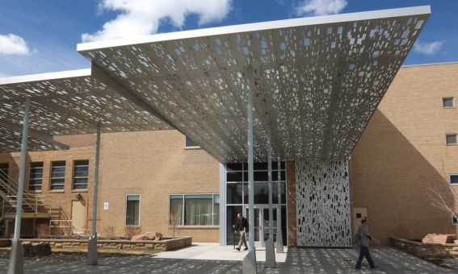
Canopies

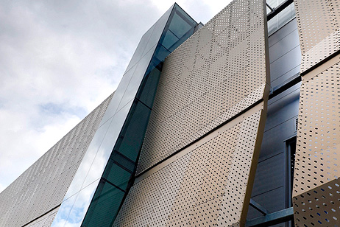 Decorative Aluminium
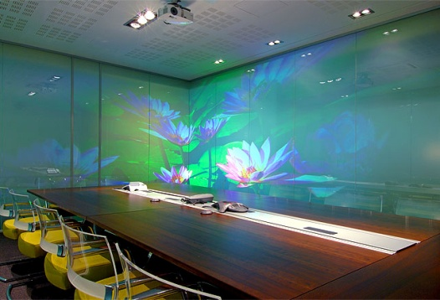

Decorative Glass VALUES & POLICIES
VAULTARMOR Quality Management System: -The management of VAULTARMOR is dedicated to the task of employing a quality system. The company has a quality policy established at all relevant functions and levels within the organization which warranties that the performance is to the total client satisfaction.
Quality is our top priority. Our trained quality assurance and quality control officer undertakes stringent measures to ensure our products that reach clients are of highest quality and to the total customer satisfaction. We consistently use international standard quality aluminum, steel, glass and accessories to manufacture all our products. Our internal quality officers at work sites are assigned to analyze and check the quality of installation in detail to ensure that a high quality is consistently maintained from the factory manufacturing to onsite installation.


The management of VAULTARMOR is committed to:
- Provide high quality of fabrication and installation of architectural aluminum, glazing and cladding work.
- Provide reliable, efficient and courteous services to its clients in order to achieve customer satisfaction.
- The quality policy is integrated and communicated to all its employees.
- Comply with regulatory and statutory requirements.
- Continually improve in all aspects of quality management systems.
VAULTARMOR Quality Promise
European / British standards followed
- European/British Description
- EN 12150-2 Glass in Building. Thermally toughened soda lime silicate safety glass.
- Evaluation of conformity / Product standard.
- EN 1279 Glass in Building. Insulated Glass Units.
- EN 1096-1 Coated Glass
American standards followed
- ASTM C 1048 Standard specification for Heat-Treated
- Flat Glass-Kind HS, Kind FT Coated, and Uncoated
- ASTM C 162 Standard terminology of Glass and Glass Products.
- ASTM C 1036 Standard specification for Flat Glass
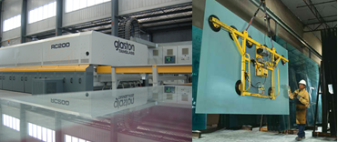

HEALTH & SAFETY PLAN  VAULTARMOR conform to all occupational health and safety rules and regulations in effect in INDIA. We provide and take all necessary actions to protect our employees from occupational hazards and diseases both in the factory and on site. We are committed to continually recognize the possible hazards to health and safety and to eradicate or control in the best possible approach. All employees are trained to accomplish these safety and health measures and goals. | 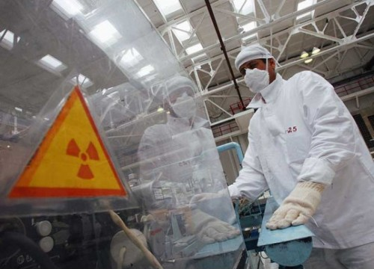

INTRODUCTION
Execution of contract without any time loss accidents shall be the priority of VAULTARMOR. Our staff and workers have successfully completed many projects wherein they had the opportunity to be educated on all safety regulations. VAULTARMOR has achieved the goals of timely completion of projects without any time loss incidents.

1. OBJECTIVE
The main objective of the Project Safety Plan is to maintain healthy and safe work environment for all the employees and personnel employed by VAULTARMOR.

2. PROCEDURES
Safety Induction: - Before any personnel is allowed to work on the site, he shall be given safety induction by the Project Safety Officer.
Safety Rules: - Safety is of utmost importance in the performance of all operations and must be an integral part of each work task. The company’s policy is to abide by all safety rules and regulations formulated for the project. The company understands that safety is our utmost importance in the performance of all operations and must be an integral part of each task.
Use of electrical tools & machineries
- All electrical tools shall be properly checked before use, any wear and tear in the cable to be rectified.  - All electrical machinery are fitted with safety plugs and sockets.  - No machine shall operate without plugs  - No loose connection shall be allowed  - Workers to exercise caution in wet areas. | 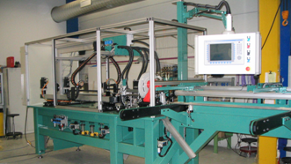

Use of ladders
- All ladders exceeding 2.0 meters shall be tightly secured in position or supported by a person.
- Maximum inclination shall not exceed 75 degrees with reference to horizontal. Hoisting & Material handling
- All hoisting/carnage equipment shall be operated by Main Contractor’s representative.
- All slings, chain pulleys for the carnage to be tested and certified by an independent agency.
Area falling under lifting to be protected with barricades and trafficking should not be permitted

Use of scaffoldings.
- Any scaffolding shall be checked by Safety Officer/ Supervisor and tagged for safe use.  - All mobile scaffolding shall be erected as per given catalog with necessary bracings, platform and toe boards where required.  - The safety belt is compulsory on all scaffolding exceeding 1.5 meters.  - All wheels shall be in lock position while working. | 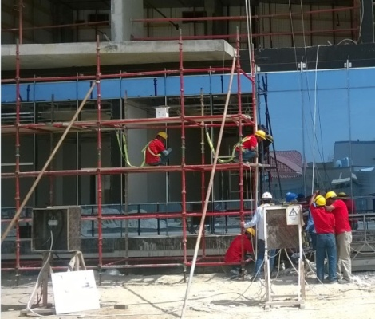
General Rules
- Tools throwing from one person to other are not allowed.
- Temporary platform for high level works not allowed.
- Shortcut accesses shall not be allowed.

3. SAFETY GEARS
- Every personnel at the site should wear safety helmets and safety shoes.  - Safety belts shall be compulsory for those working on scaffolding above 2.0 meters  - Coverall bearing the company logo shall be worn by workers.  - Hand gloves shall be compulsory for all activities which may lead to injury such as hoisting/grinding/cutting.  - Face mask shall be made available at the site for all activities which generate dust.  - Goggles shall be compulsory while handling the cutting machine, grinding machine, jigsaw etc. | 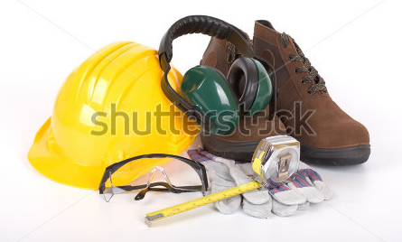

4. DISCIPLINE ON SITE
- Manpower shall be strictly controlled by Supervisory staff.
- Eating and resting are restricted at designated areas.
- Site timings and hygiene on site to be adhered to by all.
- Cigar smoking, chewing tobacco etc. shall not be allowed.
5. HOUSEKEEPING
Each working team shall be instructed to clean the wastage generated from their respective areas and this waste shall be discarded at designated areas marked by Main Contractor. This shall maintain cleanliness and good working environment.
6. FIRE HAZARDS  Any activity, that has a potential for fire, shall only be carried out with necessary precaution and with the approval from Main Contractor. In addition fire, extinguisher shall be provided. | 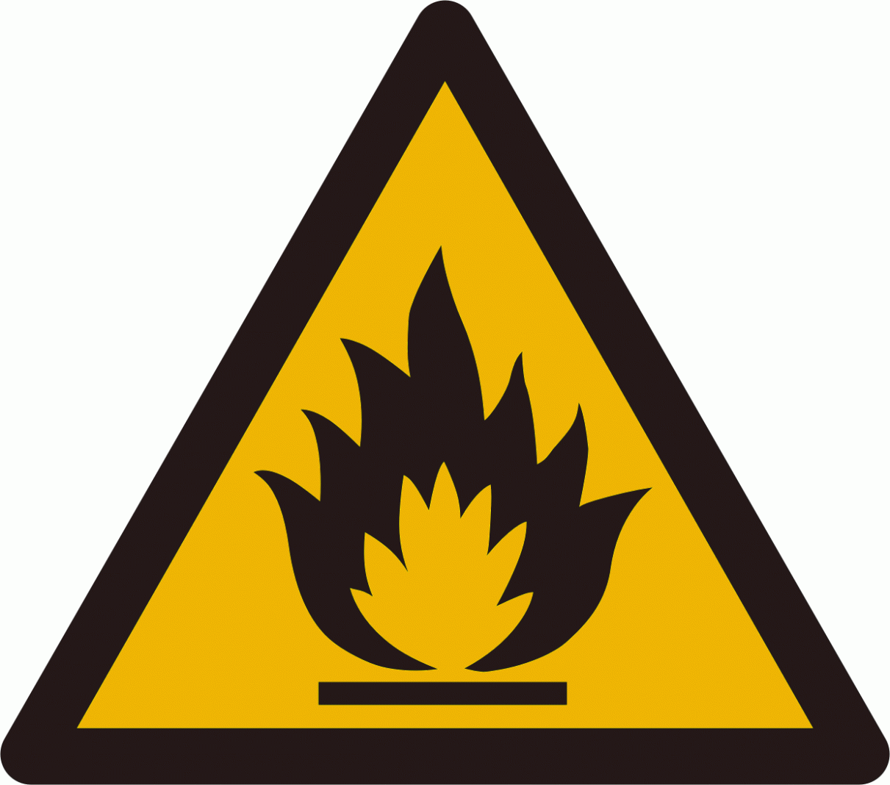

7. FIRST AID
Site Office shall be equipped with necessary first aid materials. VAULTARMOR has few trained first aiders working as Supervisors. The vehicle shall be available at the site.

8. SAFETY VIOLATIONS
Safety violation by any parties shall be reported to the Project Manager, VAULTARMOR will view such violations very seriously and strict action shall be taken to avoid the recurrence. All violations shall be noted and recorded to ascertain that all workers are following safety rules.

COMPLETED PROJECTS: Abroad
1 | Varkey International School | Jasaf Building Technology | Dubai
2 | Emirates Hills Villa Projects | Nasco Contracting | Dubai
3 | Emirates Hills Villa Projects | Al Shaffar | Dubai
4 | Emirates Hills Villa Projects | Helwan fro Hotels | Dubai
5 | G+3 Building near Lamcy Plaza | Al Bakhit | Dubai
6 | 50+ Private Villas | Naturtal Construction | Dubai
7 | 30+ Villa | Al Burhan Construction | Dubai
8 | Sewage Treatment Plant | Al Turath Contracting | Dubai
9 | Emirates Hill Villa | Julfar Contracting | Dubai
10 | Transgulf-Jebel Ali | Roshan Construction | Dubai
11 | Private Villa at Sharjah | Raffiy Vartanian Consultant | Dubai
12 | 8 x Villa Project ,Garhoud | Nasco Contracting | Dubai
13 | G+6 Building near lamcy Plaza | Jasaf Building Contracting | Dubai
14 | 16 x Villa , Jumeira | Jasaf Contracting | Dubai
15 | G+5 Building ,Al Murar | Al Memzar Contarcting | Dubai
16 | Discovery Garden Project | Dubai Properties | Dubai
17 | 10 x Villa ,Dubai Municipality | Al Burhan Construction | Dubai
18 | G+7 Shamsa Building | Ideal Engineering | Abu Dhabi
19 | G+7 Jumma Building | Ideal Engineering | Abu Dhabi
20 | G+13+HC Project, Al Barsha | Artco, Sharjah | Dubai
21 | 2B+G+7 Al Junaibi Bldg | Barek Engineering | Abu Dhabi
22 | 3 Villa Project at safa, Dubai | Al Etqan Real Estate | Dubai
23 | Villa project in Nad Al Sheba | Arif Contracting | Dubai
24 | G+1 Shopping Complex | Al Memzar Contracting | Dubai
25 | Farm House Project in Khwaneej | Golden Tower Contracting | Dubai
26 | Warehouses In Al Quoz | Al Memzar Contracting | Dubai
27 | G+2 Building in Al Dhaid | Sharjah Awqaf | Sharjah
28 | G+4 Building In Abuja Nigeria | Adkan Services | Nigeria
29 | G+9 Building for DGS Sudan, Khartoum | DGS Sudan | Sudan
30 | G+3 Shopping Mall, Zambia | AMRO Group(Mohammed Patel) | Zambia
31 | Entrance Gate G+2 | Inland Properties Limited | Lusaka, Zambia

Complete project: INDIA
 | Project Name | Company Name | Place
1 | Aluminium Sliding Window –G+5 | Aisha Developer | Kolkata
2 | Embassy Tech Village G+11 –Aluminium Composite Panel and Structure Glazing | KEF Infrastructure Private Limited | Bangalore
3 | Powder Coating Aluminum window -G+4 | Afroz Construction | Kolkata
4 | Design Arch fixing with Aluminium sliding window-G+3 | Jama Mosque | Kolkata
5 | 4sight Florence-G+6  7 Nos of the tower –Skylight Work | Ganguly Group Pvt Ltd | Kolkata
6 | ITD Cementation –Structure Glazing G+12 | Bose Institute- Kamdhenu Construction | Kolkata
7 | Aluminium Office Partition and Doors | Grupennt Technology Pvt Ltd | Kolkata
8 | MS Structure of Canopy with Glass | Cam Enterprises | Kolkata
9 | AMRI Hospital-Cement Cladding with Bracket G+9 | AMRI /NITSON | Kolkata
10 | Ramaya Hotel-Triangle Glass Façade G+5 | Ramaya Group. | Haryana
11 | MS Structure of Staircase and Balcony | DTC Group  Southern High. | Kolkata
12 | ACP Glazing Work – Auditorium | IISER( Indian Institute of Science and Education Research Center) | Nadia, West Bengal
13 | 4sight Florence – Structure Work | Ganguly Group Pvt Ltd | Kolkata
14 | Aluminium Composite Panel and Curtain Wall System G+7 Shopping Mall | Yeti Engineering & Sales –  National Business Trade Center | Kathmandu  Nepal
15 | Casement Window G+16 Building | Onrush Maintenance Pvt Ltd | Kolkata
16 | Fixed Window and Doors of Restaurant Project G+1 Building | Arkid Restaurant | Kolkata
17 | TAFE- Chennai- Aluminium Lamella Façade etc. | Linder Group- Germany | Chennai, India
18 | Bangalore International Airport Terminal-2- Bamboo Façade | Linder Group- Germany | Bengaluru, India
19 | Glass Façade and Domal Window System Project G+2 | Quba Educational Trust | Mangalore, India
20 | MS Façade -Arch MS Façade with Perforated Sheet | Sugam Group-Avikam Buildcon LLP | Kolkata, India
21 | Glass Façade -Arch Glass Façade | Sugam Group-Avikam Buildcon LLP | Kolkata, India
22 | Sliding Window- | Sugam Group-Avikam Buildcon LLP | Kolkata, India
23 | Glass Railing . | Sugam Group-Morya Project- Sugam Diamond Abasan LLP | Kolkata, India
24 | Aluminium Door and Window | Sugam Group-Morya Project- Sugam Diamond Abasan LLP | Kolkata, India
25 | Aluminium Window and Doors | Kinglay India Pvt Ltd | Kolkata, India
26 | Glass Curtain Wall | Sasya Group | Kolkata, India
27 | Roof Top Glass Canopy | AK Design Studio | Kolkata, India
28 | Façade Work- ACP & Glass Glazing work | DC Star Hotel Project – DC Construction | Kolkata, India
29 | Façade Work-SS Glass Railing & Revolving Doors and Doors | The Nostalgia Project – Naoolin Infracon Pvt Ltd | Kolkata, India
30 | Façade Work-Roof Top Glass House | FOB Restaurant Project – UUC Hospitality Pvt Ltd | Kolkata, India

OUR SUCH CALIBER IN PROJECTS.

Roof Top Façade Glass House-UUC Hospitality Pvt Ltd-2024
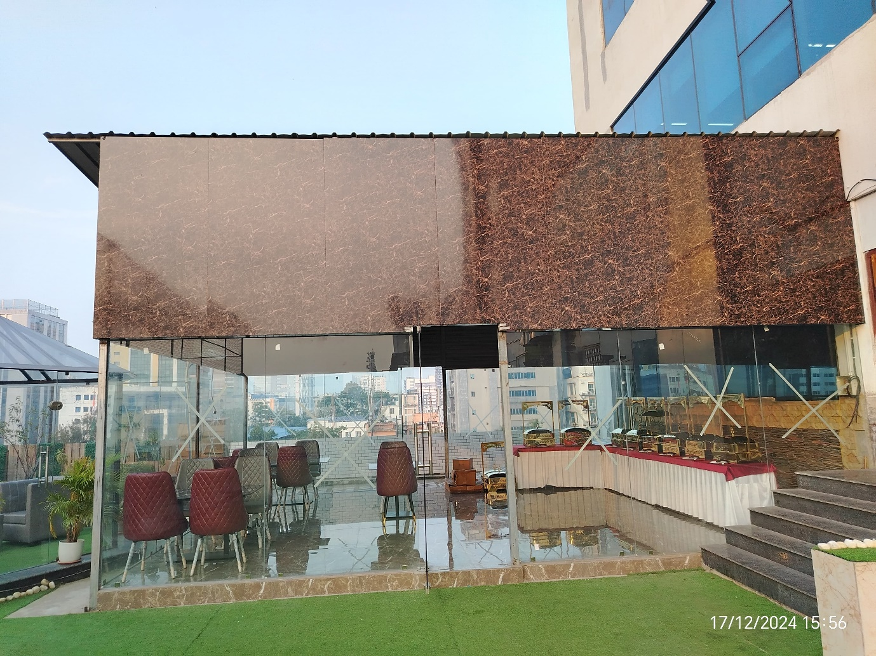
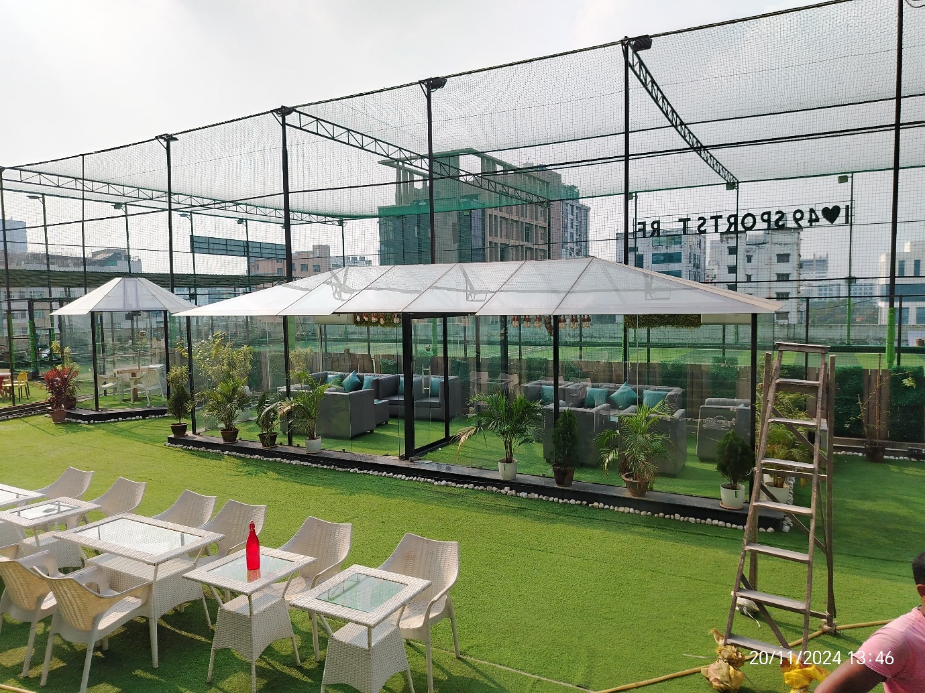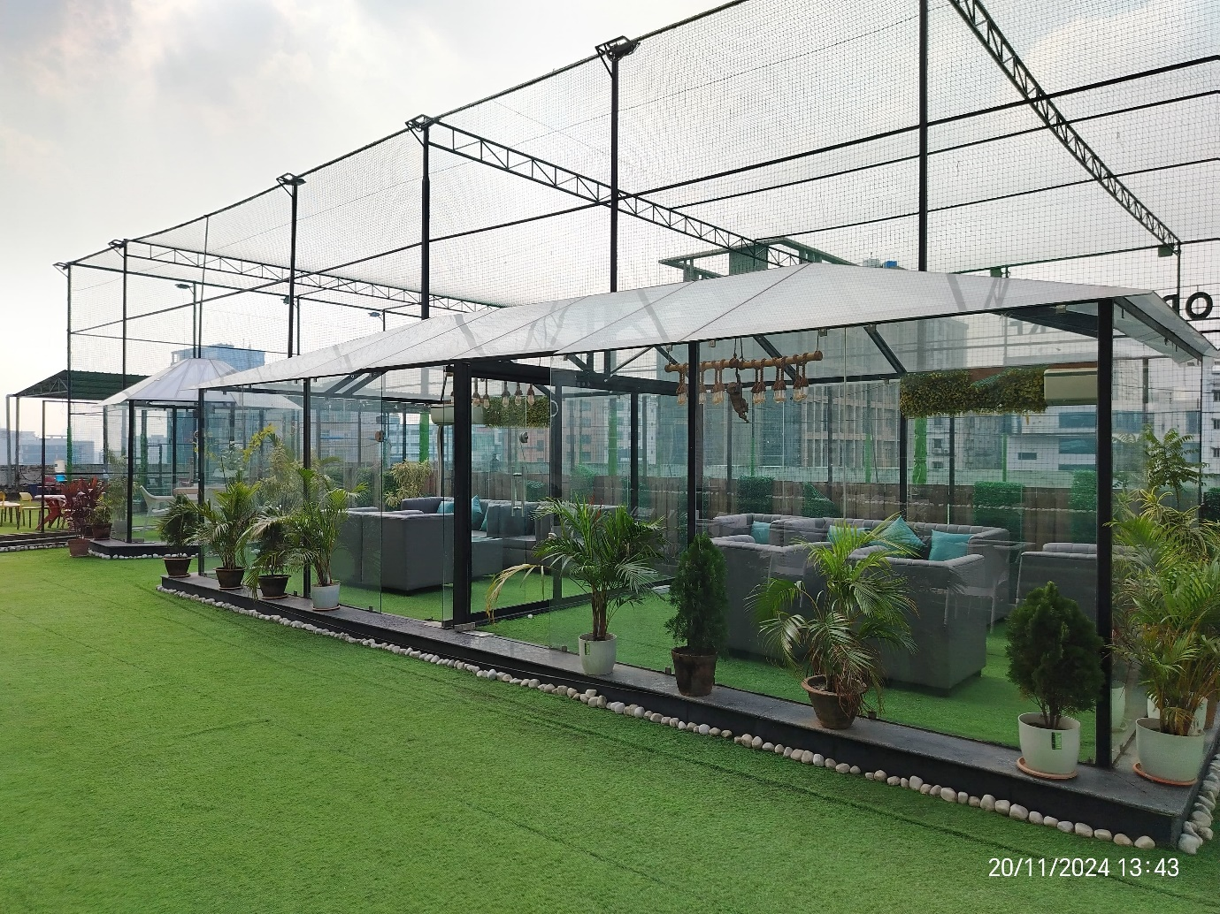

The Nostalgia Project- Kolkata 2024 SS Railing
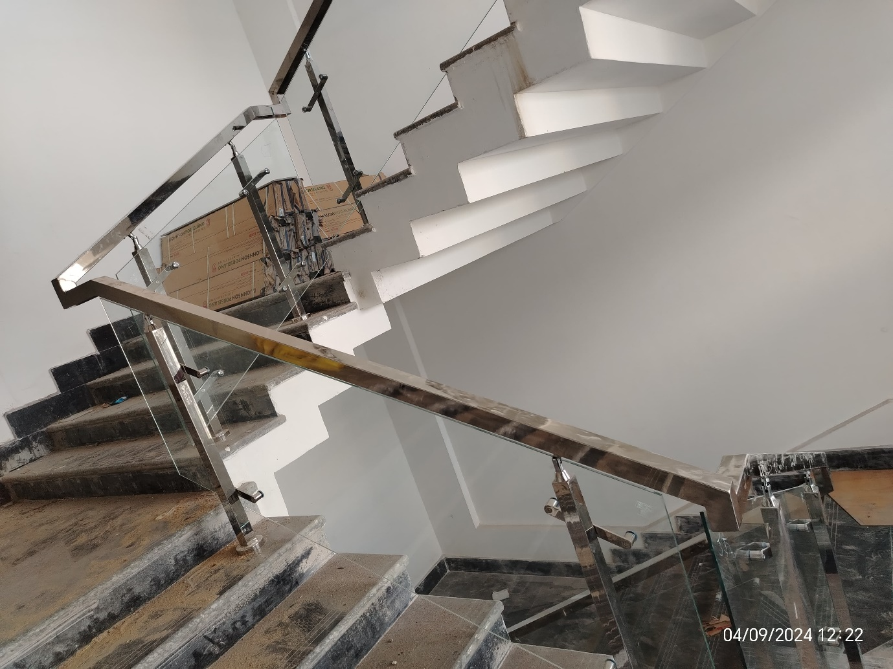
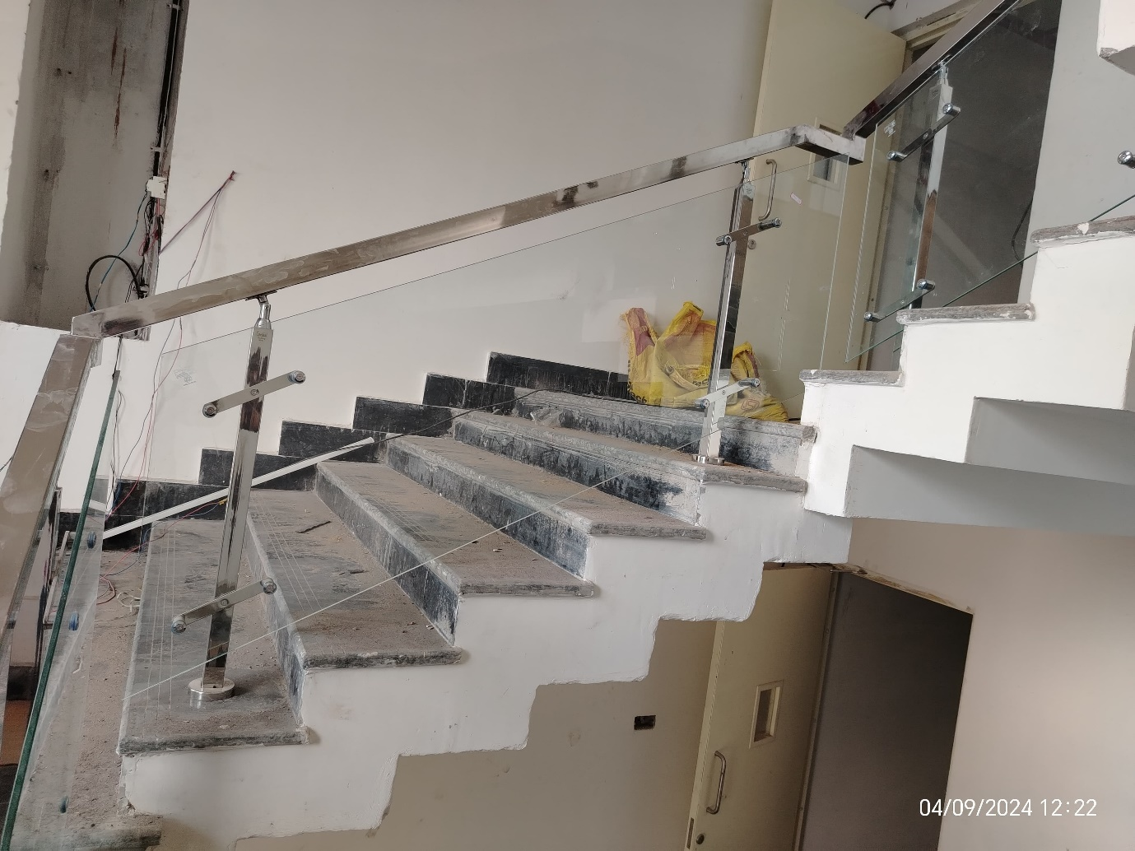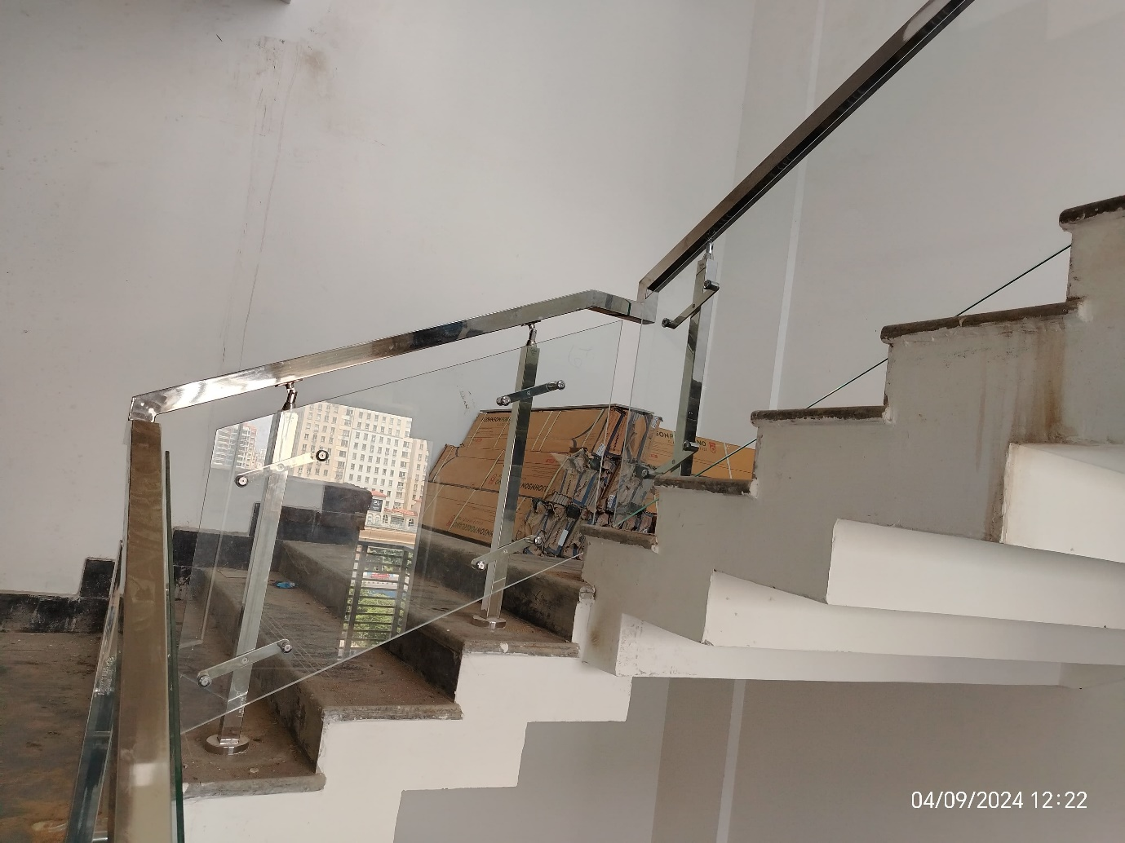
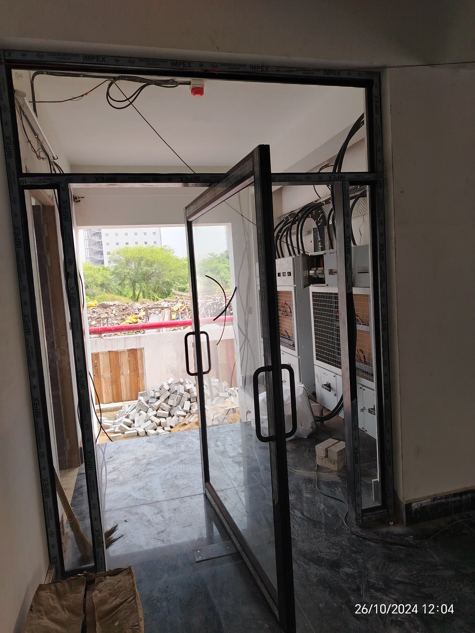
Revolving Doors
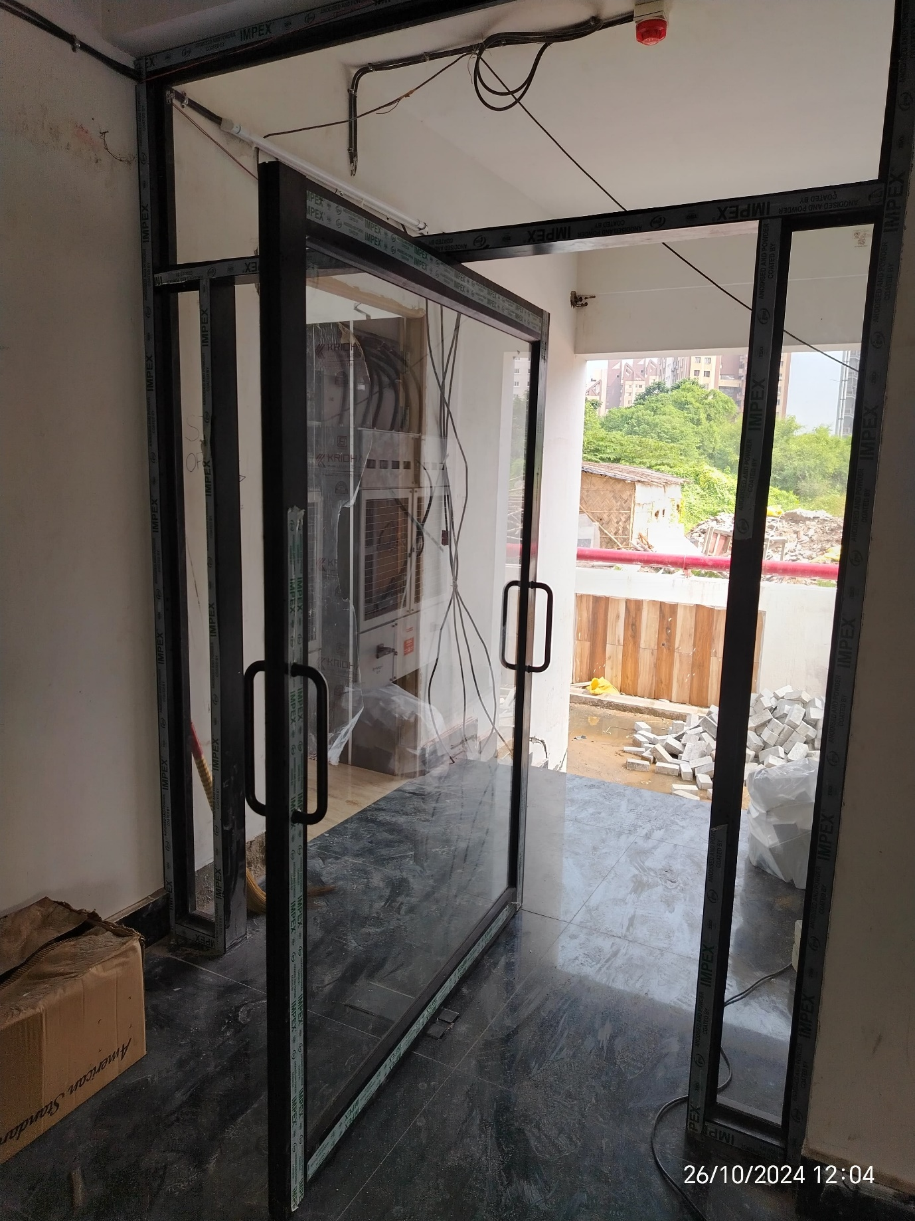

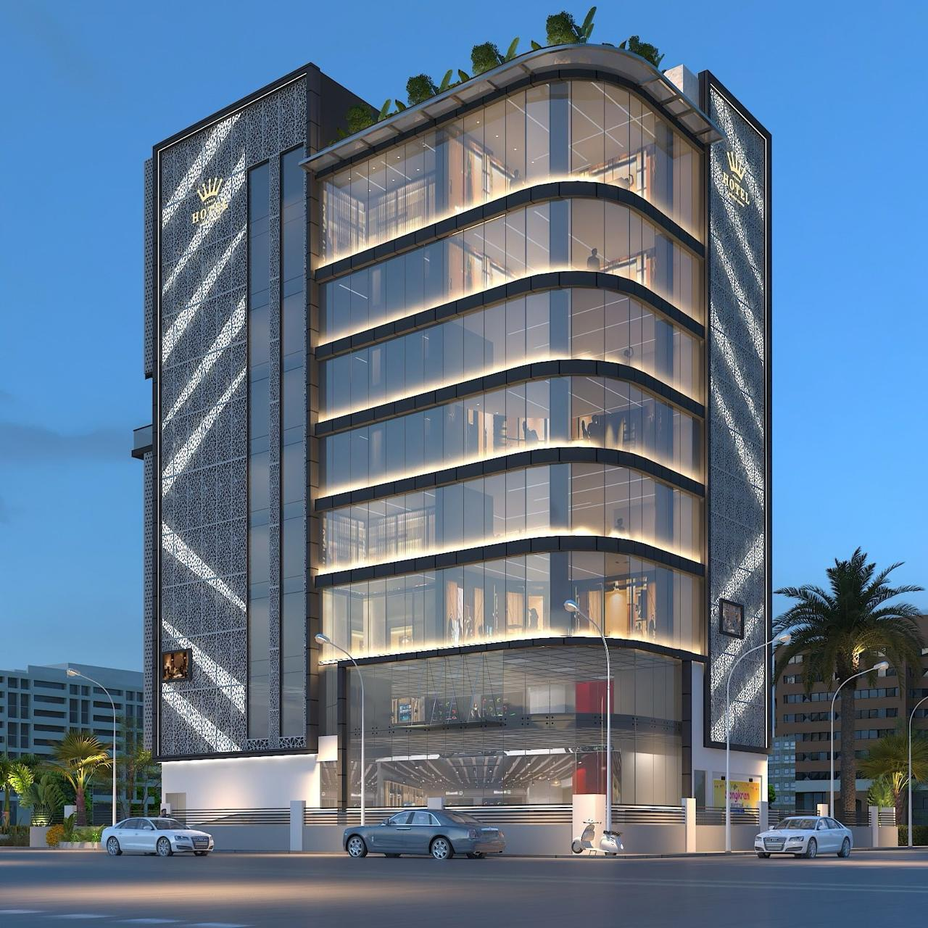

DC Star Hotel Project-Façade work
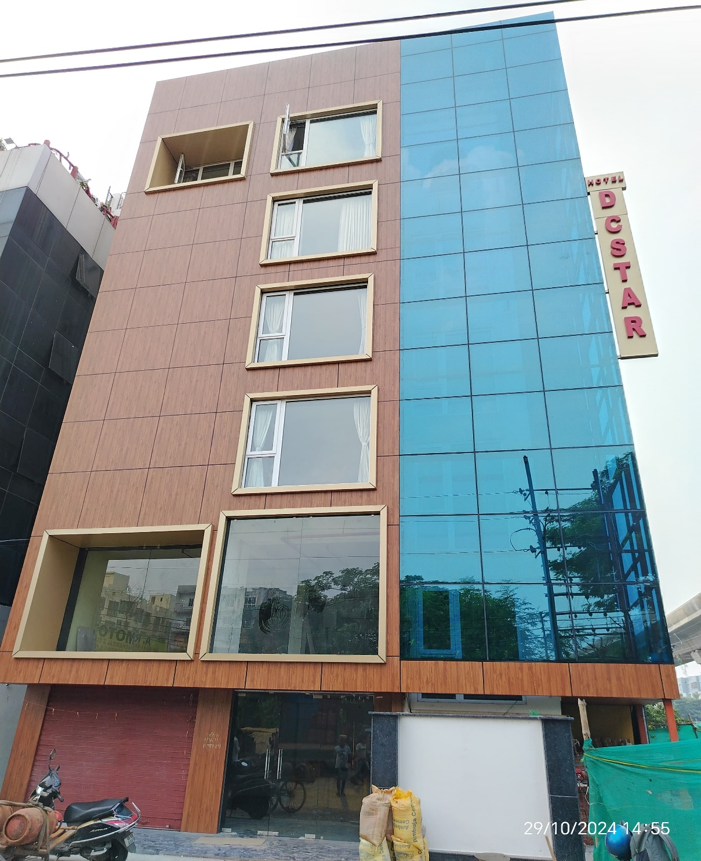
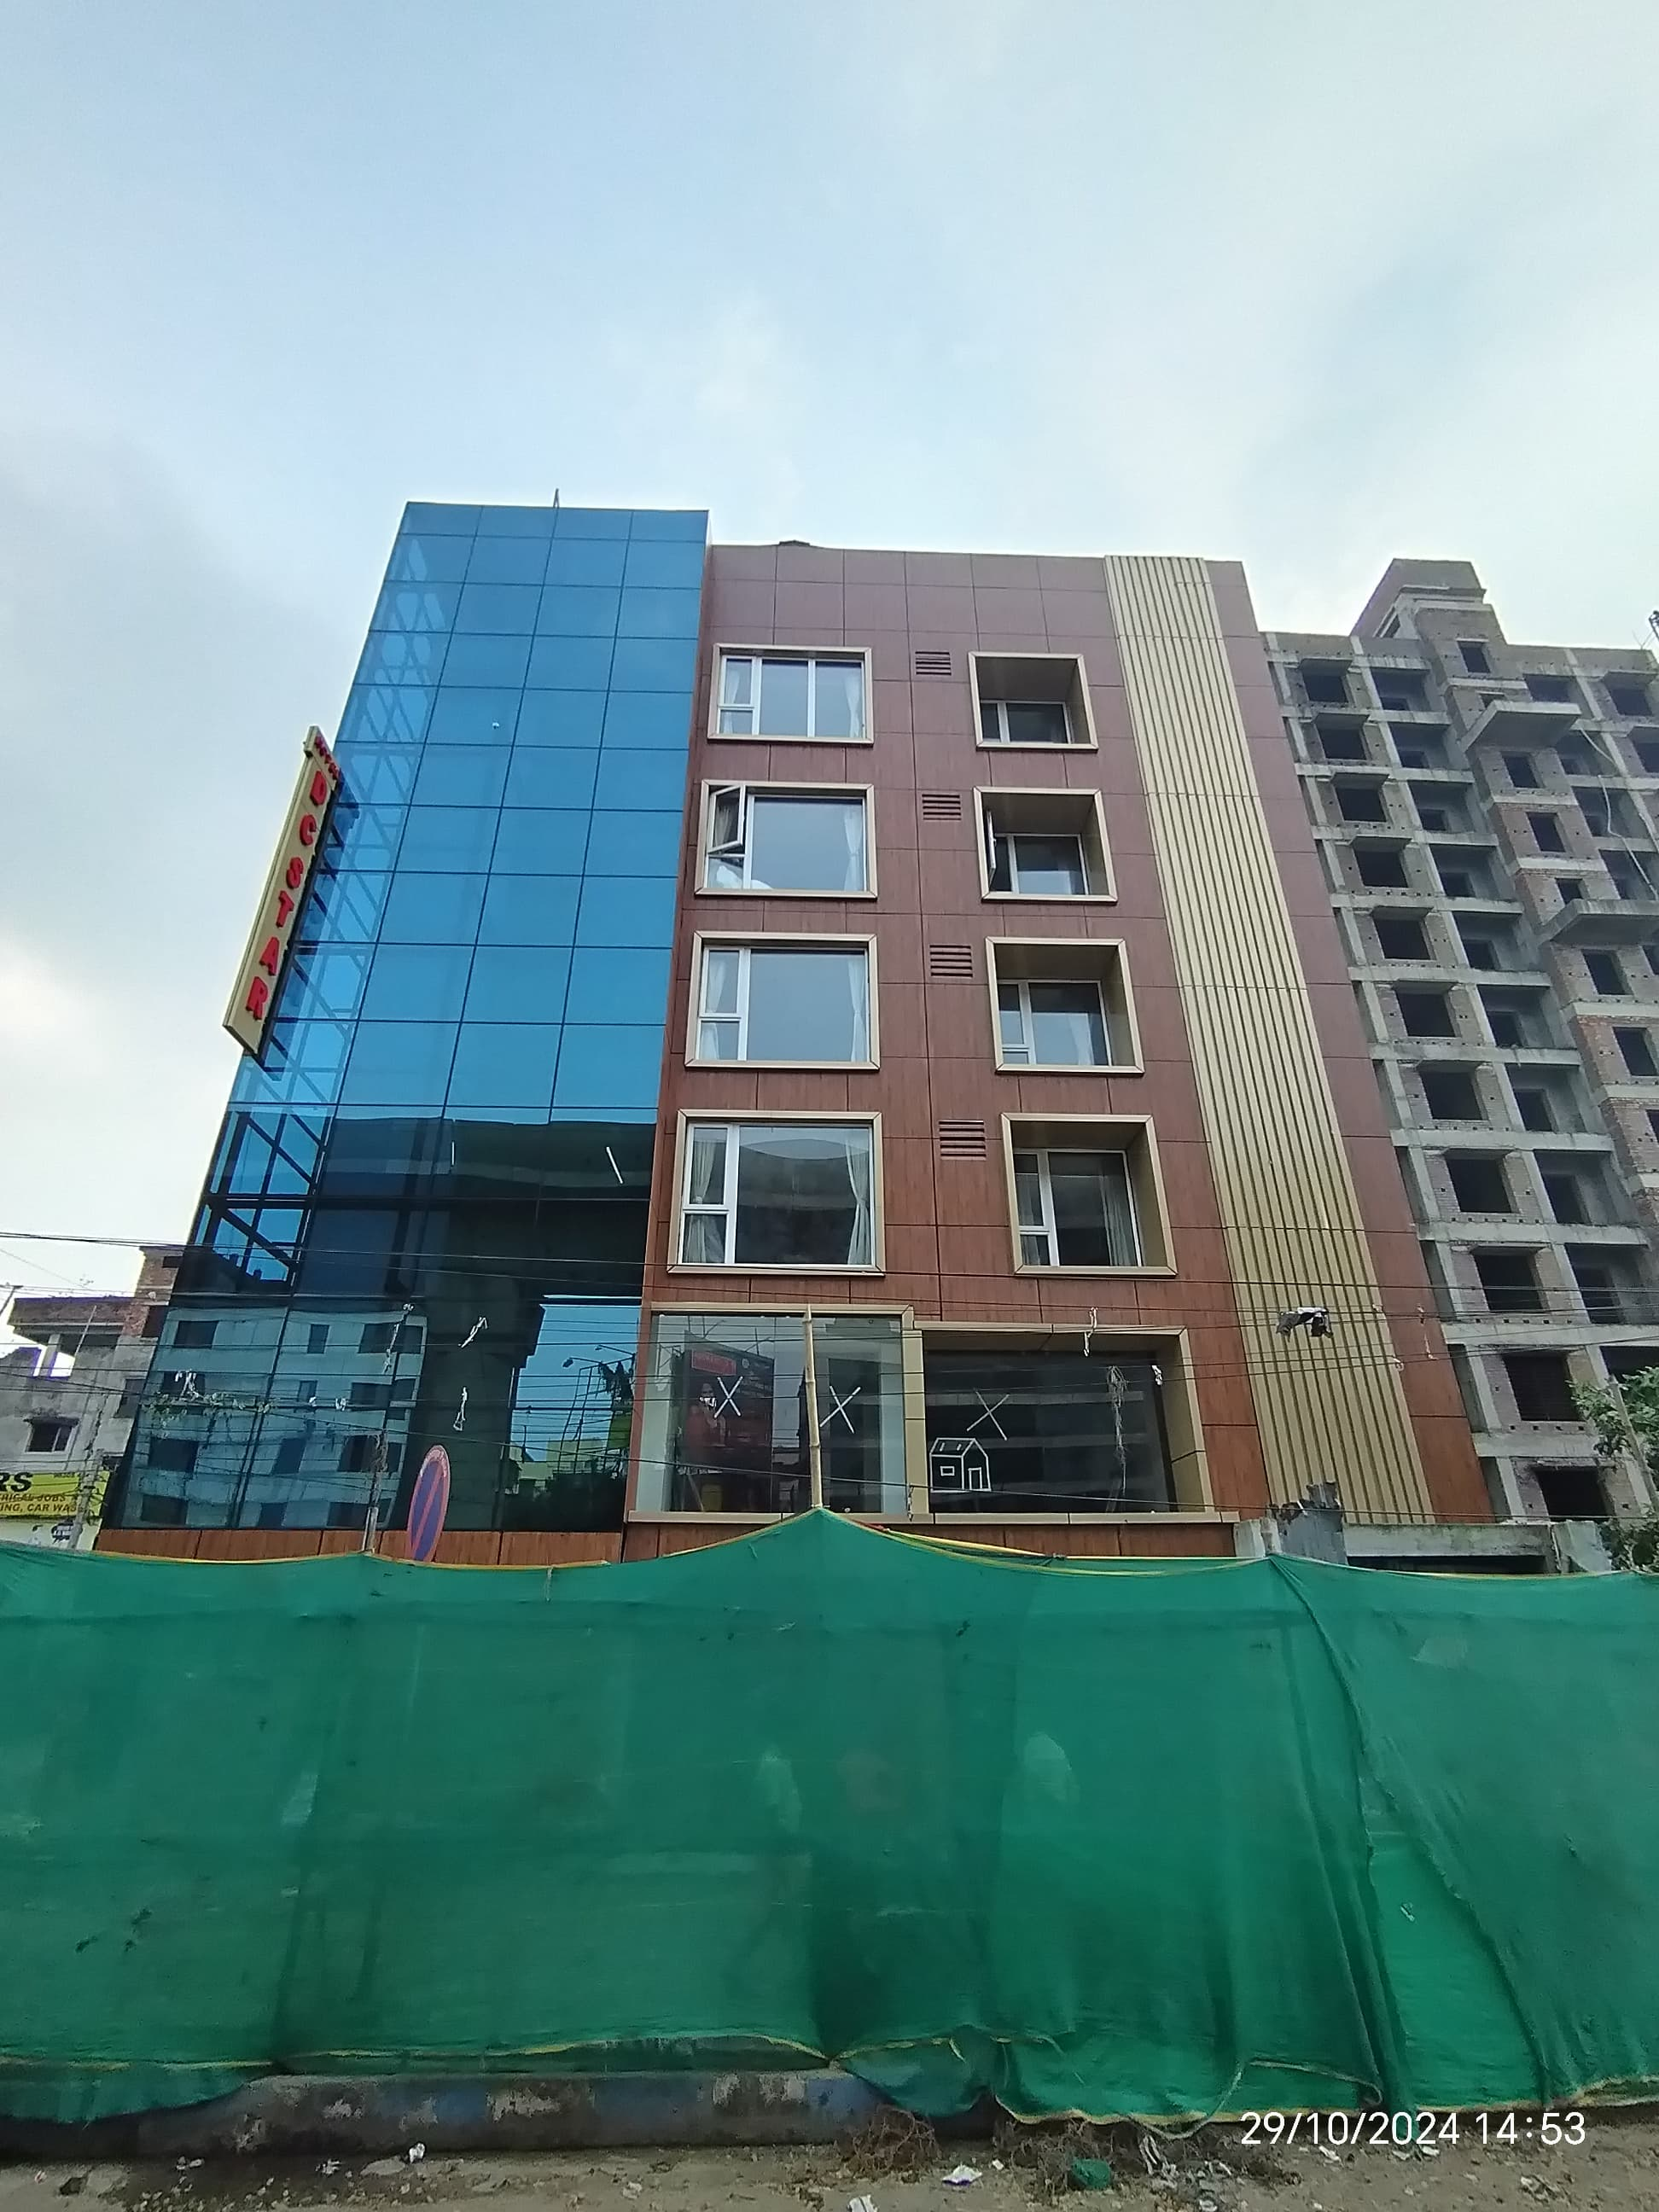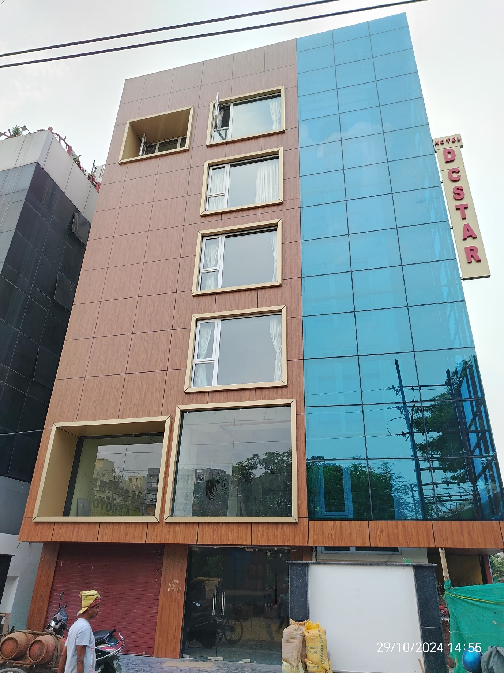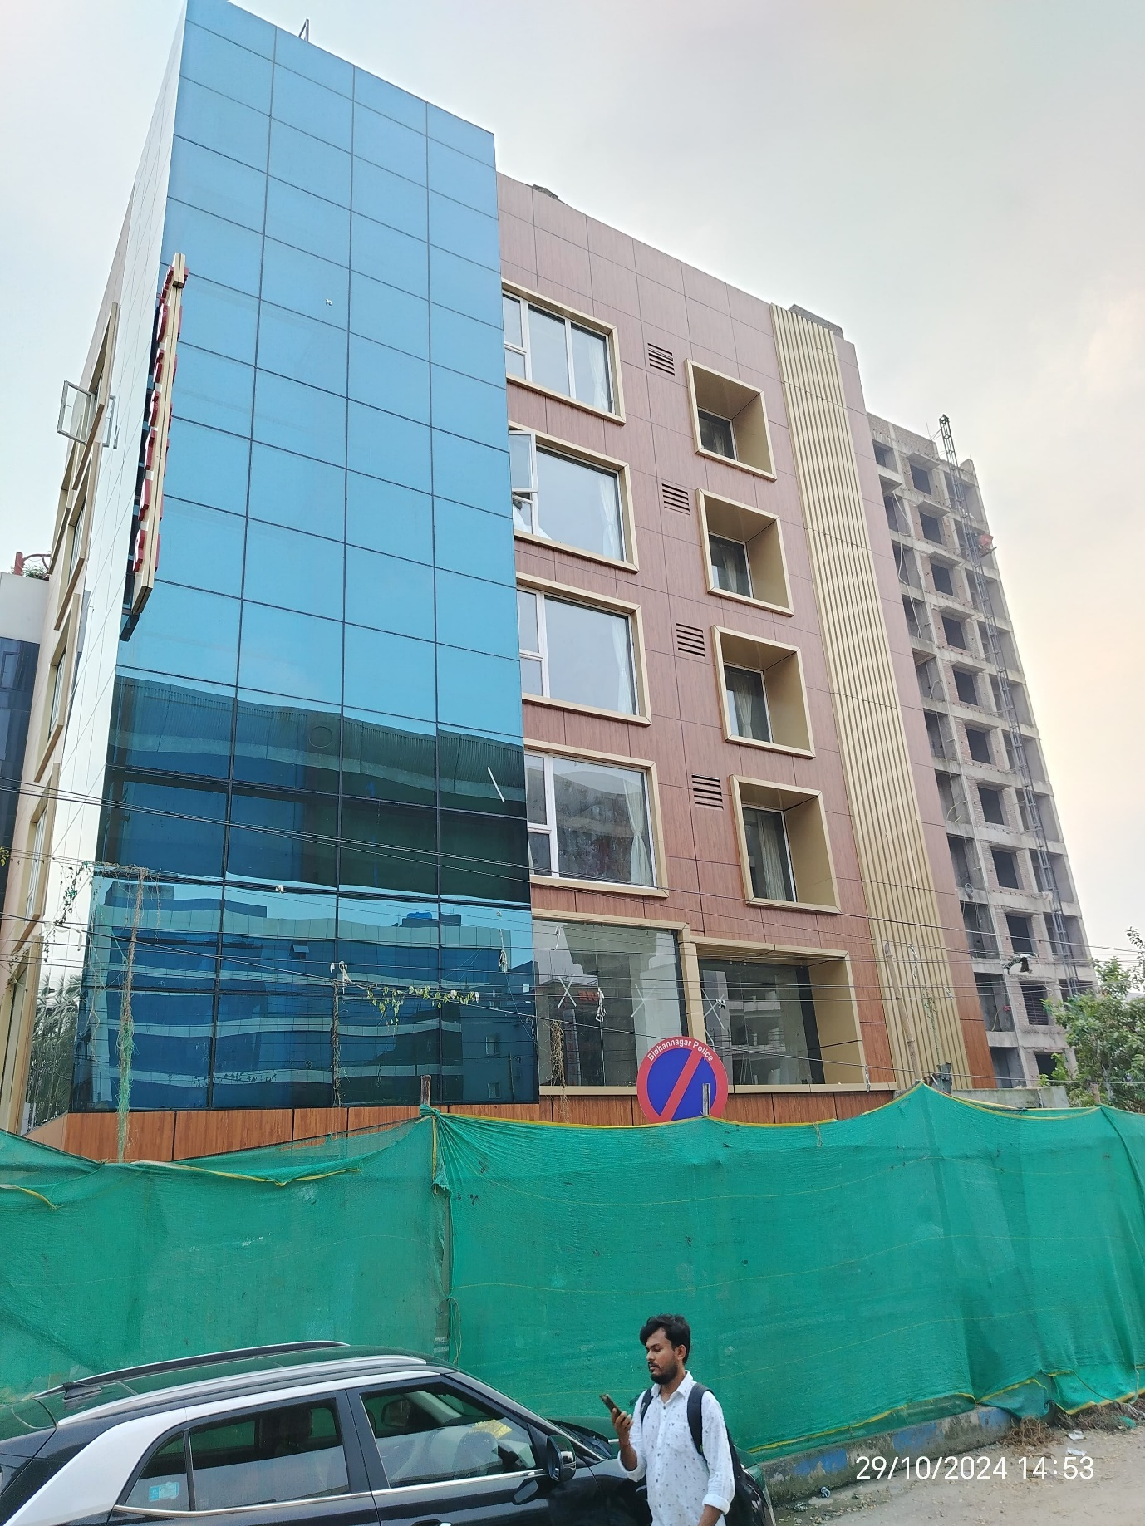

IAS Residency Roof Top Canopy-Kolkata -2024
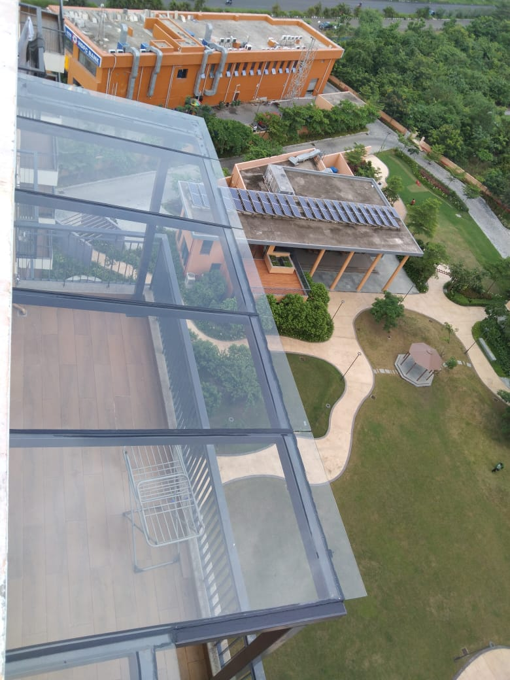

Sasya Project- Curtain Wall System 2023-Kolkata
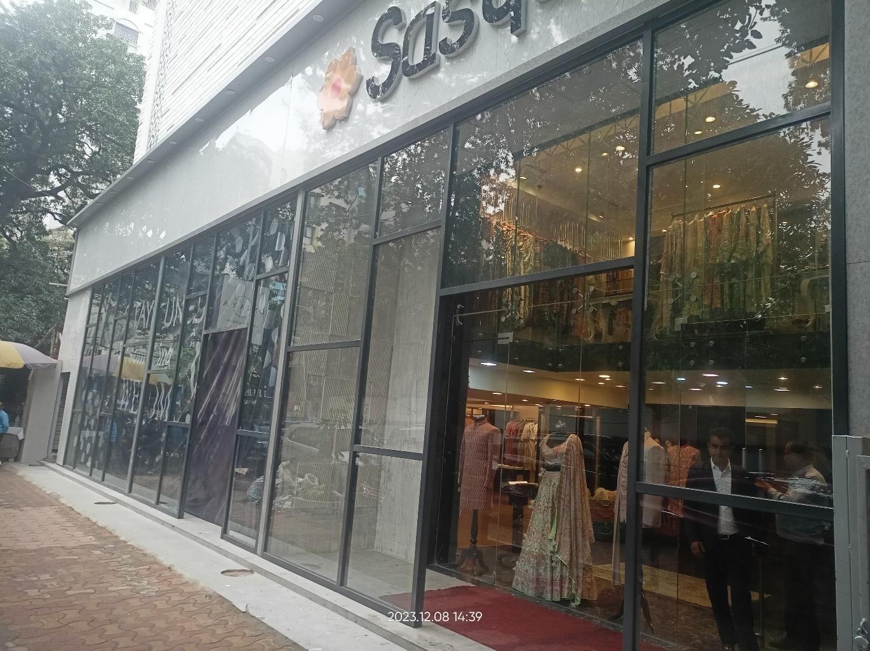
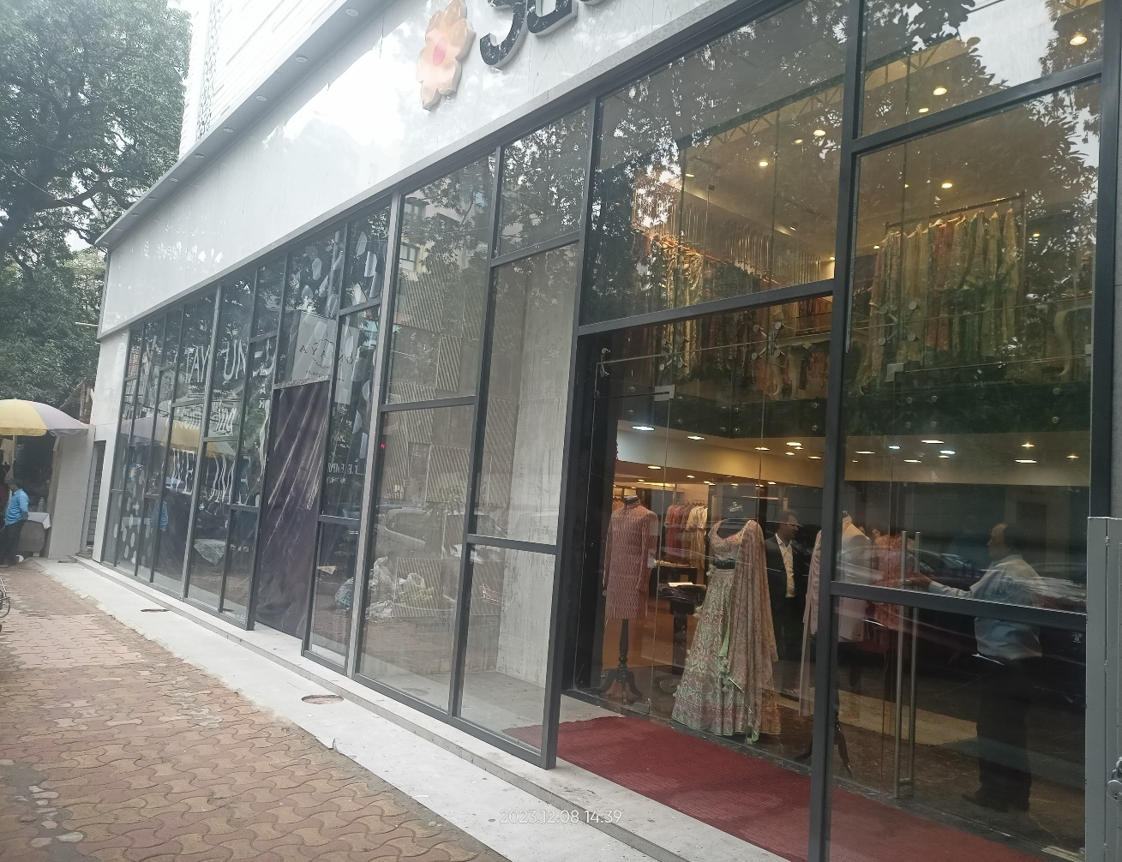
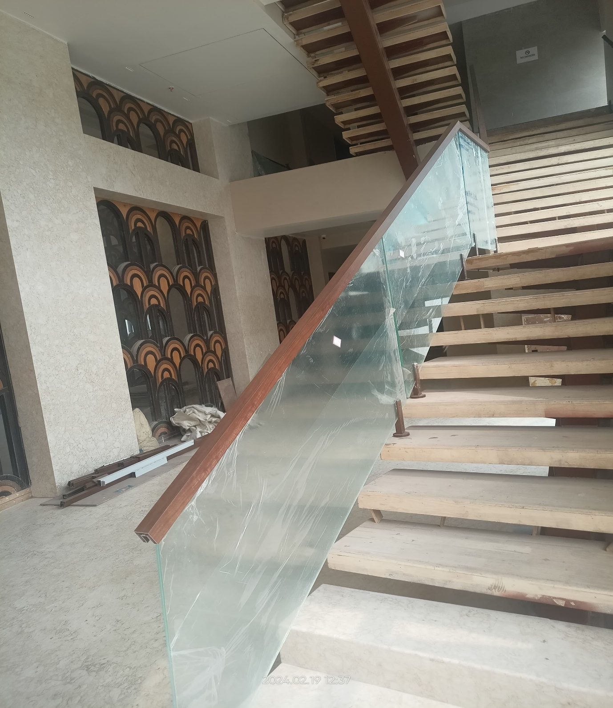

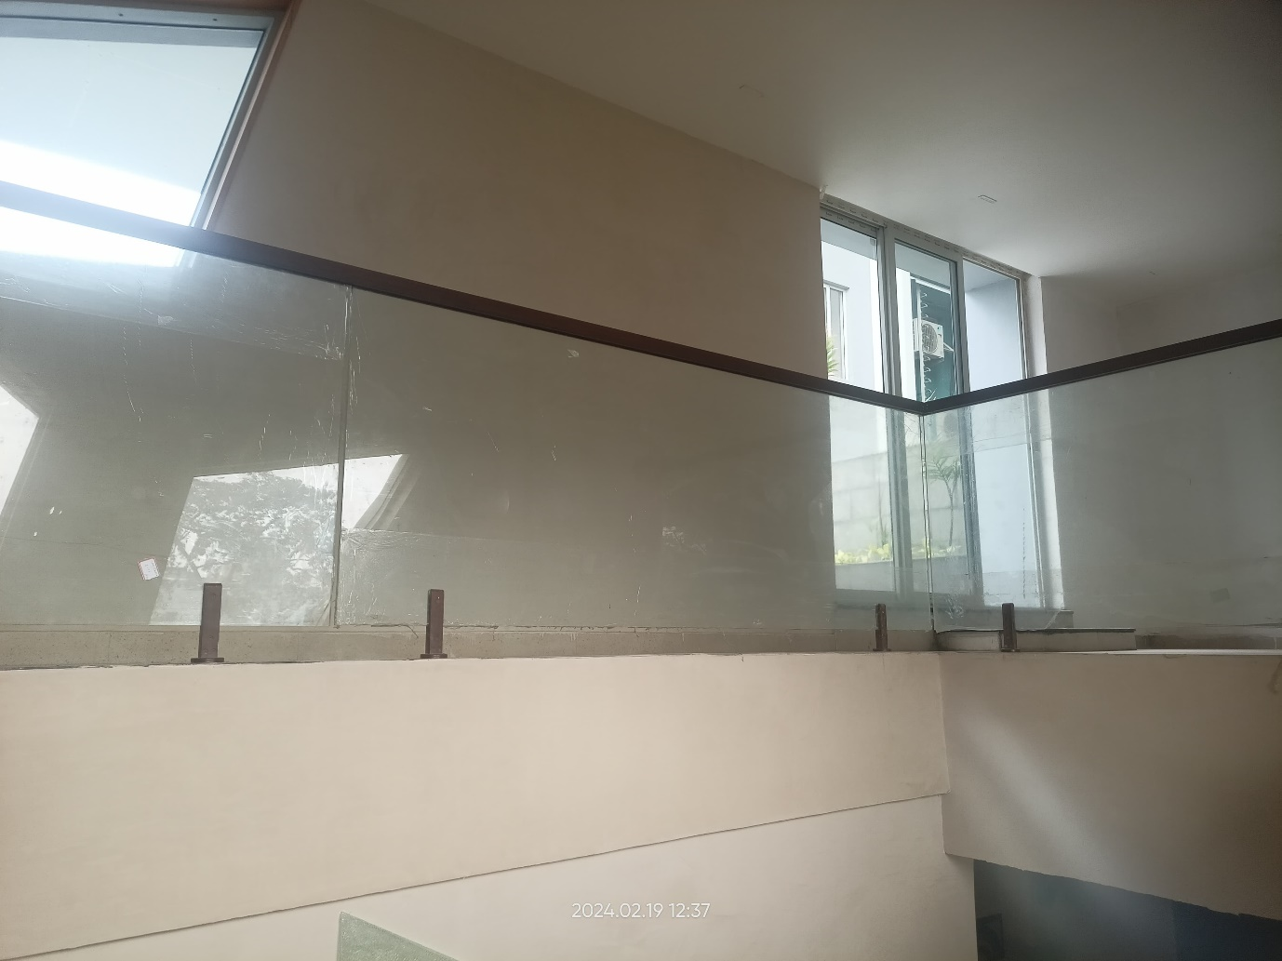

Sugam Morya Project- Glass Railing Laminated Glass-Kolkata-2024

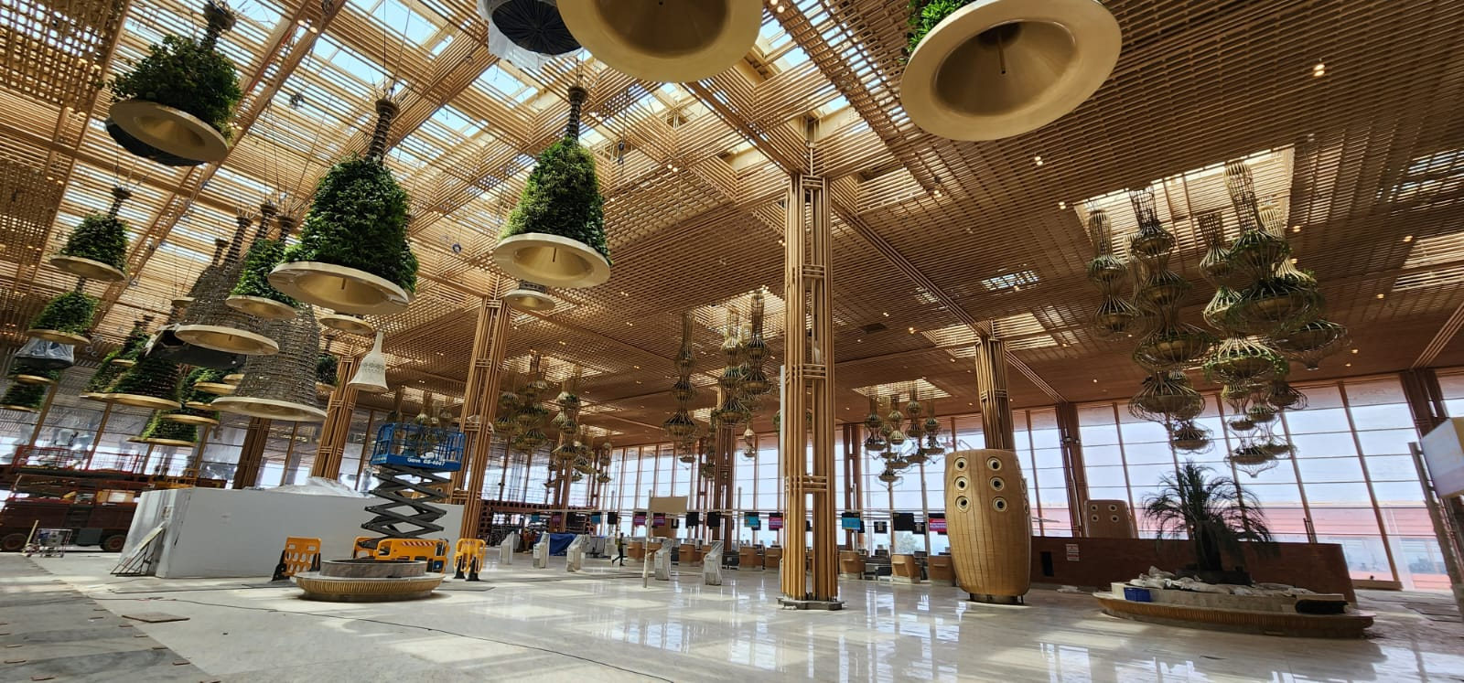
Bangalore International Airport Terminal-2
Bamboo Facade Ceiling and Column
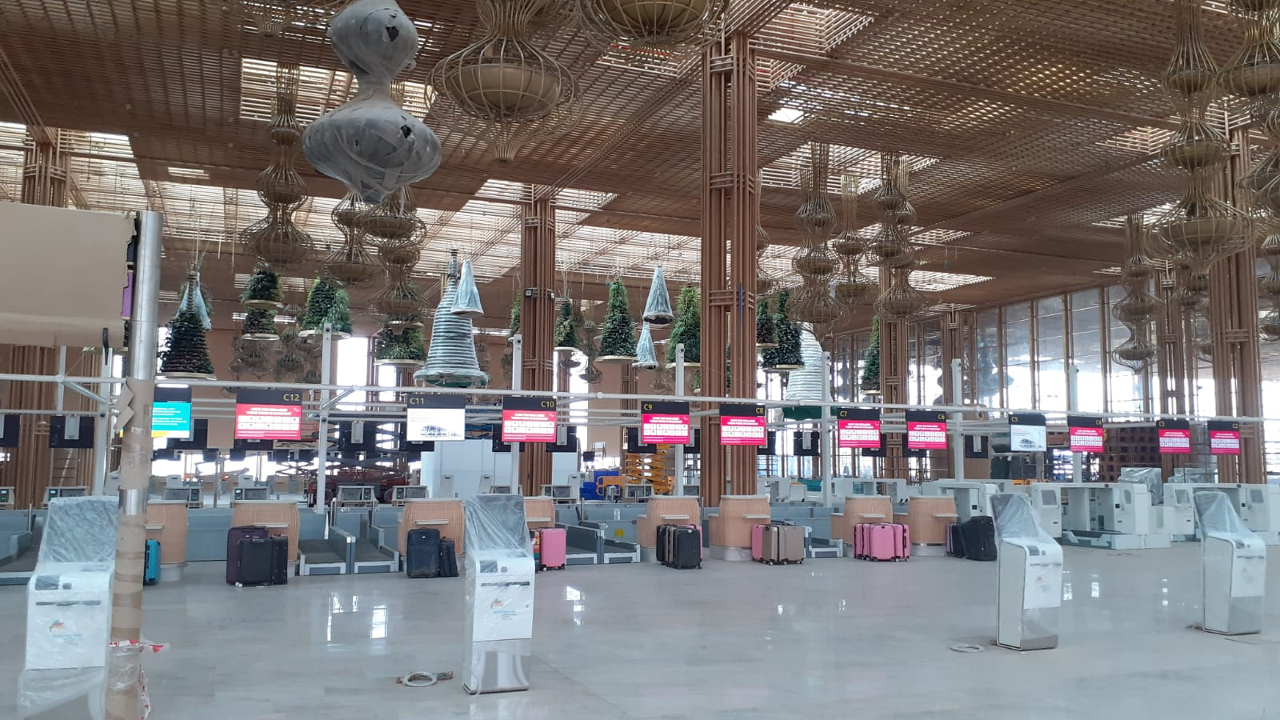
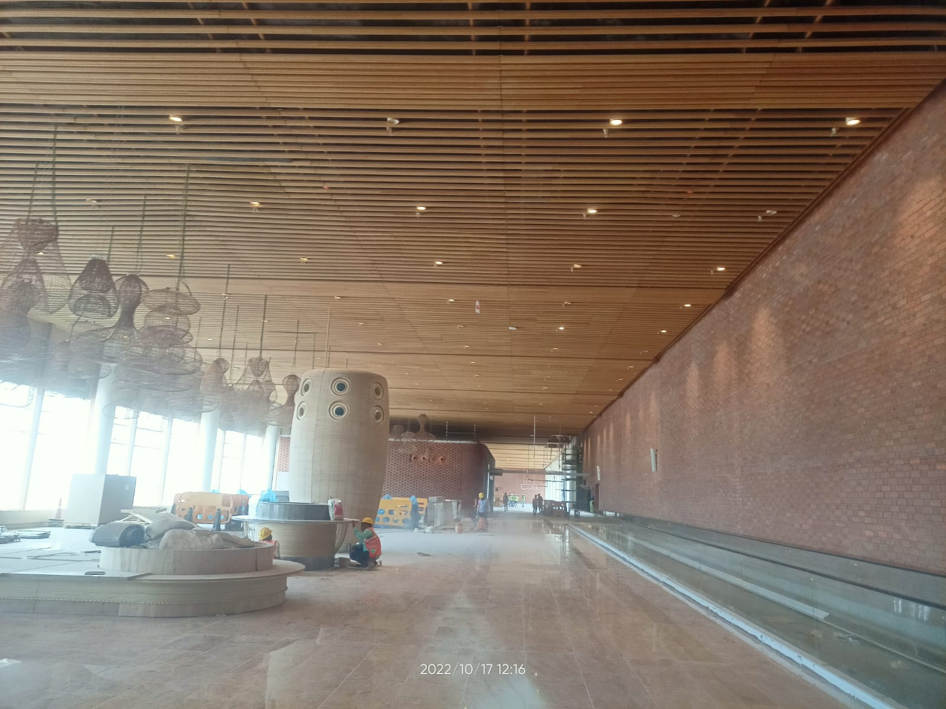
Bangalore International Airport Terminal-2
Bamboo Facade Ceiling and Column
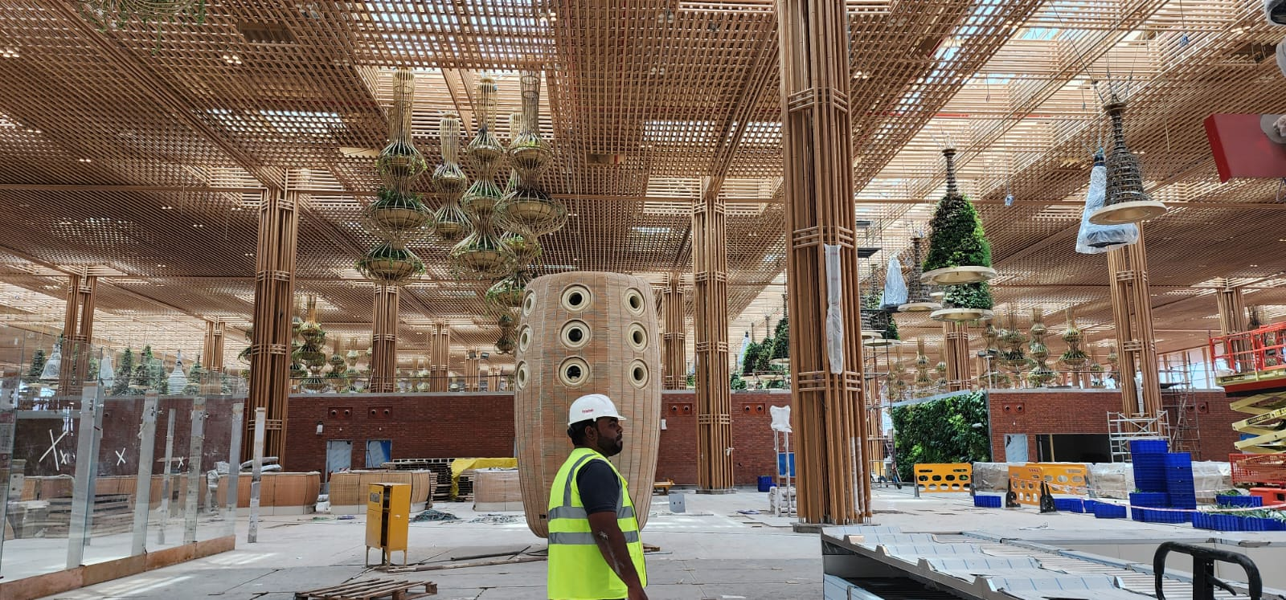

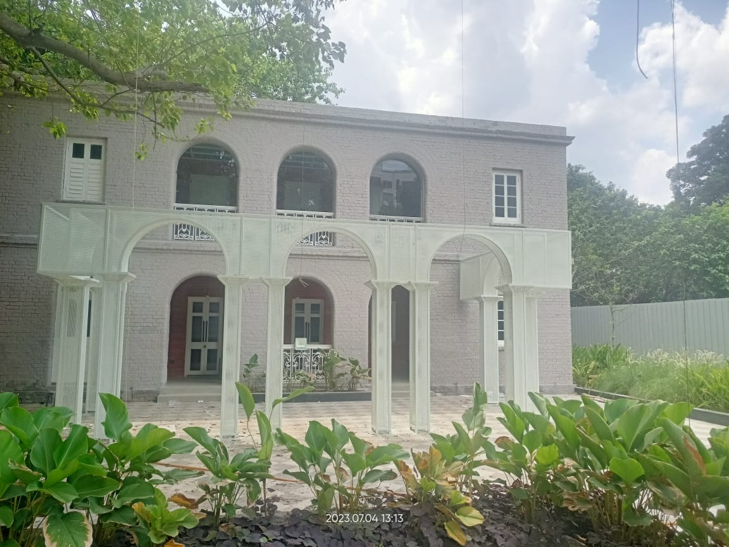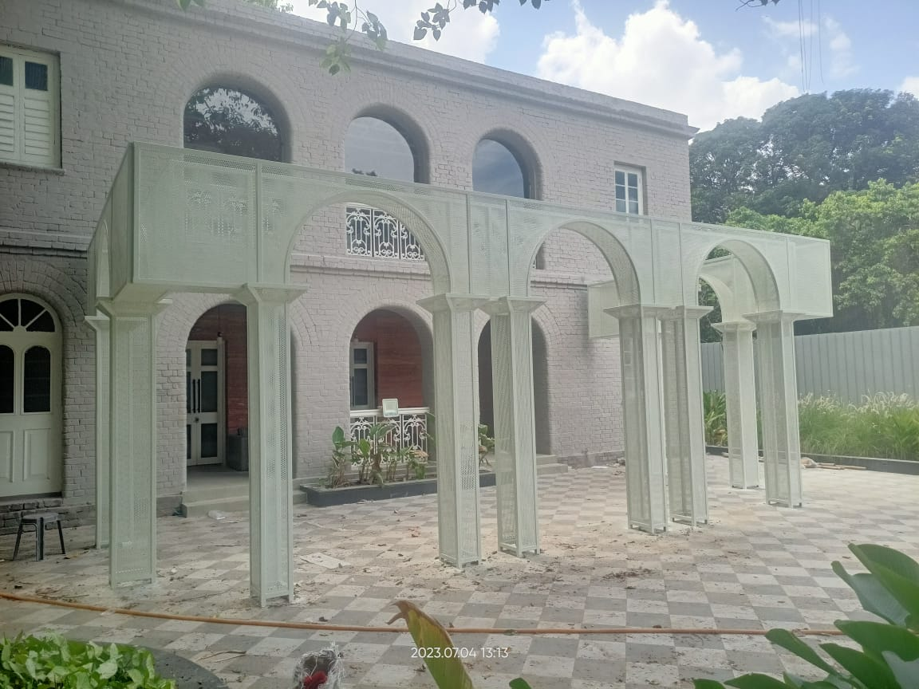
MS Perforated Sheet ARCH FAÇADE and Glass ARCH Façade

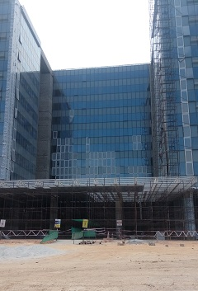

Embassy Tech Village- Bangalore, India

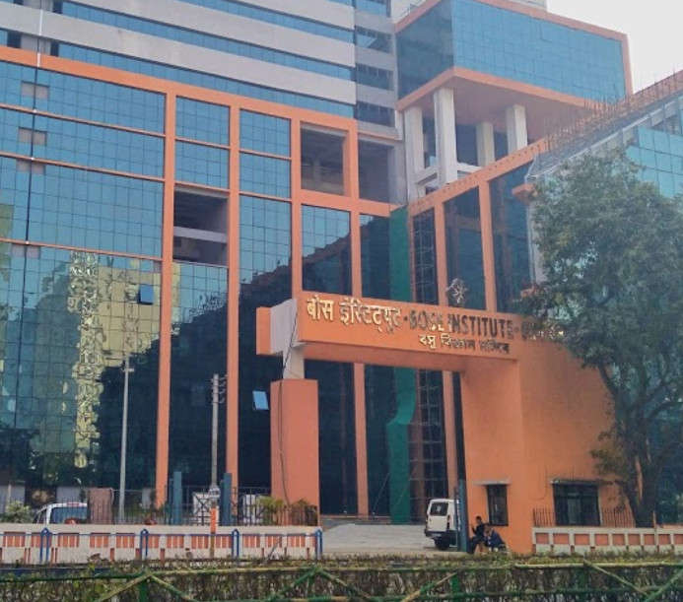
Bose Institute- Salt Lake Kolkata, India
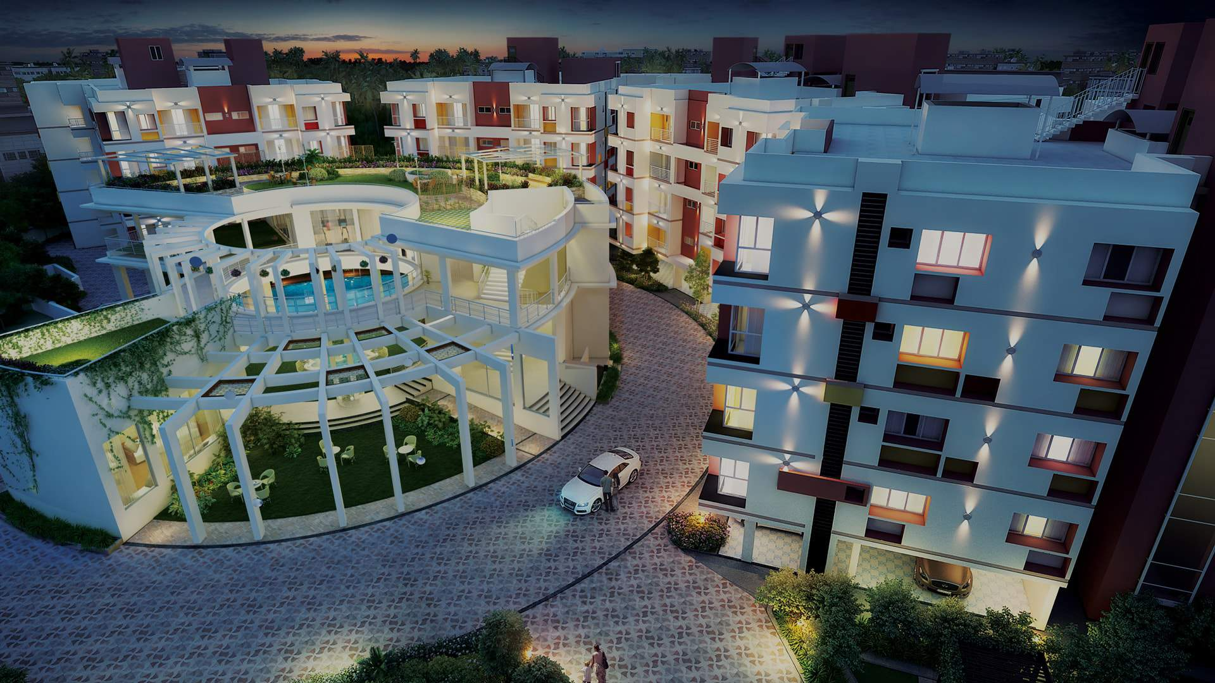
Ganguly Group- Garia, Kolkata, India

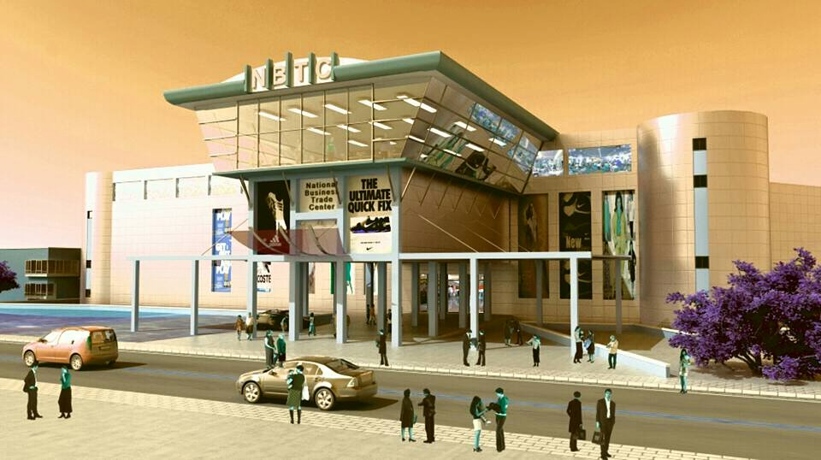
National Business Trade Centre-Kathmandu, Nepal

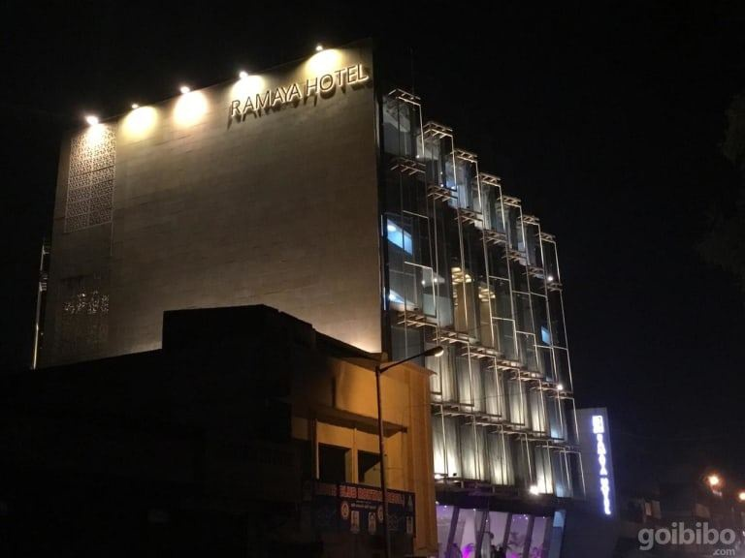

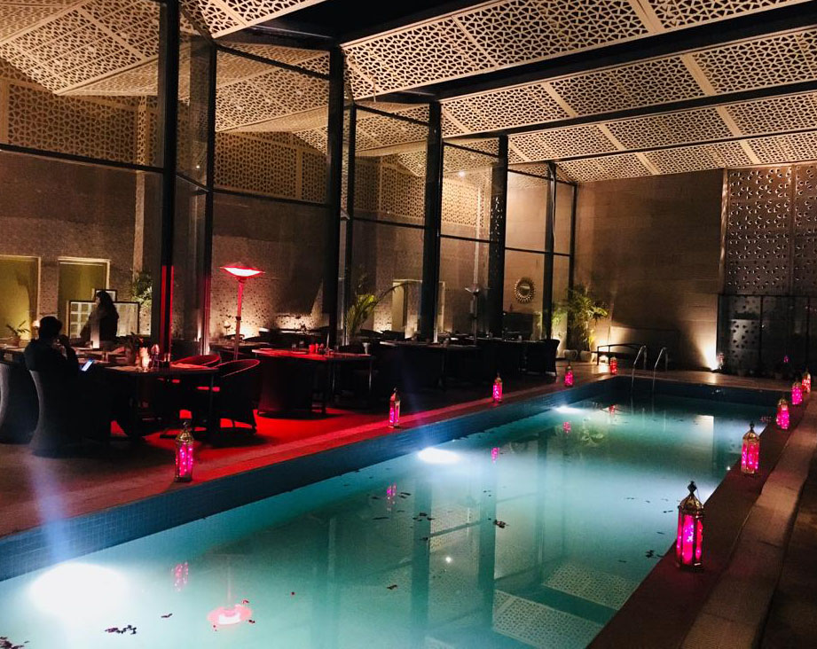
Ramaya Hotel- Haryana

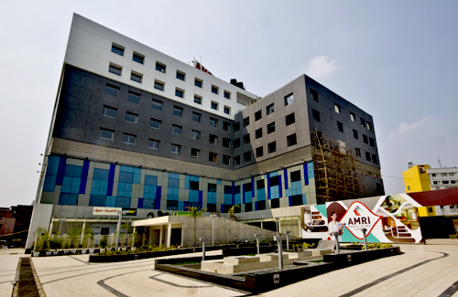
AMIR Hospital-Kolkata, India

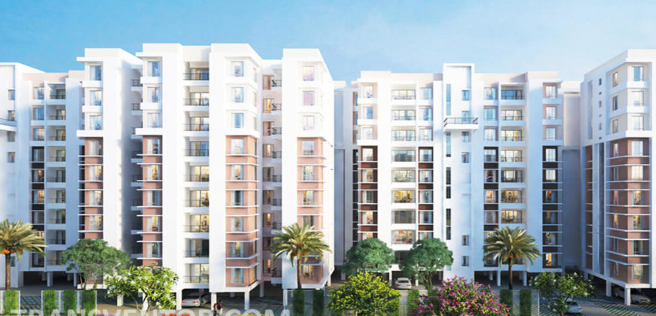
DTC Group Southern Height Project –Kolkata, India

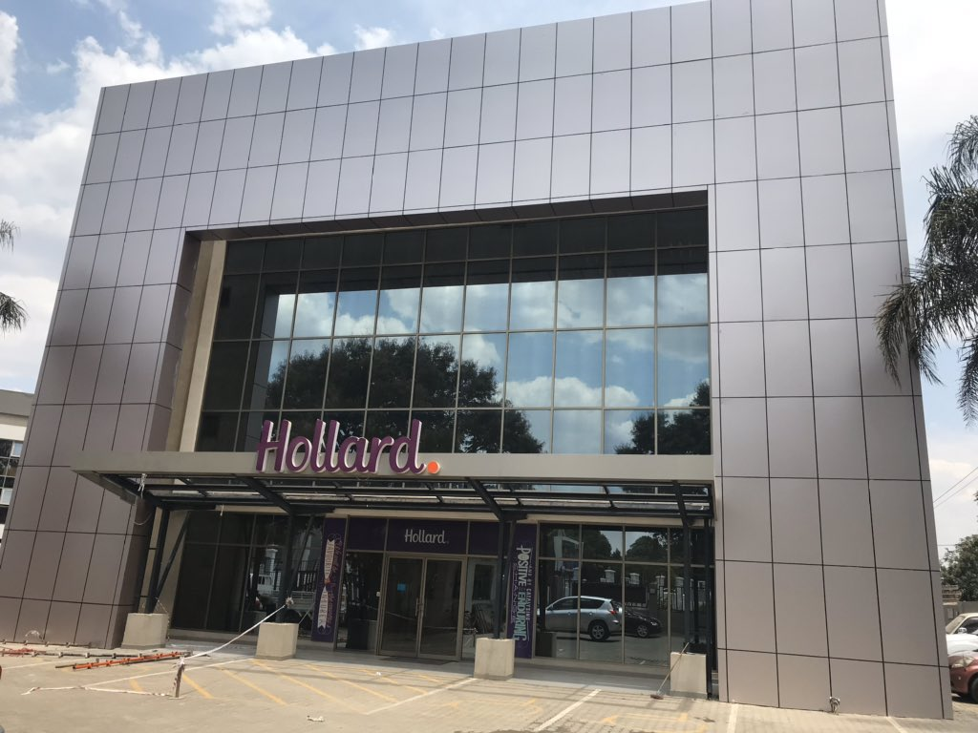
Inland Properties- Lusaka, Zambia
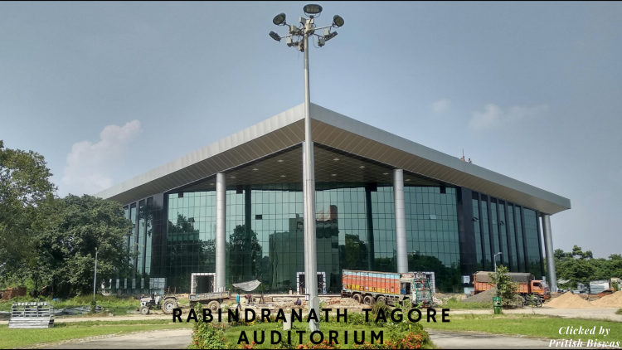
Indian Institute Sciences Education of Research Center-Kolkata, India
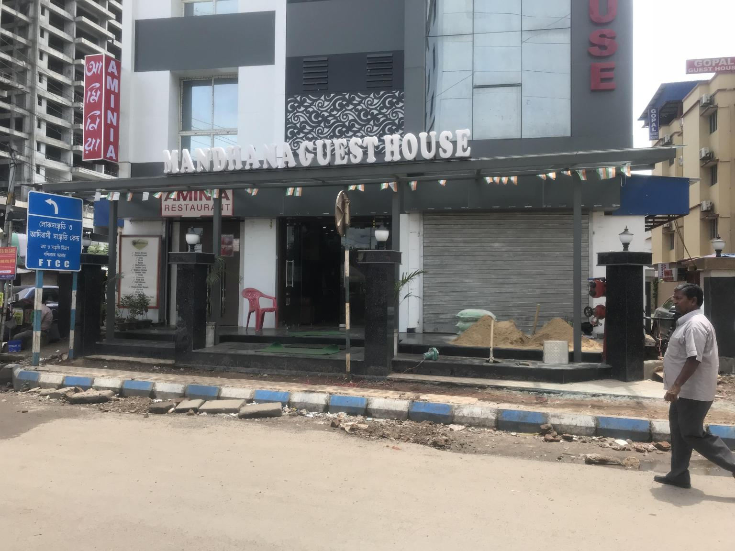
Mandhana Guest House –Kolkata, India
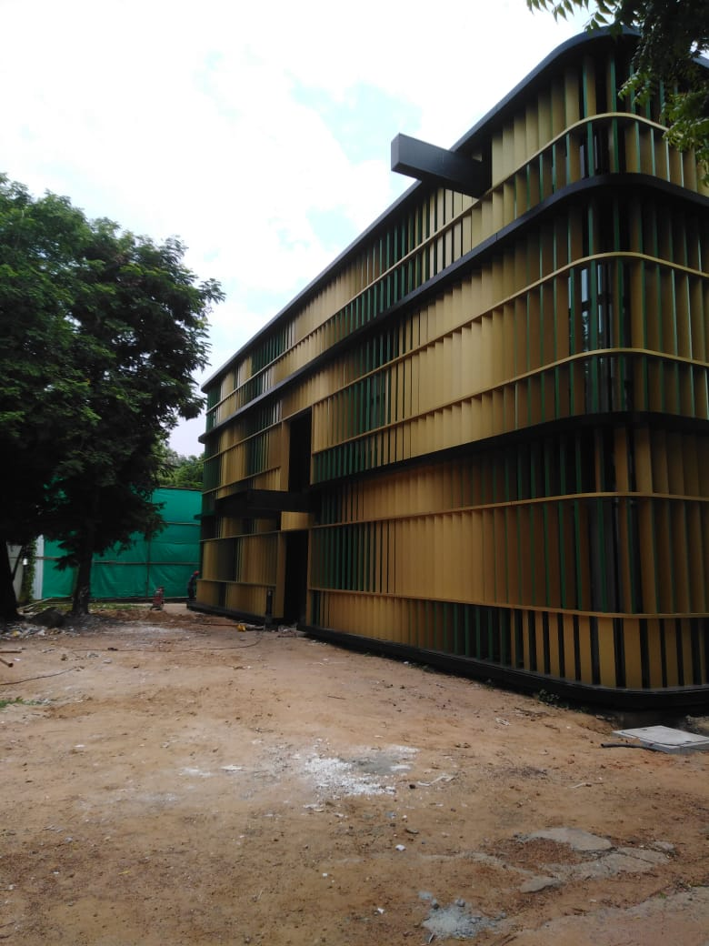
TAFE-Chennai, India
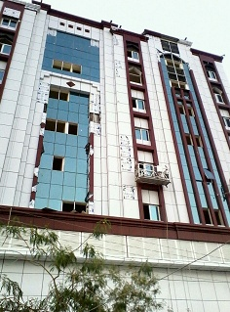
Kuwaiti Building in Khorfakkan - UAE

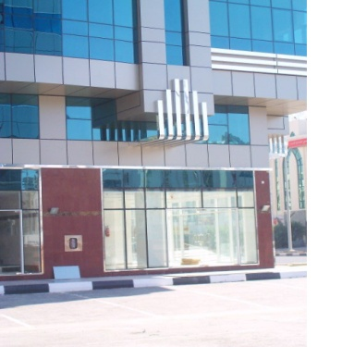
Shamsa Building-Abu Dhabi-UAE
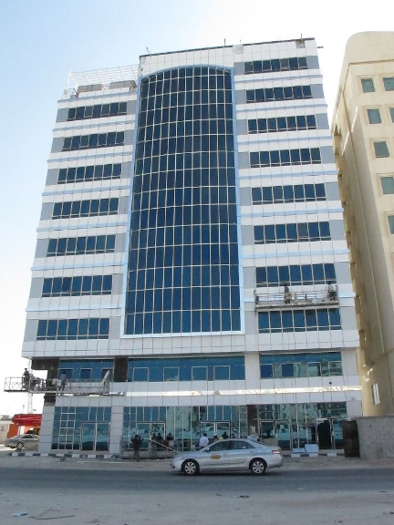

Mariam Building-Abu Dhabi, UAE
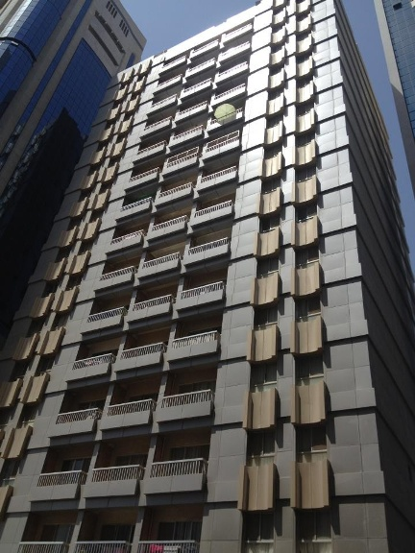
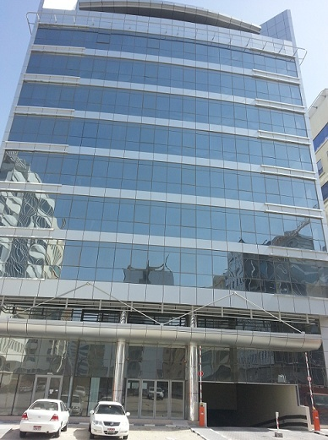
Kuwaiti Building-Abu Dhabi,UAE Junaibi Building – Abu Dhabi
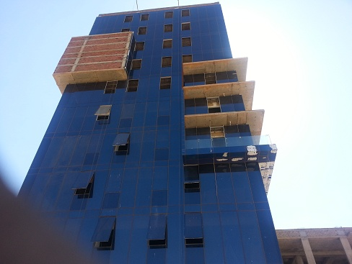
G+9 Building in Khartoum – Sudan
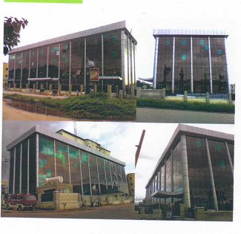
G+4 Building –Abuja, Nigeria

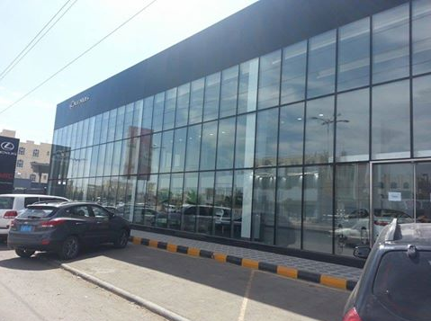
Lexus Showroom, Sana - Yemen

LIST OF MACHINERY& VEHICLE

1 | Semi Automatic Single Head Cutting M/C-----Italy | 2 Nos
2 | Freezing Machine-------Italy | 2 Nos
3 | Crimping Machine----Italy | 1 Nos
4 | Vertical Panel Saw-----Italy | 1 Nos
5 | Vertical Drilling Machine-----China | 1 Nos
6 | Wall Mounted Grinding Machine-----China | 1 Nos
7 | Welding Machine-----Italy | 1Nos
8 | Slotting Machine-----China | 1 Nos
9 | Working Table-----Local | 10 Nos
10 | 3 ton Pickup-----Mitsubishi | 1 Nos
11 | Small Pickup-----Nissan | 1 Nos
12 | 14 Seater Van-----Toyota | 1 Nos
13 | Car-----Mitsubishi | 1 nos

Machines:

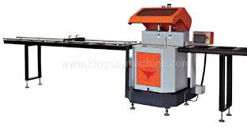
SINGLE HEAD ALUMINIUM CUTTING MACHINE

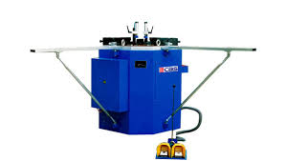
ALUMINIUM FRAME CRIMPING MACHINE

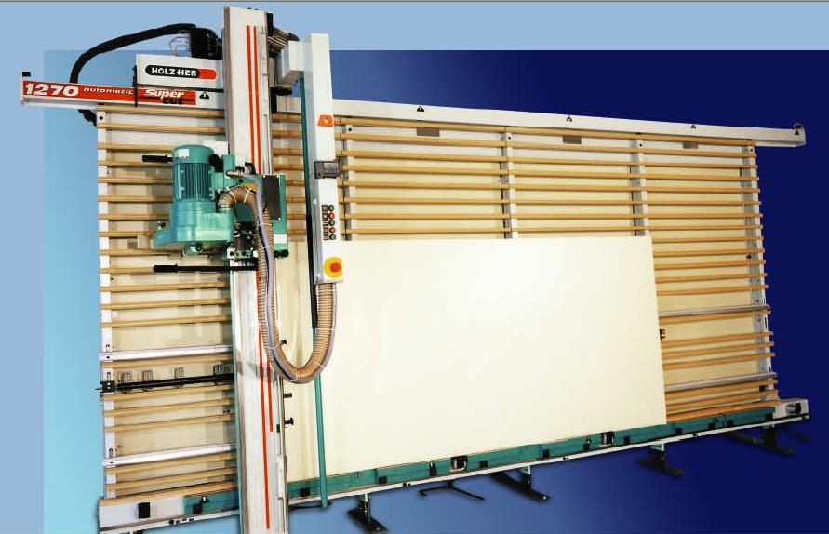
VERTICAL PANEL SAW MACHINE

LIST OF EMPLOYEE
1 | Division Manager | 1 Nos
2 | Project Incharge | 4 Nos
3 | Site Foreman | 7Nos
4 | Workshop Forman | 4 Nos
5 | Co-Ordinator | 3 Nos
6 | Office  Administrator | 3 Nos
7 | Draughtsman | 1Nos
8 | Accounts | 2 Nos
9 | Purchase | 2 Nos
10 | HR Department | 1 Nos
11 | Technician | 13 Nos
12 | Semi Technician | 5 Nos
13 | Helpers | 25 Nos

Head Office REGENT GROUP
P.O Box:-22542, Industrial Area 10
Sharjah, UAE
Tel:-+971-6-534 3511 Fax:- +971-6-534 0078
info@regentsteelind.com
sales@regentsteelind.com
www.regentgroup.ae
Branch Offices:
Dubai P.O.Box: 95786
Al Naboodah Building Office 301, 3rd Floor
Tel:- +971-4-283 0800
Fax:- +971-4-283 0820
Abu Dhabi Regent Steel Industries LLC
Saeed Bin Mubarak Sabt, Office No.10, 1st Floor
Tel:- +971-2-583 2238
India Vaultarmor Industries Pvt. Ltd
96/H/7 Cossipore Road
Kolkata—700002,West Bengal
Tel:- +919830754345
info@vaultarmorfacade.com/ waqar.s@vaultarmorfacade.com / sales@vaultarmorfacade.com/ project@vaultarmorfacade.com
website:- www.vaultarmorfacade.com
Facebok:- www.facebook.com/vaultarmorindpvtltd/
LinkedIn:- www.linkedin.com/company/vaultarmor-industries-private-limited/
Twitter:- Vaultarmor Industries Pvt Ltd (@LtdVaultarmor) / X (twitter.com)
Youtube:- www.youtube.com/@vaultarmorindustriespvtltd.
IndiaMart:- www.indiamart.com/vaultarmor-industries

