Name: _________________________________________ Today’s Date: ______________

Date of birth: ____________________ Age:______

Address:______________________________________________________________________________

Phone:___________________________________ Email:__________________________________

Occupation: __________________________ Leisure activities: _______________________________

**Marital Status: Married Separated Divorced Widow Single Other**

**Height and Weight:_____________________________**

Do you have any barriers to learning? (if yes, explain) **_________________________________________**

**ALLERGIES**: Allergic to latex? YES NO

Other allergies: ___________________________________________________________

**Please provide a list of medication (prescription and non-prescription to your provider and/or review your medication during your initial examination.**

**Do you take blood thinners**? YES NO

**Please identify all health care providers you are currently seeing**:

___ Medical doctor (MD) ___ Osteopath (DO) ___ Physical therapist ___ Chiropractor

___ Dentist ___ Psychiatrist/Psychologist ___ Other:_______________________

Date of last physical examination: ___________________

Primary Care Physician Name: ________________

**Have you EVER been told you have any of the following conditions**?

YES NO Cancer YES NO Rheumatoid arthritis

YES NO Heart disease / problems YES NO Other arthritic condition

YES NO High blood pressure YES NO Depression

YES NO Stroke YES NO Hepatitis

YES NO Diabetes YES NO HIV

YES NO Circulation problems YES NO Tuberculosis

YES NO Asthma / Lung disease YES NO Blood clots

YES NO Stomach ulcers YES NO Osteoporosis or Osteopenia

YES NO Thyroid problems YES NO Fibromyalgia

YES NO Multiple sclerosis YES NO Other _____________________________

YES NO Kidney disease

YES NO Substance use disorder

**Please list all past surgeries/operations/hospitalizations**:______________________________________

_____________________________________________________________________________________

_____________________________________________________________________________________

**During the past month, have you often been bothered by feeling down, depressed, or hopeless**? YES NO

**During the past month, have you often been bothered by little interest or pleasure in doing things**? YES NO

**Is this something you would like help with**? YES NO

**Are you afraid of increasing your pain when you are moving during your day?** YES NO

**On the picture to the right, please indicate where you feel your symptoms, using the symbols below.**

Pain Rating (0-10 scale) Current ____ Past 24 hrs: Best _______ Worst ______

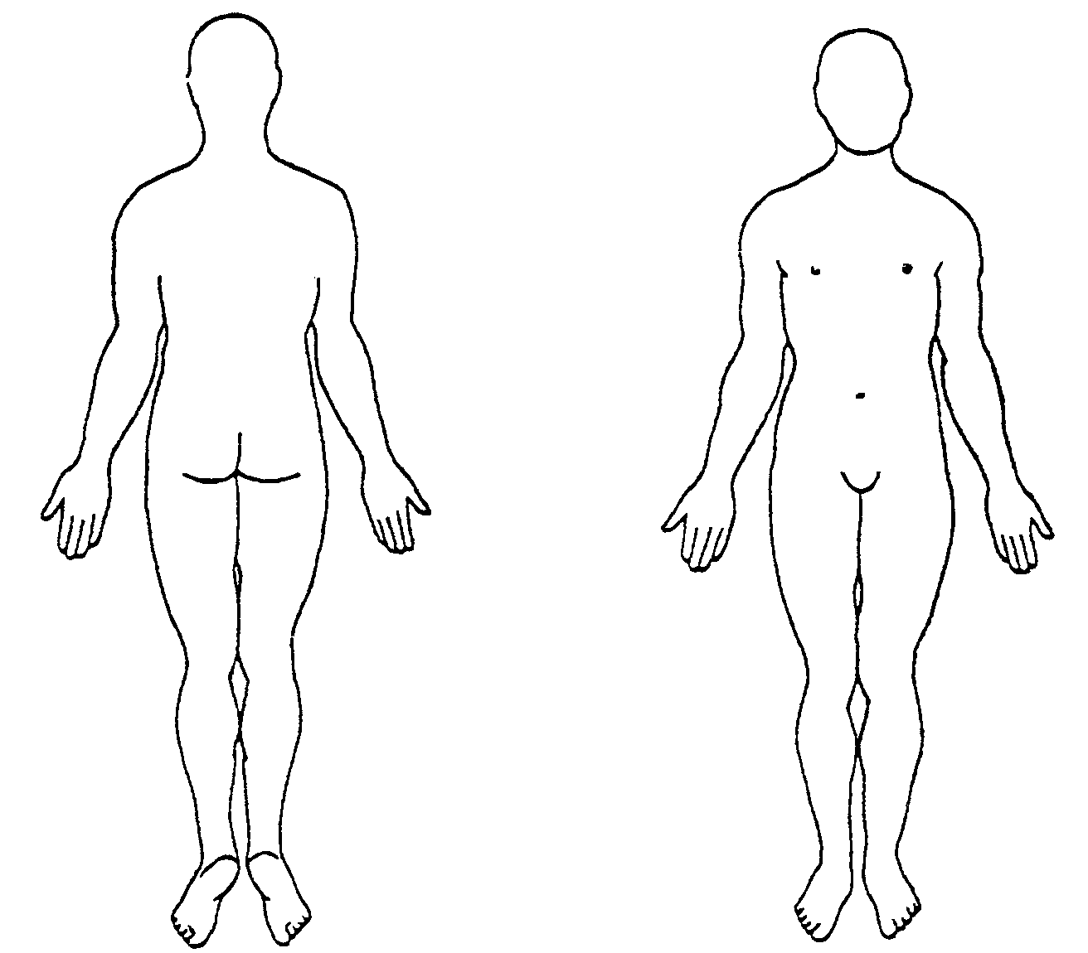

For **Pain** use xxx

For **Numbness/tingling** use ooo

For **Other symptoms** use <<<

**Insurance Information:**

I understand, as the patient and/or above noted responsible party, that I am fully responsible for payment of all charges incurred. I authorize my insurance benefits to be paid directly to: Bodyworx Physical Therapy & Chiropractic Wellness Center LLC (Brad Profitt, PT,DPT,DC,DScPT,OCS or Neil Evans,PT,DPT,CSCS,PhD,OCS or Jeremy Stephenson,PT,DPT) for services rendered. I understand I am financially responsible for any deductibles, non-covered services or non-authorized services. I authorize my Bodyworx provider listed above to release any information requested by my insurance company with regards to payment of benefits

___________________________________________ ___________________  
Patient/Responsible Party Signature Date  
___________________________________________ ___________________  
Provider Signature Date

( ) Medicare patient has signed ABN on file for all non-covered services.