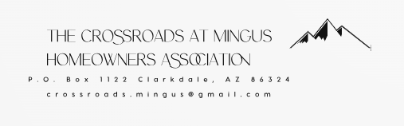

Courtesy Notice

Lot # ________ Homeowner ________________________________________

Physical Address _______________________________________________________

It has been brought to the attention of the Executive Board that you are currently in violation of our community standards as designated in the Covenants, Conditions & Restrictions. (CC&Rs) You may be unaware that:

1.
2.

Here is the CC&R for your reference.

1.

Thank you for correcting this matter promptly. If this matter is corrected within 14 calendar days of receipt of this notice, great! You won’t hear from us again.

If the violation still exists after 14 days, you will be sent an official violation notice. Please correct the violation as soon as possible or you risk fines being imposed upon you for failing to correct the issue.

We thank you for your cooperation in keeping our neighborhood a great place to live. If you have any questions regarding the violation, the CC&Rs, or the fine policy, please refer first to the published CC&Rs which should have been provided to you when you purchased a lot. They are also available on our website, www.crossroadsatmingushoa.com. The county also makes them available at https://yavapaicountyaz-web.tylerhost.net/web/user/disclaimer. Once you click the button I ACCEPT, type in Book 4381 and Page 801. Four options (Declaration of CC&Rs blue "D", and three Amendments to the Restrictions pink "A") appear. Select the blue D. You can print, view, or purchase a copy. Note that the Restrictions also apply and should be reviewed as well.

You may also email the Executive Board at crossroads.mingus@gmail.com. You must include your name, lot number and your contact information if you desire a response.

If you are experiencing some type of hardship that makes you unable to comply with the CC&Rs within the time frame above, please contact the Executive Board so we can work with you, if possible, to come to an acceptable resolution. Hardship requests will be reviewed on a case-by-case basis. Information provided will be kept in confidence by the Executive Board.

Thank you,

The Executive Board of The Crossroads at Mingus Homeowners Association.

