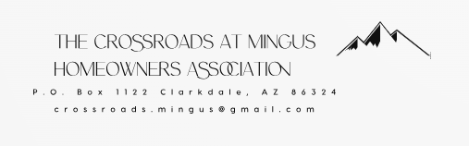

Timeline for Violations

- Courtesy Notice
  - The owner has 14 calendar days to correct the violation without further contact from the Executive Board.

- Notice of Violation
  - From the date of issuance, the owner has 30 calendar days to correct the violation.
  - The owner has 21 calendar days to contest the violation by sending a certified letter to the Association.
  - The Association has 10 business days to respond to the certified letter from the owner.

- Notice of Failure to Correct the Violation/Notice of Fine Imposed
  - On the 31st calendar day (regardless of whether the Association has responded to a certified letter from the owner), the first fine of $15.00 will be imposed.
  - The fine is due and payable immediately upon receipt of the Failure to Correct Notice. It is considered past due if not received within 30 days of the issuance of the Notice of Failure to Correct/Fine Imposed.
  - Additional fines will continue to be imposed and accrue starting on the 31st calendar day if the violation has still not been corrected and will continue to accrue until such time the violation is corrected or, if applicable, the lien has been satisfied.

- Example

  - Courtesy Notice is issued on July 1st.
  - On July 15th, the issue has not been corrected, so a Notice of Violation is issued. The property owner now has 30 days to correct the violation
  - On August 13th (the 30th day) the violation is still observed.
  - On August 14th (the 31st day), property owner has the $15.00 initial fine imposed. And on August 15th (the 32nd day), the $ 20.00 per day fine begins.
  - On August 19th, we see that the issue has been corrected. The total fines owed would be $15.00 + $80.00 which is the initial fine, plus the per day fine of $20 for August 15, 15, 17, 18, for a total of $95.00.

