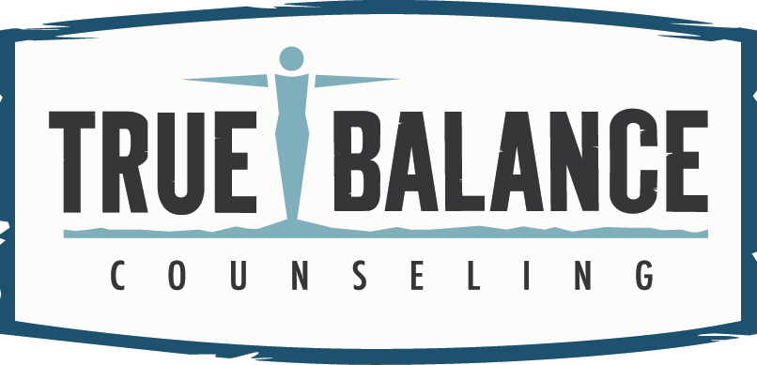
True Balance Ltd
16016 233rd Street
Little Falls, MN
320-632-5524 (office)
888-991-2741 (fax)
www.truebalancefarm.com
office@truebalancefarm.com

REFERRAL FORM
Please provide as much of the following information as possible.
Please let your patient know we will contact them and include the appropriate release of information
Date of referral:
Patient last name: First: MI:
Date of birth: | Gender:
Parent/guardian name: | Best contact phone(s):
Address: | Insurance Plan:  Policy #:  Policy holder name:
Referral Question  Please describe specific problems/symptoms and diagnoses: | Category of Request (Check all that apply):  Developmental Consultations  High Risk/ Complexity Case Consultations  Fetal Alcohol Spectrum Disorders (FASD) Diagnostic Evaluations  Autism Evaluations  Psychological and Neuropsychological Evaluations  Psychiatric Medication Management  Court Ordered Services _________________________________  Group Therapy  Family Therapy  Individual Therapy  Other:_________________________
Previous/current relevant health or mental health history (include duration of symptoms):

ICD-10 Code(s) (for insurance prior authorization):
Does the patient have any of the following limitations: (check)
Communication Language Vision Hearing Physical Disability History of Head Injury
Requesting provider: |  | Primary Care Provider Other
Best contact number: |  | Fax:

Referring Provider Signature:

Today’s Date:
***Please send any recent chart notes, history and physical reports, or discharge summaries.

