**Counselling and Wellness** 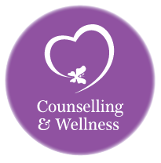

**Coronavirus (Covid-19) Wellness Plan**

**Be kind to yourselves and look after your mental health, body, emotions and immune system keep them as healthy as possible.**

We have put this information together to invite you find ways of helping yourself in these uncertain times.

Ensure you maintain a healthy, nutritional diet. Look after your mental health and keep your stress levels down. Ensure you have adequate sleep. Minimize sugar consumption and stay off processed foods if possible. Identify your individual health challenges and vulnerabilities and work to optimize health and reverse disease. Washing your hands and not touching your face is one of your best defences against this virus. Follow the NHS and government guidelines.

**Vitamin and Magnesium**

Ensure that your A, vitamin B,C, D, Magnesium and Zinc levels are optimized for a healthy immune system and mind. You can generally find nutrition in whole foods, but it may be advantageous to take supplements, particularly during these tough stressful and viral times.

It can be hard to get enough vitamins and minerals from diet alone and we recommend that you take supplements during the winter months, when feeling rundown or unwell.

**Foods, we need to include in our diet to help reduce stress and improve our immune system and mental health.**

**Fruit and vegetables** 

**Fruit and Vegetables:** Eating a diet rich in fresh fruit and vegetables will ensure you get plenty of nutrients, improving your immune system and your serotonin up take for mental health. Which is crucial when your body is feeling stressed or rundown.

* **Eat** at least five portions of fruit and vegetables a day to get a sufficient amount of vitamins and minerals,
* **Foods to focus** **on** need to be rich in vitamins A, B, C, D, magnesium and zinc
* **Vitamin A:** is our number one protection against viruses**.** Take Cod liver oil, one that contains natural vitamin A and eat liver at least once a week. Othersources of vitamin A: Milk, egg-yolk, carrots, dark green leafy vegetables and yellow fruits.
* **B vitamins:** Are known to be essential in the biochemistry of the brain, Found in bananas, leafy greens, nuts, seeds, meat, fish and dairy products. These provide the body with energy after a period of stress. Deficiencies can lead to anxiety, depression, irritability, and fearfulness. For this reason, you may want to take a B-complex vitamin, which includes all the B vitamins. It is involved in many processes in the body and is necessary for normal cell growth and function.
* **Vitamin C:** is a great immune booster and lowers your blood pressure. Found in citrus fruits and many vegetables, including oranges, bell peppers, tomatoes, and cauliflower. The best source of vitamin C is in fermented Veggies like sauerkraut there is ten times more vitamin C in sauerkraut than fresh cabbage.
* **Supplementing:** With Vitamin C. There is [evidence](https://www.ncbi.nlm.nih.gov/pubmed/10796569) that supplementing with Vitamin C 200mg daily throughout the year can help shorten the frequency and duration of viral illnesses. If you feel symptoms of the coronavirus. Up this to from 1000mg to 3000mg per-day. You can buy pleasant-tasting vitamin C chewable for school-age children.
* **Vitamin D:** The best source is cod liver oil, fresh free ranged eggs from farm pastured hens, Butter from grass fed cows. (Dairy-gold butter is a good one). It is difficult to get enough D from diet alone and I recommend that most people supplement D during the winter months: in general, babies can take 400iu/day, school-age 600-800iu and adult 1000-2000iu.
* **Zinc:** Helps fight against viruses. It is found in meats, legumes, and seeds, shellfish, eggs. There is some  [evidence](https://www.ncbi.nlm.nih.gov/pubmed/19906491) that lozenges, allowed to dissolve slowly in the mouth, work to prevent viral upper respiratory illnesses and shorten their duration.. Sucking on a high-quality zinc lozenge at the first sign of illness or even a few times a day as a preventive measure could be good. For children there are a variety of zinc sprays that you can spray into their mouths. It needs to be limited to 5-10mg per day in children between 6 months and 2 years and 15-20mg daily in school-age children.
* **Magnesium:** Is essential to nerve health. It is found in nuts - particularly Cashew and Brazil nuts are high in magnesium, as are beans and lentils, wholegrains and leafy greens. This mineral is crucial in helping to relax the nerve system and muscles reducing stress, while also playing an essential role in hormone and energy production.
* **Sauerkraut:** is rich in dietary fibre and a great sauce of vitamin A, C, K and B, manganese, iron, sodium, copper, magnesium, and calcium. In addition, it also contains moderate amount of protein and leads to the production of probiotics. These ingestible microorganisms have been connected to improved endocrine, immune, digestive and cognitive functions.
* **Bone Broth:** Make bone broth It nourishes your immune system, gut and bones and helps us detoxify. Eat meat from grass-fed animals has a better fatty acid composition and contains more antioxidants.
* **Avoid If Possible:** Eating meat from animals grown on a feed lot or in a cage will not nourish your body properly. This is what gives meat a bad name. Find a local a farmer who raises livestock on he’s land.
* **Propolis:** This is what bees make to protect their hives from infection. itis a great tool for your antiviral arsenal, with very little downside. Though clinical studies are limited, it appears to have [antiviral and antimicrobial properties](https://www.researchgate.net/publication/5241325_Anti-Influenza_Virus_Activity_of_Propolis_in_Vitro_and_its_Efficacy_against_Influenza_Infection_in_Mice), is safe for use in children and can also be found as a spray. It also appears to have anti-inflammatory properties, which may be a helpful remedy for symptom relief, should you become unwell.
* **Garlic:** For the chest or when fighting virus, Flu or you feel chestly. Crush 3 clove of garlic into water and drink it. if you find this difficult:

Place 8 cloves of garlic into a sealed jar and cover with water and seal  
Place garlic water in refrigerator for an hour before using

**What to do:**Pour 1/4 cup of garlic water into an eight-ounce glass.  
Add 1 cup purified water.  
Drink with a straw.

* **1st day** Drink garlic water every hour and a half throughout the day.
* **2nd day:** Drink garlic mixture every two hours or at the least three times that day.

**Continue:** To drink garlic water for the next seven days several times a day**.**

You may continue to use the same garlic cloves and refill the jar with water for up to three days. Discard garlic or any unused mixture on the fourth day. Always keep refrigerated.

**Ensure you buy a good quality Vitamin and Mineral:** The company we use at the moment is called Cytoplan. we are in the process of researching other companies that offer good quality nutrition. When we have finished our research we will put it on my website and my Counselling and Wellness face book.

**Natural Remedies for the emotions**

**We offer Australian Bush Essences for the emotions**: These are helpful for emotional disturbance such as worry, anxiety stress etc. These remedies are used to help restore mental health and harmony in the body. The Australian Bush Flower Essences bring forth the positive qualities that reside deep inside every one of us. Their activation allows us to replace fear with courage, hatred with love, insecurity with self-confidence, etc. Remember Stress worry and anxiety lower our immune system.

**We offer infoceuticals Drops:** For stress these are delivered by posted**:** whilst we are in isolation:

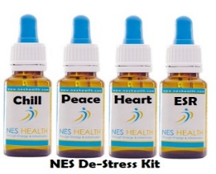 **For example The Peace drops:** Promotes inner peace, calms mental state, mental clarity, and honesty with oneself. Enhances the head-heart connection to transform conflicts between emotions and logical thinking, and memories that have caused disharmony.

**Emotional Stress Release (ESR) Drops:** Supports the entire body-field in releasing emotional stress. Especially soothing for the digestive tract and assists in the absorption of nutrients.

**Taking your healing Further Energy health scans**

**Blocked Energy Release Treatment** 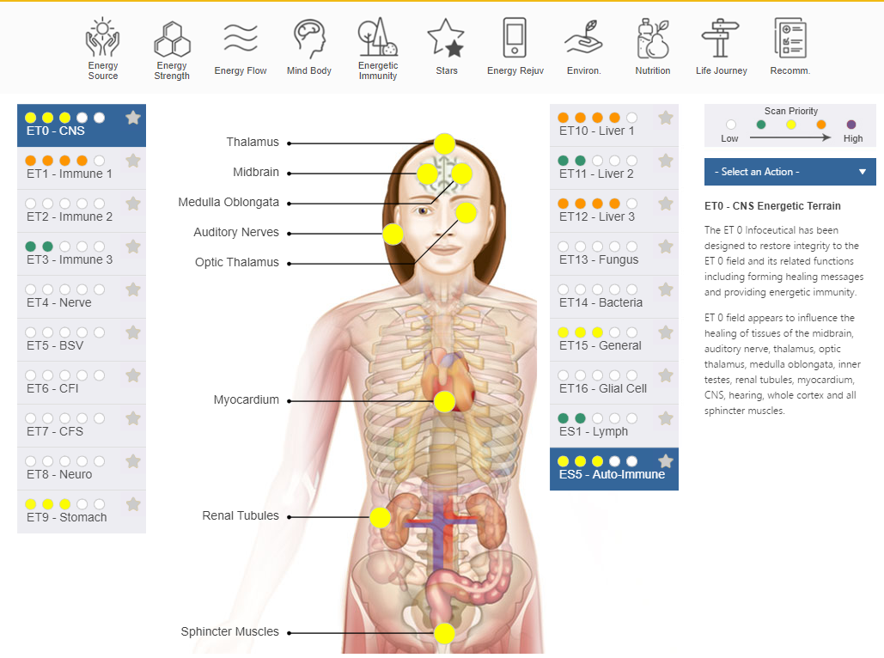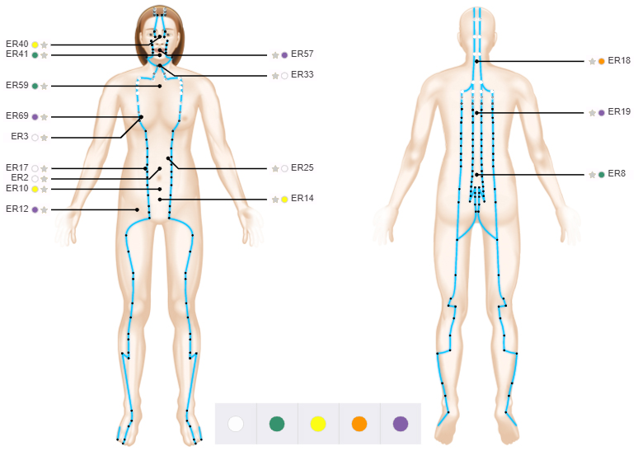

If you are interested in taking your healing further. We offer energy scans. These scans look for energy blocked in your organs and meridians. They can help in enabling the body to absorb the nutrition form your food improving the immunes system. The infoceuticals drops are made up to suit your system. They can be taken under the tongue or in water, when taken they initially assimilated into the bloodstream. Then they settle midway between the circulatory and nervous systems. There’s an electromagnetic current that runs around the body through a pathway called meridians. The treatment helps unblock energy which results in the healing of our physical, emotional and psychological well-being. There are NES Health infoceuticals drops for boosting the immune system. These drops are all natural and don’t interfere with medication.

**Whilst we are in isolation:**

The Scan can be carried out from your home through a finger scan that is sent to your home. Then I would connect with you Via Zoom, WhatsApp or Phone.

**NES health has put 2 pack together to help support our Immune system.**

**Immune Support Pack**

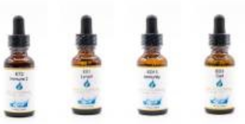

NES Health Infoceuticals are designed to support the body-field in directing efficient and accurate activity of the body. In this way, we support the body's everyday health and recovery efforts.

**Emotional Immunity Pack** 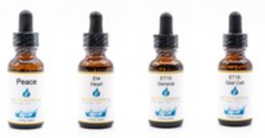

Our health relies heavily on the state of our emotions along with the strength of our immune system. This Emotional Immunity pack is designed to support positive emotions and an efficient, accurate energetic immune system.

**Healthy Mind:** Stress, anxiety and diet are linked to a healthy mind and immune system. It is possible that someone eating a healthy balanced diet is going to be far less stressed and healthier than someone eating a poor diet.

When we are stressed or worried, we use up our nutrients in our body, putting a strain on our immune system and brain affecting our thought patterns/mood/focus/behaviour. Because stress and anxiety eat up the nutrition in the body it slows down the production of serotonin (a hormones that make our happy endorphins which helps reduces stress)

**happy people lead happy lives**



Serotonin is a neurotransmitter that carries signals along and between nerves - It is mainly found in the brain, bowels and blood platelets. Serotonin is thought to be especially active in constricting smooth muscles, transmitting impulses between nerve cells, regulating cyclic body processes and contributing to wellbeing and happiness If the body is not making the correct amount of serotonin then this has an effect on our brain function, causing us to start losing our focus and make mistakes. This then leads to further stress.

**Fight Fear and don’t let it take over your health:**

At the end of the day. **Covid-19** presents an opportunity to take stock of your health and wellbeing, identify your and your family’s vulnerabilities and work towards minimizing them. Offer help to vulnerable elderly members of society.

**Techniques**

When feeling stressed or anxious remember use the tools I have given you in therapy

when your mind in running away from you or you are feeling anxious. use grounding on 5 focus on……

* 5 things you can see.
* 4 things you can touch
* 3 thing you can hear
* 2 things you can smell
* 1 thing you can taste
* Then take a breath

**Mindfulness**

Practice mindfulness breathing and being in the present moment as much as possible.

It is also useful to take a deep breath and remember that even though covid-19 is a new virus, we have seen the likes of nasty, highly contagious viruses before and got through them.

**Sleep:** A good night sleep is important for our mental health and immune system. Put some Lavender on your pillow to help relax you: or the Tropic company have a spray that helps promote sleep. (Called So Sleepy)

**Progressive Muscle Relaxation:** to help sleep and anxiety. This is an exercise that relaxes your mind and body by progressively tensing and relaxing muscle groups throughout your entire body. Tense each muscle group vigorously but without straining, and then slowly release the tension and feel the muscle relax. Tense each muscle for about 5 seconds. If you have any pain or discomfort at any of the targeted muscle groups, feel free to omit that step. Throughout this exercise you may visualize the muscles tensing and a wave of relaxation flowing over them as you release that tension. It is important that you keep breathing throughout the exercise.

Start at your feet as you breath in for 5 seconds. Tighten your toes hold this position for 5 seconds and feel the tension, then breath out feeling the tension release, relaxing your feet and toes. Repeat this as you make your way up your legs stomach, chest, back shoulders, hands arms, neck, face and head. You can do this with or without music when you are struggling to sleep or any time in the day when you feel anxious, depressed or stress.

**Mindfulness for stressed and anxiety**

Using APPLE all day keeps the doctor away!

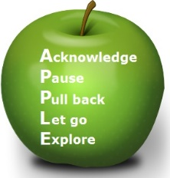

**ACKNOWLEDGE**- Notice and acknowledge the uncertainty as it comes to mind.

**PAUSE**- Don't react as you normally do.  Don't react at all.  Just pause and breathe.

**PULL BACK** - Tell yourself this is just the anxiety or depression talking, and this thought or feeling is only a thought or feeling.  ***Don't believe everything you think!***Thoughts are not statements of fact. It is a scientific fact that 90% of what we worry about doesn’t happen. The 10% we can’t do anything about.

**LET GO** - Let go of the thoughts or feelings. They will pass.  You don't have to respond to them.  You might imagine them floating away in a bubble or cloud.

**EXPLORE** - Explore the present moment, because right now, in this moment, all is well. Notice your breathing, and the sensations of breathing. Notice the ground beneath you.  Look around and notice what you see, what you hear, what you can touch, what you can smell  RIGHT NOW Then, SHIFT YOUR FOCUS OF ATTENTION to something else - on what you need to do, on what you were doing before you noticed the worry, or do something else – mindfully, with your full attention.

Research tells us that our minds wander at least 50% of the time. It's ok for minds to wander, but it is helpful to be able to notice, when the mind wanders onto things that aren't so helpful, and then to choose our focus, even for a short time.

**Exercise:** make sure you keep up with having some kind of exercise

Regular exercise helps prevent or manage many health problems and concerns, including:

* Improving cognitive function
* Depression
* Anxiety
* Many types of cancer
* Arthritis
* Stroke
* High blood pressure
* Type 2 diabetes

**Exercise improves mood and reduces stress**

When you need an emotional lift or need to blow off some steam after a stressful day brisk walks can help. Physical activity stimulates the production serotonin in the brain - a chemical that helps to leave you feeling happier, more relaxed and less anxious.

You may also feel better about your appearance and yourself when you exercise regularly, which can boost your confidence and improve your self-esteem.

**Coronavirus Covid-19**

As a therapist we always encouraging clients to socialise and connect with people for wellbeing.

However, in these unsettled times it is important to follow the guideline set down by the NHS. These may change as the weeks continue. Below is a simple view of their guideline. This doesn’t mean you just stay on your own. Your mental health is important, even more so at these disturbing times. Therefore, if you are able still connect with us. Via - Skype, Zoom WhatsApp or Phone do so. If you have family members that have access to these means of communicating keep in touch for your own wellbeing as well as your love ones.

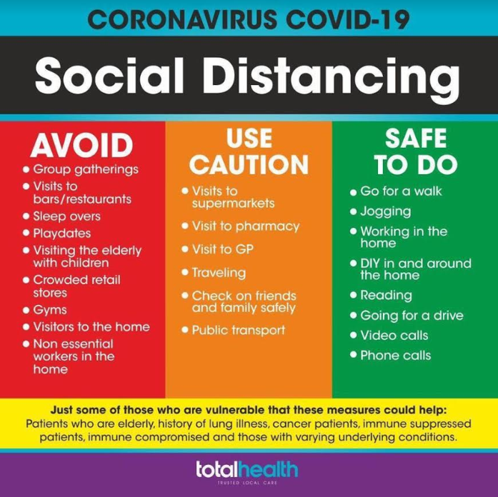

Up date on the Government announcement. We are having to isolate further this includes….

* Only go outside for food, health, reasons or work (where this absolutely cannot be done from home)
* Stay 2 meters (6ft) away from other people
* Wash your hands as soon as you get home

You can spread the virus even if you don’t have symptoms. We need to protect ourselves, our families and the nation.

We hope this is of some help in these uncertain times ahead

Stay safe, be kind to yourself and others.

**Please feel free to circulate this information to your family and friend. We need to help as many people as we can.**

Counselling and Wellness Joan 07979103886 Margaret 07968360624