Tri-Lakes TRIFECTA TM
Sponsored by peakquest
Upon successful completion of the Tupper Lake 3, Saranac Lake 6, Lake Placid 9er

Please complete this form and mail to: peakquest 479 Lake Street, Saranac Lake, New York 12983
Please be sure to enclose a $15 completion fee; checks are made payable to peakquest.
We will send you a Tri-Lakes TRIFECTA certificate of completion with your registration number, a 3-6-9er decal, a challenge coin, a patch and also add you to our official list of 3-6-9ers!
SUMMER PATCH _______ OR WINTER PATCH ________
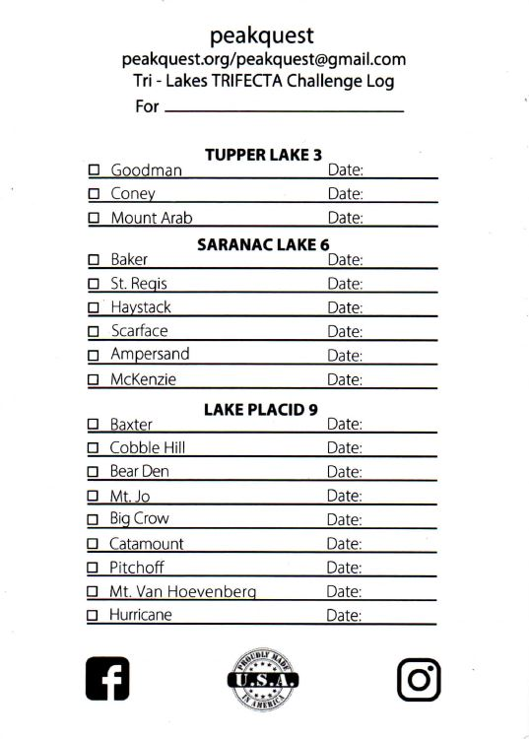
Name:____________________________________________________
Address:___________________________________________________

