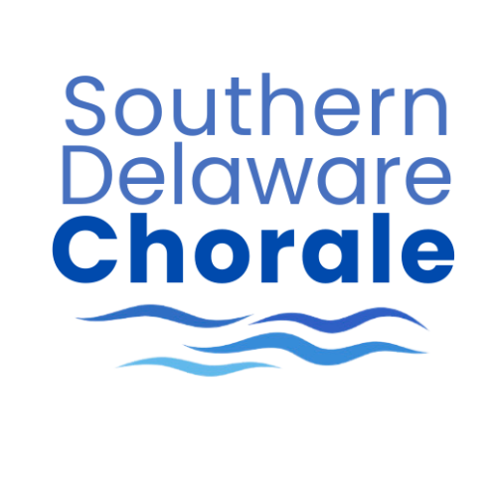

SOUTHERN DELAWARE HIGH SCHCOOL SCHOLARSHIP APPLICATION
For 2026/2027 Season

Name: _____________________________________________________________________________
First Last

Address: ___________________________________________________________________________

School: ______________________________________________ Grade: ________________

Phone: _______________________________ Cell Phone: _______________________________

E-mail: (Please print clearly, you will be contacted by text and/or e-mail)

Brief statement about your musical interest and singing experience:

_______________________________
Signature of Applicant

Recommendation from High School Choral Director:

_____________________________________ _____________________________________
Signature of HS Choral Director Signature of Applicant’s
Parent or Guardian

Deadline: We ask that you submit this ASAP so we can facilitate auditions for the fall semester.

Mail application to: Southern Delaware Chorale
High School Scholarship Application
P.O. Box 444
Rehoboth Beach, DE 19971

OR Scan/Send to: tabarrett818@gmail.com

