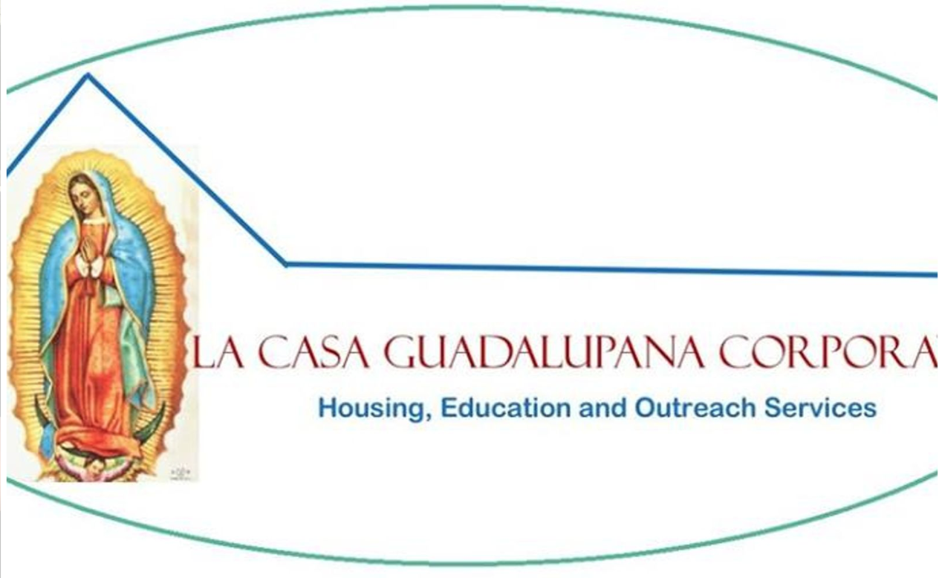
La Casa Guadalupana

Volunteer Form

Tutor Information
Name:
Address:
E-mail Address:
Phone Number:

Preferences
Days you would like to volunteer:
☐Mondays
☐Tuesdays
☐Wednesdays

Comments:

Submission Instructions
Orientation will be provided for all new volunteers.

E-mail this completed form to Sr. Marie Benzing at mbenzing@csjoseph.org or mail a physical copy to the St. Stephen/Mary, Mother of the Church parish office located at the following address:

Centro de San José
4329 Central Avenue
Detroit, Michigan 48216

