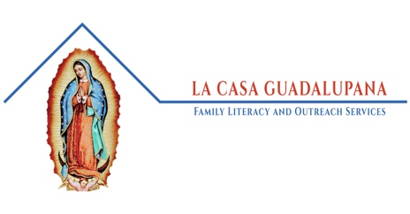
Volunteer at La Casa Guadalupana

Volunteer Form

Volunteer Information
Name:
Address:
E-mail Address:
Phone Number:

Preferences
Days you would like to volunteer:
☐Tuesdays
☐Wednesdays
☐Thursdays
Comments:

Submission Instructions
Either e-mail this completed form to Sr. Marie Benzing at mbenzing@csjoseph.org or mail a physical copy to:
4330 Central Avenue
Detroit, Michigan 48216

