THE SOUTHAMPTON DAYS COMMITTEE

Presents…

**DESIGNER BAG BINGO**

 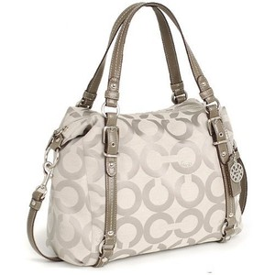

**Saturday – July 8th, 2023**

Under the Big BINGO Tent - 2:00PM – 5:30PM

BINGO begins at 2:30PM

**Tickets: $30.00 * Advance Purchase Only * Non-Refundable**

* Ticket will include one (3 card) BINGO Board which can be used for all games played
* Additional BINGO Boards will be on sale at the event
* Refreshments and snacks will be provided

***Get your tickets today…This is going to be a great event!!***

***Limited number of tickets/seats available…***

***Don’t miss out on winning a COACH Bag of your choice!***

For more information email Stephanie Miller @ [stephanie@southamptondays.com](mailto:stephanie@southamptondays.com)

Name:___________________________________________________

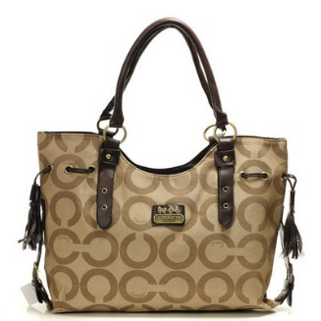Address:_________________________________________________

City:_______________________ State:_____ Zip:_______________

Phone:__________________________

Email:___________________________________________________

# of Tickets_____________ @ $30.00 each

Total $________________ Check #______________

**Make checks payable to: Southampton Days**

**Mail check & form to:**

**Southampton Days**

**Attn: BINGO EVENT**

**P.O. Box 1580**

**Southampton, PA 18966**