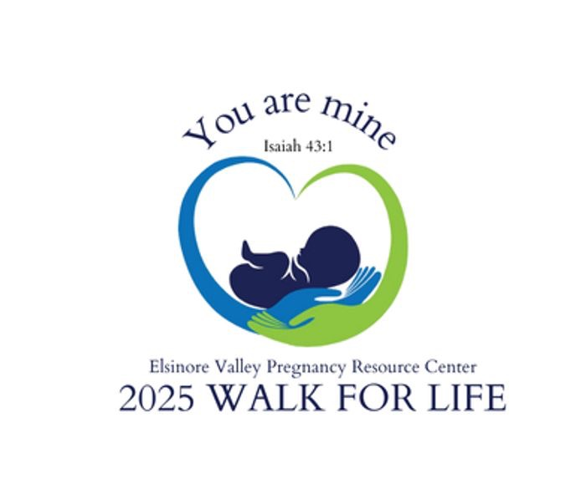

**2025 Walk for Life Pledge Sheet**

**Participant Name: ___________________________***Sponsor walkers by pledging a donation amount per mile walked, or a flat donation. All proceeds benefit Elsinore Valley Pregnancy Resource Center.*

|  |  |  |  |
| --- | --- | --- | --- |
| Sponsor Name | Address / Phone | Pledge Per Mile | Flat Donation |
|  |  |  |  |
|  |  |  |  |
|  |  |  |  |
|  |  |  |  |
|  |  |  |  |
|  |  |  |  |
|  |  |  |  |
|  |  |  |  |
|  |  |  |  |
|  |  |  |  |
|  |  |  |  |
|  |  |  |  |

Walker’s Signature: ___________________________ Date: ________________

Thank you for supporting life and the Elsinore Valley Pregnancy Resource Center!