Instructions for Transmittals:
It will be to the benefit of membership chairman that they have ALAMIS access to look up applicable topics prior to sending the transmittal.

Alphabetically list members by last name
Adams
Avarka
Fredrick
Zimmer

Include membership numbers after names
Renewal Last Name First Name member number

Use headings (New, Renewal, Online, PUFL or Honorary)
New Adams Mary 123456789

Renewal Avarka Joan 456789123
Fredrick Kimmy 789456123

PUFL Zimmer Amy 159456123

Specify class if Jr -it will be assumed that the member is Sr
Adams Mary (Jr) 123456789
Avarka Joan 456789123

If member is changing names, please list both names (from/to)
New Adams Mary (jr) 123456789

Renewal Avarka (Jones) Joan 456789123
Fredrick Kimmy 789456123

PUFL Zimmer Amy 159456123

State if the member is a rejoin next to the name
New Adams Mary (jr) 123456789

Renewal Avarka (Jones) Joan 456789123
Fredrick Kimmy (rejoin) 789456123

PUFL Zimmer Amy 159456123

Include a copy of all new member applications with this transmittal- signatures are required.

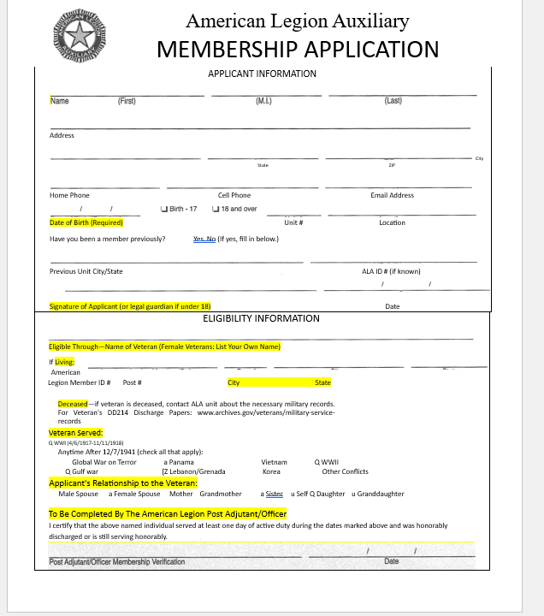

Please fill out a separate transmittal for each membership year.
2024 payments are on a transmittal for 2024 only
2025 payments are on a transmittal for 2025 only

