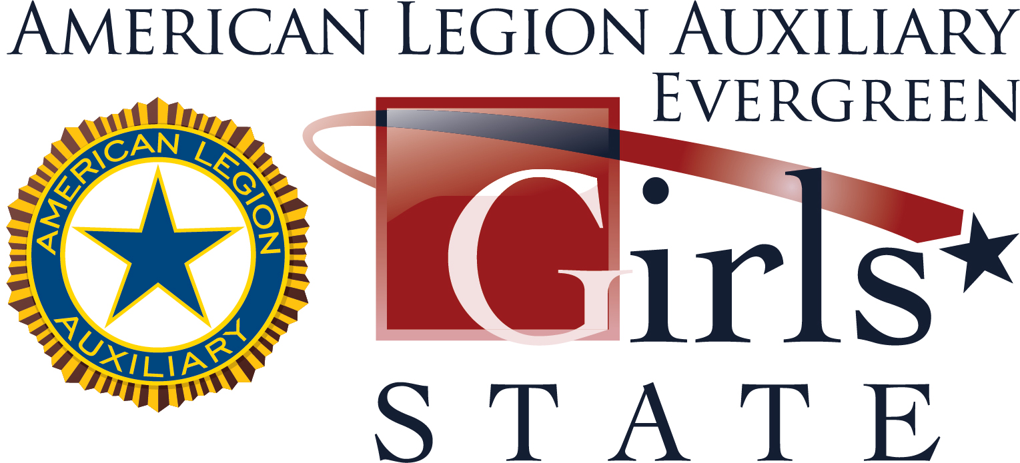

Here is a quick reference guide to ALA Evergreen Girls State 2023!

Dates
- Program Dates: June 11th - June 17th, 2023
- Deadline for the Samsung Scholarship is June 11th, 2023 (application is online and more info can be found at www.evergreengirlsstate.com).
- Application deadline: May 20th, 2023
- Registration and refund request deadline: May 26th, 2023

Cost
- Tuition—$400 (paid by Unit)
- Registration fee—$200 (paid by the citizen)

Place and Time
- Place: Central Washington University, Ellensburg
- Registration times: June 11th from 12-2pm (location on campus TBD)

Eligibility
- For 2023, both juniors and senior girls can attend ALA Evergreen Girls State
- Senior girls will not be able to run for the positions of Governor or US Senators and will not be eligible for any scholarship opportunities

Websites
- www.evergreengirlsstate.com
- www.boysandgirlsstate.org (from National)
- Also find us on Facebook and Instagram!

College Tuition Info
- www.leadershipcredit.info
- 3-credit course available. More information will be provided to the girls during the week.

Contact Information
- Director: Cathy Mulhall
cathy@evergreengirlsstate.com
- Evergreen Girls State Unit Liaison: Katelyn Andrews
katelyn@evergreengirlsstate.com
- General Questions: info@evergreengirlsstate.com

