2022 Washington Department Convention
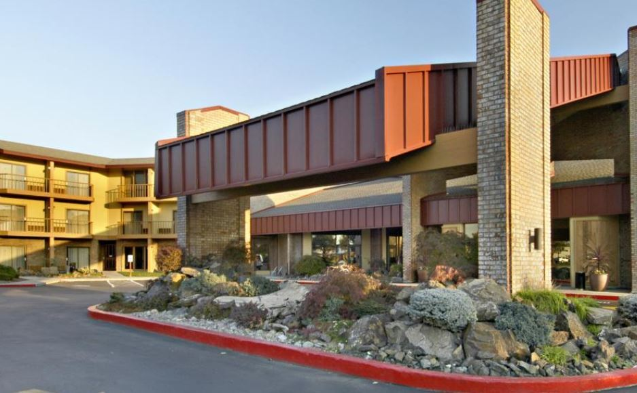
July 20 -23, 2022

Pasco Red Lion Hotel & Conference Center
2525 N. 20th Avenue
Pasco, WA 99301
Phone: (509) 5547-0701

King Room or Queen Double Room - $105.00
Suites - $139.00
To reserve online:
Copy and paste this direct link into your browser to receive the group rate:
https://be.synxis.com/?adult=1&arrive=2022-07-19&chain=13325&child=0&currency=USD&depart=2022-07-24&group=AMER2022&hotel=37024&level=hotel&locale=en-US&rooms=1

To book by Phone:

- Call 509-547-0701 ext. 0
- Ask to make a reservation at the Pasco Red Lion
- Let them know you are with a event in July 2022 – American Legion State Convention 2022
- Give them the group block code AMER2022

Should you plan on having your Service Animal with you there will be a one-time fee of $ 35.00
Please advise the hotel if you need ADA accessible facilities, as these are limited

