Dear Faculty and Staff of (School/District),

As a new school year begins, American Legion Auxiliary Unit # wants to take a moment to extend our warmest wishes to each and every one of you. Your dedication, passion, and commitment to education play a vital role in shaping the lives of countless students. Your tireless efforts in imparting knowledge, fostering growth, and nurturing young minds are truly commendable.

May this new school year be filled with inspiration, creativity, and opportunities for both you and your students. May you find joy in every breakthrough, fulfillment in every accomplishment, and resilience in every challenge. Your enthusiasm and unwavering support make a lasting impact on the lives of those you reach.

Remember that you are not alone in this journey. The American Legion Auxiliary and the broader education community stand behind you, offering their support and appreciation for your hard work. Embrace the strength of collaboration, share your expertise, and continue to empower the next generation with the gift of education.

May you thrive in vibrant spaces of learning, curiosity, and growth. May your students be engaged and nurtured with a love for knowledge. Your guidance and mentorship have the power to shape the future, instill values, and build a strong foundation for success.
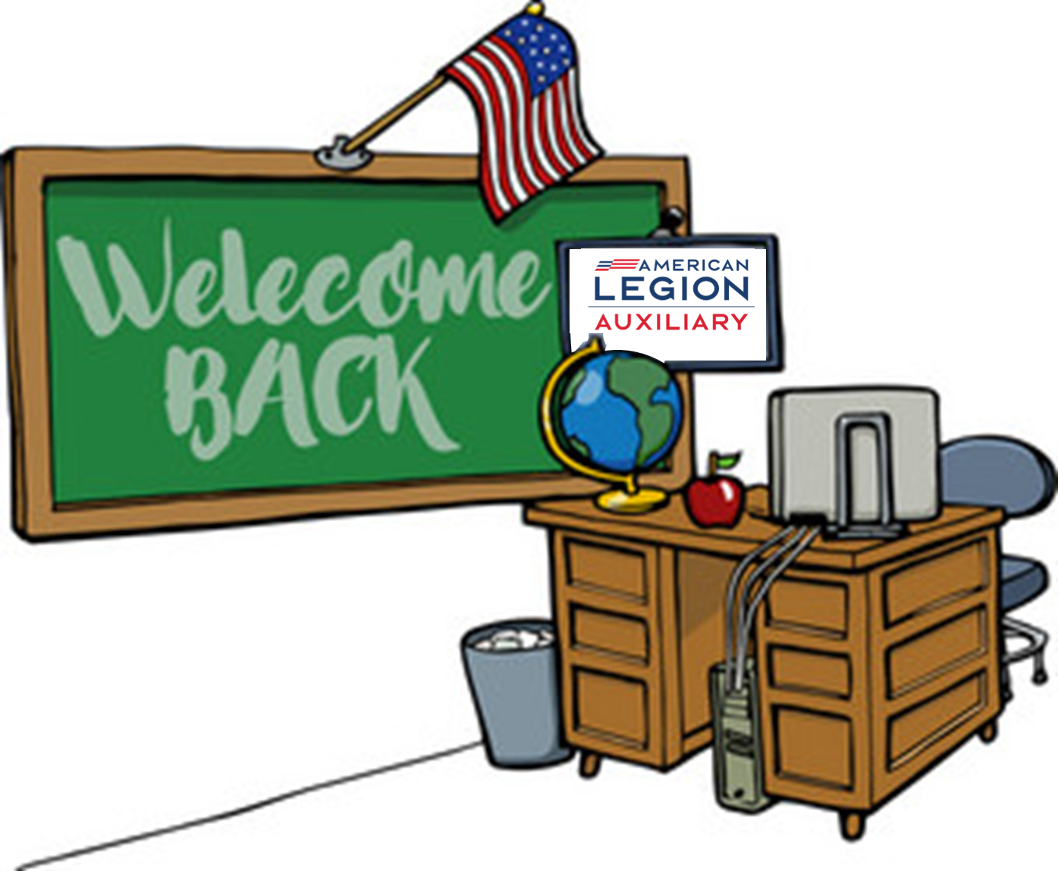
As you embark on this new academic year, we wish you boundless energy, patience, and wisdom. May you find fulfillment and joy in witnessing the progress of your students. Remember to take care of yourselves as well, for your well-being is crucial to your ability to inspire and lead.

Thank you for your relentless dedication and for being a pillar of strength in the lives of countless students. Here's to a successful and rewarding school year ahead!

With heartfelt wishes,
[Your Name]
American Legion Auxiliary #

