Hello, Fellow American Legion Auxiliary Members:

It’s hard to believe how far we are into the 2025-2026 administrative year. I’ve so enjoyed all of my department visits and look forward to many more as we remain Mission Driven, Family Focused.

Seeing departments working well together as an American Legion Family warms my heart. We need to continue working side by side to serve our collective missions focused on our veterans, military, and their families.

Please continue focusing on the two American Legion Family-focused initiatives: 1) a citation for a unit, post, squadron, or chapter that organizes, carries out, and submits a report of a project in your community that includes the whole Family; and 2) the “Family Three” award — recruit three ALA members, three Legionnaires, and three Sons of The American Legion members. This is open to members from the entire American Legion Family. Entries will come through the Auxiliary.

I appreciate everyone who has donated to this year’s ALA national fundraising focus: our Spirit of Youth Scholarship Fund. Please continue to support youth through your fundraising efforts. You can easily donate by texting SPIRIT to 1-844-940-3450 or online at www.ALAforVeterans.org/scholarships/spirit-of-youth.

I hope you use your time at this department convention to motivate and inspire each other, continue learning new and improved ways to work our mission, and make new friends from different parts of your state.

Together, we can do more to be Mission Driven and Family Focused, always putting our veterans, military, and their families first. Have a great department convention and I hope to see you in Louisville, Ky., at our 2026 National Convention in August!

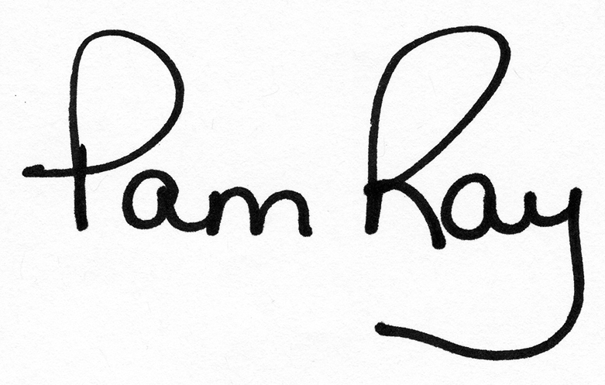
Pam Ray
2025-2026 National President

