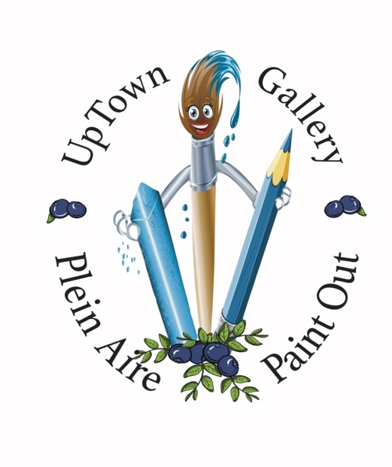

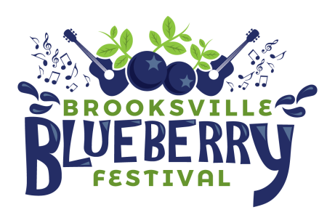
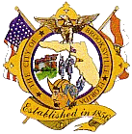
April 19-28, 2019

The Uptown Art Gallery at the Brooksville City Hall is pleased to announce the Second Annual Plein Air Paint-Out. This will be an "on location" painting event sponsored by the Brooksville Blueberry Festival and the City of Brooksville. The final presentation and judging will be at Brooksville City Hall on Sunday April 28th at 3:00 P.M.
On Friday, April 19, 2019 from 1:00P.M. to 4:00P.M., we will formally sign in the artists and stamp all paper, canvas, etc. Bring all that you will use. This is done to ensure that we know the work is completed within the 7 days of the event. Area maps will be provided so you can become familiar with the city and the county. All participants must be responsible for their own well-being and that of their artwork. The Brooksville Main Street Program and the City of Brooksville will not be responsible for any injury or loss.
Painting must be done during any or all of Saturday April 20th through Friday April 26th, and all artwork must be done in Hernando County. Paintings must be done without the aid of photography. Artists' work must be turned in to City Hall on Friday, April 26th from 1:00PM to 4:00PM. We will ask that you frame 2 paintings for judging. Please be prepared with all of your framing needs. Bring the finished pieces to the Brooksville City Hall, 201 Howell Avenue no later than 4:00P.M. on Friday April 26th.

The awards will be presented at the Brooksville City Hall on Sunday April 28, 2019 at 3:00P.M. There will be monetary awards of $300.00 for First Place, $200.00 for Second Place, $100.00 for Third Place and three awards of $50.00 for Honorable Mention.
The cost to the participant will be a non-refundable fee of $25.00 if registered by March 31st, $35.00 if later than March 31, 2019. Registration fee includes a T-shirt. T-Shirt may not be available for late entrants.
All work submitted will be on display at the Uptown Gallery at the Brooksville City Hall, where the artwork will be offered For Sale. All participating artists are invited to paint during Brooksville Blueberry Festival to promote the Festival. All work must be picked up at the Brooksville City Hall on May 10, 2019 between 9:00A.M. and 12:00P.M.
If you wish to book a space for the Brooksville Blueberry Festival, please contact John Lee at JohnLee@Activefoodservice.com.
We strongly advise early registration to ensure participation. You can send the attached form with a check for $25.00 ($35.00 if after April 10, 2019).

Make Checks Payable to: Judith McIntire
Brooksville City Hall
201 Howell Avenue
Brooksville, FL 34601

Contact: Judith McIntire, Art Gallery Coordinator at CityArt@cityofbrooksville.us
or call 207-809-9066 or 352-754-3810 for any questions.
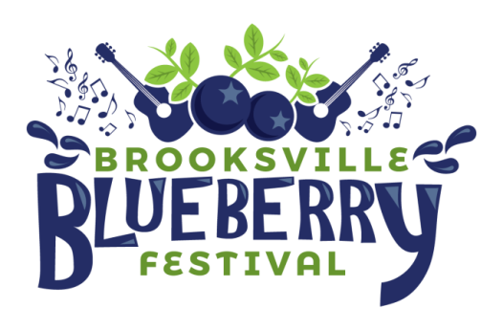

Please include check with this form

Name_____________________________________________________

Address____________________________________________________

Phone(cell)_________________________________________________

Email______________________________________________________

Medium___________________________________________________

T-Shirt Size (circle one) S M L XL XXL XXXL

