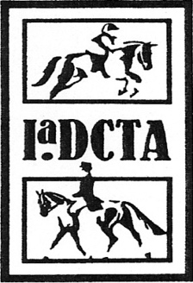 | Iowa Dressage and Combined Training Association  Application for Betsy Coester Grant

Member’s Name:
Member Email:
Member phone number:
Description of educational clinic or opportunity:

What is the Cost of the Clinic or activity?

How did you meet your volunteer hours requirement last year?

What do you hope to learn or achieve by participating in this event or activity?

If you are approved for a grant, do you agree to send a photo for the IaDCTA website/Collection, and to agree to fill out a short email questionnaire about your experience? Yes or No

Member signature: _____________________________________________________________________
If applicant is under age 18:
Parent Name:
Parent Signature: ______________________________________________________________________

