MOHAWK VALLEY BASEBALL UMPIRES ASSOCIATION

TWO MAN MECHANICS MANUAL

MVBUA field Mechanics

TWO MAN MECHANICS

Conventions used to designate players or locations
UIC = Plate Umpire
BU = Base Umpire
F# = Number designating a fielder position (F1=Pitcher)
#B = base (1B = first base)
HP = home plate
Pos A/B/C = Position A/B/C
R# = Runner and base
B = batter
BR = batter-runner
IF = Infield
OF = Outfield
AB = At Bat

Definitions
The Box
• An imaginary area in the IF that is a 45 foot square with one corner at HP and the
opposite corner at the mound.
Working land
• The area on the IF grass running parallel with the baselines between first and
second and second and third in which the BU moves while the defense is playing
a batted ball.
Sweet spot
• The area behind the mound that allows for excellent angles on all plays made at
the bases. Secondary sweet spots are designated on each side of the mound.
A play
• The course of action in which the defense attempts to put out a runner. Two
things are required; the ball and a runner.
The “V”
• The area on the field between F7 and F9 in which the BU has catch/no catch
responsibility. This area is specified on page 7.
Rotation
• A specific change in position made by each umpire in response to the ball put in
play.
Pressure
• This term derives from the movement of F3 or F4 while making a play on a
batted ball which forces the BU to clear the area around Pos A so as not to
impede play.
Time Play
• The situation in which the possibility exists that a run may cross the plate
close to or at the same time the third out of an inning is made on the bases.

PREGAME

- Umpires should coordinate the game with a phone call prior to the game date and arrive at the game site 30 minutes before game time. First umpire that arrives at the game should get vouchers and game balls from the home coach. Usually the base umpire gets vouchers and balls while UIC dresses. If you are unfamiliar with the field and/or ground rules you should arrive earlier to walk the filed together. This will enhance your authority and help shorten the plate meeting.
- Both umpires are responsible for contacting the athletic director of the school before the game to confirm their intention to work the game.
- Start the plate meeting five minutes before game time. UIC is in charge of the plate meeting. UIC is required by FED to ask both coaches if they are “Properly equipped according to Federation rules.” UIC is also required to inform both coaches that the game is being played in accordance with FED sportsmanship requirements and rules.
- Directly following the plate meeting, if the National Anthem is played, umpires will stand side by side directly behind home plate. If no Anthem is played or after the Anthem is played the BU should jog out to a position in shallow right field while the pitcher takes his warm-ups.

POST GAME CONFERENCE

- Leave the field together immediately following the conclusion of the game.
- Always meet with your partner after the game to debrief. This does not have to last long. Items to consider for discussion:
- Be honest and critique one another about the validity of tough calls and each other’s positioning.
- Coverage mistakes made during the game.
- Situations that occurred that drew the attention of the coach, i.e., disputed calls.
- Keep an open mind and control your ego.

IN BETWEEN HALF INNINGS

Plate Umpire:

- Assume a position on the first or third base line about a third of the way toward the base. Take the baseline of the team leaving the defensive field. Wait for the last defensive player to cross the foul line heading for the dugout then follow that player to the foul line.

- Count the warm-up pitches and be prepared to give F2 another ball if one gets past the catcher. Observe warm-up pitches, dugouts and the on deck batter. Do not turn your back on the infield to take substitutions from a coach.

Base Umpire:

- In between half innings, jog out to short right field. (Under no circumstances should BU be near a fence or bench area talking to bench personnel or people in the crowd.) Jog back to your first base “A” position when the catcher throws the pitcher’s last warm up throw down to second base. Please take special note at the word “JOG”. There is no walking between the white lines.
- Be aware of the UIC accepting substitutions in between half innings or during pitching changes. If he is busy with a coach, move into the infield dirt and count pitches until the UIC finishes with the paperwork. Inform him of the number of warm-up pitches remaining.

PUTTING THE BALL IN PLAY

Three situations must be in place before the UIC makes the ball ready for play:
- F1 must be on the rubber.
- F2 is squatted in the catcher’s box.
- B is in the batters box and ready to hit.
Glance at the BU to be sure that he is in position and ready to begin.

MECHANICS

UIC stands behind F2 and points his index finger toward F1 announcing “PLAY” loud enough for the infielders to hear.

Frequency

This must occur prior to the first batter of each half-inning and after every stoppage of play during an AB. Make sure BU is in position and ready. Since play is not stopped after base hits, fly ball outs, base on balls, etc, it is not necessary to put the ball in play for each new batter or pitch.

POSITIONING DEFINITIONS

Pos A is used with no runners on base and is approximately 10 feet behind F3 in foul territory. Pos B is used with a runner at 1B, and runners on 1B & 3B. Pos C is used with runners on 2B & 3B, 3B only and bases loaded. Positioning for B and C should be half the distance between the pitchers mound and second base and in a direct line with the edge of the dirt cut out of the mound and home plate.

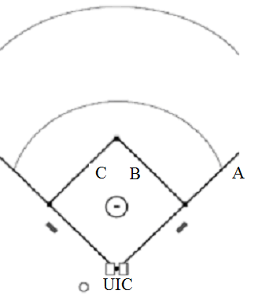

UMPIRE RESPONSIBILITIES

2 MAN MECHANICS

NO RUNNERS ON BASE

GROUND BALL TO INFIELD

Plate Umpire:

- Ground ball to the infield you should get out from behind the catcher and trail the batter-runner up the line. Be prepared to help the base umpire with a swipe tag or pulled foot. If BU requests your observation of the play, tell him what you saw and let him make the call.
- On an overthrow, you need to communicate with your partner who is taking the ball and who is taking the runner. If the BU is trapped in the infield dirt behind the runner in position to make the safe out call at 1B, there is no way he is going to be able to follow behind the runner into second base and make a call if the throw gets away from the first baseman. Often it is better for the plate umpire to cut in on the infield grass between 1B and the pitchers mound and take the runner into 2B to make the call while the BU stays with the ball to determine if it stays in live ball territory or goes into dead ball territory. If there is a throw to second base, the rotation would be plate umpire takes runner into 2B and 3B and BU then rotates to cover home. If BU is not trapped and can follow runner into 2B to make a call, plate umpire stays with ball and BU takes runner all the way into 3B.
- You have fair/foul responsibilities on all batted balls to the left side and fair/foul responsibilities on batted balls to the right side up to the base.

Base Umpire:

- Hustle from Pos A to a spot on the infield that will allow you to observe the runner’s progress and the play of the ball. Typically, this will be to a spot on the infield dirt that creates a 90 degree angle between you and first base. Watch the release of the ball from the fielder, then watch the runner hit the base and listen for the pop of the first baseman’s glove.
- On an over throw, follow explanation above.
- On a ground ball to F4 or F3 in which the play prevents you from entering the infield (pressure), you may have to stay out in foul territory to make the call at 1B.
- You have fair/foul calls on any ground ball that is hit past 1B.

FLY BALL TO OUTFIELD OR BASE HIT

Plate Umpire:

- You have catch/no catch, fair/foul from the left field line to the right fielder (when BU does not go out). Get out from behind home plate and into the infield to develop an advantageous angle on the play. Always take your mask off to make a call on a ball batted to the outfield. Communicate with your partner as to the status of the play (“Sal, I have a catch.” Or “The ball is down, Sal.”)
- If BU goes out on a batted ball to the right side, you have the batter-runner all the way to 3B.

Base Umpire:

- You have catch/no catch, fair/foul from the center fielder to dead ball in RF. You should go out on any trouble ball hit from center field toward right field. Once you go out, stay out until ball is played by defensive player, then make your way back in foul territory to cover home plate. If it is a base hit or a fly ball hit to the left side of center field, come inside the diamond and pivot on the infield grass. Get into the infield grass before the batter-runner reaches 1B. Watch the batter-runner touch 1B and be prepared to take BR all the way to 3B.

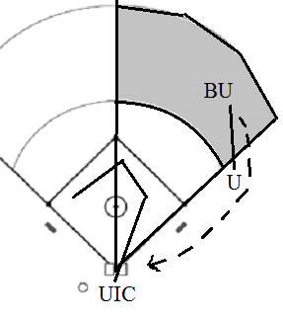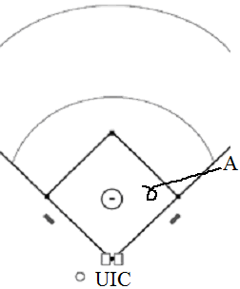

FLY BALL COVERAGE IN THE ‘V’

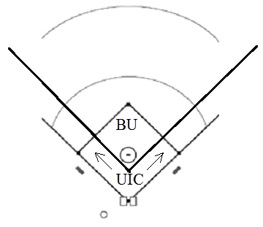

- The ‘V’ is the area from F7 to F9. BU will make calls on fly balls in this area when he is in the infield. UIC will make calls on batted balls that approach the foul lines (from the 3B line to F7 or 1B line to F9).
- It is important to communicate who will make a call on balls hit to F7 or F9 that are on the boundary of the ‘V’. Since UIC has the whole field in front of him, he should make the decision and communicate it to his partner in time for BU to react.

ONE RUNNER ON BASE

RUNNER AT FIRST BASE ONLY

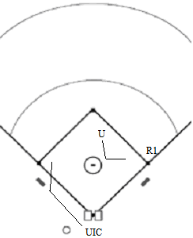

Plate Umpire:

- You have any fly ball hit from the left fielder to the line, and the right fielder to the line. If you are taking the ball, communicate that fact to your partner, so you are both not looking at the ball.
- On a ground ball to an infielder, get out from behind the catcher and be prepared for the interference call at second base on an attempted double play. If the fielder throws the ball to first, the interference call belongs to you.
- On a batted ball or base hit that leaves the infield, start to rotate to 3B as a play on R1 at 3B is your responsibility. You should start up the line in foul territory. When both the runner and the ball are going to 3B, enter the diamond, at about the cut out, to make the call.
- On an overthrow at 3B, work inside the diamond and take the runner to home plate.

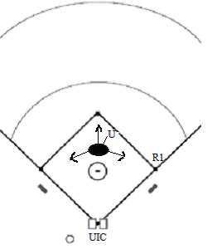

Base Umpire:

- You should start in Pos B.
- You have any fly ball hit in the ‘V’. Right fielder to the left fielder.
- On ground balls to the infield, be prepared for the double play. Move into the ‘sweet spot’ (as shown in the diagram above) to observe the first play at 2B and fade toward 1B as the ball is released to 1B. In the event there is interference at 2B and the fielder does NOT throw the ball to 1B, the call belongs to you.
- On a base hit, watch runner touch 2B, and take a glance at BR touching first. Take the BR into 2B & 3B if he attempts to advance past 1B.
- If the ball does NOT leave the infield you have R1 all the way into 3B and the BR into 2B.

RUNNER AT SECOND BASE ONLY

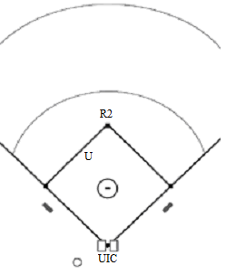

Plate Umpire:

- You have fly ball coverage from the right fielder and left fielder to the respective foul lines.
- On a ground ball to an infielder, watch R2 touch 3B and be prepared to help BU on a swipe tag or pulled foot at 1B.
- On a base hit or error by an infielder, observe R2 touching 3B and stay home for a play at HP.

Base Umpire:

- You should start in Pos C.
- You have fly ball coverage in the ‘V’. Do not leave the infield.
- You have the tag up of the runner on 2B, the touch of 1B by BR and the play into 3B.
- On a ground ball to an infielder, you have the play at 1B and the return play at 3B should R2 attempt to advance.
- On a base hit you have the BR all the way to third and touches of all bases along the way.

RUNNER AT THIRD BASE ONLY

Plate Umpire:

- You have fly ball coverage from the right fielder and left fielder to either foul line.
- You have the tag of the runner at third. Move to get in best position to see the catch and the runner.
- On a ground ball to the infield, watch the BR up the line and observe the R3 touching home from 1B extended.
- Base hit stay home.
- Stay home during a run-down of BR. Be aware of the intention of R3 should the defense attempt to play on him.

Base Umpire:

- You should be in Pos C.
- You have fly ball coverage in the ‘V’.
- On a base hit you have the BR all the way to third.
- You have responsibility for calling an attempted pick-off of R3.
- You have sole responsibility for a run-down involving BR between 1B and 2B.

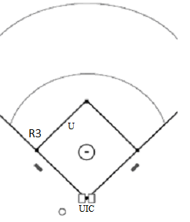

MULTIPLE RUNNERS

RUNNERS AT FIRST AND SECOND

Plate Umpire:

- Fly ball coverage from the left fielder and right fielder to either foul line. Communicate that you have the ball, so the BU knows he has the runners.
- You have the runner on 2B into third if he tags up after a caught fly ball in the outfield. Move up the line toward 3B in foul ground and come into the cut out when both the ball and the runner are coming into 3B.
- On a ground ball, get out from behind the catcher and be prepared to rule on interference on the front half of a double play.
- Observe runners touching third on a base hit and ground ball to an infielder and stay home for a play at the plate.

Base Umpire:

- You should be in Pos C.
- You have fly ball coverage in the ‘V’.
- You have the tag-up of the runner at 1B after fly ball catches in the outfield. Get the best angle on the runner at 1B and the catch. You have the runner coming into 2B and plays at 3B, (with the exception of the tag up of R2) including attempted steals of that bag.
- On ground balls in the infield, be prepared for a double play by moving into the ‘sweet spot’.
- Observe runners touching first and second base on a base hit. Keep your eye on the ball and be prepared to rule on runners at any base.

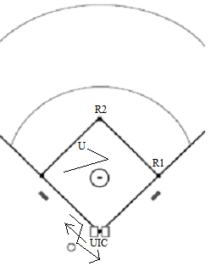

RUNNERS AT SECOND AND THIRD

Plate Umpire:

- Fly ball coverage from right and left fielder to either foul line.
- You have the tag up of the runner at 3B and the play at the plate. Be prepared to move to an appropriate angle to observe a catch in the OF and R3 tagging.
- Watch BR to first on ground ball but observe runner touching home (from 1B line extended, as shown in the diagram).
- Stay home on a base hit. Observe runners touching third from 3B line extended.

Base Umpire:

- You should be in Pos C.
- You have fly ball coverage in the ‘V’.
- You have tag-up of the runner on 2B and the play into 3B if R2 advances after a caught fly ball in the OF.
- Observe runners touching 1B and 2B on a base hit. Keep your eye on the ball and be prepared to rule on plays at any base.

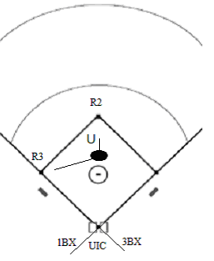

RUNNERS AT FIRST AND THIRD

Plate Umpire:

- Fly ball coverage from right and left fielder to either foul line.
- You have the tag up of R3 and play at the plate.
- Get out from behind F2 on a ground ball and you have the interference call at 2B on the front end of a double play. Be aware of the runner coming home as there might be a play there.
- On a batted ball or base hit leaving the infield, start to rotate to 3B but look back to observe R3 touching HP.
- Stay home during a run-down between 1B and 2B until R3 crosses HP.

Base Umpire:

- You should be in Pos B.
- You have fly ball coverage in the ‘V’.
- You have the tag up and advance of R1 on a caught fly ball in the OF.
- Be ready for the double play on a ground ball in the infield.
- On a base hit, take R1 into 2B and observe runners touching 1B and 2B.
- You have sole responsibility for a run-down involving R1 or BR between 1B and 2B.

BASES LOADED

Plate Umpire:

- Fly ball coverage from the right and left fielder to either foul line.
- You have the tag up of R3 and the play at the plate.
- You have the interference call on the front end of a double play but remain aware of R3 advancing to HP.
- Base hit you are staying home. Read the play from behind HP and move into the most advantageous position to see the play (runner and ball).

Base Umpire:

- You should be in Pos C.
- You have fly ball coverage in the ‘V’.
- You have the tag up of R2 and R1 on an advance after a catch in the outfield. If R2 advances to 3B after an out in the outfield, do not forget about the possible advance of R1 during a play on R2. You have to read the play from the 3B side of the mound. Do not over commit to 3B before or after a play there as it is a long way to 2B on a snap throw by F5 in an attempt to put out a following runner.
- On a ground ball, read the play from the ‘sweet spot’ and be prepared to rule at any base.

OBSERVING PLAYS AT THE PLATE

These are only typical positioning guidelines for use in MOST situations; remember every play is different and must be handled accordingly.

Watch the play develop from directly behind the point of home plate and move to the appropriate position based on where the throw is coming from and where the catcher is catching the throw.

Position yourself behind the catcher. You should shadow the catcher staying approximately 4-5 feet behind him. Follow him as he catches the throw and attempts to tag the runner. He will take you to the play. As the tag is being made, move closer to the catcher and be ready to move from one side to the other to get the best possible look at the tag. Do not hesitate to follow the catcher toward the pitcher’s mound. Calling the play from in front of the plate is ok.

DO NOT GET BLOCKED BY EITHER THE RUNNER OR THE CATCHER.

Remain flexible. The play can change instantly as the result of a bad bounce or the runner changing directions. Be ready to change your angle. Do not get too close to the play, as this tends to cause tunnel vision. Do not anticipate the call. Wait… let the play finish before you make the call. Always make sure the catcher has the ball in his possession before you make that out call. Nothing looks worse than you calling the out then noticing the ball is lying on the ground.

OTHER SITUATIONS

BATTED BALL FIELDED IN ‘THE BOX’

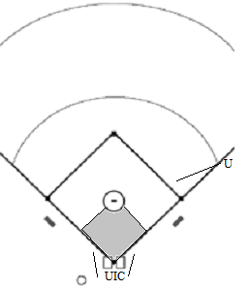

The shaded portion of the diagram is in imaginary section of the field called ‘The Box’ (45 foot square). Batted balls fielded in this area require appreciably different mechanics than those specified previously in these instructions. Typically, this batted ball is a bunted ball, a ‘Baltimore chop’ or a ‘dribbler’.

Plate Umpire:

- You have responsibility for the fair/foul call.
- When BU is in Pos A and has to move into foul territory due to pressure from F4, you must follow the play into the IF to cover possible plays at 2B or 3B.
- With a runner approaching the plate, stay outside of the box to judge fair or foul and watch the touch of HP (or the play at the plate).
- Without runners advancing home, move out from behind the plate to observe the fielding of the ball and the advancing BR running outside the running lane.

Base Umpire:

- When starting from Pos A, move quickly into the infield dirt to create a 90 degree angle on the play at 1B. Your best position will allow you to watch the ball enter F3’s glove and see BR touch 1B. You have responsibilities in judging BR interference but your partner has a better position to observe the play. When the ball is fielded by F3, be careful that your path into the infield does not interfere with F4 covering 1B. If you decide to stay in foul territory to cover this play you must be aware of the movement of the base coach.
- When you start in the infield in Pos B or C, you already have a great angle on the play so you should move into the sweet spot for the call at 1B. This position will not compromise your angle on subsequent plays at other bases. A sweep tag of BR by F3 may require you to request help from your partner.

COVERAGE OF POP UPS IN THE IF

Plate Umpire:

- Cover all pop ups excluding those covered by BU when he is in Pos A.
- With BU in the IF, and the ball is being played near either foul line, straddle the line so you will be in position to accurately judge fair/foul if the ball is dropped.
- With no runners on base, cover all pop ups in foul territory except those called by BU when F3 or F4 make an attempt behind 1B. When BU stays out on this pop up, move out from behind HP to cover the BR at all bases. Communicate to BU, “I have the runner, Sal”.
- When a runner is on 3B cover the tag up and advance to HP.

Base Umpire:

- Cover all pop ups with no runners (start in Pos A) and F3 or F4 fades back into the OF or down the right field foul line behind you. Stay 15 to 20 feet away from the play and in position to see the play on the ball. Do not allow the defensive player to get between you and the ball.
- On all those covered by UIC, hustle into the IF, pivot and take the BR to any base.
- You are responsible for all pop ups in the ‘V’ when you are in Pos B or C.
- Should there be a tag up and advance by a R1 or R2, you must cover these.

LINE DRIVES IN THE IF

Plate Umpire:

- With no runners on, cover all line drives except for F4 moving toward BU.
- With runners on base and BU in the IF, cover only line drives that take F3 or F5 toward the foul lines.
- Cover all line drives caught by F1.

Base Umpire:

- With no runners on, cover attempts by F4 moving to his left. This play is right in front of you when you are in Pos A.
- From Pos B or C, cover all line drives except for F3 and F5 moving toward the foul lines.

RUNDOWN COVERAGES

Between 1B and 2B

Plate Umpire:

- As the play is made on the runner, move up the 1B line in foul territory. Shift into the IF at the 1B cut out as the play moves toward 2B and announce to the BU, “I’ve got this end, Tony”.
- You make the call on the play if it is moving toward your position or if made at 1B.

Base Umpire:

- Stay in the ‘working lane’ and move with the play. DO NOT GET TOO CLOSE TO THE PLAY. You make the call if a play on the runner is made while it is moving toward you or at 2B.
- Do not try to keep up with the ball going between defensive players. Instead, try to get an angle on the play so that neither defensive player involved moves between you and the play on the runner.

Between 2B and 3B

Plate Umpire:

- Follow the same mechanics as a rundown between 1B and 2B except move up the 3B line in foul territory and shift into IF at the 3B cut out. Your calls are toward 3B.
- Be prepared to cover HP from inside the IF on an over throw of 3B.

Base Umpire:

- Follow the same mechanics as a rundown between 1B and 2B your calls are toward 2B.
- If there are multiple runners, you are responsible for all plays on the following runners so be cautious not to stray too far away from the sweet spot.

Between 3B and HP

Plate Umpire:

- Stay in foul territory. Make a call on all plays if BU has not had time to move in to fill his spot from Pos B.
- Be prepared to cover the play at HP. This will be the play that is hardest for you to get a good angle on as you are out in foul territory and do not have time to move to 3B extended. Be patient and allow the players to help you make the call.

Base Umpire:

- From Pos B/C or the sweet spot, move into position at the 3B cut out as the play moves away from you. Announce to BU “ I’ve got this end, Tony”. Make a call on the play if the tag of the runner is made while the play is moving toward you or is made at 3B.
- If there are multiple runners you are responsible for all plays until another runner reaches 3B.

BUNT COVERAGES

NO RUNNERS

Plate Umpire:

- Cover as you would on a batted ball in the IF.
- You have coverage of fair/foul situations.
- Watch for interference by the BR outside of the running lane and obstruction by F1 crossing in front of BR in the running lane.
- You make all calls on attempted plays on BR near the HP circle.
- Be aware of sweep tags by F1 and F3 in case BU asks for or needs help.

Base Umpire:

- When the ball is fielded in ‘the box’, hustle into the IF toward the corner of the cut out up the 2B line to make the call at 1B. Don’t get caught flat-footed as you will have to change your angle on a bad throw.
- Be aware of F4 covering 1B without getting to close to the play.
- If the bunt is fielded by F3 just outside the box, F1 will attempt the put out at 1B. Make this call from the same spot you would on a grounder fielded by an infielder.

ONE RUNNER

RUNNER ON 1B

Plate Umpire:

- Be prepared to make a fair/foul call then cover R1 to 3B if the first play is at 1B. Make this call from inside the IF.
- In the event of an overthrow at 3B, you have the play at HP. Stay inside the IF and make the call at HP from near the HP cut out.

Base Umpire:

- You are responsible for all put out attempts on the BR except for those made by UIC near HP circle. You are also responsible for all put out attempts of R1 at 2B. Be prepared to cover BR to all bases on an overthrow of 1B.

RUNNER ON 2B

Plate Umpire:

- Cover all fair/foul calls and plays at HP.
- Stay home with R2 on base.

Base Umpire:

- You are responsible for all plays on the BR and the runner at 2B (except plays on the BR in ‘the box’).

RUNNER ON 3B

Plate Umpire:

- Cover all fair/foul calls and plays at HP.

Base Umpire:

- Your responsibility is the first play in the infield except for the play at HP.
- Cover all plays on the BR.

MULTIPLE RUNNERS

Plate Umpire:

- You have all fair/foul calls and plays at HP.
- With R1 and R3, you cover the touch of HP.

Base Umpire:

- Cover any play at any base or tags of runners on base lines away from HP. The best place to read plays of this kind is from the ‘sweet spot’, in case there are put out attempts at multiple bases.
- Do not try to get too close to the first play with multiple runners.

PAST BALL COVERAGE

Plate Umpire:

- Cover plays at the plate and the ball leaving the field of play.
- Don’t get too far away from HP with R3 on base on a pop up behind HP.

Base Umpire:

- You are responsible for plays at all bases.

COMMUNICATIONS WITH PARTNER

- Prior to an AB with men on base, UIC should initiate hand signals to specify his responsibilities in the event the ball is put in play. BU should respond in kind to indicate understanding.
- Typical signals used prior to an AB with runners include the number of outs followed by the rotation of the UIC.

PITCH COUNT AND OUTS

- Count is given with palms facing outward, arms extended with hands in front of you.
- Left hand shows balls, right hand shows strikes. Use your: fist to designate no balls or strikes; index finger to show one ball/strike; index and middle finger to show two balls/strikes; middle, ring and little finger to show three balls.
- To show a full count, show three fingers on the left hand and two fingers on the right hand.
- To show the number of outs, extend your right arm to the side at shoulder height with the appropriate fingers extended.
- If a coach requests the count between pitches, face him, show the count and verbalize it.

Frequency

- Signal the outs to your partner between AB’s. With runners on base, signal the outs to your partner along with the rotation. Partners should respond in kind to indicate understanding.
- Signal and verbalize the count during an AB after a stoppage of play (foul ball, a substitution, a time out, passed ball, etc.)

REVISED 2017
JOE BELMONT MVBUA
PRINT SEQUENCE:

24, 1, 22, 3, 20, 5, 18, 7, 16, 9, 14, 11

12, 13, 10, 15, 8, 17, 6, 19, 4, 21, 2, 23

