Application #   
Fee Paid

Date Received   
Zone

Date Deemed   
Complete

Attest. ---=-----::-:--:-

Town Clerk

**APPLICATION FOR ZONING PERMIT   
 Village of Old Bennington**

Bennington, VT Town Clerk's Office

_______ ,20 at

o'clock minutes M

book on page __ of

________ Records

**NAME OF APPLICANT** Jasmine Aimaq and Karl D. Otto _

Address: 115 Monument Av Email jaimaq@gmail.com Phone 818 -792-3979

**NAME OF PROPERTY OWNER** (If different from above) same as above _

Address: same as above

**LOCATION OF PROPERTY** same as above (near intersection of Monument/Elm) _

**PARCEL ID.** (Tax Bill): 49503700

**LOT SIZE** 0.54 acres Frontage on Public Road 159.5 ft.

**TYPE OF USE: x** Residential O Business O Agricultural   
o Sign 0 Change of Use 0 New Construction

**IF APPLICATION IS FOR CHANGE OF USE:** Existing Use n/a _

**x** Public Water **x** Public Sewer

o Institutional

o Subdivision

o Addition 0 Alteration 0 Amendment

**BUILDING** Length__________ ft. Width ft. Height ft. No. of Stories__________

**SETBACK FROM PROPERTY LINES:** Front ___________ ft. Rear __________ ft. Side ft. Side ft.

**COST OF PROJECT:** < $1000(Include land preparation and all sub-contractors' costs. Attach builder's

estimate, if available). Appropriate fee (see fee schedule) must accompany application.

**Date**: August 18, 2025 **Signature of owner**: (see below)

**ZONING ADMINISTRATOR'S REPORT** (Office Use Only)

**ACTION:** To *PC*

To ZBA

Minor Permit _

Date

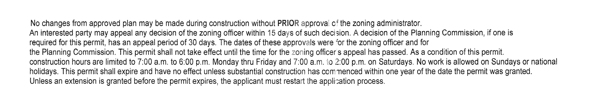

o Approved O Approved with conditions O Denied Date

**CONDITIONS/COMMENTS** ____

_____________________________________________________________________________________________________________

Start Date_______________________

Completion Date

**ZONING ADMINISTRATOR**

I understand I must secure a certificate of use/occupancy before using or occupying this structure.

I hereby certify that all statements contained herein and in all accompanying documents are true and correct. to the best of my knowledge.

Proposed Use: n/a (If business or institutional use, attach description)

**IF APPLICATION IS FOR NEW CONSTRUCTION, ADDITION, ALTERATION OR AMENDMENT:** Describe

1. Replace all brown window shutters with forest green window shutters of same material (vinyl), size, and design as current. See attached. 2) Second stage of project is to change color of current front door to forest green to match new shutters. Timeline for both stages is within 6 months of application approval date.

**______________________________________________________________________________________**

