Application #
Fee Paid
Date Received
Zone
Date Deemed
Complete
Attest. ---=-----::-:--:-
Town Clerk
APPLICATION FOR ZONING PERMIT
Village of Old Bennington
Bennington, VT Town Clerk's Office
_______ ,20 at
o'clock minutes M
book on page __ of
________ Records
NAME OF APPLICANT Kristin Castellanos _
Address: 13 Monument Circle, Bennington VT 05201 Email roessbud@gmail.com
NAME OF PROPERTY OWNER (If different from above) _
Address
LOCATION OF PROPERTY Same _
PARCEL ID. (Tax Bill): 425011000
LOT SIZE 3.3 acres Frontage on Public Road Approximately 100ft.
TYPE OF USE: Residential O Business O Agricultural
o Sign 0 Change of Use 0 New Construction
IF APPLICATION IS FOR CHANGE OF USE: Existing Use _

Public Water 0 Public Sewer
o Institutional
o Subdivision
o Addition 0 Alteration 0 Amendment
BUILDING Length__________ ft. Width ft. Height ft. No. of Stories__________
SETBACK FROM PROPERTY LINES: Front ___________ ft. Rear __________ ft. Side ft. Side ft.
COST OF PROJECT 30,000 (Include land preparation and all sub-contractors' costs. Attach builder's
estimate, if available). Appropriate fee (see fee schedule) must accompany application.
Date: 10/24/2025
Applicant's Signature:
ZONING ADMINISTRATOR'S REPORT
(Office Use Only)
ACTION: To PC
To ZBA
Minor Permit _
Date

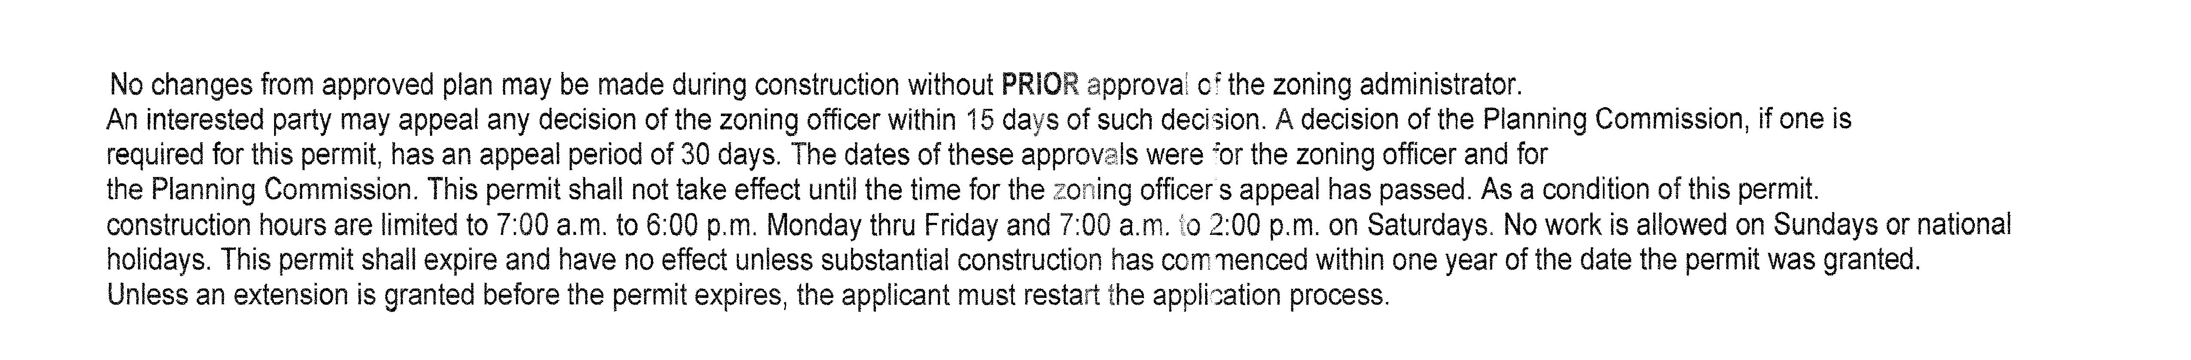
o Approved O Approved with conditions O Denied Date
CONDITIONS/COMMENTS ____
_____________________________________________________________________________________________________________
Start Date_______________________
Completion Date
ZONING ADMINISTRATOR
I understand I must secure a certificate of use/occupancy before using or occupying this structure.
I hereby certify that all statements contained herein and in all accompanying documents are true and correct. to the best of my knowledge.

Proposed Use: (If business or institutional use, attach description)
IF APPLICATION IS FOR NEW CONSTRUCTION, ADDITION, ALTERATION OR AMENDMENT: Addition of a 320 square foot addition to expand the dining room and add a home office.

Phone (917) 975-8262
No changes from approved plan may be made during construction without PRIOR approval of the Zoning Administrator. An interested party may appeal within 15 or 30 days depending on whether PC approval necessary. As a condition of this permit construction hours are limited to 7:00AM to 6:00PM Monday thru Friday. Saturday 7:00AM to 2:00PM. No work on Sunday or holidays. Permit good for 1 year.
