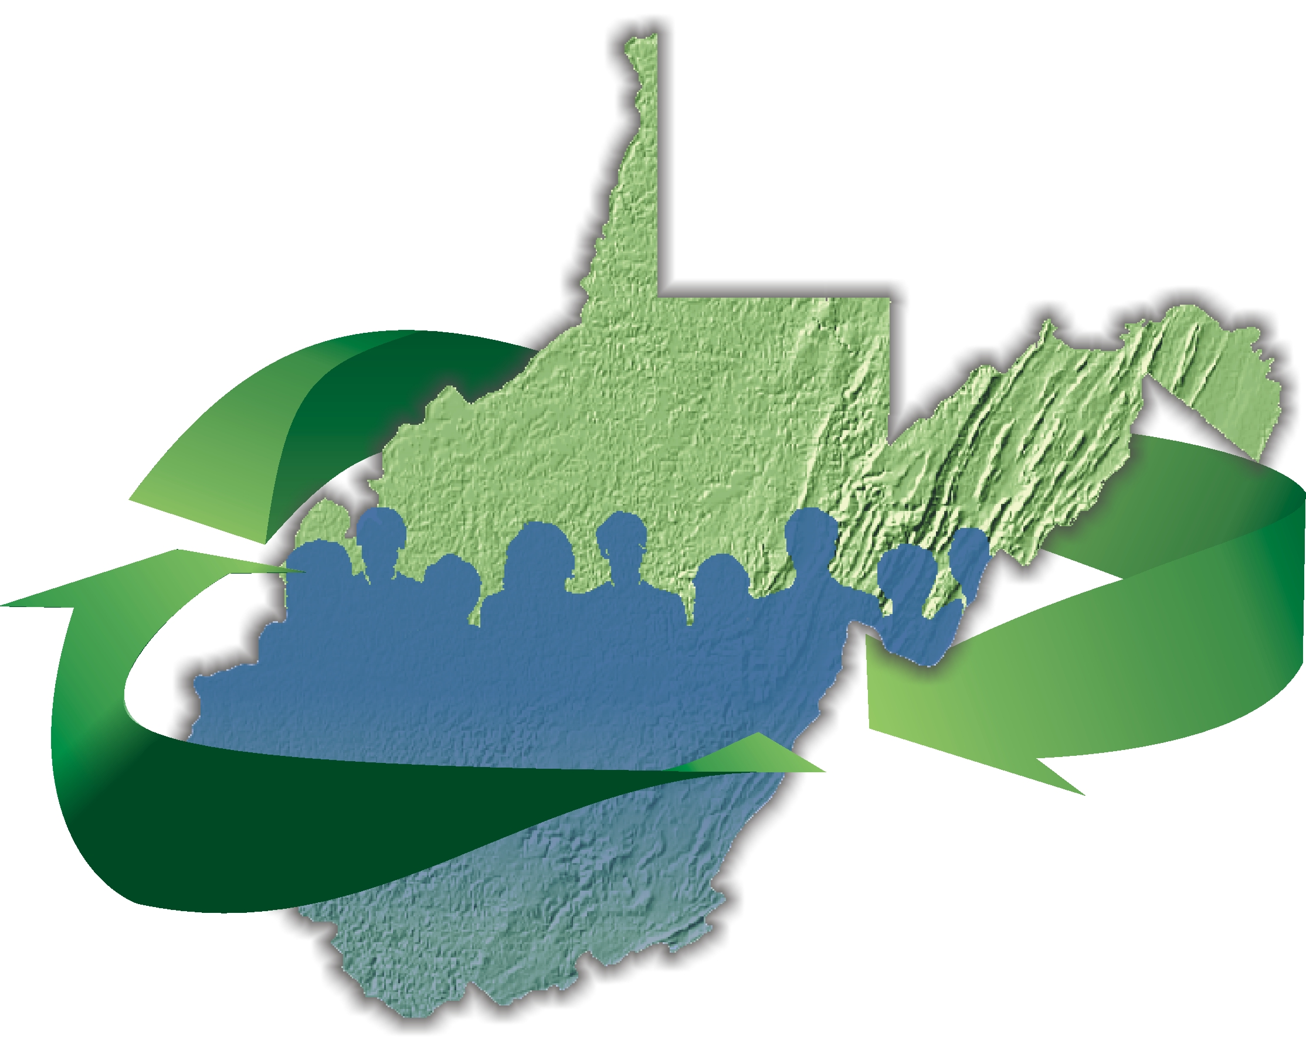

Association of WV Solid Waste Authorities
c/o Putnam County Solid Waste Authority
PO Box 46, Winfield WV 25213
(304) 586-0495

INVOICE

TO: ALL County SWA’s

FROM: Charity Fellure, Treasurer

DATE: June 18, 2019

SUBJECT: Invoice for 2019-2020 Dues

Amount due: $200.00

Due upon receipt.
Dues must be received by September 15, 2019
in order to have voting privileges at conference!

Please issue check to: Association of WV Solid Waste Authorities

Mail check to: Association of WV Solid Waste Authorities
c/o Putnam County Solid Waste Authority
PO Box 46
Winfield, WV 25213

