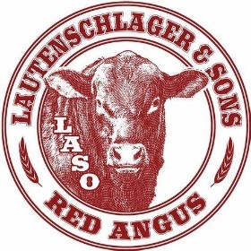
2020 FALL SALE SUPPLEMENT
LOT# SCROTAL
90 | 38
91 | 37
92 | 37
93 | 40
94 | 36
95 | 37
96 | 36
97 | 38

OUTS
LOT # 3

