


The Digital Stethoscope Newsletter
January 2026

A New Start. A New Year. Let’s Make an Impact.

Welcome to the January Issue of The Digital Stethoscope!
January invites reflection . . . but more importantly, it invites action.
As we step into a new year, nurses are once again standing at a pivotal intersection of care, education, technology, and policy. Artificial intelligence is no longer a future concept or an experimental tool . . . it is already shaping how we teach, practice, document, and decide.
This moment isn’t about chasing trends. It’s about clarity. It’s about confidence. And it’s about ensuring that human judgment remains at the center of every digital decision.
In this January issue of The Digital Stethoscope, we focus on practical impact—building AI literacy, strengthening guardrails, and empowering nurses to lead rather than react. The goal isn’t perfection. It’s progress that protects patients, supports educators, and strengthens the profession.
A new year doesn’t require a complete reinvention. It requires intention.
Let’s make this the year nurses shape the conversation—and the outcomes.
Please join “Nurses for AI^{TM” !} You can join the LinkedIn "Nurses for AITM" Group with this link: https://www.linkedin.com/groups/14944079/ Facebook Group "Nurses for AITM" with this link: https://www.facebook.com/groups/778335102032483
Dr. Susan Deane
Online Education Consultant

Spotlight Feature: “From Awareness to Action: Turning AI Literacy into Impact”

Artificial intelligence is no longer something nurses can afford to “keep an eye on.” It is already influencing clinical workflows, educational design, documentation practices, and decision-support systems. But awareness alone isn’t enough. The real impact comes when nurses move from passive exposure to active, informed engagement . . . understanding not just what AI can do, but when, how, and whether it should be used. AI literacy is not about mastering every tool; it’s about developing the critical thinking skills needed to evaluate outputs, recognize limitations, and safeguard professional judgment.
True AI literacy centers on accountability. Nurses remain responsible for decisions, outcomes, and patient safety, regardless of how advanced the technology becomes. This means knowing when AI supports efficiency and clarity, and when it introduces risk, bias, or over-reliance. Human-in-the-loop decision-making is not optional; it is the ethical and professional foundation that keeps care human, contextual, and responsive. When nurses are equipped with clear guardrails and practical frameworks, AI becomes a support . . . not a substitute . . . for expertise.
As we begin a new year, the opportunity is not to experiment endlessly, but to make intentional progress. Investing in AI literacy empowers nurses to lead conversations at the bedside, in the classroom, and in policy spaces. It positions the profession not as a passive recipient of technology, but as an active designer of how digital tools are used responsibly. Awareness starts the journey, but action is where impact happens.
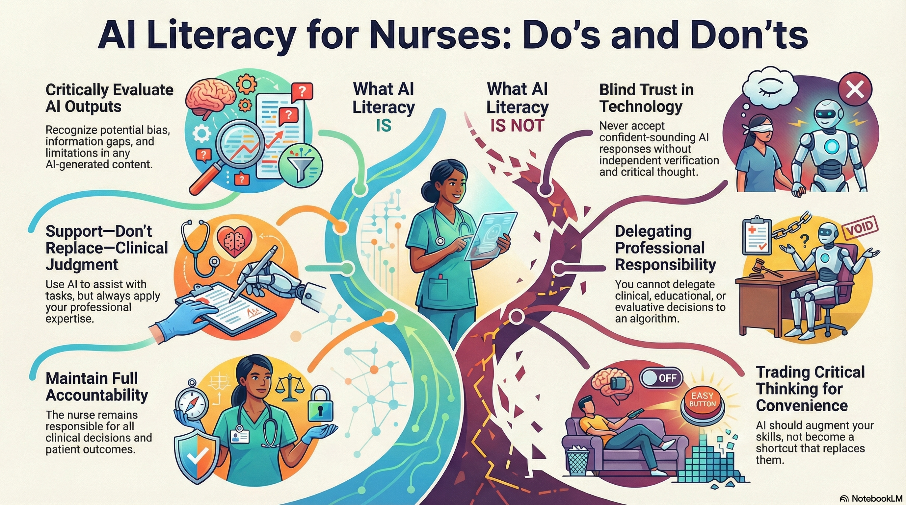
AI literacy doesn’t reduce the nurse’s role . . .it reinforces it.
The nurse always decides.

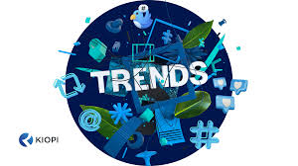
Trending Topics:

“What’s on the Monitor Right Now”

🔹 From Experimentation to Expectation
AI in nursing education and practice has moved beyond pilots and curiosity. Institutions are shifting from “try it and see” to “prove it’s safe, ethical, and effective.” This means clearer policies, defined guardrails, and growing expectations that nurses understand how AI tools influence workflows, documentation, and decision support . . . not just how to use them.
🔹 AI Governance Is Becoming a Nursing Issue
Questions about accountability, bias, transparency, and oversight are no longer just technical concerns . . . they’re professional ones. Nurses are increasingly being called upon to help shape AI governance, ensuring that tools align with standards of care, patient safety, and ethical practice. Human-in-the-loop models are emerging as the minimum standard, not a bonus feature.
🔹 Literacy Over Tools (Finally)
The conversation is slowly . . . but importantly . . . shifting away from “Which AI tool should I use?” to “What competencies do nurses need to use AI responsibly?” This reframing puts the focus back on judgment, context, and decision-making. Tools will continue to change. Competence is what creates lasting impact.
🔹 Understanding Digital Twins & Decision Support
Digital twins, predictive analytics, and advanced decision-support systems are gaining attention across healthcare. For nurses, the opportunity . . . and responsibility. . . is to understand what these systems can inform, where they fall short, and how human assessment remains essential. Insight is valuable. Oversight is non-negotiable.

___________________________________________________________________
Practical Insights:

“Starting the Year with Intentional AI Use”

Making an impact with AI doesn’t require sweeping change or advanced technical skills. It starts with intentional use. choosing moments where AI can support efficiency, clarity, and reflection, while keeping professional judgment firmly in the driver’s seat. For nurses and educators, this often means using AI behind the scenes: drafting, organizing, summarizing, or generating ideas that are then reviewed, refined, and owned by the nurse.
A practical starting point is to ask one simple question before using any AI tool: What am I trying to improve: efficiency, clarity, learning, or decision support? When the purpose is clear, the boundaries become clearer too. AI can help draft patient education materials, generate discussion prompts, outline policies, or summarize evidence, but it should never validate clinical decisions, replace assessment, or stand in for evaluation. The value comes from pairing AI’s speed with nursing insight, context, and accountability.
As the year begins, small, consistent practices matter more than bold experimentation. Build habits that reinforce critical thinking: verify sources, question outputs, document human oversight, and reflect on when AI helped . . . and when it didn’t. These everyday decisions shape a culture of responsible use. Impact doesn’t come from using more technology; it comes from using it well.

Research/News Corner


“What the Evidence—and Headlines—Are Telling Us”
🔬 Research Is Shifting Toward “Responsible Use”
Recent scholarship in nursing and health professions education is moving beyond whether AI can be used to how it should be used. Studies increasingly emphasize AI literacy, transparency, and human oversight as essential competencies rather than optional add-ons. The emerging consensus is clear: effective AI integration depends less on the sophistication of the tool and more on the preparedness of the professional using it.
🧠 Cognitive Load, Learning, and AI
Education research is paying closer attention to how AI influences thinking, not just productivity. Early findings suggest that when AI is used to support idea generation or organization . . . rather than replace analysis or synthesis . . . it can enhance learning. Conversely, over-reliance may reduce engagement with complex reasoning. For nurse educators, this reinforces the importance of intentional design, clear expectations, and guided use.
🏛️ Policy Signals Are Getting Louder
Regulatory and professional organizations are increasingly calling for defined guardrails around AI use in healthcare and education. Themes such as accountability, bias mitigation, documentation of human oversight, and role clarity appear consistently across guidance documents. While specific policies continue to evolve, the direction is unmistakable: responsible AI use will be measured not by innovation alone, but by safety, ethics, and professional judgment.

Educator’s Toolbox: “AI Tools That Support Teaching . . . Without Replacing It”

For nurse educators, AI is most effective when it works behind the scenes. The goal isn’t automation of teaching, but amplification of educator expertise . . . freeing time for feedback, mentoring, and deeper learning. Used intentionally, AI can support course design, assessment development, and student engagement while keeping academic integrity and professional judgment intact.
Where AI Can Help Educators
- Drafting discussion prompts, case scenarios, or reflection questions
- Generating quiz questions or rubric language that educators review and refine
- Summarizing research articles to support lesson planning
- Creating alternative explanations for complex concepts
- Brainstorming simulation debrief questions or learning activities
In each case, the educator remains the editor, evaluator, and decision-maker. AI offers a starting point . . . not the final product.
Where Educators Must Draw the Line
AI should never be used to replace evaluation, grading decisions, or academic judgment. It should not determine student performance, provide personalized feedback without review, or be used in ways that obscure authorship or accountability. Transparency, oversight, and alignment with institutional policy are essential to maintaining trust and rigor.
A Simple Rule for Educators
If the task requires professional judgment, evaluation, or ethical responsibility, it belongs to the educator.
If the task supports organization, ideation, or efficiency, AI may assist . . . under supervision.

🔧 Toolbox Tip
Start the semester by choosing one AI-supported task . . . such as drafting discussion prompts or summarizing readings . . . and apply clear guardrails. Small, transparent use builds confidence and competence over time.
___________________________________________________________________________
Closing Note

Starting Strong, Leading Forward
A new year doesn’t ask nurses to become something different . . . it asks us to step more fully into who we already are. Leaders. Educators. Advocates for safe, ethical, and human-centered care. As technology continues to evolve, the nursing voice is not optional to the conversation . . . it is essential.
The impact we make this year won’t come from using more tools or chasing every innovation. It will come from thoughtful choices, clear boundaries, and a commitment to keeping human judgment at the center of every decision. When nurses lead with intention, technology follows in service of care . . . not the other way around.
As you move into the year ahead, start where you are. Ask better questions. Use AI thoughtfully. Stay curious, stay grounded, and stay human. The future of nursing isn’t waiting to happen . . . it’s already being shaped by the choices you make today.
🩺 Susan
Feedback: Please share your feedback, experiences, questions, and ideas or articles for upcoming issues. Send email to: susan@thedigitalstethoscope.com or susandeane119@gmail.com

