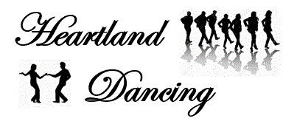

Dance! It’s Good for the Heart!

Questions: 605-484-1054 or [dellerton@rushmore.com](mailto:dellerton@rushmore.com) www.heartlanddancing.com

***Facebook: Heartland Dancing***

**March 5 – April 16, 2020**

***Thursdays (6 weeks) No class on April 2***

Cost per person per class: $50

($35 per person for Canyon Lake Activities Center Members)

For information on memberships at the activities center:

<https://www.canyonlakecenter.com/prospective-memebers>

**6:30 – 7:30 pm**

***Line Dancing Beyond the Basics***

No Partner Needed

If you haven’t tried line dancing, now is the time to start.

**7:45 – 8:45 pm**

***Beginner Triple Two Step***

**6:30 – 7:30 pm**

Couples and Singles are Welcome!

Triple two step is also called double two step. The triple two step is often called “swing on the move,” since the dance uses a progressive version of the triple timing swing basic. Like the polka and like the standard two-step, the triple two-step progresses around the perimeter of the dance floor in a counterclockwise fashion.

**Dance Classes at the Viking Hall**

**Canyon Lake Activities Center**

2900 Canyon Lake Drive