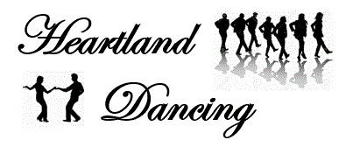

Don’t feel comfortable taking group classes?

The dance class schedules don’t fit your schedule?

Want some help getting ready for a wedding or reunion?

Call Debbie for information on private lessons.

Questions:

605-484-1054 or [dellerton@rushmore.com](mailto:dellerton@rushmore.com) www.heartlanddancing.com

***Facebook: Heartland Dancing***

Dance! It’s Good for the Heart!