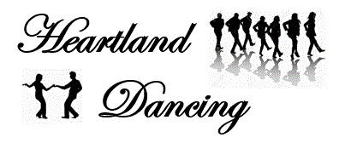

***Rapid City Swim Center***

***125 Waterloo Street, Rapid City, SD***

**March 11 – April 15, 2020**

***Wednesdays (6 weeks)***

***$50/Person/Class***

***Beginner Waltz***

**7:45 – 8:45 pm**

The Waltz is a graceful, smooth partner dance.

Even though it is a ballroom dance, many country fans have taken a liking to dancing waltz too!

Singles are Welcome!

Dance! It’s Good for the Heart!

Questions: 605-484-1054 or [dellerton@rushmore.com](mailto:dellerton@rushmore.com) www.heartlanddancing.com

***Facebook: Heartland Dancing***